PROPOSAL FOR SOLAR ROOFTOP
POWER GENERATING SYSTEM
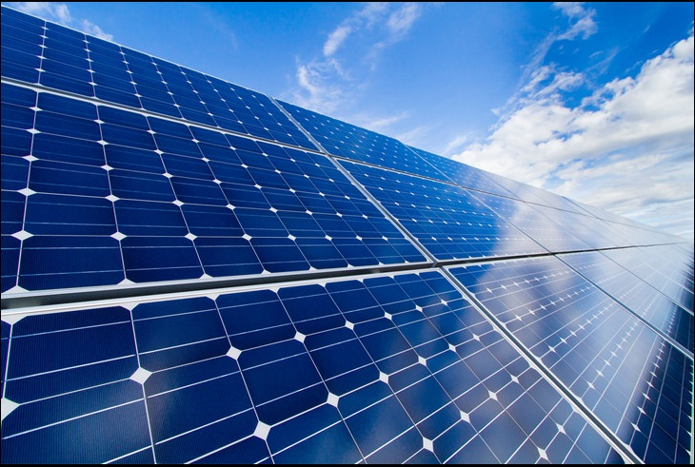
PROJECT NAME: GRID-CONNECTED ROOFTOP SOLAR POWER PLANT
CLIENT NAME: The Hope House, Karigiri
PROJECT CAPACITY: 5.2KWp
REFERENCE NO:SMT/006/18-19
DATE: 18 Aug 2018

Contents
ABOUT HAVELLS INDIA LIMITED 3
TECHNICAL DESCRIPTION 4
GRAPHICAL REPRESENTATION – CONVENTIONAL SOLAR POWER PLANT: 4
ABOUT HAVELLS SOLAREDGE SOLUTION – UNIQUE FEATURES 5
CLIENT DETAILS: 6
SITE DETAILS: 6
SCOPE OF WORK 6
ASSUMPTIONS 7
CUSTOMER SCOPE: 8
FINANCIAL ANALYSIS: 10

AboutHavells India Limited

HAVELLS INDIA LIMITED is a leading US$ 1.4 bnFast Moving Electrical Goods (FMEG) Company with a market capitalisation US$ 3.4bnand a major power distribution equipment manufacturer with a strong global presence.
Havells enjoys enviable market dominance across a wide spectrum of products, including Industrial & Domestic Circuit Protection Devices, Cables & Wires, Motors, Fans, Modular Switches, Home Appliances, Electric Water Heaters, Power Capacitors, CFL Lamps, Luminaires for Domestic, Commercial and industrial Applications.
Today, Havells owns some of the most prestigious brands like Havells, Crabtree and Standard. Its network constitutes of 4000 professionals, over 6000 dealers and 40 branches in the country and presence in 45 countries globally. Its twelve state-of-the-art manufacturing plants in India located at Haridwar, Baddi, Noida, Sahibabad, Faridabad, Alwar, and Neemrana are manufacturing globally acclaimed products, synonymous with excellence and precision in the electrical industry.
The company pioneered the concept of exclusive brand showroom in the electrical industry with ‘Havells Galaxy’. Today over 375 Havells Galaxies across the country are helping customers, both domestic and commercial, to choose from a wide variety of products for different applications. Havells became the first FMEG Company to offer door step service via its initiative ‘Havells Connect’. Thanks to the quality of products and quicker service, it has minimum customer complaints and highest customer satisfaction.

Technical Description
Solar energy is important for many reasons and has great positive impact on environment.
Solar / Photovoltaic devices convert light from sun into usable form of electrical energy.
These mainly consists of PV modules, module mounting structures, inverters, batteries, monitoring devices etc. The system is further classified as Grid Connect (where the energy from PV system is fed into the Utility Grid) and Off-grid (where the energy generated by the PV system is stored and used when required) and Hybrid (where multiple sources are used for generation of power including conventional sources and utility). The proposed system is a Grid Connected system.
As the name suggest, Solar Grid Interactive solutions work in tandem with grid electricity, or in some cases in reference with another constant electrical energy source like diesel generators. The systems are designed to reduce energy consumption from the DISCOM, and hence directly help in reducing the energy bills.

GRAPHICAL REPRESENTATION – CONVENTIONAL SOLAR POWER PLANT:
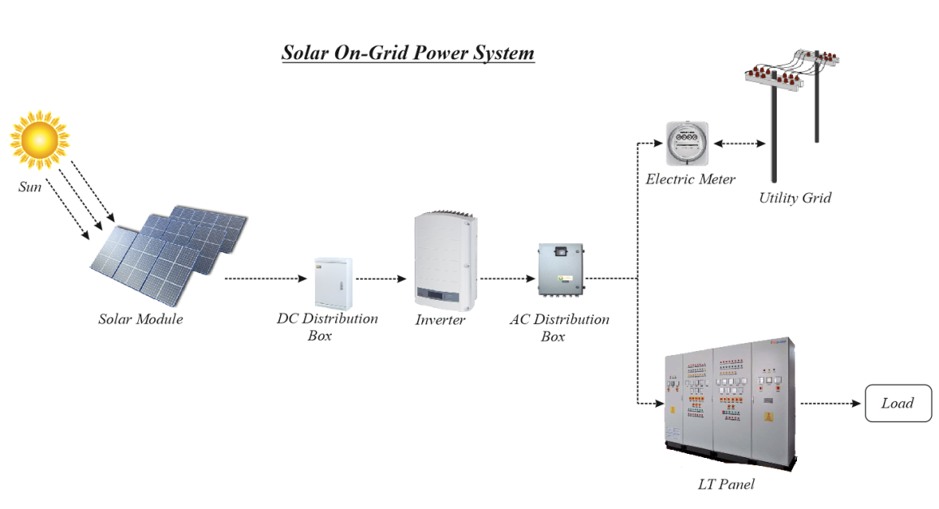

ABOUT HAVELLS SOLAREDGE SOLUTION – UNIQUE FEATURES
We are going to use SolarEdge Inverters which are safe and pose no danger to people or property. However, with a traditional inverter, as long as the sun is up, PV wires are energized with high DC voltages. With SolarEdge it has Unique “DC Safe” feature which ensures rapid shutdown to 1Volt per Optimizer when AC Grid is turned off.
- It has also a high tech feature of module level monitoring which provides for-
- Full visibility of system performance & remote troubleshooting.
- Less trips to site
- Less time spent on site
- Higher system uptime
- Automatic alerts on system issues
- Easy access via web browser and mobile device
- Real-time full insight into system from anywhere
- Free module-level monitoring for system lifetime.
- Fault detection pinpointed on a virtual site map.

- The SolarEdge optimized DC inverter solution enables higher system lifetime value by maximizing revenue and saving installation and maintenance costs. Power generation is optimized at the panel level, which minimizes power losses and leads to a higher lifetime revenue from the PV systems.
The power generated can be easily synchronised with your main LT panel and help subsidise your consumption from the EB connection. You may also opt for a Net Metering connection if necessary.
The Havells-SolarEdge SPV Grid –Tie system apart from the features illustrated in the report ensures utmost safety due to its unique “DC Safe” feature which gains all the more significance when Solar is used in areas with higher human engagement. All safety precautions such as against Lightning, Earth leakage etc. are also in built into the system design proposed.
Havells is privileged to be considered to partner your esteemed organisation in your endeavour to support the cause of a Greener and Cleaner Planet.

CLIENT Details:
Client Name – The Hope House,
Client Address - Karigiri, Vellore

Site Details:
- Capacity of Plant-5.2KWp DC Capacity
Type of Roof- RCC
Phase Connection- Three Phase

Scope Of Work
Scope of Work in this offer includes the following
- Design & Engineering
- System design
- Engineering drawings
- Detailed Bill of Materials & Project Report
- Electrical Works
- Wiring of Modules
- Cabling from Modules to Inverter
- Cabling from Inverter to AC Distribution box
- Cabling from AC Distribution Box to LT Panel
- Earthing

- Installation Work
- “Any Statutory variation in taxes and duties from the date of submission of this proposal including change of rates for solar PV system and/or its parts/ components/equipment under GST, Imposition of Antidumping Duty (ADD) and/or Safeguard Duty (SDD) on imported modules and cells by the Government of India would be to the clients account and shall be Payable by the client at actual.”
- Cost of Shifting materials from ground floor to the fourth floor is not included in the above cost
- Feeder / LT panel for connection to grid will be made available at site and shall be in Client’s Scope.
- Net-metering and approval of DISCOM, if applicable, is not part of this proposal
- Warranty as per terms and conditions mentioned herein.
- After sales service during above period, directly or through local contractual arrangement.

Assumptions
- Peak sun shine availability of 5 hours – average as per the geographical site conditions.
- It is assumed that sufficient shadow free area will be available for installation of modules. In case of restriction due to already installed equipment, other roof (as available at site) may have to be used keeping minimum impact on generation.
- Load bearing capacity of the roof should be adequate to carry the load of the MMS system considering the wind load of zone.
- Height of the building is considered 15meters.
- ACDB, DCDB & Inverters will be placed on roof.
- Distance from ACDB to LT Panel is 30 meters.
- Cable Tray, Cable trench, safety equipment’s, Water cleaning system, Handrail & Pathway shall not in our scope of work.
- Provision of suitable rating spare feeder shall be in owner’s scope.
- Location of Inverter and ACDB at the terrace level.

Customer Scope:
- Customer to provide space for storing of materials.
- Making the site ready and clearing the terrace / roof of any unwanted items is not included in scope of work. Necessary support will be extended to our Installation team for taking material inside the premises and also to the roof top. The same has to be kept at proper and secure place till completion of Installation.
- Safety of material supplied would be in customer scope after delivery at site
- Customer shall provide access to feed in solar power to LT panel located in ground floor of building. Feeder / LT panel for connection to grid will be made available at site and shall be in Customer’s Scope.
- Customer to provide LAN (Ethernet facility) for cloud monitoring.
- Cleaning of Modules is not in our scope. Customer is request to clean panels twice a week.
- Net-metering and approval of DISCOM, if applicable, is not part of this proposal.
- Net-metering charges would be in the scope of customer. Havells will extend support in applying for a net-meter with relevant DISCOM by fulfilling all technical documentation.
- Fees and Charges related to any sort of statutory approvals & clearance from local authorities, DISCOM and SNA shall be borne by the owner directly.
- Warranty as per terms and conditions mentioned herein.
- Customer to provide land ownership document and also a declaration that the rooftop system is being installed their own usage.
- Water & Electricity required for construction of solar power plant shall be in Customer’s scope.

Financial Analysis:
Initial Investment in terms of components cost & service charges
Total Project Cost- INR. 5,14,350/- (RUPEES FIVE LAKHS FOURTEEN THOUSAND THREE HUNDRED FIFTY ONLY)*
* Applicable taxes.
For Supply of SPV System-
SL NO. | SOLAR ON GRID SYSTEM | UNIT PRICE (INR) | Rs.  Including GST | QTY.
1 | Supply of 5.2KWp Solar On Grid System power plant | INR. 3,55,000/- + GST @ 5% Extra as applicable  (Rupees Three Lakh Fifty Five Thousand Only + GST @ 5% Extra as applicable | 3,72,750.00 | 1 Set

SL NO. | SOLAR ON GRID SYSTEM | UNIT PRICE (INR) | Rs.  Including GST | QTY.
1 | Supply of 5.2KWp Solar On Grid System power plant | INR. 1,20,000/- GST @ 18% Extra Installation and Commissioning as applicable  (Rupees One Lakh Twenty Thousand + GST 18% Extra Installation and Commissioning as applicable) | 1,41,600.00 | 1 Set

Please Note:
- *GST will be charged extra as actuals
- The final capacity might vary during the detailed engineering.

TERMS & CONDITIONS:
Prices | Prices are upto Ex Havells Warehouse Noida. Freight charges will be extra as actuals.
Transit Insurance | Upto delivery of material at site.
System Installation | System Installation will be done by our authorized system installer.
Goods & Service Tax | For Solar PV System,  Supply-Above prices are exclusive of GST and shall be charge 5% extra as applicable  Installation - Above prices are exclusive of GST and shall be charge 18% extra as applicable
Delivery | Material Dispatch in 8- 10 Weeks from the date of receipt of your technically and commercially valid Purchase order (P.O). Installation will be completed within 6- 8weeks from date of receipt of materials at site,  Provided site is ready for installation in all respects
Warranty | We offer a 12 years warranty for Solar Edge Inverter & 25 years for Power optimizer. All solar modules are covered under linear performance warranty of 25 years with a degradation of 10% over first 10 years and further 10% thereafter as extended by Panel manufacturer.  Solar Edge Product are covered by the Solar Edge Limited Warranty , the terms of which you may find at http://www.solaredge.com/sites/default/files/solaredge-warranty-june-2016.pdf
Payment Terms : | 100% Advance Payment
Validity | This offer is valid for 30 days from the date of this offer
Force Majeure | Force Majeure conditions apply for this offer & resultant order
*GST rates mentioned as per rates specified under tariff heads. Rates can vary as per final notification post GST implementation on July 1, 2017.

CORPORATE OFFICE ADDRESS:
HAVELLS INDIA LIMITED,
QRG Towers,
2D, Sec- 126, Express way,
Noida - 201304 UP ( India)
Tel: + 91- 120- 3331000
Fax: +91 - 120- 3332000
CIN: L31900DL1983PLC016304

OFFICE ADDRESS:
S.M TRADING COMPANY,
No: 236, Katpadi Road,
Vellore – 632 001.
Contact Person:
Mr. Umesh Kumar
Cell: 94433 47543
Email ID: smtco40@yahoo.com

