GLOBAL GIVING REPORT
JUNE 2021

Updates on the progress of new family micro-enterprises

In April this year, we conducted home visits to all the guardians of the reunified children under our family-based care programme to monitor new microenterprises that we established for them during this period of Covid 19 so it can boost the level of their income since most of the microenterprises that had been implemented earlier were affected by covid-19 pandemic.
The new microenterprises are progressing well and some of the guardians have started to earn some income out of them. The microenterprises established included livestock farming, Maasai beadwork, poultry and salon business.The below are some of succefull stories we gathered.
One guardian with beadwork business purchased a sheep from the profits generated from selling Masaai belts, bangles and neckless as shown in the pictures below

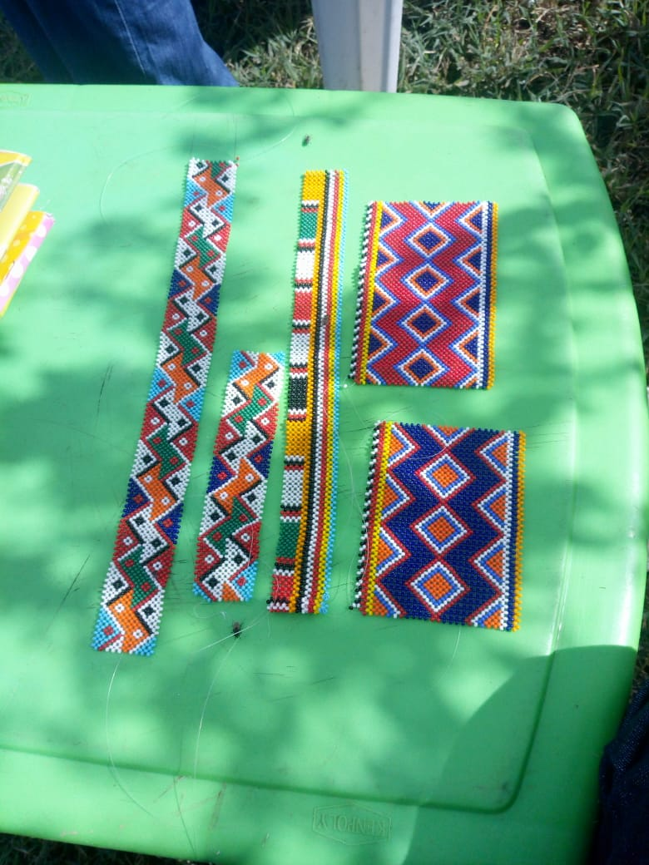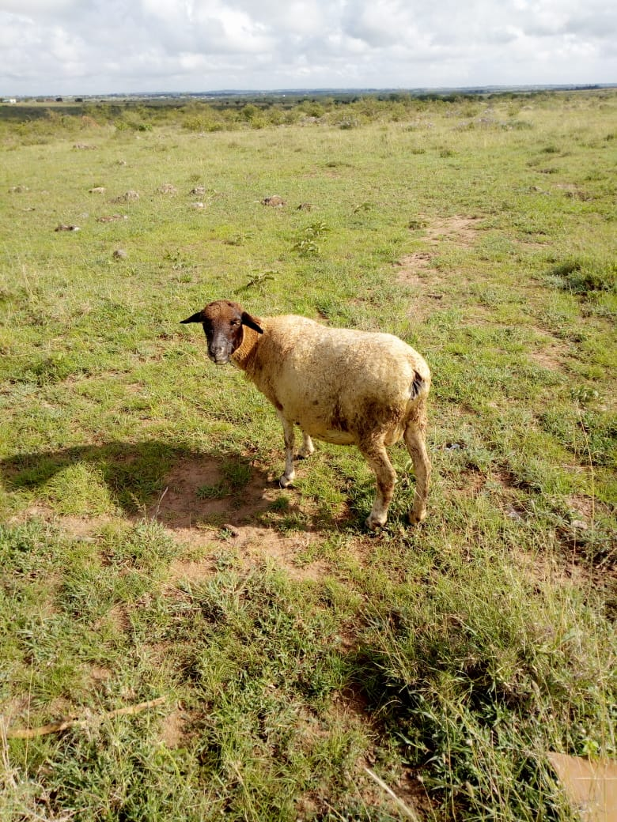
Fig1.Beads products produced that generated profit to purchase a sheep

Still on beadwork business, another guardian managed to sell everything she made. The money was used to buy more stock of beads and cloth material that was used to make several Maasai cloths with different designs. In the pictures below are some of the clothes
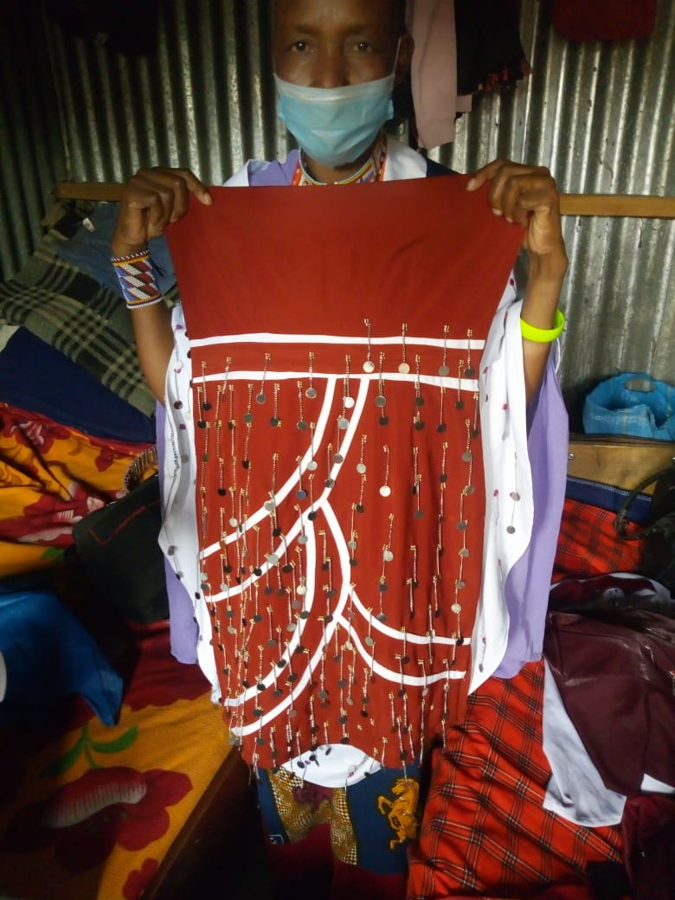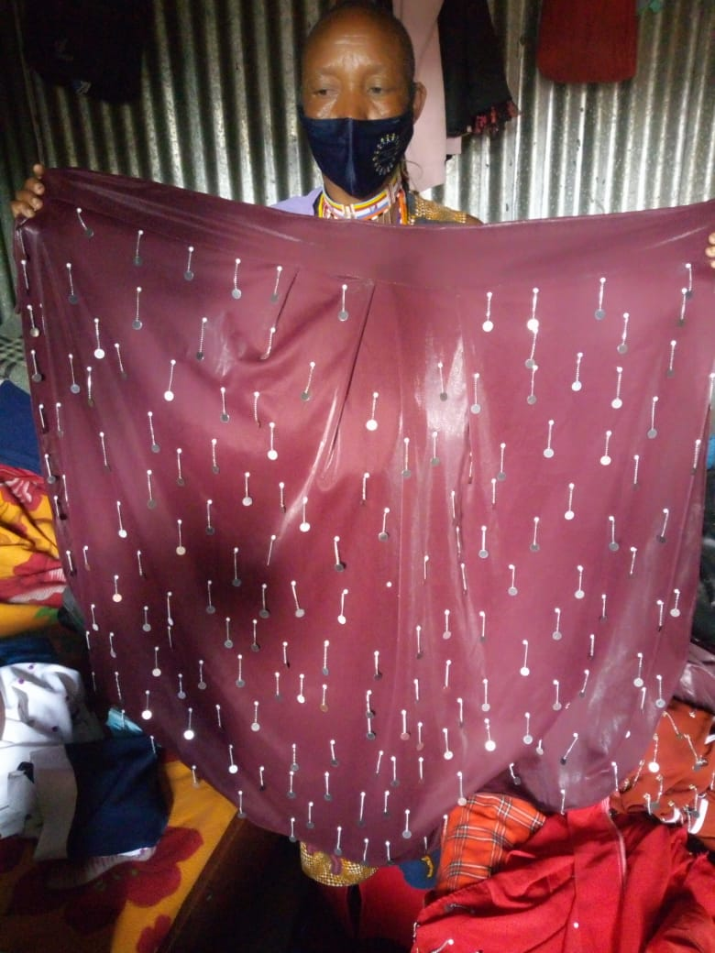
Fig 2. Masaai clothes with different designs made by the guardian

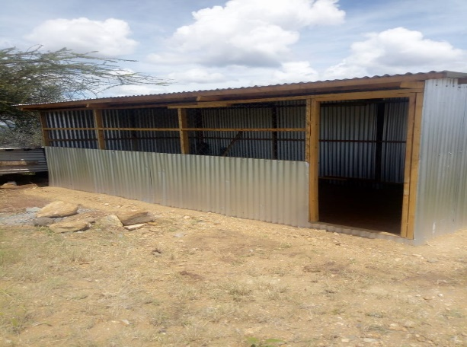
Fig 3 a guardian constructed the beautiful poultry house for poultry business that will produce eggs for sale. This will help the family to generate a sustainable income for the family together with the reunified child. This house will accommodate more than 50 chicken and we will continue to walk with the family to ensure the project's aim and objectives are achieved Fig 3. Poultry house constructed by the guardian

On top of the above, all the guardians during the visit were also supported and equipped with the soap starter kit to enable them to kick off the business as an additional income-generating activity that matches this challenging time of the covid-19 pandemic where washing hands using soap is essential. This was after the guardians had received training on how to make and run a soap business from our franchise partners Wessex Social Ventures (WSV). Also we identified one guardian among themselves who will be distributing ingredients to other guardians.

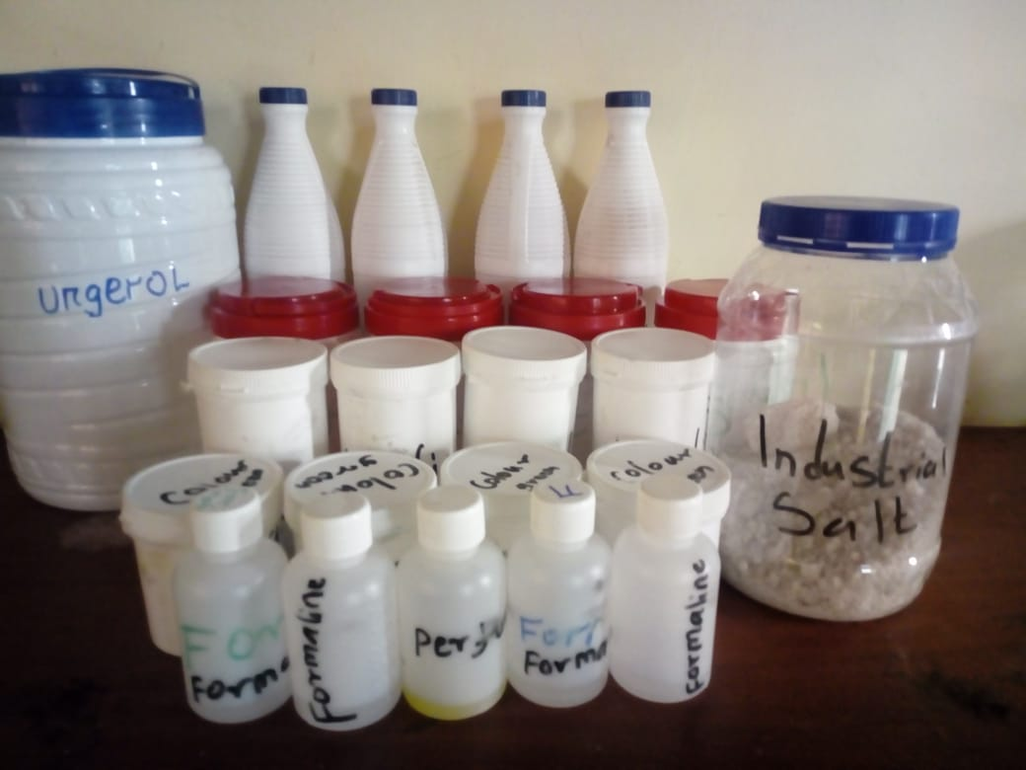

Fig4- Soap starter kit for guardians

Herewith are some of the pictures of the progress of income-generating activities IGAs.

Fig 5- Charcoal purchased for one of the guardians to start a charcoal business
Fig 6- Sheep purchased for one of the guardians
Fig 7- Expectant cow that is almost giving the family milk

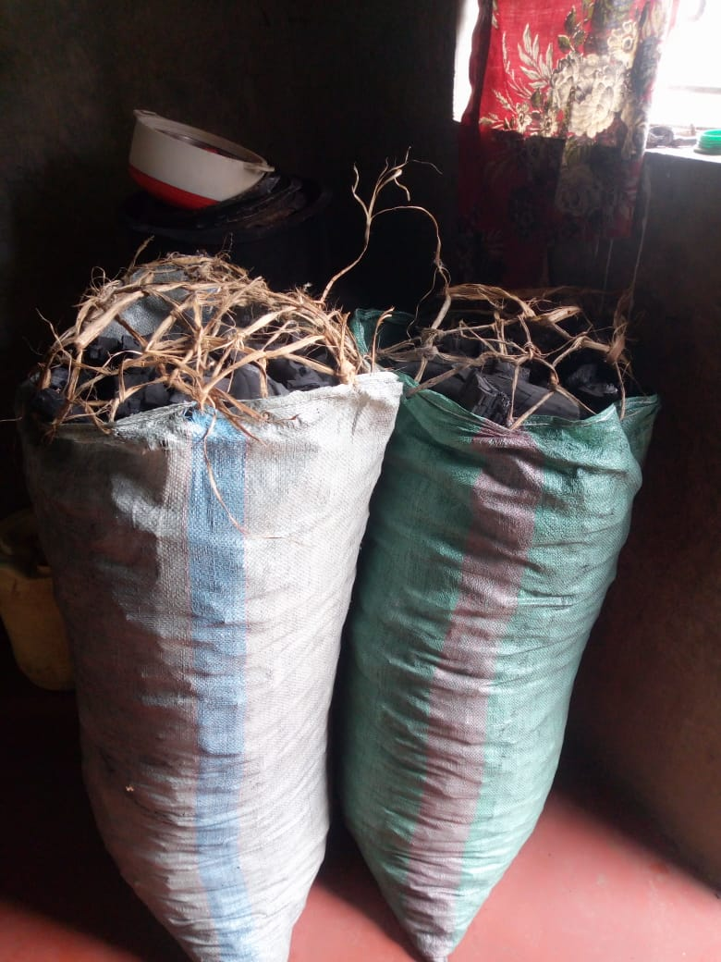
Fig 5- Charcoal purchased for one of the guardians to start a charcoal business

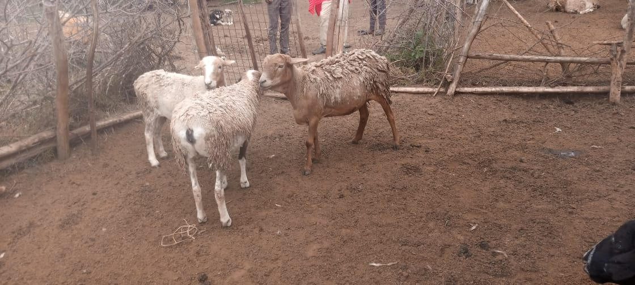
Fig 6- Sheep purchased for one of the guardians
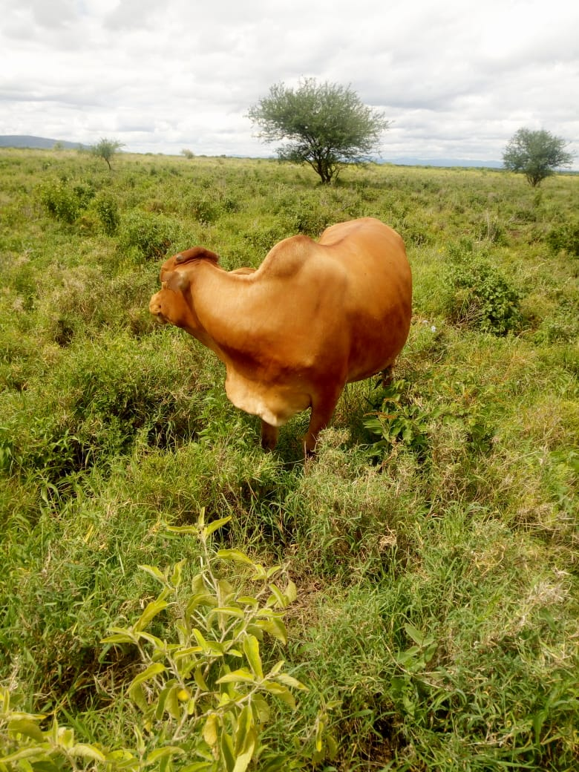

Fig 7- Expectant cow that is almost giving the family milk

