**GLOBAL GIVING REPORT**

**OCTOBER 2022**

**Updates on the progress of family micro-enterprises in October**

We are pleased to update you on the progress of the family microenterprises that you assisted us in establishing for families with vulnerable children as part of our child protection programme. Thank you for empowering these families once more.

We have been working closely with these families for the past three months to monitor the microenterprise business that we started for them to ensure that it is meeting its objectives. Follow-ups were conducted both physically and via phone calls.

Apart from a major challenge of drought, which is affecting the families with livestock businesses, the business were doing well.

Kindly allow us to share with you the success of the two businesses over the last three months.

A family in the poultry business category purchased local chicken that is cost effective since they can withstand cold weather and survive without electricity.

The hens have already begun to lay eggs, which will be used for home consumption, sale and the income generated will assist the family with their day-to-day basic needs as well as provide the necessary needs for the reunified child.

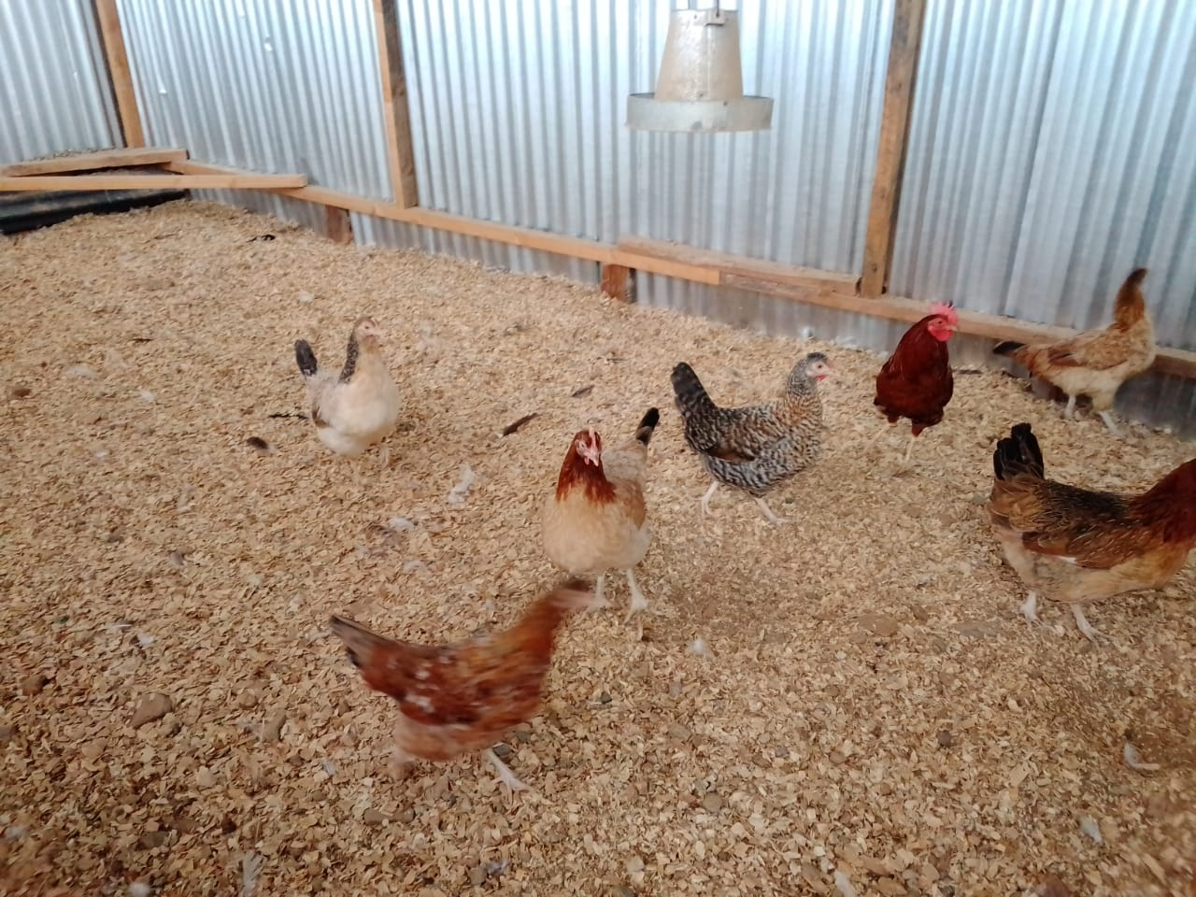 ***Local chicken with for one family with poultry business***

The other family is the one we shared their story in our previous report, whom we started the sheep business. As we paid the family visit, the sheep had reproduced and reached a total of seven, which is an incredible achievement for the family. The sheep provide milk for the family, and the offsprings will be sold to generate income to meet the family's needs, with a portion of the proceeds going toward investment and saving.

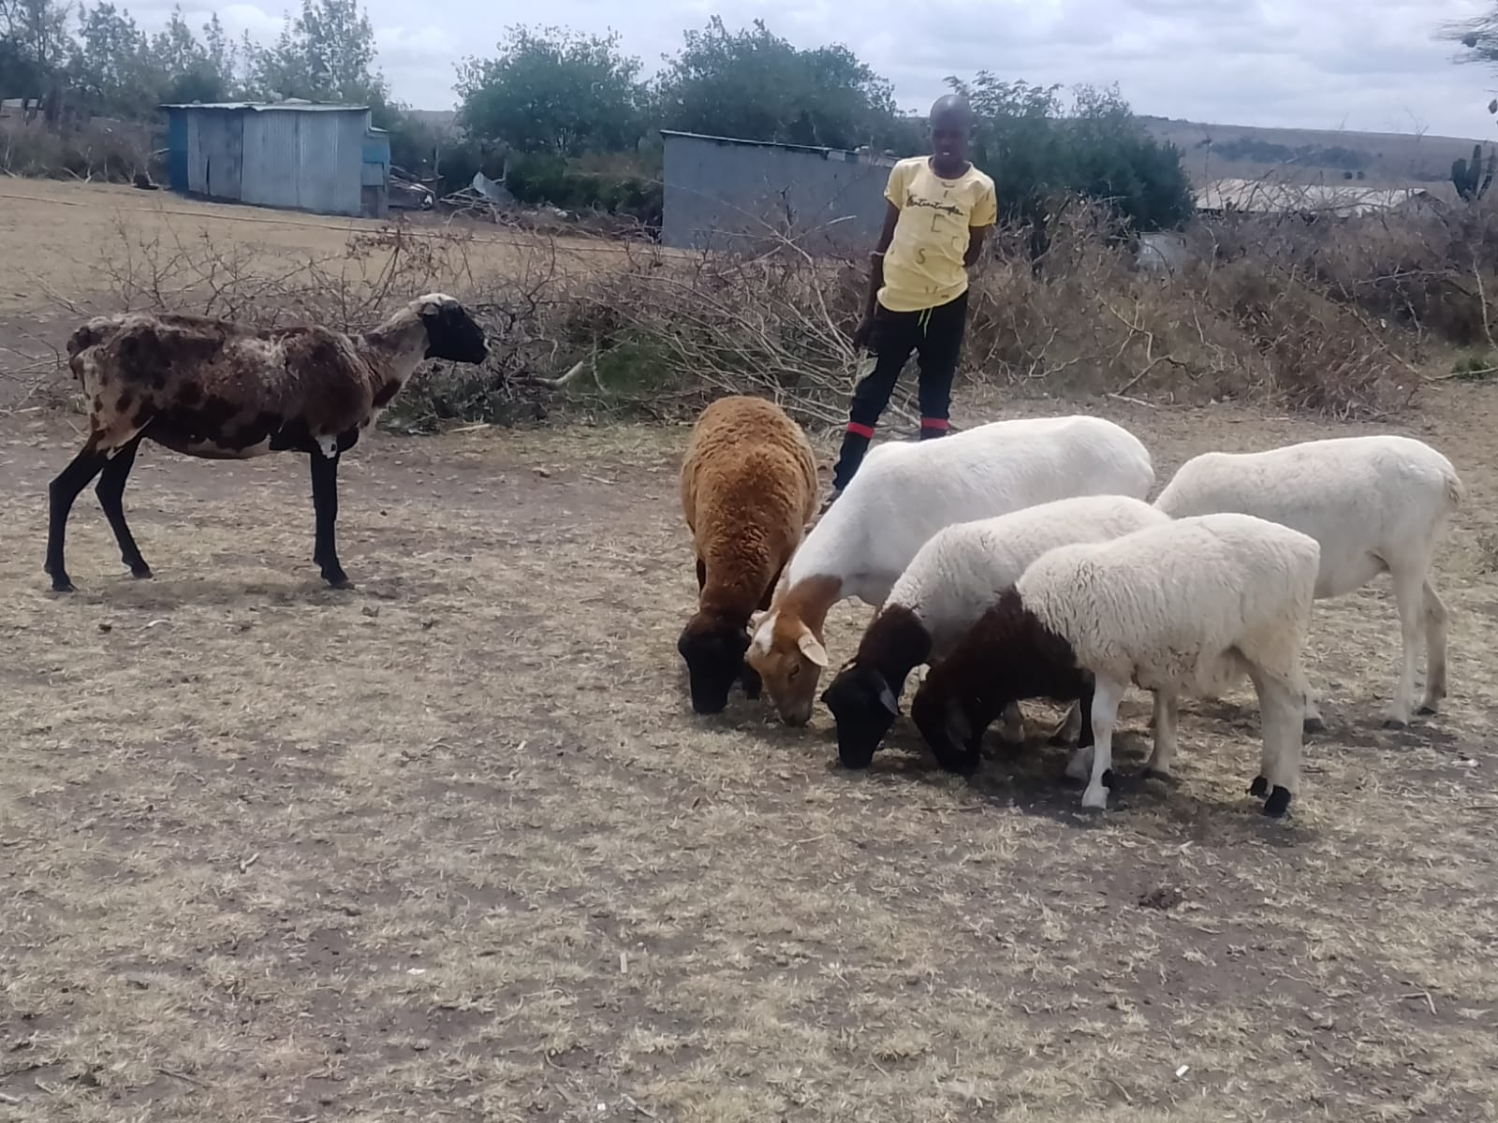

***A photo of some of the sheep***

Thank you so much for your continued generosity. We will keep you up to date on our progress.