**GLOBAL GIVING REPORT**

**JUNE 2022**

**Updates on the progress of family micro-enterprises**

**We have been following up on the microenterprises you helped us establish for our children's families as part of our family based care program for the past three months. The Follow-ups were done via phone calls, guardian meeting, and home visit. The feedback and results we received and saw from these microenterprises were outstanding. The businesses were doing well despite a few challenges, such as drought in semi-arid areas where livestock rearing is the main activity.**

**The below are some of the businesses' success stories:**

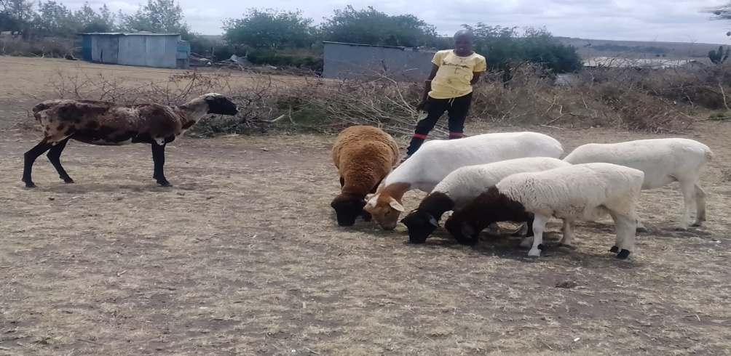One of the families received three sheep to start a sheep livestock business. Recently when we carried out our home visits for the first quarter of the year, we were astounded by the results of this micro-enterprise, as the sheep had reproduced and reached a total of six in number thus doubling their herd

***A photo of the six sheep***

Another family that we assisted with a dairy cow is now receiving milk after the cow gave birth to a calf. The family sells milk and earns at least Kenyan shillings 30-50 per day. The first calf is doing well, and the cow is expecting a second calf. The cow and calf had gone to grase far away from home at the time of our visit, so we were unable to photograph them. We will get pictures during our next visit and share them.

**Bead work business**

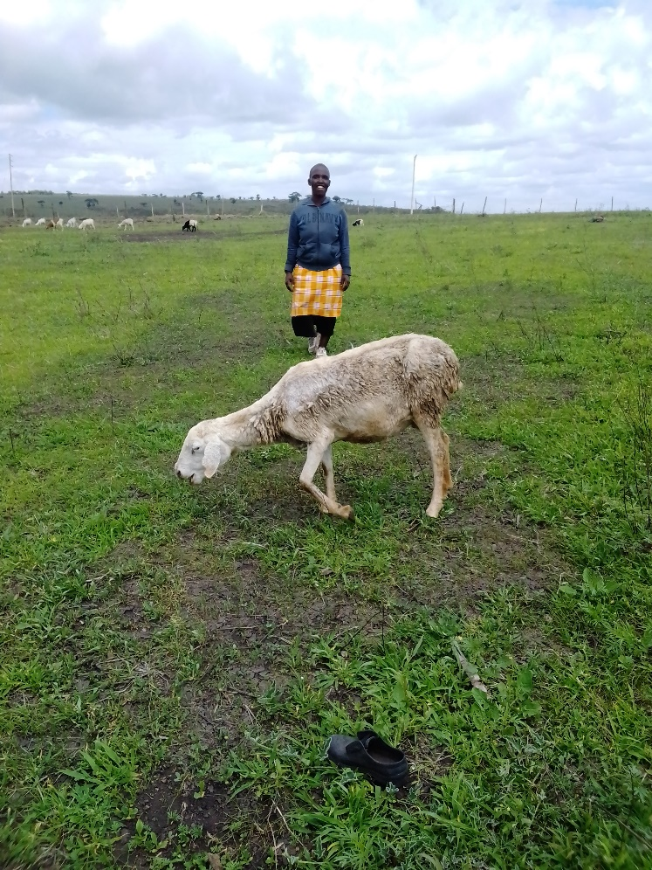One guardian with a beadwork business had generated profit from the business and purchased a sheep as a result. The sheep will provide milk for the family, and their offspring will be sold to expand the business.

Another guardian generated profit in the same business category and decided to expand her business by purchasing cattle salt blocks, which are made from screened salt and formulated with sulfur, which aids the cattle in neutralizing nitrates that cause grass tetany. We shall provide updates together with the pictures in our next report.

Once again, we express our appreciation for your assistance with these microenterprises. This success is solely due to your generous support. Thank you very much, and we will keep you informed of our progress.