**GLOBAL GIVING REPORT**

**FEBRUARY 2023**

**Updates on the progress of micro-enterprises**

We are glad to update you on the progress of microenterprises that you assisted establish for families of our children that we reunited with their families in 2019 as part of our child protection programme.

**Petal micro-enterprises (reusable towel)**

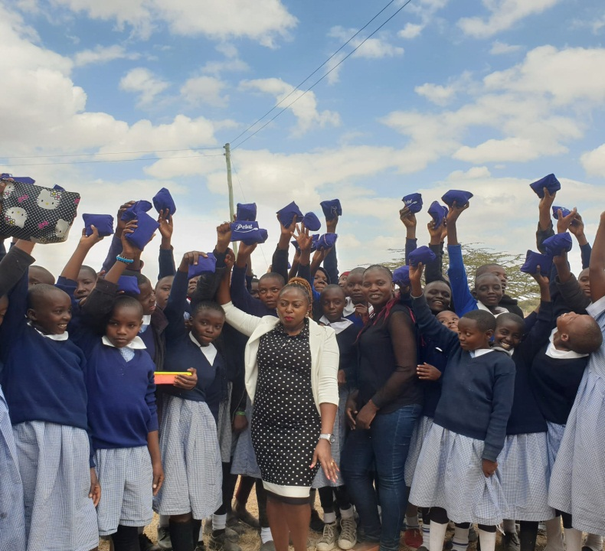As part of our child protection program, we were able to distribute Petal reusable sanitary towels to schoolgirls at one of our neighboring primary schools over the last three months. Access to sanitary towels among girls and young women has been a significant challenge, so we decided to assist some of the girls by distributing some sanitary towels.

The sanitary towels are intended to boost girls' self-esteem so that they can compete with other students.

During the distribution, the girls were also given a hygiene talk.

**Right Light micro-enterprises (solar lamp business)**

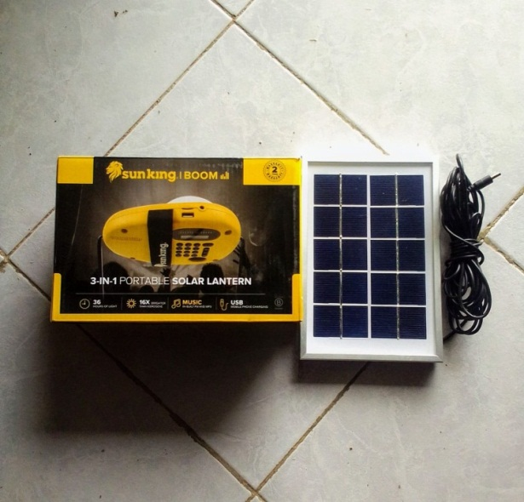 We have leased some of the solar lamps, which customers rent on a daily basis. The payments are made on a daily basis, and the funds go directly to helping the children.

**Update on microenterprises**

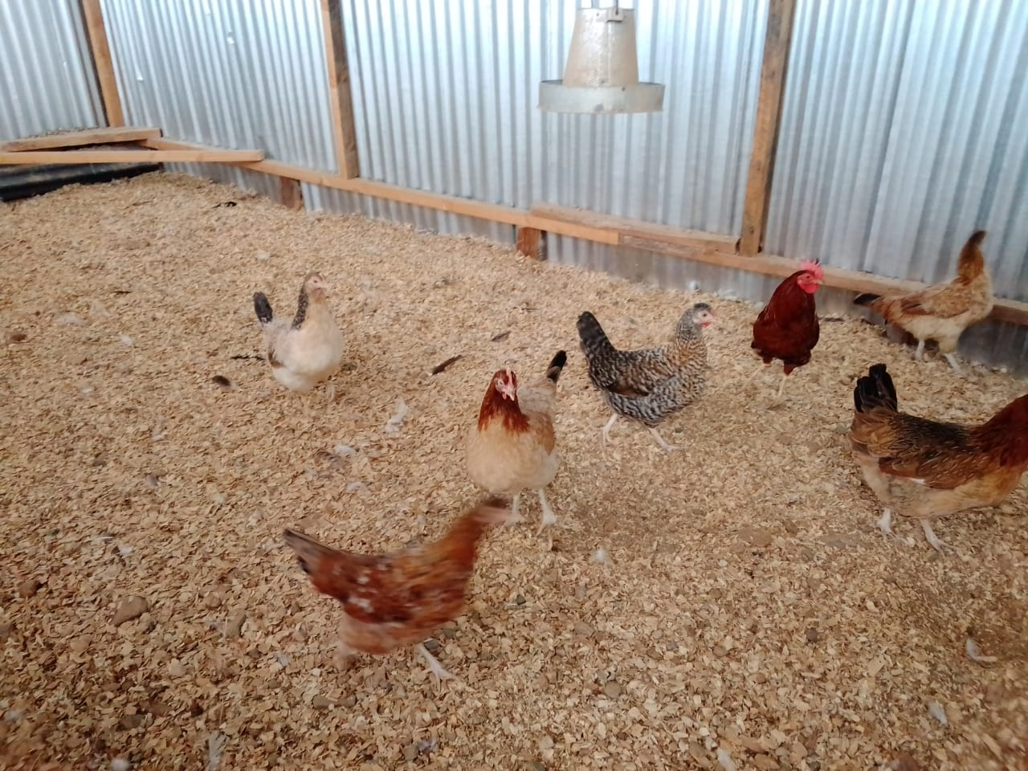 Despite the drought that has affected most of the country, causing the majority of livestock to die, Please allow us to share with you the success of one of our businesses over the last three months.

A poultry business family that purchased local chicken is now profiting from egg sales. The income generated helps this family meet their day-to-day basic needs while also providing for the reunified child's needs.

We are much obliged for your continued generosity. We will keep you up to date on our progress.