**GLOBAL GIVING REPORT**

**FEBRUARY 2022**

**Updates on the progress of family micro-enterprises**

In December 2021, we conducted home visits to all the guardians of the reunified children as part of our family-based care program to monitor the microenterprises that we established for them. The microenterprises were doing well, and some of the updates are listed below.

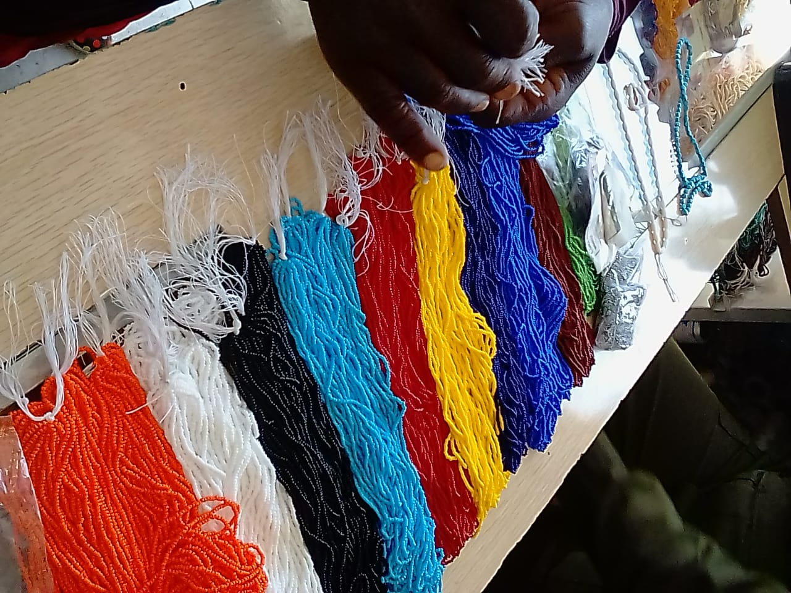

***Various beads guardians use for beading***

One guardian with a beadwork and soap business had made a profit and purchased a sheep, and when we visited, we discovered she had purchased a solar system with three lamps and a radio. The family now has lighting in their home, and their children can study without any challenge.

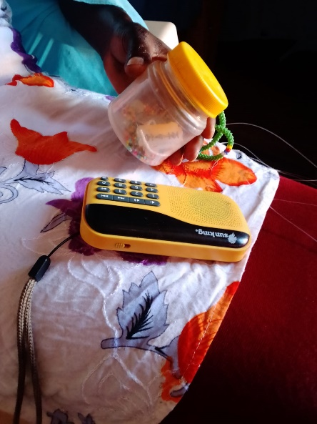 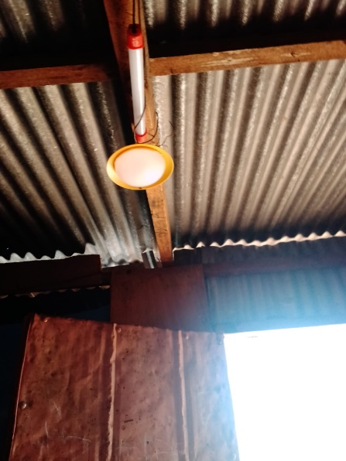

***Solar system comprising of 3 lamps and radio***

Another guardian in the same beadwork business made beadwork products in bulk, including Masaai belts, which retail for Ksh 8000, as well as Masaai necklaces and bracelets. When the guardian sells these products, she will earn a good income and be able to support the family's day-to-day needs.

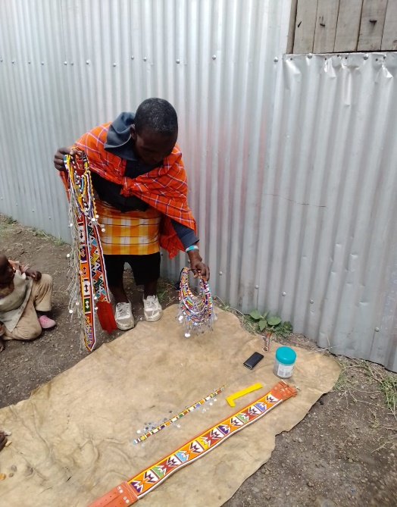

***Some of products the guardian have made from beadwork***

**Updates on Petal Micro-enterprise**

**In January, we empowered the elder sister of two of the children we support so that she can generate income to support the children and the entire family. She was taught how to make and market reusable sanitary towels through the petal training, so that after the training, she will be able to make them, sell them, and generate the income that will support the entire family.**

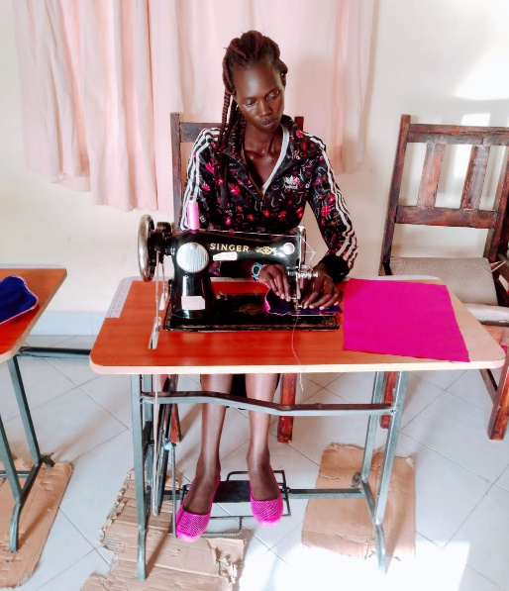

**On the same Petal microenterprise, we received a request from our chief to assist schoolgirls in our community who do not have access to sanitary towels. By doing so, the girls will be able to attend classes freely and with confidence, and their self-esteem will be high. We made some of the sanitary towels that will be distributed to these girls. In our next report, we will provide an update on this.**

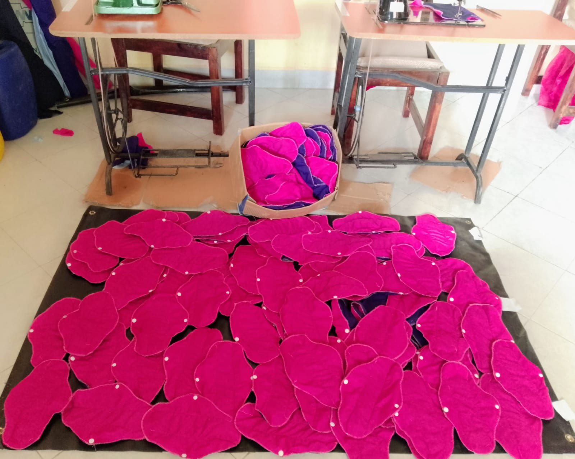

***Ready petal sanitary towels for distribution***

Finally, we have many plans with the guardians, and we will continue to collaborate closely with them to ensure that the goals of these microenterprises are met. Every quarter, we will hold a guardian meeting to discuss and brainstorm ways to improve each microenterprise. We also had a meeting with our partners, Wessex Social Ventures (wsv), and we discussed a lot on ways to enhance these microenterprises. In our next reports, we will keep you up to date on each activity.

Thank you once more for your continued support, and we wish you a prosperous 2022.