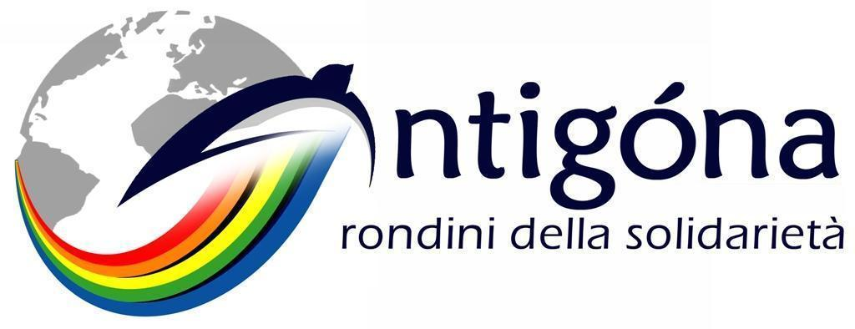
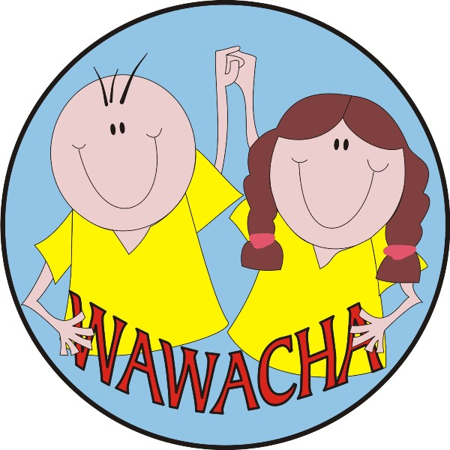
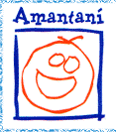

"Early Stimulation and Food Security for Children coming from poor Families of marginalized Areas Primero de Mayo and Miravalle, in the City of Cusco"

Peru

CONTENTS
Place, duration and start date of the project page 3
Economic, geographic and social context page 3 Justification for the project page 7 Identified needs page 9
Synthetic description of the project page 10 Aims of the project page 11 Expected outcomes page 12 Project’s activities page 12 Logical framework page 16
Chronogram of activities page 19 Sustainability page 19 Partners in the project page 20 Budget page 24

A. Place, duration and start date of the project
The project is realized in the city of Cusco, located in southern Peru; in detail it concerns the urban marginalized areas Primero de Mayo and Miravalle, which administratively belong to the District of Cusco.
The administrative division of Peru

On the administrative level, in Peru the hierarchy shows to its highest point the Departments, which are 24 plus 1 autonomous Province. One of these Departments is that of Cusco, which is divided into 13 Provinces. The Provinces are furtherly divided into Districts, which in fact constitute the bottom level of the administrative hierarchy: juridically, in Peru there are no cities, which are merely agglomerations of Districts, each one with its own District Mayor.
In the case we’re referring to, one of the 13 Provinces of the Department of Cusco is also called Province of Cusco: it’s divided into 8 Districts, five of them currently composing, in whole or in part, the urban set of the City we call Cusco. One of the five Districts is called, once again, District of Cusco, and that’s where’s located the social and organizational entity considered in the project.

This proposal is about supporting the Nursery School Wawacha, managed by the Peruvian Asociación Civil Wawacha, for a duration of two years, approximately by August 2009 to June 2011, which is the time necessary to the promoters of the initiative, namely the same Asociación civil Wawacha and the Associazione Antigóna, to study the ways of, first of all overcoming the situation of economic emergency which the Nursery School Wawacha is facing at present, and later finding the most appropriate courses of action to achieve, in total or in part, the sustainability of the project at the local level, ensuring its perpetuation in the following years without being dependent any more on foreign donors. The partners define these two stages in the following way:

- 2nd semester 2009 - 1st semester 2011: stage of consolidation of the experience;
- from the 2nd half of 2011 on: formalization of an institutionalized Community Action.

B. Economic, geographic and social context

Peru is showing a notable growth rate: the Inter-American Development Bank credits the increase of its Gross Domestic Product as per 8,3% in 2008, while the international rating agency Fitch Ratings is estimating it even to 9.8%, further growing with respect to the 8.9% of year 2007. Whatever the source, the figures are quite similar, highlighting Peru as top-ranked as per economic dynamism in South America. Of course, the terrible world economic crisis of 2009 is affecting even this country, which in fact has seen, month after month, its economic performances plunging downward. However, the same Fitch Ratings is forecasting for year 2009 a growth of the Peruvian economy as per 3%, and Moody's goes up to 4.3%, inserting Peru in the list of the five countries, led by the usual China and India, which will better resist the global financial collapse (the other two are Egypt and Qatar).
So, apparently there would be many reasons to be happy, but macroeconomics on one side, and daily street-level economics on the other, are different things. This new well-being, which has been remaining in constant growth or, however, at a high level since 2003, is not homogeneously spread in the country, creating therefore a potential, negative correlation between economic development and social injustice. The poverty rate remains high, especially in rural areas: according to the latest data made available by the Peruvian National Institute of Statistics and Informatics (I.N.E.I.), at the end of 2007 the 39.3% of the Peruvian population was officially living in poverty, i.e. with a monthly income of less than Soles (S/.) 229.40, approximately equivalent to $ 76.21, which is considered as the poverty line; among them, 13.7% was in situation of extreme poverty, i.e. with a monthly income less than S/. 121.20, approximately equivalent to $ 40.27 (amount considered as the extreme poverty line). These data indicate a significant improvement compared to previous years: however, they’re showing how much is on the way towards an acceptable subsistence level for all Peruvian population, given that they’re stressing the fact that about 40% of Peruvians yet encounter difficulties in satisfying even its basic needs.

Peru shows a very broad spectrum of geographic conditions, microclimates and biodiversity. Traditionally you divide it into three parts: the coast (the western part with the capital city, Lima), the mountains (the central part, resting on the Andes Cordillera) and the forest (the eastern part, where it shares with Brazil a piece of Amazon). In statistics, the District of Cusco is considered a urban area of the mountain part, that is the poorest of the three ones, with a percentage rate of poverty, at national level, up to 60.1% in year 2007 (compared with 22.6% of the coast and 48.4% of the forest; and the gap amongst the areas is even wider when taking into consideration the extreme poverty). Even more worrying is the slowness with which the mountains react to the initiatives to alleviate its state of misery: the data show the coast and the forest have improved more rapidly their conditions in recent years. The geographic domain named urban mountains, according to the census conducted by I.N.E.I. in 2007, is showing a delay in eliminating poverty determinants second only to that of rural mountains: between 2006 and 2007, the progress towards better conditions of living for the population was estimated at 3.8%.

These figures, reported at the national level, should be read in light of a surprising information, which at the same time supports the need for this project and boosts the desire to find solutions to the situation: the Department of Cusco is the only one of the Peru as a whole to have worsened its situation with respect to poverty in comparison with year 2006, shifting from group 4 (showing a range of population in poverty between 37.3% and 45%) into group 3 (characterized by a range of population in poverty from 54.6% and 57.4%). And it’s exactly the Department of Cusco to represent, with its 57.4% of poor population, the limit between the group 3 and the following group 2, ready to slip inside it, perhaps because of the global economic crisis. Leaving the dry numbers, all of this means that more than half of its inhabitants are experiencing problems to reach a proper and healthy life level.

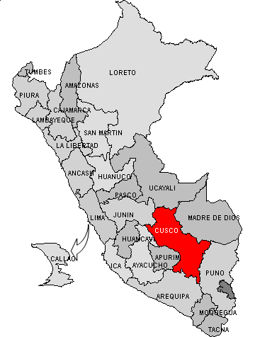
No doubt that there are areas in worse situation, and Poverty Map 2006, published by the Foncodes Program, updated with data from the census 2007 and organized at the district level, shows us the District of Cusco, where the project is developed, is in the reassuring fourth of the five quintiles in which have been divided the 1,832 Peruvian Districts, as well as, related to human development index, it’s at 318th positions, leaving behind 5/6 of the country. Also on specific indicators taken into account by Poverty Map 2006 and referred to living conditions, more than to simple income, the values obtained from the District of Cusco don’t appear so alarming compared to national averages. However, the District of Cusco, with its 108,798 inhabitants (according to the census, but in fact most) is quite a lot populated with respect to the country average, and therefore even small values occurring on indicators of distress, are actually lights of a problem affecting many people: saying that 6% of the population doesn’t have any access to safe drinking water and sanitation means, in practical, that more than 6,000 people are at high health risk; crossing the data of the census 2007, according which the children in the District were 28,051, with the admission on the part of the Regional Government of Cusco that the level of child malnutrition in the Department is touching 43.3% (the second highest rate among Peruvian Departments), leads to the conclusion that probably in the District of Cusco there are approximately 12,000 children underweight (Poverty Map 2006 shows only the data of groups aged between 6 to 9 years, estimating the malnourished up to 14%, but the numerical evidence of the studies on the subject shows that is the group aged from 0 to 5 years, just that involved in our project, to be the most affected by the problem).

The department of Cusco is located in southern Peru, and, as already written above, is consisting of 13 Provinces.

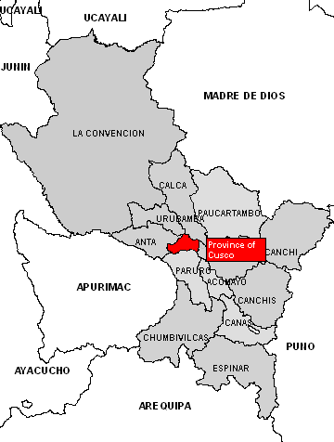
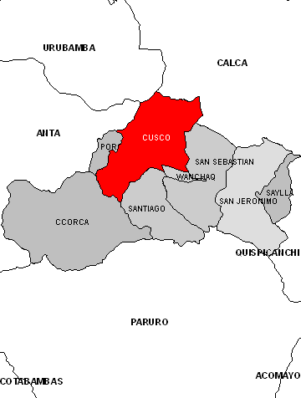
The Province of Cusco is just in the center of the Department, with the District of Cusco located in its northern part, at an average altitude of m. 3,340 above the sea level.
If, as a territory, the District of Cusco includes various geographical aspects, the demographic structure is almost totally urban: the 98% of its 108,798 official inhabitants is declared as urban population. In fact, the District of Cusco coincides mostly with the high, historical and monumental sector of the city of Cusco, capital of the Inca Empire, the so-called Rome of the South America. Much of the old town, with the main square (Plaza de Armas), the Convent of Santo Domingo built above the Q’orikancha complex, one of the main worship places for the ancient Incas, as the fortress of Saqsaywaman, fall within its territory. Inca ruins and colonial architectures attract every year well over a million tourists from all over the world, to walk in the streets of the charming old town, as many young people, especially from North America, choosing Cusco as a place for learning the Spanish language. Cusco is also the starting point to visit three famous and extraordinary Peruvian places: the Sacred Valley of the Incas, Machu Picchu and the Titicaca Lake.
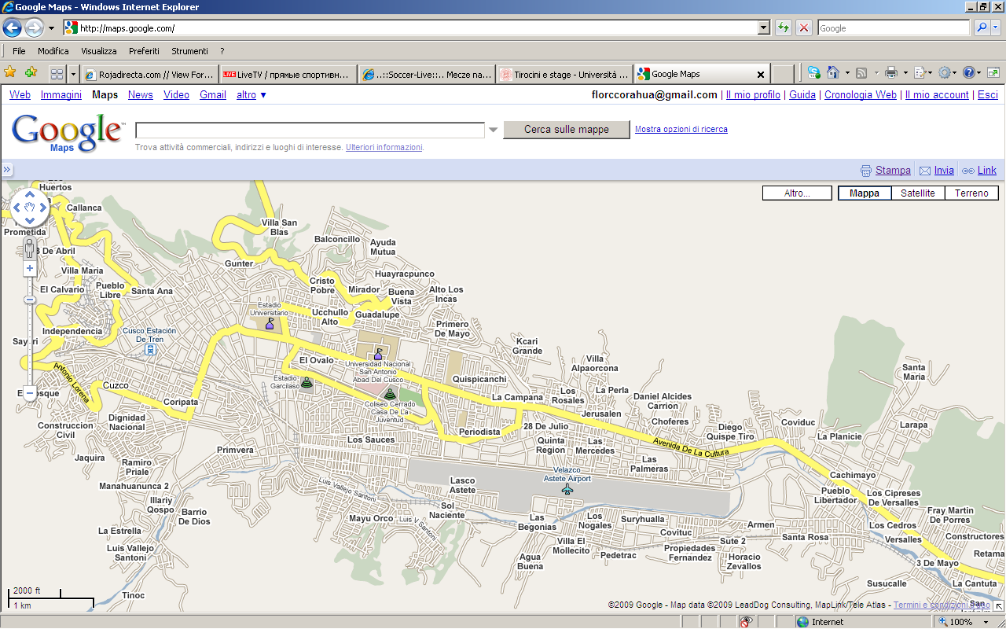
Probably tourists and foreigners in general don’t imagine that with a five minutes of taxi ride, or walking half-hour from the historic center, you can reach areas such as Primero de Mayo and Miravalle, those which the Wawacha Nursery School and our project are addressed. Huddled under a hill, in south direction respect to the downtown, their population five centuries after the heyday of the Inca Empire is appearing to live in the same conditions of servitude as the poor people of that age, this time no more in the service of the Emperor, but for families of Cusco sometimes only slightly more wealthy, or for the various structures involved in the tourism field.
Miravalle

Since the far 1993 the I.N.E.I. haven’t been realizing any more investigations at quarter level, so the latest official data concerning the two areas scenarios of this project are dating back at that time. In the beneath box you can find a summary of the more significant results emerged from that survey of year 1993. Being useless now reporting these data in absolute terms, since in 16 years Cusco profoundly changed, we can yet think in terms of percentage, as the backwardness that still characterizes the two considered urban areas suggests that the social and economic conditions, as the global quality of life, may have undergone minor changes.
Key findings of the census of year 1993 relevant to the Quarters Miravalle and Primero de Mayo

Demographics
Children under 14 were the 32.5%, which is one third of the population: children up to 4 years, who represent the age group to whom the project is directed, were equivalent to 9% of the Quarters’ inhabitants.
Primero de Mayo and Miravalle aren’t recent urbanization, maybe due to the influx of peasants from the surrounding Departments’ mountains to escape the terrorism that bloodied the country in the '80s: they are rather neighborhoods of old tradition, but constantly marginalized, not having been able to take advantage from the progress made by the rest of the city since the ‘90s, mostly linked to the development of tourism. The 81.5% of their inhabitants is living in the Quarters from birth.

Schooling
The illiteracy rate was 7.5%, centered for 2/3 among women. The percentage of residents who had never attended a school was 8%, with the remainder equally distributed among those who had achieved one of the different school levels (primary, secondary and upper).

Employment
With regard to employment, the Economically Active Population in the two Quarters was estimated at 68% of the total, with a share of 2% of child workers. Overall, the 64% of the inhabitants declared occupied: so, a few unemployed as opposed to the Economically Active Population (but we must take into account that it includes all children over 15 years, and sometimes even below, in any case a large share of minors), but ever with a very low job qualification, and a prevalence of workers without fixed salary.

Housing
About 2 over 3 of the households lived in independent houses, and is still unusual to find condominiums in this area; that is also due to the dominant technique of construction with adobe (brick made with clay, straw, sand and water, prepared by hand within special moulds and left below the sun to harden), which for its low characteristics of resistance make it impossible to raise buildings with more than two floors. The 58.5% of these houses was owned, while 25.5% was rented: in the remainder, it’s enough common to meet the modality of the loan of the house from another family for purpose of housekeeping, in an area where violent crime is fortunately a very small scaled phenomenon, but thefts in house are quite frequent.
With respect to the hygienic conditions, the two Quarters, which are adjacent, in 1993 had very different situations: while the Primero de Mayo was in a totally acceptable situation, the Miravalle showed a more pronounced decay, with only 55% of homes connected to the public water supply network and having regular toilets, and 13% of houses without electricity. Especially as opposed to these latter points, in recent years, thanks to revenues generated from tourism, the Provincial Administration (which has direct jurisdiction over the two Quarters) committed a lot to improve the living conditions of these areas, at least with regard to the public spaces, and therefore the situation is now largely improved. On the private side there haven’t been a comparable evolution, and therefore the data of 1993 may still be up-to-dated: one third of the residences is composed by a promiscuous single room, which serves as a living room and bedroom for the whole family, when not even as a kitchen, and half of the families must share toilets with at least another one.

Maternity
In 1993, every woman of the considered Quarters had given birth an average of five children, and 5% of them had more than 4 dependent children. The 3.5% of the mothers was officially in the category of single mothers, and 1.5% in that of teenage mothers (12 to 19 years old).

In the box above the maternity point has been left as last, because the most related to the project proposal in place, namely the support to the activities of Wawacha Nursery School, run after the homonymic association, which is hosting during the morning the younger children of the mothers, single or not, forced to go looking for at least a daily job, to get those amounts necessary to make the income just enough to meet the primary needs of the whole family.

C. Justification for the project

As quoted before, whatever its current level of poverty, the Department of Cusco has been the only one that during year 2007 passed back on the route towards development. Having not yet been provided the data related to 2008, we must take this information as a reference point, concluding that in the Department shall be penetrated noxious economic, social and demographic dynamics, to cope with one must react quickly and effectively, to avoid that the Department, and particularly the very city of Cusco, Peruvian tourism’s showcase, is converted into a golden space, separated from reality, only for tourists’ eyes, and into a cage of increasing poverty for the majority of the population that can’t economically benefit from the touristic flow.
In the Department of Cusco have always coexisted situations of progress with social and economic retardations, reflected by the growth and economic modernization of some locations, and by the backwardness and the extreme poverty of large rural areas.
Since the ‘80s the city of Cusco has been receiving an accelerated migration from rural areas of its Department, as well as from neighboring Departments, due in part to its traditional gravitational role for historical and economic reasons, and partly to the attempt of the peasants of the heights of escaping the battle between the terrorists of Sendero Luminoso and the smallest Tupaq Amaru Revolutionary Movement on one hand, and the national armed forces on the other hand. In 2005, the metropolitan area of Cusco was the seventh of the Peru as per population (the figures for 2007 aren’t yet available), with its surrounding areas which still suffered the invasion taken place without prior planning, and leading to the rapid formation of concentrations of hovels. In addition, the majority of these one had occupied areas characterized from a high hydrogeological risk, making it impossible to equip them at reasonable costs with adequate urban water and hygiene services. Obviously, environmental problems, paucity of good quality water, lack of sewerage systems and solid waste disposals, combined with the persistence by the population in adopting certain practices disrespectful of nature, contributed to the deterioration of the setting, in detriment of the health of those living in these areas, and in turn feeding further the cycle of poverty. The Quarters Primero de Mayo and Miravalle are good examples of the above described urban dynamics, which only in the last few years is experiencing a turnaround, at least in terms of public infrastructures.
In all mountain areas of southern Peru, including those considered in our project, child and adolescent population is subjected to a general situation of serious violence, abuse and neglect. Old data collected by Save the Children in year 2002, reported a 48% of children who received maltreatments from their family, with an alarming frequency of premature pregnancies resulting from incest and violations. The Associazione Antigóna, who was at work during the year 2008 in the neighboring Department of Apurímac, can testify directly as the situation haven’t evolved so much.
Clearly, this type of events is considerably more frequent in rural areas than within the city, but they’re a light of an aptitude spread even into large fringes of the Peruvian urban population, where the situation of extreme poverty leads the parents to be not prepared to offering their children the care we are accustomed to in the West World, and that, far from being a luxury for rich countries, is the basis for the harmonious mental and physics growth of the minors, as childhood experts have repeatedly demonstrated in their studies.
Another major issue concerning Cusqueños children is the malnutrition: in 2007 the National Strategy Crecer estimated at 31.9% the percentage of malnourished children in the Department. On this matter studies are immensurable and unanimous: a poor nutrition in children under 5 years increases their risk of dying, inhibits their cognitive development and weakens irreparably and forever their resistance to diseases.

We emphasized the lack of care towards children on one hand, and the malnutrition on the other hand, because they’re just the two main problems that the project Early Stimulation and Food Safety for Children coming from poor Families of marginalized Areas Primero de Mayo and Miravalle, in the City of Cusco intends to attack, and that, evaluating the situation of the two considered areas, justify its proposal.
The Wawacha Nursery School (which in Quechua language can be translated both as small child and as small doll), was created as a response of social sensitivity and human solidarity to the alarming situation of poverty from which is beset virtually the entire population of the Quarters Primero de Mayo and Miravalle, composed by 130 families of peasant origin who emigrated, according to various family stories, in this part of the outlying belt of the so-called imperial city. These families may have as head both the father and the mother; but this latter case is that of women abandoned by husbands with an average family charge of four children, mostly minors. In them, are summarized all those characteristics that are typical of the level of poverty enveloping their families, with ruthless consequences on their future which isn’t difficult to predict: we could dare these children to be the litmus tests of the very fragile socio-economic situation of this population. In their struggle for survival, the parents of these children are forced to ramble looking for any source of income, which in most cases takes the form of a not qualified job (washing clothes, cleaning houses, collecting garbage, selling low value goods), all services paid in a monetary way (when it happens) depending on the level of compassion inspiring who’s receiving them. Not many people may dispose of a regular income, however estimated around $ 3.6 per day; the majority of the population doesn’t reach this amount, stabilizing their average monthly salary between $ 72 and $ 108, to maintain family groups which may be constituted by up to seven members. In such a context, it’s sad to note the presence of many children, even in very tender age, living in a state of substantial moral and material abandonment, exposed not only to the scourge of hunger and malnutrition, but also to that of diseases (mainly respiratory, gastrointestinal and dermatological), and with few possibilities to access to a complete development of their physical and intellectual potential.

The origins of the project

The above framework tells what, since the beginning of year 2000, is daily before the eyes of the promoter of the Asociación Wawacha, who, touched on her sensitivity, was thrust in solidarity with the poorest families of the Quarters Primero de Mayo and Miravalle, trying to develop actions to improve the condition of their younger children. After an initial phase of approach and knowledge of the families of the two areas, the initiative of the promoter resulted in a series of awareness activities for the parents about the care of their children. The positive return she gained among the population pushed the Asociación Wawacha to pursue activities for the younger children of the quarters, which, thanks to the helpfulness of the San José Obrero Parish and of numerous Peruvian and foreigners privats, led in 2 April 2007 to open the Wawacha Nursery School.
Since the beginning the nursery school moves in the thematic field of early stimulation and food security for younger children, especially those of abandoned mothers who, rambling for a job, are obliged to leave them closed in their precarious housings (usually narrow rooms, without basic services, shared by up to seven people in a situation of overcrowding and promiscuity).

Starting from the beginning of year 2009 the main donor of the nursery school, an informal group of British citizens, declared it was unable to continue its support, and the Wawacha, which, despite having already thought on the subject, hadn’t yet embarked on the path towards sustainability, largely due to too much poor economic situations of its indirect beneficiaries, found itself without funds to continue its activities. In addition, in that same period, the San José Obrero Parish, which had granted to the nursery school some free areas indefinitely, was forced to withdraw this facility due to stability problems of the land on which these spaces were, thus leaving the nursery school without home too. At this stage was that the Asociación Wawacha contacted the Associazione Antigóna at its Cusco branch, to seek help to face this state of paralysis.
We’re telling these facts in the chapter entitled Justification for the project because it’s in this occurrence of extreme difficulty that has been shown how much this project and its continuation could be desired and considered as important by the local community. Apart from the collaboration of the Associazione Antigóna, which, after having visited the two quarters and talked to people, considered the project worthy of its support, the Asociación Wawacha solved the problem of the structure thanks to the intervention of the Asociación Amantaní, a Peruvian institution also engaged in helping local children, who came to rescue of the colleagues through the provision to the nursery school of a prefabricated module, so that the Wawacha could continue its activities with the children after its forced relocation, in addition with the offer of a small contribution in cash and materials. A wealthy person living in the area, who appreciated the activities conducted by the nursery school towards the poorest, allowed it to occupy a space of its propriety for a nominal rent, and, at that point, all parents of the children previously attending the Wawacha before its temporary closure put them at voluntary work to make the space provided accessible, build the basement above which to install the prefabricated module and carry on other necessary works to make the nursery school functioning. The director of the Wawacha, the assistant teacher and the kitchen assistant decided to continue working without salary until the restoration of the prior situation, while, to save the wage of the guardian, the mother of a Wawacha’s child took the night surveillance upon her, spending the night inside the nursery school to avoid thefts or accidents. Many other people, Peruvian and foreigners, financially contributed to the resumption of the functioning of the nursery school, convinced of the importance of the social work that the Asociación Wawacha is realizing in this urban area.
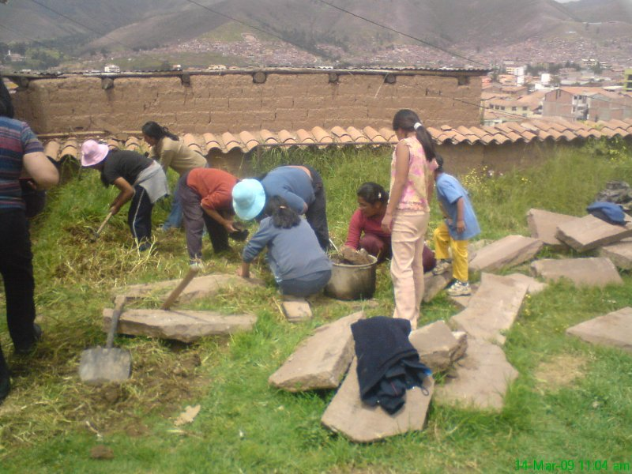
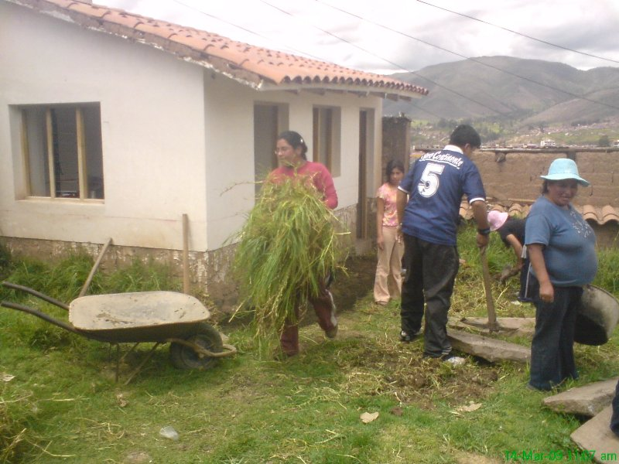
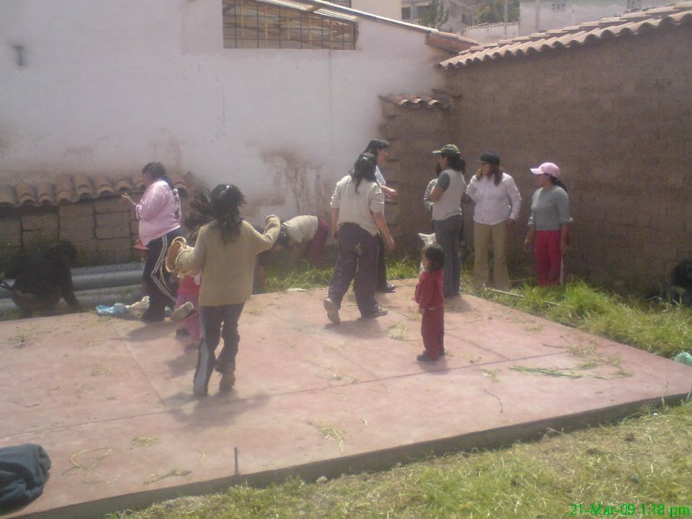
Through this collective effort, led for the most by the same poor people indirectly benefiting from the activities of the nursery school, in the interest of their younger children, the Wawacha is carrying on a strenuous survival, without salaries for staff, adopting shortened opening hours and reducing to the minimum the activity of food security for the children, that is the more costly part of the project.

Parents of Wawacha’s children working to arrange the new location

D. Identified needs

In a general sense it isn’t difficult to describe what is the urgent need of Wawacha Nursery School: once that was almost miraculously solved the problem of finding a new place where to resume receiving the children, now the necessity is to find the funds to ensure the level of performance hold in the two previous years, and to identify a funding mechanism that prevent a repetition of the regrettable state of paralysis in which the nursery school found itself this year, when the funding from abroad suddenly ceased. Indeed, the prerogative presented by the project Early Stimulation and Food Safety for Children coming from poor Families of marginalized Areas Primero de Mayo and Miravalle, in the City of Cusco is to support an institution that is certainly experiencing temporary, even if severe, economic difficulties, but whose consolidation, clear vision of the ongoing project and high appreciation gained at local level no one can doubt. Therefore, we aren’t face to face with a new project, whose outcomes are yet to be understood and evaluated, but with a initiative, albeit perfectible, offering adequate guarantees of effectiveness in achieving its objectives, and that’s finding itself in a difficult situation mostly of pure financial nature.
In detail, the immediate needs that will be satisfied thanks to the required financial support are directly related to the nature of the three fields of activities that are the institutional purposes of Wawacha Nursery School.

Field of activity Preschool education:

- rent of the space where the nursery school is nowadays functioning;
- two salaries for the staff involved in the pedagogical activity;
- purchase of recreational and educational material;
- other miscellaneous expenses related to the activity with children.

Field of activity Nutrition:

- purchase of various types of food suitable to be combined in the three daily meals prepared for children in the nursery school;
- purchase of food for special occasions;
- supply of gas for cooking;
- other facilities related to the functioning of the kitchen;
- a salary for the kitchen assistant;
- renovation of kitchen and cleaning utensils;
- periodic maintenance of kitchen equipment;
- material to realize training meetings about nutrition.

Field of activity Health and hygiene:

- supply of first aid box;
- materials for hygiene care;
- costs of emergency medical care;
- material to realize training meetings about hygiene and sanitation.

Looking ahead to the perspectives of future sustainability, the Wawacha Nursery School also needs time to organize a dynamics, either fully autonomous or supported from the outside, but in this latter case through methods providing more security in receiving the necessary funds, that could enable it to avoid to depend totally on the support from foreign institutions in order to survive.

E. Synthetical description of the project

The Wawacha Nursery School operates in the city of Cusco (Peru): nowadays it’s receiving 31 children, with the perspective, in consideration of the strong demand coming from the most disadvantaged families of the two quarters taken into account by the project, the Primero de Mayo and the Miravalle, to expand the number of beneficiaries up to a maximum of 40, all of them aged between 2 and 4 years. These are the younger children of families where parents do precarious, low skilled and poorly paid day labours. Many of the children beneficiaries of the project live with their mother only, abandoned by her husband. The single mothers of the two quarters considered in the project play mostly three types of activities: daily washerwomen, vendor of gelatin and kitchen assistant. When they leave very early in the morning to do or ramble for their daily job, they don’t know to whom entrust their babies, if not to the older brothers during the school holidays (or forcing these latter to skip school, in other times). Sometimes they are forced to bring them on work, in unhealthy conditions for the babies and adding up practical difficulties for the same mothers. Other times they’re forced to simply abandon them at home alone, locking them in to protect them from external dangers, but in any case letting them subjected to all sorts of risk typical of the dilapidated houses like the ones in which they normally live, without even a chance to be rescued by neighbors in the event of needs. All this without considering the psychological damage coming to children because of the absence of those parental care and affection so important in the early stages of their lives, as is to be taken into account the damage occurring to the brain development of these children, to whom have been presenting limited and monotonous sensory stimuli just in that phase of their growth during which brain tissues are like sponges absorbing everything, so that this phase is influencing much of the future cognitive abilities of a person.
Therefore, the Wawacha Nursery School primarily performs the function of fostering these children, ripping them from isolation and potential hazards arising from their stay at home alone or without parental guidance. Not wishing, however, be confined to the stage of protection, it carries out a task of early stimulation for them, just to make the most of this age so fertile in terms of learning, so setting in its guests a proper psychophysical and cognitive development, right now and for the future. The term early stimulation in Peru means that sum of tools, techniques and activities, scientifically based and managed in a systematic and sequential way, applied to children from 0 to 6 years with the aim of developing at most and globally their cognitive, physical and psychological abilities. The early stimulation is also useful to prevent or early detect dysfunctions in the child development, and hence it helps parents to increase the effectiveness and the independence of their task of child care.
Another outcome generated by the abovementioned activity is to facilitate the search and the carrying out of work by the mothers of Wawacha’s children, who, not being any more forced to worry for their children or take them with in the workplace, can move with much greater freedom, and therefore find opportunities to be signed up possibly more profitable.
However conscious of the serious material difficulties in which are struggling the families of children received in the nursery school it’s managing, the Asociación Wawacha is also strongly focused in contributing to a proper nutrition for them, assuming, as confirmed by all medical surveys, that a poor child nutrition is the cause of many permanent physical and intellectual problems. That’s why we intend to prepare three meals a day for the children, in order to guarantee them a sufficient diary nutrition even in case of shortage of food in their homes, and at the same time relieving a part of the economic burden from their families of origin, that they can use for the benefit of the other components, in particular the slightly older children.
Finally, the hygiene and health side: already in this first age children are taught and guided to apply the correct principles of personal hygiene, that later are disseminated by themselves, and sometimes required, in their own homes. Every forth months children undergo a medical check-up at a local agreed medical center.
The last operational side of the project is finding a way to ensure its sustainability in the time, or at least to put away the risk of suspension or closure of the activities after the two years for which the support is sought. To this end, Antigóna and Wawacha associations will implement an activity of child sponsorship that, given the number of children involved, which is limited in absolute terms, but nevertheless capable of ensuring the coverage of all costs with a share of support affordable by a single private, should be able to secure a lasting sustainability to the project.

F. Aims of the project

- General purpose:

Contributing to the improvement of social, educational and health conditions of poor families in the city of Cusco (Peru).

- Specific purpose:

Enabling the resumption of a full and sustainable functioning for the Wawacha Nursery School, as a means to combat the abandonment to which are subject to the younger children of the families in the greatest difficulties in the Quarters Primero de Mayo and Miravalle, in particular in the aspescts of early stimulation of children, their food security, the care of their health and hygiene, and the search for a future sustainability for the nursery school.

G. Expected outcomes

- Children result stimulated thanks to early recreational, entertainment, social, emotional, intellectual and artistic activities.
- The project contributed to the achievement of the food security for the children received in the nursery school.
- The health and hygiene conditions of the children received in the nursery school have improved.
- The Wawacha Nursery School reached the economic sustainability with respect to institutional fundings from abroad.

H. Projects’ activities

Expected outcome 1: children result stimulated thanks to early recreational, entertainment, social, emotional, intellectual and artistic activities.

  - Recreational activities of early psychomotor stimulation
The early stimulation is an educational process aimed to facilitate the development of physical, emotional and intellectual capacities of younger children, to maximize their probability of living a standard social and educational future.
The first and fundamental area for children early stimulation is related to the game, both solo and along with other children. In the time articulation of this activity there’s room for:

- the educational intervention aimed to motivate and stimulate the children to play, in order to help them in organizing and implementing, increasingly and in autonomous way, constructive situations of socializing;
- the development of learnings through the enhancement of child expressiveness, in its various forms: physical and verbal communication, imagination, fantasy and creativity. To do this can be used fairy tales (adapted to their age), psychomotor activities, games directed by the educator, stimuli to listen to the music, to participate in group songs and to move the body through dance and mime;
- the drive towards a progressive conquest of autonomy by the child, intended as the ability to organize its own reality, in other words to do things alone. Through the possibility of experiencing spontaneous games, of doing and undoing, the child will have the opportunity to acquire security in its own abilities, and to boost its self-esteem. In this case, the psychomotor activities are useful to improve motor skills, equilibrium and mastery of space by the child;
- the self-management of free play and the development of the abilities to participate in a shared engagement, interpreted as belonging to everyone. It’s important that children feel as to living in a community shared with peers, where there are little rules and where it’s fair that everyone have its own space: this will allow them to grow in meeting and comparison with other children.

Among the main activities in which children are involved we emphasize decanting, handling, disguises, music and dance; the activities evolve in the course of time, they multiply and structure according to always different specific features, resulting exactly for this gratifying.
In this context, the role of the educator, whom children will have in any case to develop and build a relationship of trust with, will be that of listening, advicing, supporting and guiding, to help them in building positive and rewarding mutual relations, but even that of mediator, in those situations where children are unable to autonomously find a compromise between their respective needs and expectations.
Critical to this part of the project is the availability of suitable recreational material such as game balls, hoops, ropes, containers and anything that might help to increase psychomotricity and dynamism of children through the play.

  - Entertainment, social and emotional activities
This group of activities is aimed to strengthen in the child the formation of correct habits and healthy educational values, with positive consequences respect to a rise of its self-esteem and self-confidence. They’re directed mainly to the following aspects:

- personal hygiene and management of physiological needs, crucial moment where the child lays the foundation of its autonomy and self-management of practical experiences. In this occasion the educator must play the role both of a valuable and caring help, especially in circumstances of momentary difficulty by the children in attending to themselves, and of a subject who listens to, gives advice and participates to the small-great achievements taking place in this so intimate space;
- proper conservation of tools and toys, teaching children to respect and take care of the offered materials, as well as placing them neatly after their use;
- protection of the environment, teaching children where throwing the trash;
- correct food habits and principles of good education, disseminated during the times of meals. These moments are very important also; during them, the educator acts as a support in the event of particular difficulties of single children to be self-managing, and as a guidance regarding to the correct implementation of the common and accepted rules of good table manners. They’re steps helping to promote the understanding and the evolution of one’s social sphere, and, despite repeated every day, they’re structured in such a way as to make them always varied and interesting (organized variables).

Another important activity for the early stimulation of children is the realization of workshops, outings (to the zoo, the playground or in the countryside surrounding the city) and parties, special moments that allow them to beat the time of the weeks, making them different and interesting: they can be both commemorations on occasion of official celebrations at national or local level, and initiatives spontaneously decided for some reason or special event related to the life of the Wawacha. Even in this we’re trying to raise in the children a pleasant and constantly renewed collective participation, always trying to involve all of them in a doing together; however, these are the occasions on which you can appreciate more clearly the level of stimulation achieved by the child due to his attendance of the nursery school, and what the child have learned and attained in terms of new skills and dexterity.

1.3 Intellectual and artistic activities
Among the activities carried out from Wawacha Nursery School we can find the introduction to basic artistic skills, providing children with:

- materials as games consisting of logic blocks, plasticine to handle, other games useful to let the children explore colors, shapes and sizes, and puzzles enabling them to develop their intelligence;
- pastels, tempera, colors, pencils, cards, paper and various stationery, to make them begin to express their creativity through the realization of their early sketches and drawings;
- short poems, songs and stories to be learned;
- colored books supporting the narration of stories, to make them know the animal world, the plant world, the seasons and other phenomena related to the nature surrounding them.

Expected result 2: the project contributed to the achievement of the food security for the children received in the nursery school.

2.1 Help to overcome food shortages
Three meals are assured to children attending the Wawacha Nursery School: breakfast at 8.30 am, snack at 10:30 and lunch at 12:45. It’s important to provide these meals, in order to reduce the vulnerability of the children against of the difficulties by their family to obtain the necessary food requirement (difficulties that the statistics quoted in the previous chapters of this document, and direct observations by the Associazione Antigóna, suggest as far from being only eventual).
As with regard to this activity we can’t speak in a strict sense of a real proposal for food security, but rather of a support action to human development and to right of children to a healthy and appropriate nutrition; the three meals provided by the nursery school gather in any case basic food and nutritional conditions, certified by a local nutritionist, that rarely the children may encounter in their own homes.

The refection of the nursery school’s children takes place in accordance with the following modalities:

- breakfast, 8.30 am: milk every day, sometimes accompanied by bread, butter and jam, and on other times from oats or flour of broad bean;
- snack, 10.45 am: a fruit in season or a cooked egg;
- lunch, 12.45 am: main course of quínoa with rice, stew of zapallo, chicken sauce, lentils or fish.

2.2 Training meetings for parents about child nutrition
On a regular basis the Wawacha Nursery School is organizing meetings with the parents of the enrolled children, and in particular their mothers, to illustrate them various principles and concepts of food security. As an example, the issues illustrated during these meetings can be:
- food’s intake of vitamin, and health problems resulting from the absence of essential nutritional elements in the dairy diet of the children;
- information about the nutritional power of some foods available at a low cost;
- concepts about the proper preparation of food;
- guidelines on how to combine ingredients to create more varied, nutritious and appetizing courses;
- planting and management of home gardens.

Mindful of the limited extent of its activities, during these conferences the Wawacha Nursery School is also updating the parents of enrolled children about the many public initiatives related in some way to the fight against child malnutrition (such as the National Strategy Crecer, the Juntos Program, U.N.I.C.E.F.’s Buen Inicio program, the Global Nutrition Program, the Wawa Wasi Program or the Vaso de Leche Program), pushing them to turn to these institutions for the enrollment of their children in these initiatives, if and when the family conditions could entitle to do.

Expected result 3: the health and hygiene conditions of the children received in the nursery school have improved

3.1 Supply of the first aid box, and medical assistance in emergency
The Wawacha Nursery School is equipped with a first aid box containing all the emergency products (bandages, plasters, hydrogen peroxide) ensuring the first aid to children in the event of their injury. To western eyes this may appear trivial and obvious, but we must always remember that the alternative to the nursery school is the abandonment of the children locked in their homes, or their entrustment to care of inexperienced people devoid of that equipment. In case of more serious problems, the nursery school’s staff has means and knowledge to provide for a timely hospitalization of the children in a Cusco’s medical center that could be appropriate as opposed to the existing emergency: in this sense, the relatively central geographic location of the Wawacha is a real facility. In particular, the Regional Hospital is really very close, attainable by taxi in a few minutes.

3.2 Care and training of the children about correct principles of personal hygiene
This activity is a cornerstone of the operational philosophy of Wawacha Nursery School. It wants to create a healthy, safe and clean environment where children can spend their time in complete reliability from the hygiene and sanitation points of view. For that purpose will be bought materials for personal hygiene such as toothpaste, toothbrushes, soap, combs and brushes, and to older children will be passed on all the principles of basic personal hygiene, both through play and through their practical application on the same children. Beyond the immediate purpose related to the hygiene of children, the ultimate and long term goal, which various episodes occurred in the two years of life of the nursery school show as already achieved, at least partially, is to stimulate a dynamic of emulation, certainly using the lever of the sense of parental responsibility, but also the comparison among peers and the sense of social pressure in the neighborhood. In regard to this we reiterate once again that the Quarters Miravalle and Primero de Mayo neither suffer from external events such as wars and disasters, nor are they particularly affected from situations of social deprivation and crime: the problem of these two quarters is the extreme poverty of their inhabitants, which is negatively reflected on the overall quality of life for their children, neglected or abandoned by their parents rambling for work. It’s however of evidency that combing and washing own child before taking to the nursary school don’t be either too demanding or costly tasks: an attention to this type of care, on which the nursery school is stressing a lot, and sometimes it’s directly realizing in substitution for negligent parents, in a long term leads the parents to convince that dealing with these issues is a task of them, especially when comparing in a competitive way the status of their own children with that of other ones, knowing well that all of them are coming from families with the same standard of living. The circle of values transmission goes to en end when, as actually happened in some cases, in an attempt to escape the social pressure that visibly, despite their tender age and perhaps unconsciously, the children themselves are already feeling, they threat not going any more to the nursery school if their mothers don’t wash, comb and dress with clean clothes, so acting as educators of their own parents and agents of diffusion for important values, which hopefully could set forever their present and future behaviour.

3.3 Periodical medical check-up in a local health center
Every fourth months the children are undergoing a medical check-up at a local health center: so far this service has been made available for free by the dispensary of the Virgen del Carmen Parish, a well-equipped structure managed by the Franciscan Missionary of the Sacred Heart Sisters. Thanks to these controls it was possible to diagnose early the possible occurrence of serious diseases in the children of the nursery school, allowing a complete and more rapid recovery to lower costs as opposed to normal ones.

3.4 Training meetings for parents about hygiene and sanitation topics
On a regular basis the Wawacha Nursery School is organizing meetings with the parents of the enrolled children, and in particular their mothers, to illustrate them various principles and concepts related to hygiene and sanitation issues. As an example, the arguments of previous meetings have been:

- prenatal and neonatal care;
- infectious diseases;
- diseases transmitted by air and water;
- first aid;
- epidemics;
- cleaning and hygiene: body, home and surroundings;
- ecological lifestyles.

Mindful of the limited extent of its action, during these meetings the Wawacha Nursery School updates the parents of enrolled children about the way to access to the different health services brought by international aid organizations, religious congregations and public policy initiatives, which are therefore numerous, but often underused, because of ignorance, laziness, inability to manage the related bureaucracy and fear that they may include hidden costs that later families would be unable to afford.

Expected result 4: the “Wawacha” Nursery School reached the economic sustainability with respect to institutional fundings from abroad.

4.1 Entering the nursery school into local institutional networks, allowing to achieve in the future a significant share of economic sustainability
The very nature of Wawacha Nursery School’s activity, as well as the extremely modest conditions of children’s families of origin, let it impossible to think about a fully autonomous financial management of the nursery school by its beneficiaries. However, the sum of the value of voluntary work of children’s parents, of aids received from institutions inside and outside the partnership, of inscription fees to the children be enrolled and of some occasional contributions by Peruvian and foreigners privates is attaining a significant amount however, that in the two years for which funding is requested, is reaching a percentage of 21% of the total costs of the project.
During the two years will be up to the proponent associations to make Wawacha Nursery School enter within local institutional networks (like the Red Semilla nueva del Cusco, a network of institutions dedicated to children and adolescents at risk in the Department of Cusco), which, through appropriate agreements, may take charge over a long period of some parts of the project, thus lowering the share of funding in charge of other partners.

4.2 Implementation of a child sponsorship activity for the children enrolled in the nursery school
To ensure a permanent coverage of the Wawacha Nursery School’s operating costs, beyond the institutional contributions that could still arrive after the biennium, a project of child sponsorship will be implemented for the children enrolled in. In fact, as the children remain in the Wawacha for up to two years, we’re talking about a sponsorship of the project, more than a real remote support to individuals, and in any case the contribution of the sponsors will not be given to either the child or the families, but will fully serve to fund the project as a whole. Anyway will be organized a coupling between one or two sponsors and a single child, with a regular sending to sponsors of photographs and information about their protégé, and the opportunity to get in touch, and even meet him in case of travel in Peru of the sponsor fellow: in fact, beyond the purpose for which such contributions are intended, for a good achievement of the activity it’s considered as crucial establishing a condition of affection between a well-identified child and a sponsor fellow, also in terms of disseminating information about these geographically, culturally, socially and economically so far lands.
Since the maximum number of children included in the project has been fixed at 40, this for reasons of room and capacity of the staff to look after them properly, it’s considered as a realistic expectation to find as many sponsors in the two years separating the beginning of the project financed from outside from the one in which the Wawacha Nursery School will begin to walk with its own legs.

I. Logical Framework

 | Logic of intervention | Indicators | Means of verification | Assumptions
General purpose | Contributing to the improvement of social, educational and health conditions of poor families in the city of Cusco (Peru). | Positive percentage changes on various evaluation parameters about the status of a community, such as morbidity, nutrition, education and employment, in particular when referring to children. | Official statistics, published by various Peruvian and foreign institutions, about the main features to assess the status of a community, and especially the census carried out by the Peruvian National Institute of Statistics and Informatics.
Specific purpose | Enabling the resumption of a full and sustainable functioning for the Wawacha Nursery School, as a means to combat the abandonment to which are subject to the younger children of the families in the greatest difficulties in the Quarters Primero de Mayo and Miravalle, in particular in the aspescts of early stimulation of children, their food security, the care of their health and hygiene, and the search for a future sustainability for the nursery school. | The nursery school resumes the full standard functioning, in its three fields of action, as it was in the years 2007 and 2008, increasing the number of enrolled children from about 30 to 40, and acting to get a more solid future sustainability. | Register of the enrolled children.  Pictures, made by project managers, relevant to the children attending the nursery school and the activities being undertaken.  Register of accounting related to the activities of the nursery school, in particular with respect to its staff. | The current staff is able to manage properly the three strands of activity even with 40 children enrolled.
Expected outcomes | 1. Children result stimulated thanks to early recreational, entertainment, social, emotional, intellectual and artistic activities.  2. The project contributed to the achievement of the food security for the children received in the nursery school.  3. The health and hygiene conditions of the children received in the nursery school have improved.  4. The Wawacha Nursery School reaches the economic sustainability with respect to institutional fundings from abroad. | Cognitive, physical and psychic children capacities are higher than at the moment of their enrollment in the nursery school, resulting as similar or superior to the average ones of their peers coming from wealthier backgrounds.  The children enrolled in the nursery school show a normal nutritional status, and their growth parameters are similar to those of the 56.7% of children in the Department of Cusco who don’t suffer problems of malnutrition.  No more than 9% of the nursery school children, i.e. no more than 3 children per year, get still sick because of situations of poor hygiene: this is the percentage of diseases, over the total, that in the year 2006 the Peruvian Ministry of Health imputed to intestinal and dermatological reasons in the Department of Cusco.  Children always appeared as properly cared.  Any other health problem of some significance is diagnosed on time thanks to periodical medical check-up.  In the year 2011, the Wawacha Nursery School no longer needs for funding from foreign institutions for its sustainability. | Periodical reporting by the Wawacha Nursery School’s operators of individual cards highlighting the progress under way in each child.  Periodical meetings between the operators of the nursery school and colleagues from other similar institutions, to be upgraded about new operational methodologies, and to compare the progress of Wawacha’s children with that of children enrolled in other centers, in order to evaluate the effectiveness of the currently used methods.  Periodical check-up at a medical center in the city of Cusco.  Periodical check-up at a medical center in the city of Cusco.  Evaluations carried out jointly by on-site project managers, parents of children enrolled in the nursery school and eventual visitors (deputies of funding agencies or local institutions, children sponsors, volunteers, other stakeholders).  Register of the enrolled children.  Pictures, made by project managers, relevant to the children attending the nursery school and the activities being undertaken.  Register of accounting related to the activities of the nursery school, in particular with respect to its staff. | The current staff is trained to pursue an effective early stimulation over 40 children.  The current staff is properly trained to carry out an effective food security action over 40 children.  The parents of the children enrolled in the Wawacha actively participate in training meetings about this topic, and when back at home put in practice the prescriptions received.  A medical center in Cusco agrees to periodically check-up for free the health of Wawacha’s children.  A medical center in Cusco agrees to periodically check-up for free the health of Wawacha’s children.  The current staff is properly trained to carry out an effective action about the hygiene and health conditions of 40 children.  The parents of the children enrolled in the Wawacha actively participate in training meetings about these topics, and when back at home put in practice the prescriptions received.  Local institutions enter the Wawacha within their long term programs.  An adequate number of subjects are subscribing a child sponsorship for Wawacha’s children.
Activities |  | Resources | Costs
 | Outcome 1  - recreational activities of early psychomotor stimulation.  - entertainment, social and emotional activities.  - intellectual and artistic activities.  Outcome 2  - help to overcome food shortages.  - training meetings for parents about child nutrition.  Outcome 3  - supply of the first aid box, and medical assistance in emergency.  - care and training of the children about correct principles of personal hygiene.  - periodical medical check-up in a local health center.  - training meetings for parents about hygiene and sanitation topics.  Outcome 4  - entering the nursery school into local institutional networks, allowing to achieve in the future a significant share of economic sustainability.  - implementation of a child sponsorship activity for the children enrolled in the nursery school. | a) Area for rent.  b) Set up of the new home of the Wawacha (realization of platform and connections, and related labors).  c) Premises in use (prefabricated module).  d) A human resource for night surveillance.  e) Two human resources carrying out for the activities (director and assistant teacher).  f) Teaching materials (games, plasticine, material for design, stationery and child books).  g) Materials for special occasions (decorations, sweets, tickets for outings).  h) Various foods.  i) Utilities (gas, electricity and water).  j) A human resource (kitchen assistant).  k) Equipments (kitchen and refrigerator).  l) Various materials for the realization of the training meetings.  m) Medicinal products for the first aid box.  n) Various materials for children hygiene (soaps, toothpastes, toothbrushes).  o) An agreed medical center for the periodical check-up to children.  p) Various materials for the realization of the training meetings.  q) Transport for children to the local health center.  r) Participation in meetings or other activities related to institutional relations.  s) Typical activities of child sponsorship (photos, cards to update the children’s situations, interchange of various material between beneficiaries and sponsors). | a) $ 1,444.66  b) $ 1,883.57  c) $ 827.18  d) $ 579.03  e) $ 10,339.81  f) $ 991.42  g) $ 1,210.17  h) $ 13,009.37  i) $ 1,008.47  j) $ 4,549.51  k) $ 344.66  l) Included into the overhead  m) Included in the item “n”  n) $ 302.54  o) $ 683,81  p) Included into the overhead  q) $ 131,42  r) Included into the overhead  s) $ 1,240.78 | The rented area remains constantly available for the same price.  The prefabricated module remains constantly available.  The children’s parents maintain their promise to perform the night surveillance service.  The prices of the materials keep unchanged.  The prices of materials and utilities keep unchanged.  The prices of the materials keep unchanged.  Permanent availability of medical centers in Cusco to visit the Wawacha’s children for free.  Local networks and institutions accept the Wawacha Nursery School and its promoting associations within a framework of formal relations of interchange, collaboration and partnership.  An adequate number of subjects are subscribing a child sponsorship for Wawacha’s children.
 |  |  |  | Preconditions
 |  |  |  | The Asociación Civil Wawacha has been entering since year 2007 in the Peruvian Public Register as a non-profit organization, and has been managing for already two years the Wawacha Nursery School with the full support of the population of the Quarters Primero de Mayo and Miravalle.

j. Chronogram of activities

k. Sustainability

As you will already have noticed, in our proposal the sustainability isn’t considered as a future state which achievement constitutes a precondition for the decision to implement or not the project as a whole, but rather as one of the outcomes to be obtained through specific activities. This is due to the intrinsic characteristics of the project proposal, which is concerning an initiative unsustainable in itself by the only direct and indirect beneficiaries (who are very young children and poor families), but with no doubt with respect to its positive appreciation, usefulness and effectiveness at a local level. Moreover, the involvement of Antigóna in this project happened just because of a negative and unforeseen circumstance, which highlighted that securing a stable economic survival is in fact the central problem for the Wawacha Nursery School.

The sustainability, intended as the persistence of a benefit for a current generation without that this could constitute a threat to the welfare for a future generation, or, more simply, as a process with the characteristic of being able to maintain at a certain level indefinitely, in the case of the project Early stimulation and Food Security for Children of poor Families in marginalized Areas Primero de Mayo and Miravalle, in the city of Cusco is obviously present, because nothing and no one in the future will be able to steal the children comprised in the project those benefits obtained attending the Wawacha Nursery School in the psychosocial, nutritional and health strands described in the previous pages. Yet, in all probability, the transmission of positive values that from children is first reflected on their parents, and later on the same children in their adult life, is something self-powering, preserving unaltered over time without need for new supplies.
Unfortunately, to this virtuous social dynamic doesn’t correspond a similar ease in terms of economic sustainability of the project: it’s obvious that the its direct beneficiaries, namely the children, can’t produce any useful resource for financing the activities, and alike scarce will be the contribution of their parents, given the precarious economic conditions in which they’re struggling, although the inscription fee for S./ 15 per month correspond to 11% of total project costs, as a permanent contribution of beneficiaries to its implementation.
For the promoters of this project, the lasting capacity for coverage of the other costs after the two years this proposal is referred to, and without considering new contributions that could spontaneously come from external donors, becomes not so much the final result deriving from the obtaining of a series of outcomes on a project well planned, hoped even if not certain effect, but as a crucial need to protect the intangible and sure social outcomes abovementioned; hence the proposition of the economic viability of the Wawacha as a result to be achieved like the other ones, through the activities described in paragraphs 4.1 and 4.2, so that the nursery school doesn’t find anymore in those conditions of survival at risk which led to the intervention of the Associazione Antigóna and to the preparation of this project.

The promoters, after the positive experience of Community Work organized by the parents Wawacha’s children during the move of the nursery school in its new location, and some strong expressions of intent by some parents, aren’t excluding in the future to pursue another path towards a more extensive self-funding by the same nursery school, i.e. the establishment of some form of cooperative venture between the parents (who, we repeat, are all making more or less the same two or three jobs); this could be able, thanks to organization and scale economies, to generate collective profits higher than those of the individual now, with consequent economic collective benefits which, in turn, could be channeled towards a more communitarian management of the nursery school, economically and from the point of view of direction. By now, that prospect remains, however, a mere hypothesis, to be studied and eventually put into practice through another ad hoc project.

l. Partners in the project

Associazione Antigóna, non-commercial entity of associative type founded in Rastignano (Italy) on 7 February 2008

Registered Office: Via dello Scalo 10, Bologna (Italy)
Operational Office: Urbanización Urubambilla A-7-4, Cusco (Peru)

Contacts - tel.: 01139051550163 - Mob. 0115184984248255 - e-mail: antigona@libero.it
Website: www.antigona.it
_________________________________________________________________________

Registered as a non-profit association in the Office Bologna 2 of the Italian Directorate of Revenue on 13 February 2008
Enrolled in the List of Free Associative Forms of the Municipality of Bologna on 26 May 2009
_________________________________________________________________________

Active members at 11 August 2009: 22
Other supporters at 11 August 2009: 14

Board of Directors:

- Paolo Stollagli (Chairman and legal representative)
- Valentina Cocozza (Vice-chairwoman)
- Alessandro Magoni (Adviser)
- Giorgio Stollagli (Adviser)
- Fausto De Santis (Adviser)
_________________________________________________________________________

Since March 2008, Antigóna is involved in projects of cooperation to development in Peru, through the permanent presence of its chairman in the city of Cusco. The collaborations realized during the year 2008 were related to the following projects:

- Hogar para Niños (Home for Children, in Tambobamba, Peru), with Gocce di Vita O.N.L.U.S. and the Municipality of Tambobamba.
- Permanent medical Assistance (in the Province of Cotabambas, Peru), with Gocce di Vita O.N.L.U.S., the Province of Cotabambas and the Cotabambas Health Network.
- Child Sponsorship (in the Departments of Apurímac and Cusco, Peru) with Gocce di Vita O.N.L.U.S..

In 2009, Antigóna has an ongoing collaboration with the Municipality of Tambobamba for the project called Canalización de Acequias pluviales y Aguas servidas (Canalization of pluvial Dikes and Wastewater, in Tambobamba).

Asociación Civil Wawacha, non-profit association founded in Cusco (Peru) on 21 May 2007

Registered and operational office: Urbanización Quispicanchis E-15, Cusco

Contacts - tel.: 0115184226243 - e-mail: a.zegarra@hotmail.com
_________________________________________________________________________

Registered at the National Superintendence of Public Registries of Cusco in 21 May 2007
_________________________________________________________________________

Active members at 11 August 2009: 3

Board of Directors:

- Carmen Alicia Zegarra Balcazar de Del Castillo (chairwoman and legal representative)
- Zandra Libertad Zegarra de Gonzales (Adviser)
- Maria Pilar Echevarría Perez (Treasurer)
_________________________________________________________________________

From 2 April 2007 the Asociación Wawacha manages the homonymous nursery school with the help of donors, local and foreign institutions, foreign volunteers, the San Juan Obrero Parish and the active participation of the parents of children beneficiaries.

Asociación civil Amantaní, association of Christian inspiration founded in Cusco (Peru) in 1997

Registered and operational office: Avenida Brasil C7 Urbanización Quispicanchis, Cusco
Contacts - tel.: 005184251407 - e-mail: amantanih@gmail.com
Website: www.amantani.info
_________________________________________________________________________

Registered in the Registry of Legal Persons of Cusco
Registered in the Central Registry of Institutions in Lima (Peru).
_________________________________________________________________________

Founders:

- Maria Echevarría Perez
- Pilar Echevarría Perez

Since 1997, the Asociación Amantaní has been managed various centers for orphans or abandoned children in the city of Cusco and in the village of Ccorca, caring for their return to original family or, when not possible, their national or international adoption, so that they could go back to live with the warmth of a family. Since the beginning of its activities in year 1997, and until June 2009, 867 children have been received in all its various structures.

On 12 June 2009, the Asociación Wawacha signed an agreement with the Cultural Center Amauta of Cusco: the object of the agreement is the participation to the activities of Wawacha Nursery School, as a volunteers, of foreign students attending courses of Spanish language at the Amauta Center, with the aim of contribute to a deeper social and cultural immersion for them in the day-life of Cusco.

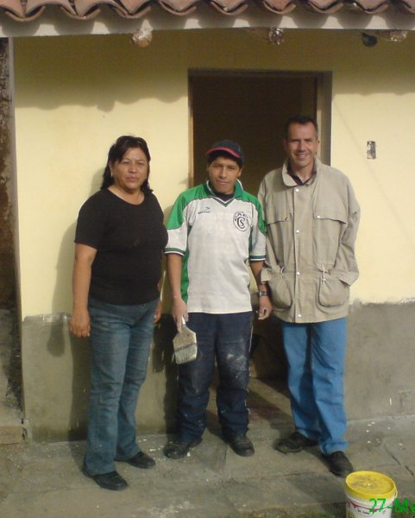

Carmen Alicia Zegarra Balcazar de Del Castillo (chairwoman of Asociación Wawacha) and Paolo Stollagli (chairman of Associazione Antigóna) together with the father of a nursery school’s child painting to arrange the new premises (March 2009)

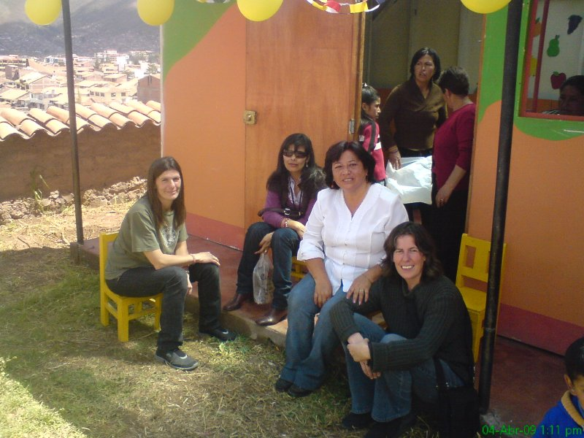

Carmen Alicia Zegarra Balcazar de Del Castillo together with three deputies of Asociación Amantaní, during the inauguration of the prefabricated module given from Amantaní to Wawacha for free use (April 2009).

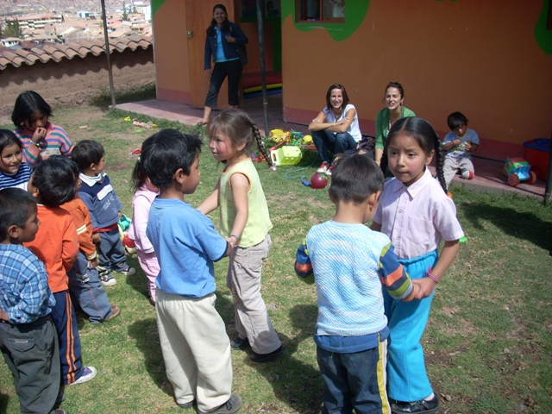

Some “Wawacha”’s children finally dancing in front of the new premises (May 2009)

m. Budget

COSTS FOR EACH OF THE PROJECT'S ACTIVITIES | PROPONENTS |  | LOCAL CONTRIBUTIONS |  | DONOR | TOTAL
COSTS FOR EACH OF THE PROJECT'S ACTIVITIES | Cash | Valorization | Cash | Valorization | Cash | Cash | Valorization | General
1.1) Recreational activities of early psychomotor stimulation
1.1.1 Share of salaries (director, assistant teacher and warden) |  |  |  | $ 71,87 | $ 1.829,39 | $ 1.829,39 | $ 71,87 | $ 1.901,26
1.1.2 Share of facilities (area, preparations, premises) | $ 59,89 | $ 132,62 | $ 143,95 |  | $ 205,34 | $ 409,18 | $ 132,62 | $ 541,80
1.1.3 Share of teaching material |  |  |  |  | $ 492,22 | $ 492,22 |  | $ 492,22
TOTAL ACTIVITY 1.1 | $ 59,89 | $ 132,62 | $ 143,95 | $ 71,87 | $ 2.526,95 | $ 2.730,79 | $ 204,48 | $ 2.935,27
1.2) Entertainment, social and emotional activities
1.2.1 Share of salaries (director, assistant teacher and warden) |  |  |  | $ 71,87 | $ 1.829,39 | $ 1.829,39 | $ 71,87 | $ 1.901,26
1.2.2 Share of facilities (area, preparations, premises) | $ 59,89 | $ 132,62 | $ 143,95 |  | $ 205,34 | $ 409,18 | $ 132,62 | $ 541,80
1.2.3 Materials for special occasions |  |  |  |  | $ 1.201,65 | $ 1.201,65 |  | $ 1.201,65
TOTAL ACTIVITY 1.2 | $ 59,89 | $ 132,62 | $ 143,95 | $ 71,87 | $ 3.236,38 | $ 3.440,22 | $ 204,48 | $ 3.644,71
1.3) Intellectual and artistic activities
1.3.1 Share of salaries (director, assistant teacher and warden) |  |  |  | $ 71,87 | $ 1.829,39 | $ 1.829,39 | $ 71,87 | $ 1.901,26
1.3.2 Share of facilities (area, preparations, premises) | $ 59,89 | $ 132,62 | $ 143,95 |  | $ 205,34 | $ 409,18 | $ 132,62 | $ 541,80
1.3.3 Share of teaching material |  |  |  |  | $ 492,22 | $ 492,22 |  | $ 492,22
TOTAL ACTIVITY 1.3 | $ 59,89 | $ 132,62 | $ 143,95 | $ 71,87 | $ 2.526,95 | $ 2.730,79 | $ 204,48 | $ 2.935,27
2.1) Help to overcome food shortages
2.1.1 Share of salaries (director, kitchen assistant and warden) |  |  |  | $ 71,87 | $ 5.114,83 | $ 5.114,83 | $ 71,87 | $ 5.186,70
2.1.2 Share of facilities (area, preparations, premises) | $ 59,89 | $ 132,62 | $ 486,18 |  | $ 205,34 | $ 751,42 | $ 132,62 | $ 884,03
2.1.3 Foods |  |  |  |  | $ 12.917,72 | $ 12.917,72 |  | $ 12.917,72
2.1.4 Kitchen facilities and utensils |  |  |  |  | $ 1.001,37 | $ 1.001,37 |  | $ 1.001,37
TOTAL ACTIVITY 2.1 | $ 59,89 | $ 132,62 | $ 486,18 | $ 71,87 | $ 19.239,26 | $ 19.785,34 | $ 204,48 | $ 19.989,82
2.2) Training meetings for parents about child nutrition
2.2.1 Share of salaries (director and warden) |  |  |  | $ 71,87 | $ 597,35 | $ 597,35 | $ 71,87 | $ 669,22
2.2.2 Share of facilities (area, preparations, premises) | $ 59,89 | $ 132,62 | $ 143,95 |  | $ 205,34 | $ 409,18 | $ 132,62 | $ 541,80
2.2.3 Stationery for the realization of the training meetings | included into overhead item
TOTAL ACTIVITY 2.2 | $ 59,89 | $ 132,62 | $ 143,95 | $ 71,87 | $ 802,69 | $ 1.006,53 | $ 204,48 | $ 1.211,02
3.1) Supply of the first aid box, and medical assistance in emergency
3.1.1 Share of salaries (director and warden) |  |  |  | $ 71,87 | $ 597,35 | $ 597,35 | $ 71,87 | $ 669,22
3.1.2 Share of facilities (area, preparations, premises) | $ 59,89 | $ 132,62 | $ 143,95 |  | $ 205,34 | $ 409,18 | $ 132,62 | $ 541,80
3.1.3 Medicinal products for the first aid box | included in the item 3.2.3
TOTAL ACTIVITY 3.1 | $ 59,89 | $ 132,62 | $ 143,95 | $ 71,87 | $ 802,69 | $ 1.006,53 | $ 204,48 | $ 1.211,02
3.2) Care and training of the children about correct principles of personal hygiene
3.2.1 Share of salaries (director and warden) |  |  |  | $ 71,87 | $ 597,35 | $ 597,35 | $ 71,87 | $ 669,22
3.2.2 Share of facilities (area, preparations, premises) | $ 59,89 | $ 132,62 | $ 143,95 |  | $ 205,34 | $ 409,18 | $ 132,62 | $ 541,80
3.2.3 Various materials for children hygiene (soaps, toothpastes, toothbrushes) |  |  |  |  | $ 300,41 | $ 300,41 |  | $ 300,41
TOTAL ACTIVITY 3.2 | $ 59,89 | $ 132,62 | $ 143,95 | $ 71,87 | $ 1.103,10 | $ 1.306,95 | $ 204,48 | $ 1.511,43
3.3) Periodical medical check-up in a local health center
3.3.1 Share of salaries (director) |  |  |  |  | $ 597,35 | $ 597,35 |  | $ 597,35
3.3.2 Periodical medical check-up in a local health center |  |  |  | $ 547,57 | $ 131,42 | $ 131,42 | $ 547,57 | $ 678,99
TOTAL ACTIVITY 3.3 |  |  |  | $ 547,57 | $ 728,77 | $ 728,77 | $ 547,57 | $ 1.276,34
3.4) Training meetings for parents about hygiene and sanitation topics
3.4.1 Share of salaries (director and warden) |  |  |  | $ 71,87 | $ 597,35 | $ 597,35 | $ 71,87 | $ 669,22
3.4.2 Share of facilities (area, preparations, premises) | $ 59,89 | $ 132,62 | $ 143,95 |  | $ 205,34 | $ 409,18 | $ 132,62 | $ 541,80
3.4.3 Stationery for the realization of the training meetings | included into overhead item
TOTAL ACTIVITY 3.4 | $ 59,89 | $ 132,62 | $ 143,95 | $ 71,87 | $ 802,69 | $ 1.006,53 | $ 204,48 | $ 1.211,02
4.1) Entering the nursery school into local institutional networks, allowing to achieve in the future a significant share of economic sustainability
4.1.1 Share of salaries (director) |  |  |  |  | $ 597,35 | $ 597,35 |  | $ 597,35
4.1.2 Participation in meetings or other activities related to institutional relations | included into overhead item
TOTAL ACTIVITY 4.1 |  |  |  |  | $ 597,35 | $ 597,35 |  | $ 597,35
4.2) Implementation of a child sponsorship activity for the children enrolled in the nursery school
4.2.1 Share of salaries (director) |  |  |  |  | $ 597,35 | $ 597,35 |  | $ 597,35
4.2.2 Typical activities of child sponsorship |  |  |  |  | $ 1.232,04 | $ 1.232,04 |  | $ 1.232,04
TOTAL ACTIVITY 4.2 |  |  |  |  | $ 1.829,39 | $ 1.829,39 |  | $ 1.829,39
Overhead for coordination and administration (8% of total) |  |  |  |  | $ 3.068,21 | $ 3.068,21 |  | $ 3.068,21
TOTAL EXPENDITURES | $ 479,13 | $ 1.060,92 | $ 1.493,85 | $ 1.122,52 | $ 37.264,44 | $ 39.237,42 | $ 2.183,45 | $ 41.420,86
REVENUES FOR THE PROJECT | PROPONENTS |  | LOCAL CONTRIBUTIONS |  | DONOR | TOTAL
REVENUES FOR THE PROJECT | Cash | Valorization | Cash | Valorization | Cash | Cash | Valorization | General
Inscription fee to the nursery school |  |  | $ 4.517,48 |  |  | $ 4.517,48 |  | $ 4.517,48
Donations |  |  | $ 141,00 |  |  | $ 141,00 |  | $ 141,00
TOTAL REVENUES |  |  | $ 4.658,48 |  |  | $ 4.658,48 |  | $ 4.658,48
 | PROPONENTS |  | LOCAL CONTRIBUTIONS |  | DONOR | TOTAL
 | Cash | Valorization | Cash | Valorization | Cash | Cash | Valorization | General
GENERAL TOTAL | $ 479,13 | $ 1.060,92 | $ 1.493,85 | $ 1.122,52 | $ 32.605,97 | $ 39.237,42 | $ 2.183,45 | $ 41.420,86
 | PROPONENTS |  | LOCAL CONTRIBUTIONS |  | DONOR | TOTAL
 | Cash | Valorization | Cash | Valorization | Cash | Cash | Valorization | General
PERCENTAGE OF EXPENDITURES COVERING | 1,16% | 2,56% | 14,85% | 2,71% | 78,72% | 94,73% | 5,27% | 100,00%

