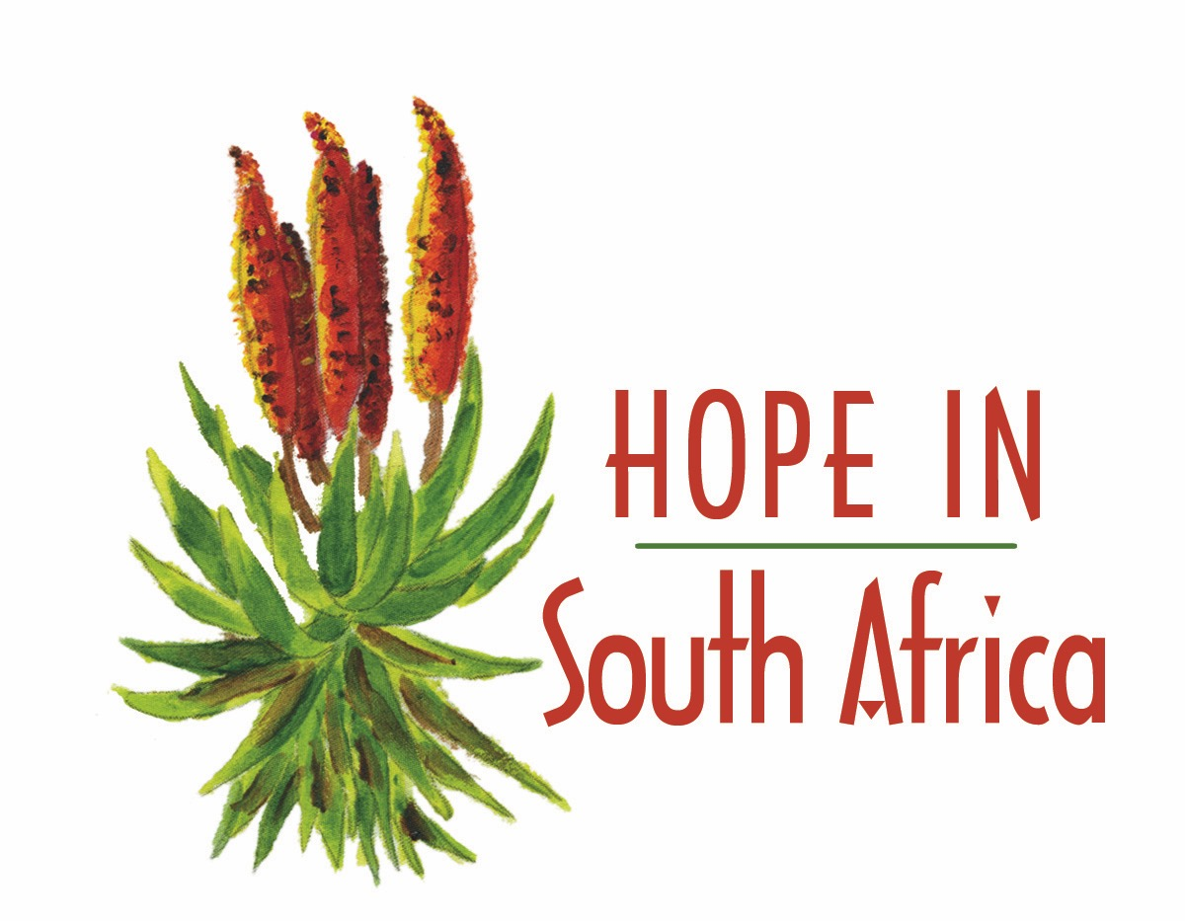
Richmond community Centre
Randsig Street
PO Box 63
Richmond, NC 7090
Tell:053 693 0047
Fax: 0866263642
www.hopeinsouthafrica.org
Company Registration: 2012/020761/08

Grassroot Hope in South Africa works in Richmond and Kimberley providing Life skills education about HIV/AIDS and Fetal Alcohol Spectrum Disorder we provide a healthy nutritional meal on a daily basis in Richmond to children and adolescents.
Since we were founded in 2012, we have created a safe space for children in our project. Last year 2017 we reached over 2000 youth through life skills by HIV/AIDS and Fetal Alcohol Spectrum Disorder (FASD) and provided 44 477 meals to children in the Richmond community.

Findings on the FASD programs we have been doing for the year with participants at the Centre we have took a sample of about 60 participants.

Early findings - we are reaching children at risk of mental health challenges, and creating programmes condusive to improving mental health outcomes.
- 83% of our target population have experienced some form of trauma in the last 6 months, increasing risk of mental health challenges. 49% have experienced multiple traumatic events, increasing risk of mental health challenges. (See attached brief)
- We are creating programmes where children feel encouraged and praised (key for improving self image and esteem) - Goals for Girls project we have introduce on a full time basis.
- We are helping children feel good about themselves, active and supported by caring adults (Key mental health indicators)
Opportunities
- Coaches are asking for more training in psychosocial support
- We can do more to improve our coaches' understanding of trauma and its impact on youth
- We can do more to teach children behaviours to cope with stress and form new relationships.
- All this revert back to the competency level of coachesprogram leaders who receive training to assist participant we work with whom are experiencing the above menstioned issues please follow attached report complied by Waves for change together with GHISA participants samples in partnership with Laureus learning community.

CHILDREN REPORT HIGH LEVELS OF WELL-BEING

Programs -

With the Program not being funded completely we manage to get the current staff to work with as to keep the programs running at the Centre as it an important piece that keeps the Centre at its full potential.

The Kitchen is running at a good past keeping up with the growing numbers daily and high price increase of food supplies.

However we had a donor from a farm outside of Richmond we received meat for the whole winter this year and even through December.

The Goal for Girls are doing a great job,as they are going to visit the clinics and the they also are busy with a school project at the Centre helping other on the computers as well as using the resources at the Centre to do their schools work.
The programs leads are in the process of recruiting new girls to mentor and to prepare them for next year potentail Joburg trip.

The G4G initiative is somethimg that has great potential which links into one s objective at this years Global summit about inclution into our program as to empower young girls.

 | Soup kitchen | Total Attendance for 2018
Jan. | 2628 | 2628
Feb. | 4591 | 4591
Mar. | 3704 | 3704
Apr. | 3018 | 3018
May | 5314 | 5314
Jun. | 2776 | 2776
Jul. | 3512 | 3512
Aug. | 4839 | 4839
Sep. | 3449 | 3449
Oct. | 4355 | 4355
Nov. | 4982 | 4982
Dec. | - | -
 | Total to date | 43168
 | Children benefiting | Meals to date

