AMURT FOUNDATION NIGERIA
REPORT OF LIFE SAVING SURGERIES 7 DECEMBER 2018 to 18 March 2019
SUMMARY:
Total surgeries sponsored:
17 surgeries
Venue of surgeries:
University of Nigeria Teaching Hospital Enugu: 4
Federal Teaching Hospital in Abakaliki: 4
Ephuenyim Health Center: 3
Odeligbo Health Center: 4
Gmelina Health Center: 2
Efeta Eye Hospital 1
Categories of surgeries:
Hydrocephalus and Spina Bifida: 4
Intestinal obstruction: 1
Hernias: 7
Ambiguous genitalia/related 2
Congenital cataract 1
Necrotizing facilitis 1
Undescended testes 1
TOTAL Money spent: Naira 1,824,151 = USD 5,042
The money spent also includes investigations and preparations for two surgeries that have yet to take place. And check ups for children who has already undergone hydrocephalus and spina bifida surgeries.

Some notable surgery cases:
UKAMAKA:
9 months girl from Mgbalukwu, Onicha Local Government Area.
She is from a very poor village in a remote rural area.
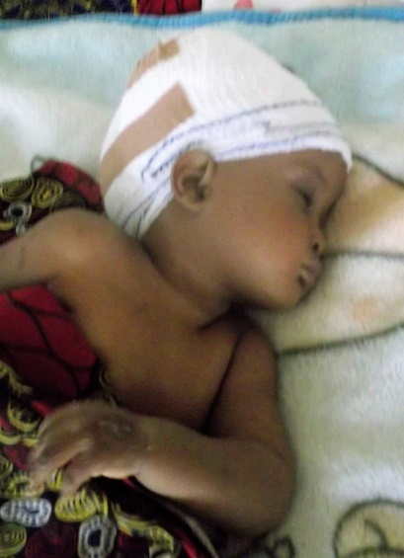 | 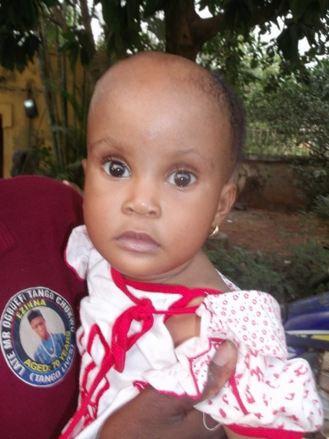
After surgery | After discharge.

QUEEN
10 year old girl from Enyadulogu, Abakaliki Local Government area
Queen was born with cataracts. Her family never had money to do anything about it. She was almost blind and could only see shadows. She had an operation to remove the cataract from her right eye. After two months she will have the same operation on her other eye. She can now see, although the eye is still learning to adjust with light.
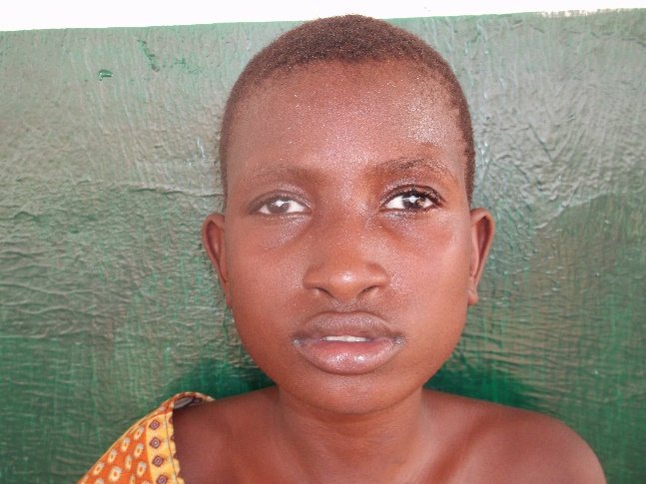
Queen– before the surgery

CHINEMERE
3 months baby from Enugu Local Government Area
This baby was admitted at the University Hospital, but the family had no money to do the surgery. So AMURT helped them out.
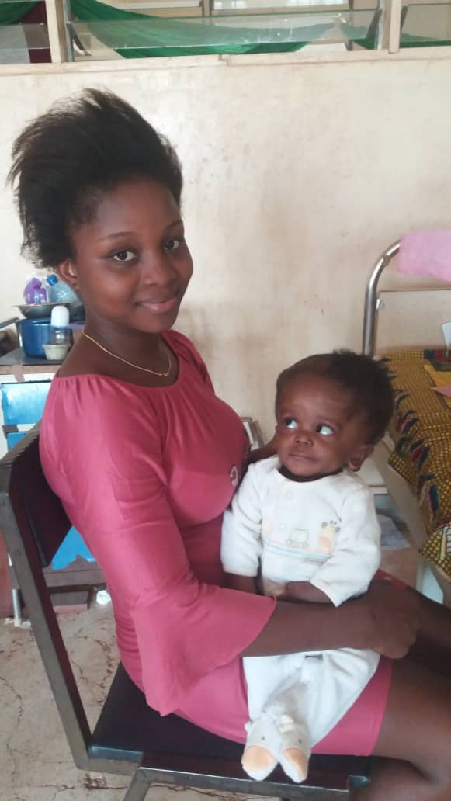
Chinemere Ogbodo before surgery

