Salvation Centre Cambodia exam results and our expanding international networks:

Salvation Centre Cambodia has had a fantastic couple of months expanding their international networks and sitting their first term exams. 130 students in our Phnom Penh school took Level 1 to 3 First Term Exams with great results! We had 125 students passing speaking and listening skills exams with over one third of students achieving an Excellent score. This is a great testament to our fantastic teaching staff and the commitment of our students.

The success of all of our SCC-CBE schools is very reliant on the ongoing support of our international friends and donors who want to see our impactful projects succeed. Almost all our generous donations come from the global community and for that we want to say thank you!

One of the things you may not know about SCC is that, since it started in 1994, it has maintained Khmer ownership and management. This is unlike many charities and NGOs within Cambodia and allows for such impactful community work and connection. In additional to SCC’s local management team and workforce, SCC has been lucky enough to benefit from a global network of international volunteers. We have volunteer teachers, volunteer fundraisers and volunteer consultants who all provide their time to see SCC continue to develop and support vulnerable families with HIV/AIDS. I wanted to specifically talk about two international volunteers who have had a significant impact for SCC over the last few months.

Firstly, Courtney was a volunteer teacher with SCC Phnom Penh from January to March this year and was heartbroken to hear that one of our schools was in danger of closing. Courtney ran her own fundraiser and managed to raise ￡660 by saving her head and donated it all to SCC!

Secondly, Ellie from Sydney, Australia has joined our team as a volunteer Fundraising and Grants Advisor. She began working from our SCC Siem Reap management office and is now travelling around the world building more fundraising and grant relationships to expand our international network.

Our SCC projects and schools wouldn’t be possible without our international donors and volunteers who make up our network so thank you for all your continued support. Lastly, I wanted to say a big thank you to some of our donors who consistently support SCC and the work we do with our schools. Thank you to Susan, Sarah, Jennifer and Leila for your regular donations.

Highlighted School Events:

SCC Head Office staff, CBE teachers and voluntary teachers had invited the venerable monk to teach and educate our CBE children about the morality, solidarity and how to become a good child, a good students and a good citizen for the humanity being at the SCC-CBE School Boengkak, slum area, and Phnom Penh municipality. It is the very special event for our children who has a valuable time to get the physically and mentally education at our school. Furthermore, SCC Head Office staff, CBE and voluntary teachers and our kids get the best way of the peaceful mind by meditated. Additionally, meditation help us and our kids with breath and heart beat working well, stable and peaceful mind, freshly feeling and it’s easily to get more informs.

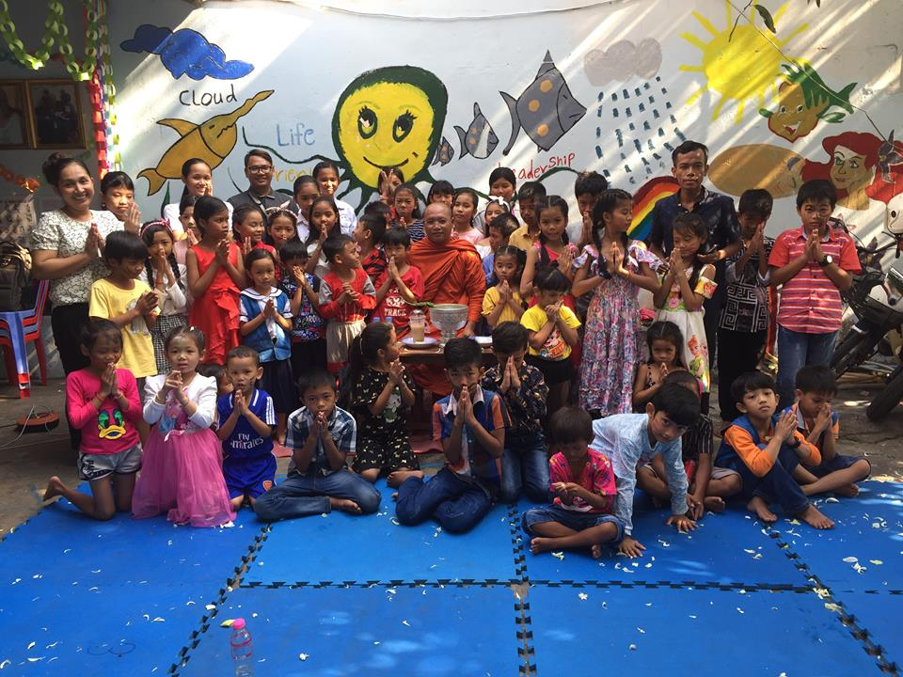
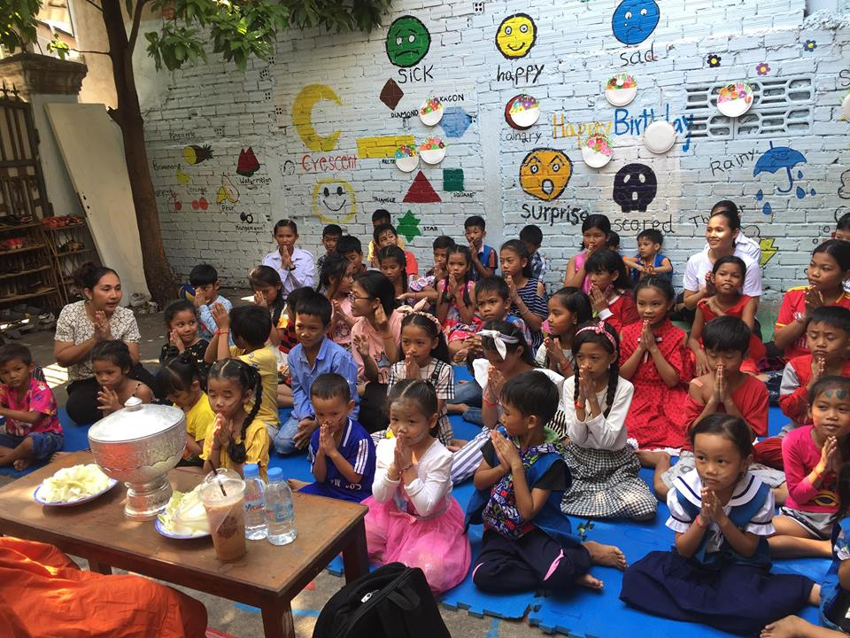

After performing a Buddhist Ceremony, children had a chance to play various games led by SCC CBE teachers. Moreover, this Happy Happy Program was participated by voluntary teachers and community people as well. Our kids played very happily and exhausted too on their holiday.
Happy Cambodian children!!

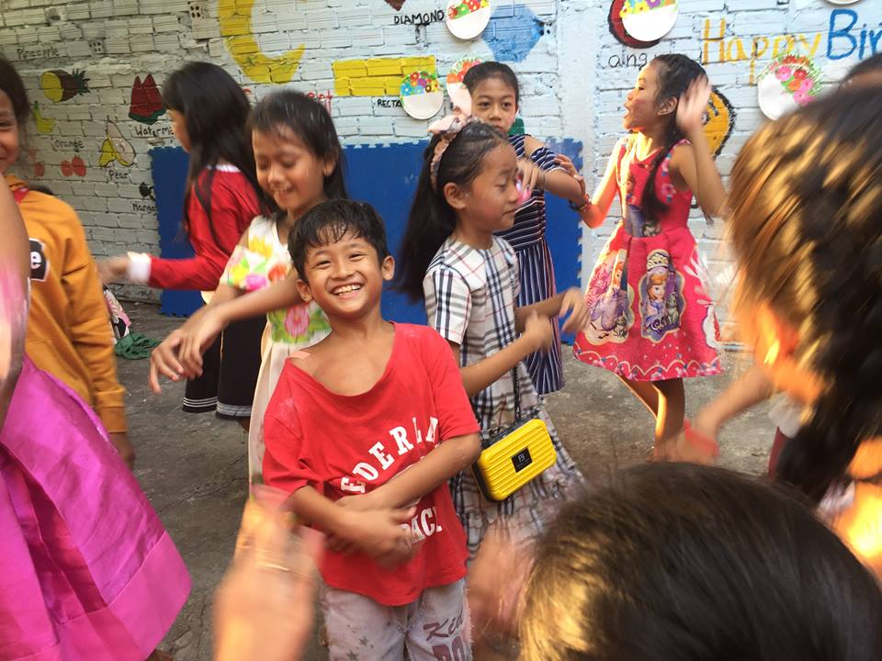
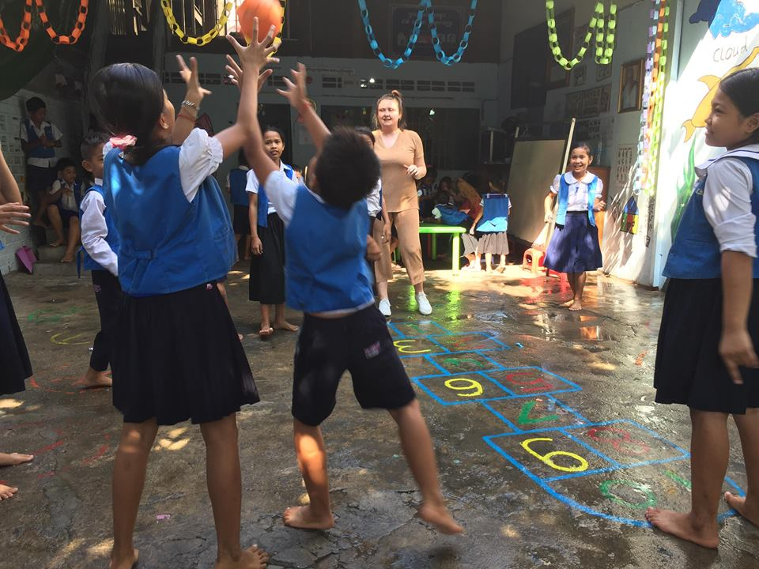

From May-July 2019, SCC-CBE School located in Phnom Penh city has been warmly welcomed the eight volunteers from Denmark, Ireland, England, Australia and Italy. They help us teaching our children and other required work at SCC-CBE School. Most of them are kind, friendly, and adorable to everyone. They shared the lovable quote that “Life is not about making others happy. Life is about sharing our happiness with others.” That’s why they do love Cambodian children, especially kids at SCC-CBE School.
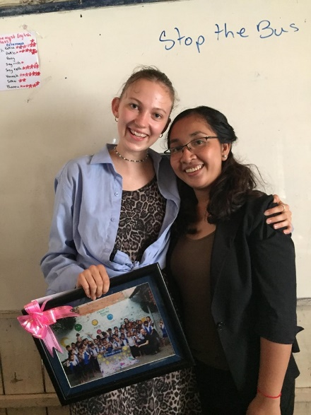
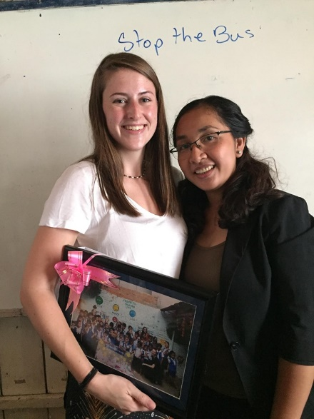
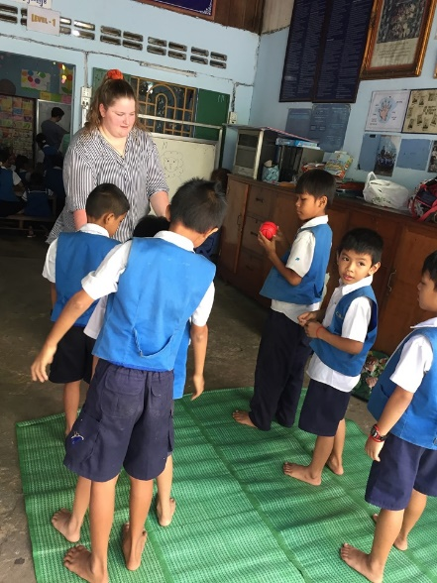
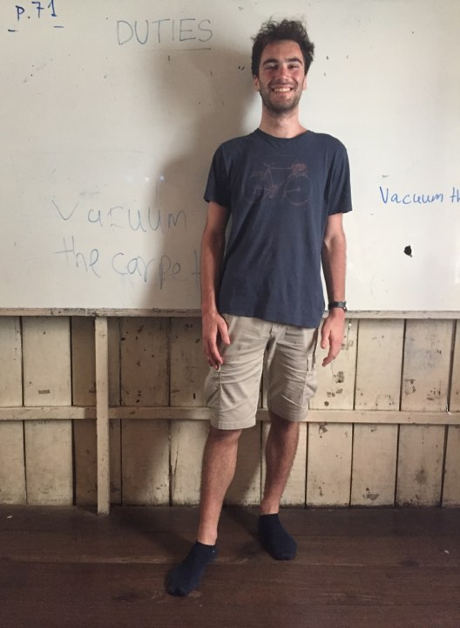
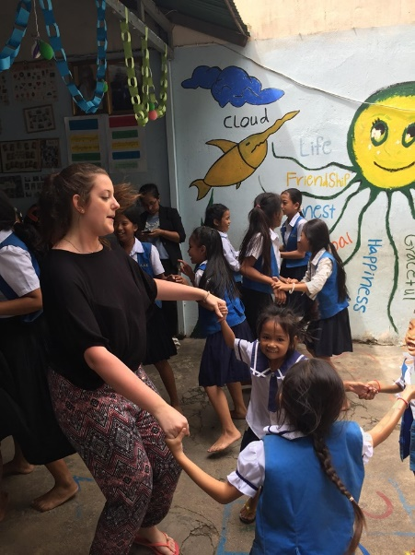
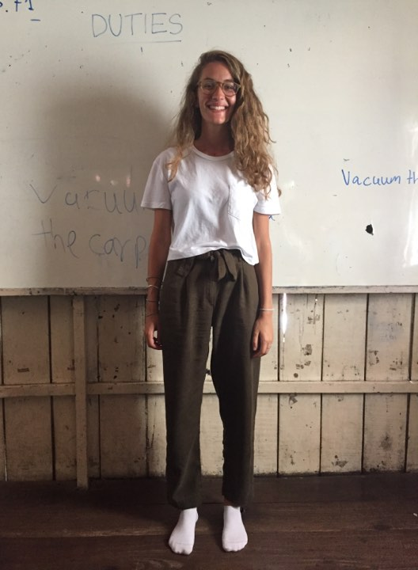
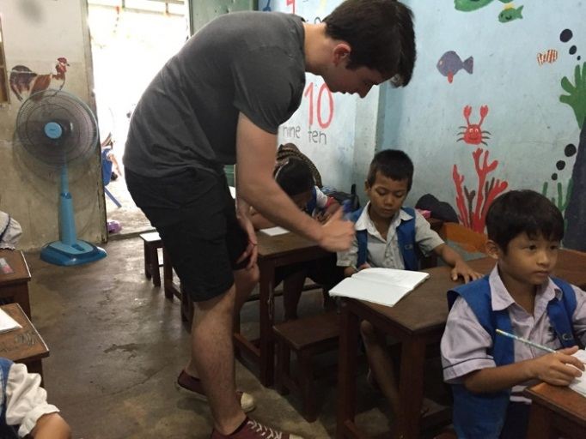
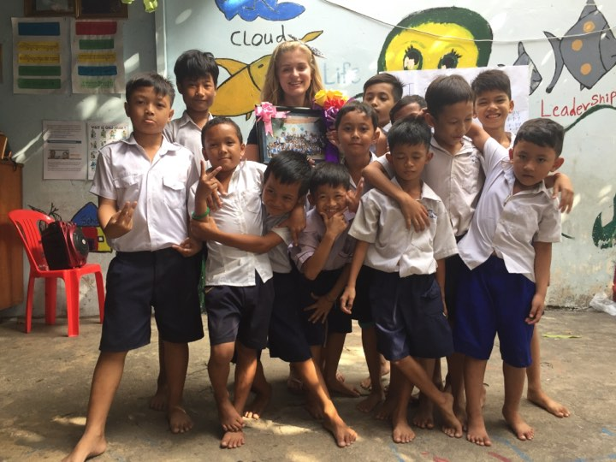

Ms. Sofie Olesen from Denmark

Ms. Katie Simkin from Autralia
Ms. Vicki Purcell from Ireland

Ms. Sofie Olesen from Denmark
Ms. Vicki Purcell from Ireland
Ms. Katie Simkin from Autralia

Mr. Eduard Edgington from England

Ms. Amy McCullagh from UK

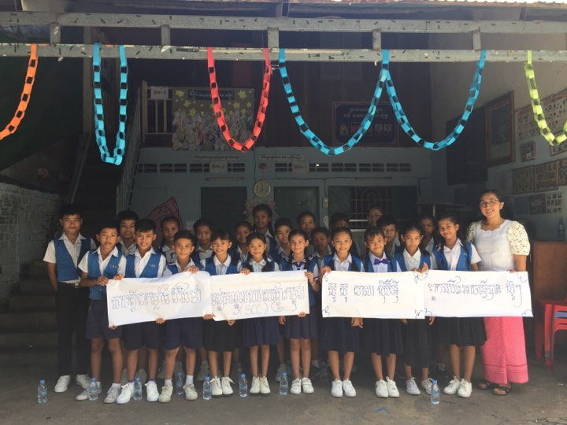
Regarding guideline children's basic education (SCC-CBE School) has been training our kids to singing and dancing because they will have the kids’ song contest at the Ministry of Information Hall. It's a good chance for our kids to challenge with this competitions which have more children who come from different schools to participate on the special kids’ song contest. All of them feel over excited when they have these Kids’ song contest, thank you so much all donors and supporters who always help them.

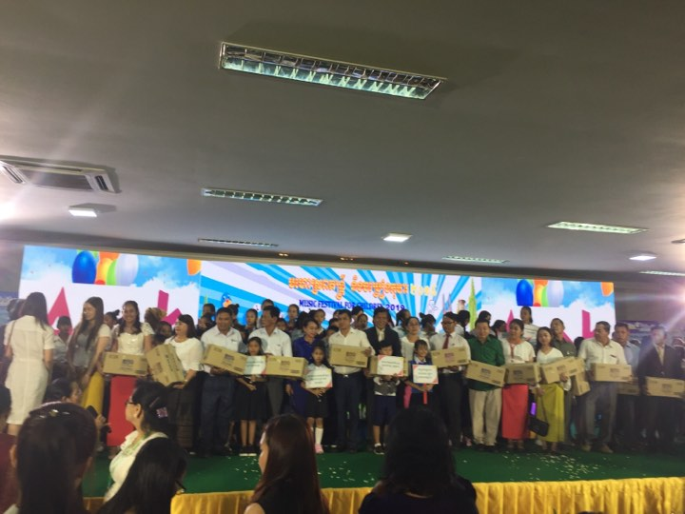
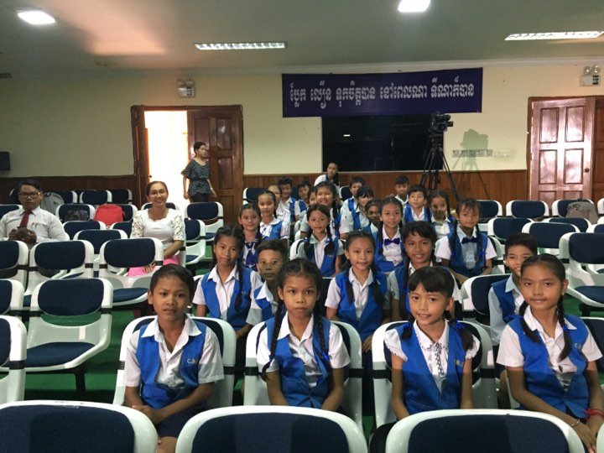

We feel very great for your kind donations. Without yours we are surely not have a very useful school where we are able to disseminate Khmer traditional culture, Happy Happy Program, learning center, and place for sharing experiences, exchange visit with both the beloved children and amazing communities.

Budget Expenditure from 1 August 2018 to 31 July 2019 (12 months)

