Overview of SCC-CBE teachers and schools situation
During the COVID-19 pandemic, SCC-CBE children were kept out of school because all schools have been suspended. This is following the guideline of the Ministry of Education, Youth and Sport instructed on March 15th 2020 with the goal of preventing the spread of the virus. From then till now, no classes were taught by any teachers in our school. However during all this time , our teachers and volunteers have been working on some school’s work such as reviewing the course outlines for the course books for all levels, revising lesson plans and examining students name lists for taking any intervention for helping them immediately. They also conducted follow-ups through phone calls or direct visits to their homes in order to guide them in preparing a schedule for self-learning at home. The teachers and volunteers have arranged other school management work too. In this reporting period, SCC Executive Director also asked our teachers to help with arranging and putting SCC’s financial documents in order for the SCC Head Office. This is a new work for them as well next to their usual tasks of teaching and learning at SCC-CBE School. Moreover, our teachers come to work and conduct peer learning, self-learning, and learning by doing at school five days per week in order to improve their teaching capacity and learning skills. They have reflected and learnt from this experience. By doing this they are getting ready before the school reopening; as a result, they have been strong in their jobs.
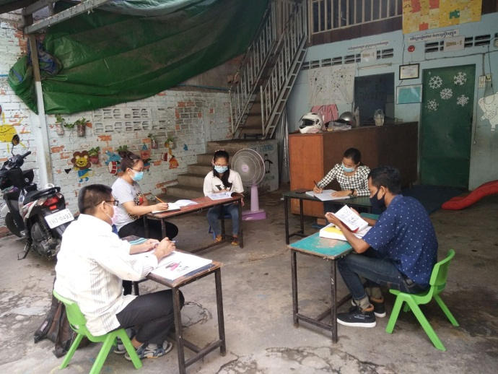
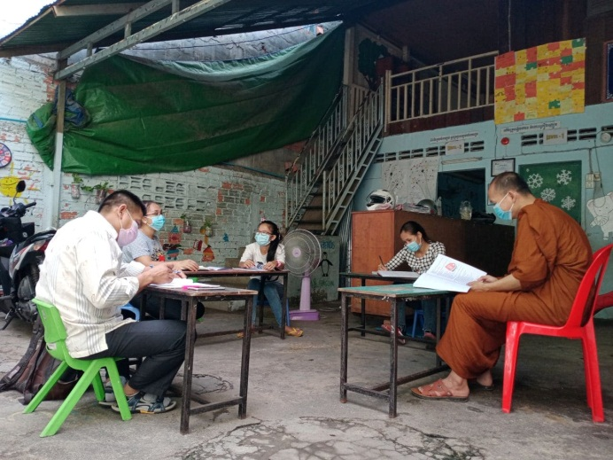

SCC-CBE teachers work on reviewing student name list and other tasks.

The situations of CBE’s students families
[When the world was hit by COVID-19 pandemic, Cambodia was also affected and most workers in the informal economy sector, many of whom were poor before, are losing their incomes because there are no customers. The president of the Independent Democracy of Informal Economy Association (IDEA), said that the areas with many non-formal economic facing new problems during the COVID-19 outbreak included Sihanouk, Siem Reap and Phnom Penh, Cambodia. He added that, "Incomes of non-formal economists were reduced by 70 to 80 %".

On the 7th of May 2020, SCC-CBE teachers conducted their home visits to our children’s homes. They met many children who stayed at home and played nearby their houses with their friends. However, some children could access their studies through an E-learning program provided by the national government through a specific broadcast on television (TV). Others were able to access their learning via online teaching classes for the medium-rich and rich households. However, most our children live under poor living conditions, and missed their classes whether online teaching or television. Some families are very poor and more children have to support their families with their own income. What has happened to these families? During the COVID-19 pandemic, most parents continued working to earn an income for their family, but in most cases their incomes were less than before. The parents have no time to stay home and take care of their children or fully support their studies through the E-learning program provided by the national government. We might think that children want to learn alone, we are sure that, they don’t. What has happened to those children whose parents leave home to go outside and earn incomes? In these cases, we try to help our parents/caregivers as much as possible to arrange a schedule for their children to continue their lessons at home. The goal is that when the parent/caregivers came back from work they just have to spend a little time checking homework or their children’s tasks. Significantly, some parent/caregivers have taught their children at home as well. Now we would like to portray two of our student’s family’s current situation as follows:

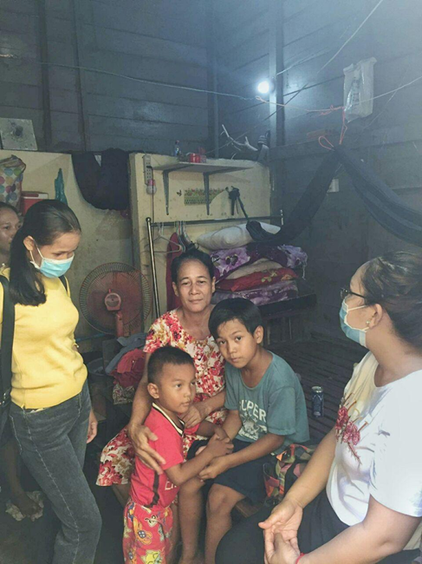
1. Dara, 11 years old, studies in grade 4 at Kolab I, primary school. He also studies English with SCC-CBE School in level 2. Dara was living with his aunt and uncle at Phum 22 village, Sangkat Sras Chak, Khan Daun Penh, Phnom Penh city, slum area when the virus broke out. They supported him going to schools every day like the other children in the community. Dara is an orphaned child who has no mother. His father has married another woman. So, he is forced to live with his uncle and aunt. Now Dara was sent to his homeland at the province for preventing COVID-19 pandemic. He will come back to his community when the pandemic has passed. His caregivers reported that since the Coronavirus outbreak, it has become increasingly difficult to earn an income for supporting their daily lives.
Teachers visited Dara's family

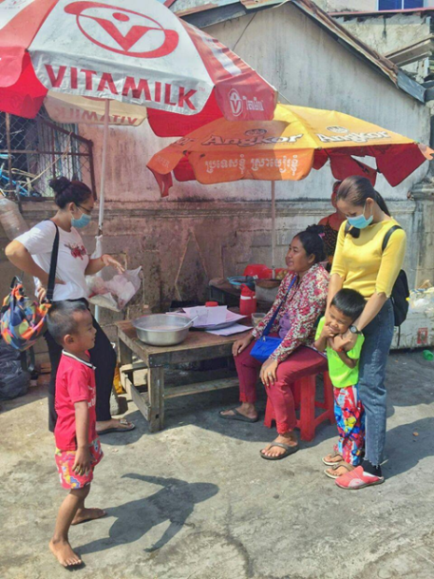
2. Phany, 9 years old, studies in grade 2 at Kolab I, primary school. He also studies English with SCC-CBE School in level 1. Phany is also an orphaned child who was abandoned by his parents when he was a baby. At the moment, he lives with his grandmother, who works as a laundry worker for someone from house to house for fee at PhumToul Sangkae SangkatSras Chak, Khan Daun Penh, Phnom Penh City. His grandma has been working very hard to earn an income for supporting her grandchild’s studies and herself. Indeed, she tries very hard for support her grandchild even though she has a chronic disease (high blood pressures). She still gives her hope to her grandchild. She expressed that since the coronavirus outbreak, this bad situation has caused a deterioration of her living standard. She faces a very hard situation in earning income to support her living.
Teachers visited Phany's family

