Some really surprising and important reporting from our SCC-CBE School.
The things/events that kids are learning from our school as follows.

Christmas Day was celebrated on the 25th of December 2019 by SCC-CBE teachers and our children at the SCC-CBE School in Phnom Penh, Cambodia. In the Christmas event, the children received various gifts from our generous supporters. They enjoyed a happy time surrounded by their friends, classmates and teachers eating delicious food and playing various educational games led by their teachers. Our students were able to strengthen the relations with each other. Moreover, they were encouraged and motivated to come to SCC-CBE School and public schools regularly too. We talked about children’s rights to education, their rights and child protection, in order to encourage them to be more self-confident and successful in their studies. It is important that the children themselves know about their rights and the chances they have in Cambodia’s society. In this event, they also learnt about a new culture and traditions, which have flourished in Cambodia after having brought here from western countries. They were able to experience some Christmas spirit and traditions, thus broadening their knowledge of other cultures and their festivities.
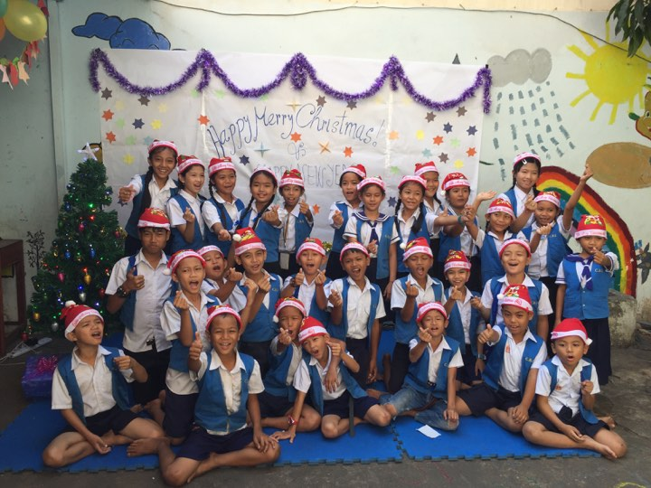
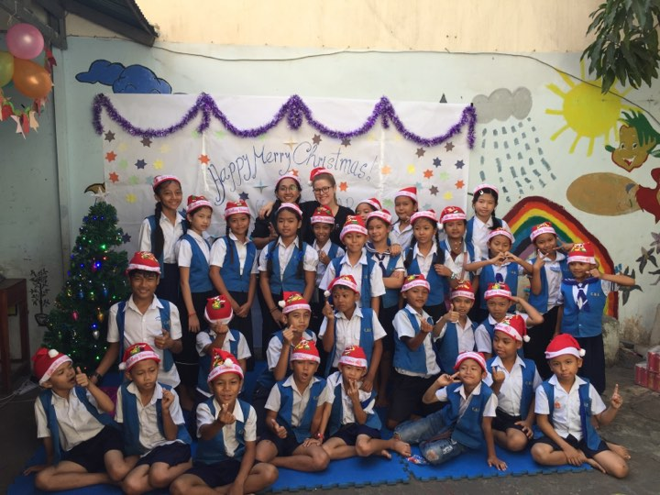

Group photo of CBE children & teachers
Group photo of CBE children & teachers

Happy Happy Program was conducted on 13th December 2019 by SCC’s staff members including CBE teachers for children at the SCC-CBE School located in Phnom Penh with 63 children of which 29 are were girls participated in this activity. In the program, the children played together, explored their skills and learned from each other. They were also able to build new relationships with one another and strengthen existing ones. During the program, the pupils were very happy together: They learned some new skills unconsciously, interacted with each other, shared knowledge, played educational games and enjoyed refreshments. It was a great opportunity to strengthen their relationships and grow together as a community. Through having fun, our children were encouraged and motivated to study at CBE School and state schools regularly. This activity promoted our SCC-CBE School and informed students and parents about their options and possibilities in the education offered, and encouraged more children to join the SCC-CBE School. Additionally, this program aimed to end stigma and discrimination against vulnerable children.
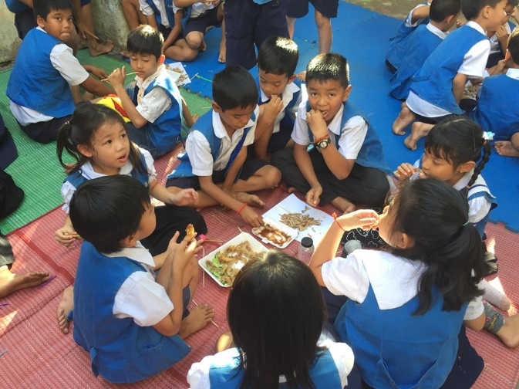
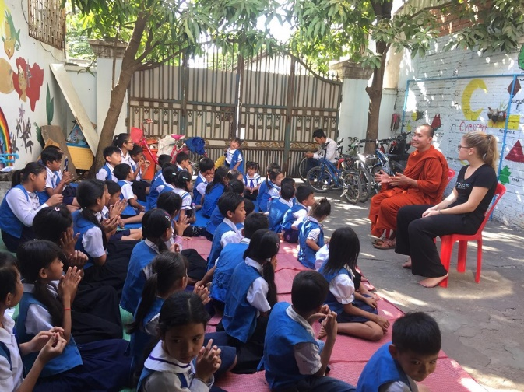

The Children ate refreshment after ending the program
The Children received moral education from SCC Monk.

Mrs. Christine Bundy is a former volunteer teacher and a fundraiser of SCC-CBE School from Australia. She has been supporting and saving SCC-CBE School’s life keep opening until now and children’s rights to education in Cambodia. At 8 o’clock on 13th January 2020, she invited her best friends, Nicola Beckett George, Zoe and Xyavia to visit our SCC-CBE School and all beloved children. She has praised that all teachers and children at SCC-CBE School are doing a great job. Whereas our visitors felt surprised and impressed when they saw SCC’s staff members including teachers and children welcome them very warmly. They told that they have learnt a lot about the real situations of CBE School and children. They appreciate our jobs. They encouraged our children to study for the sake of yourselves, your family and especially for your country.
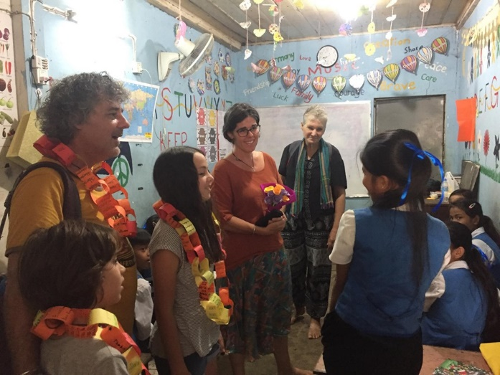
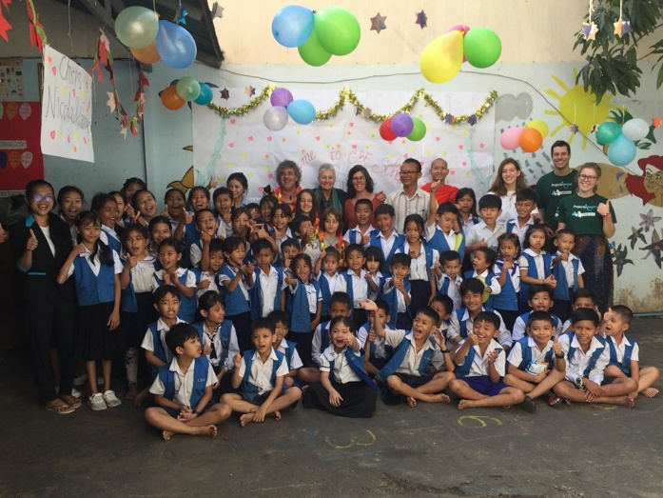

Group photo of Children & SCC staff including teachers
Our visitors come to visit SCC-CBE School

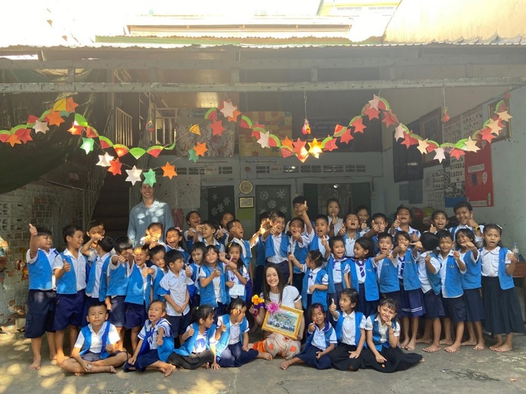
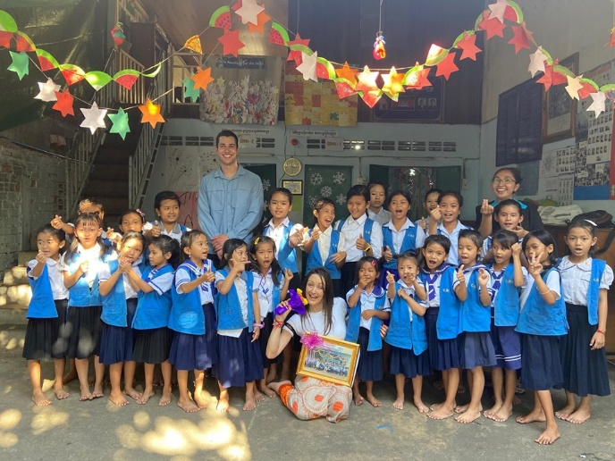
Mrs. Jane Fox is a volunteer teacher from UK and she teaches our children for two weeks. She felt that the children in her class enjoyed interactive learning. She felt very welcome by both the local teachers and children at school. She found the behaviors of some children very hard to manage but she understands and appreciates of the help that she gave. The children seemed to enjoy interactive play and activities while learning. They enjoyed songs with actions and really enjoyed the creative side of learning through craftwork and coloring. Due to these attention span and age ranges, games should keep in short and with stickers.

Group photo of Jane and children at SCC-CBE School
Group photo of Jane and children at SCC-CBE School

Ms. Friederike Louise Mayer a volunteer teacher from Germany. She teaches our children for three months. She said, “I feel very important to share my English lessons with all SCC-CBE children in Cambodia.” She added that, “I know they will improve their skills a lot.” For me, it is a great experience and the children it is an importance and fun time. Next to class, you connected with many students (from all levels) and it is great to see how they get attached to you.

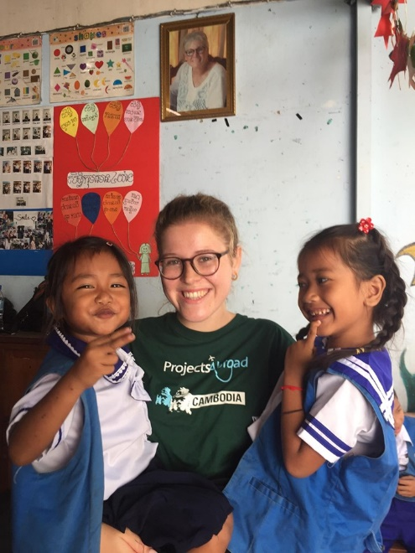
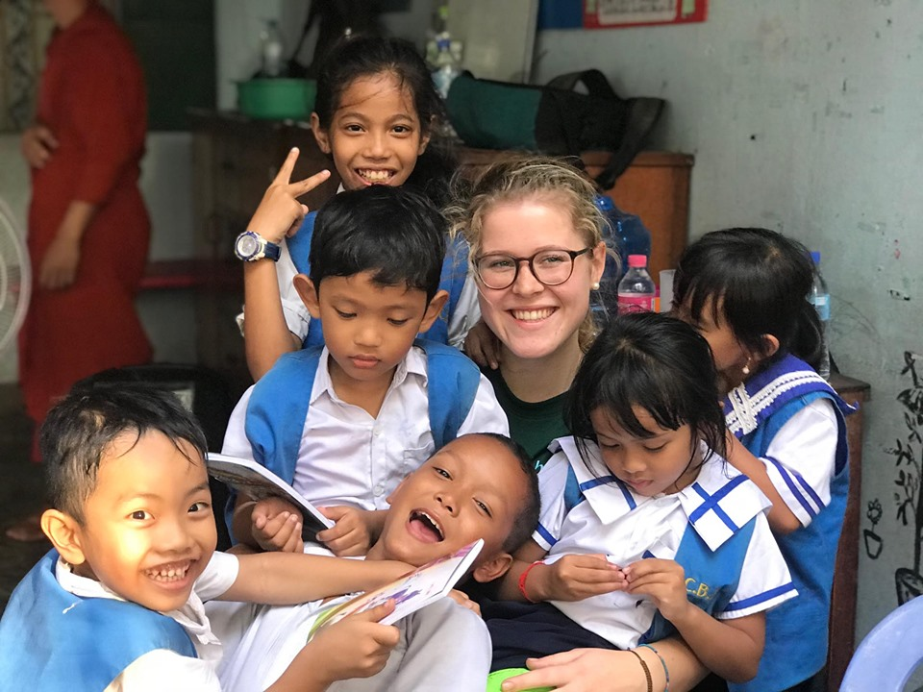
Regarding teaching children at SCC-CBE School, if due to the language barrier the students do not understand English well, so the teachers try to be patient to talk to the students in English. Not only talking, I have used body language, drawings and pictures from course books for getting my students understand. They sometimes do not understand what I meant. For my opinion, it is important to all that the students get translation from the local teachers. It is necessary for a good lesson; especially for the younger students a local teacher who assist in Khmer language is very important.
Friederike and SCC-CBE Children
Friederike and SCC-CBE Children

