Educational Situation of SCC-CBE’s Children in slum area

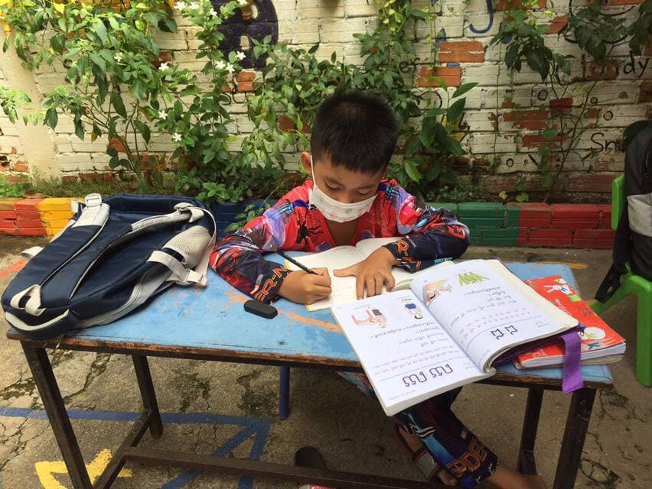
COVID-19 pandemic still continues globally, especially in Cambodia, there were new infected cases have been happening every day in the communities; it was really difficult and horror-struck. It has caused major obstacles related to people's daily lives.​ It’s a challenging economic crisis in the whole country. Separately, education was completely suspended in accordance with guidelines of the Ministry of Health in purpose to halt and prevent the spread of infectious diseases. All schools in Cambodia were suspended and no students were allowed to go to schools. However, the schools are still open and teaching children through online learning under guidelines of the Ministry of Education, Youth and Sports (MoEYS). This academic year, which was open for a month or two, was closed due to the COVID-19 pandemic. However, our teachers have still done some teaching and learning activities such as there were three or four students are allowed to come to school for forty five minutes ‘teachers told’. They continued that some students have an ability to learn via online learning with their smartphone, some students have just received homework for doing it at home separately and send it their teachers for correction, some students have been helped and taught directly by SCC-CBE teachers at their home. In addition, our teachers always pay a high attention to remind the students to be careful their health, especially wash hands frequently, spraying disinfection alcohol or gel, and wear a face mask properly when going out and keeping space between yourselves and others to prevent infectious diseases. Moreover, SCC’s teachers motivated the parents/guardians of students when have free time should remind their children to read the books or do teachers’ homework. Besides children study at school, parents is the second teacher and the first teachers of their children’s studies at home.
SCC-CBE student came to school learning individually on August 2021 in the Context Covid-19
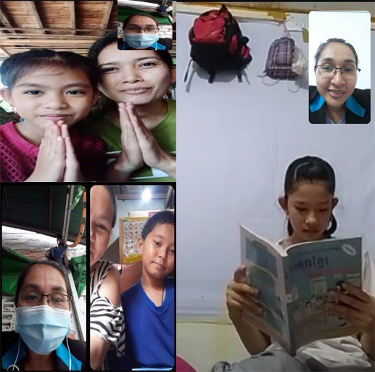
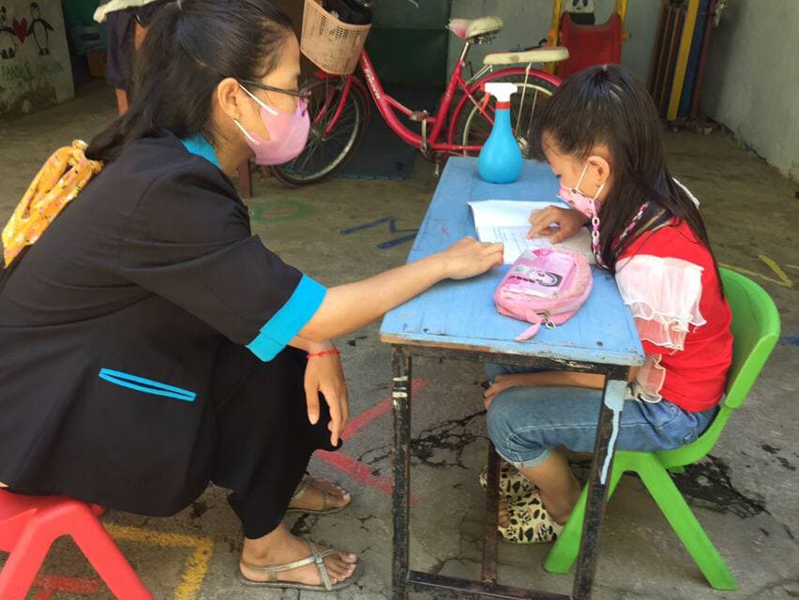

SCC-CBE Students study their subject via online in the situation of Covid-19 spread up on August 2021
SCC-CBE students came to get the lesson from the teacher on August 2021 in the context of Covid-19

Finding:
SCC-Children’s Basic Education School teachers found some outcomes including:
- Our children still have the opportunity to review important lessons such as Khmer language and English from levels 1-3. This learning activity has helped the children to be brave to continue their learning.
- Children are confident in their work, such as drawing and speaking, thanks to the encouragement of their parents and guardians, especially the teachers of SCC.
- The teachers found that SCC-CBE’s children have done their homework carefully.
- Parents and guardians have participated in encouraging their children to study hard with their teachers and self-study at home.
- The study curriculum encourages children to remain satisfied with their learning, keeping these children from dropping out of school during the outbreak of COVID-19.
- In this reporting period, there were more than 94 families of vulnerable children received emergency food assistance from SCC during the outbreak of COVID-19.
- Standard of living of our children’s parents and caretakers are decreasing in income are due to COVID-19 pandemic; they did not sell the products or sold less than before; some went to work but did not get the full salary (less than 50%), while prices went up. ‘SCC-CBE teachers’
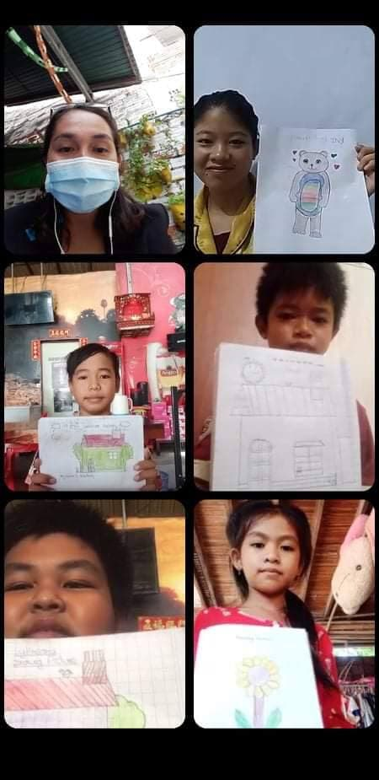

SCC-CBE students drew picture at home on September 2021

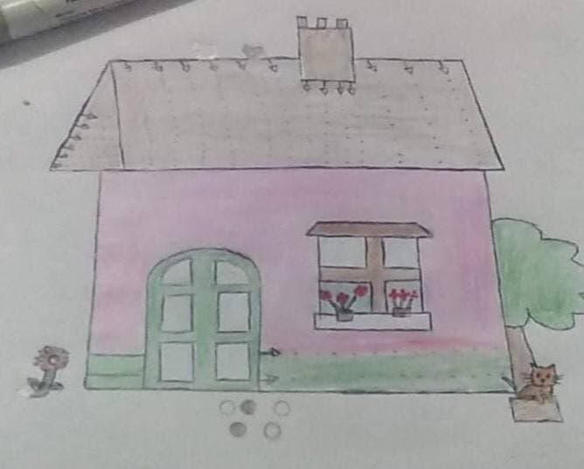
SCC-CBE student drew the house to describe their living on September 2021

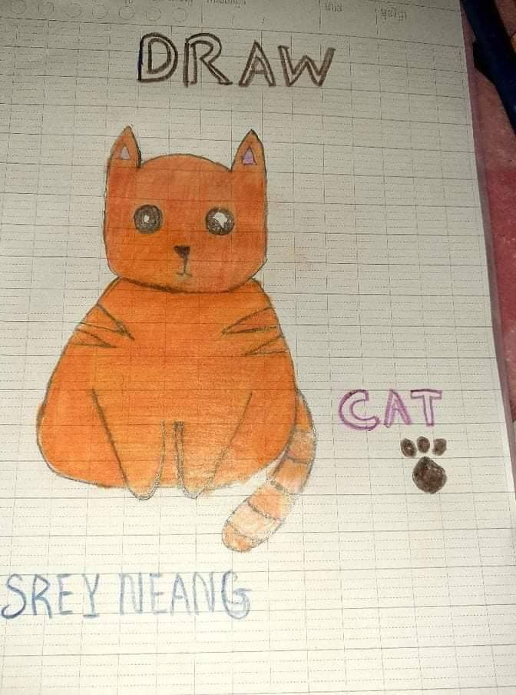
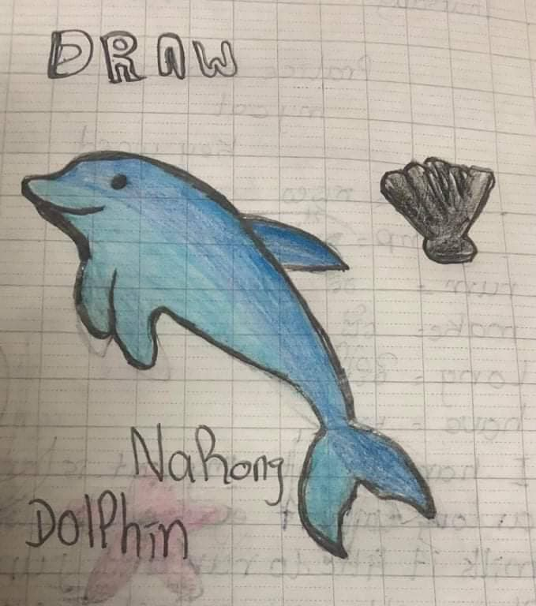

SCC-CBE Students learn to draw picture during self- learning at home on September 2021

