Improved knowledge of parent and children in preventing COVID-19
While COVID-19 pandemic has reduced new infections in Cambodia, SCC-CBE School has only been reopened from January 18th to 27th February 2021. In this reporting period from March to May 2021, SCC-CBE teachers have come to work at the school normally, but no any classes were allowed to open for teaching and learning. In March 2021, some children who live nearby the school could come to school to get lessons and homework from their teachers in order to practice at their home respectively. Note that both teachers and their students really adhered to the guidelines of Ministry of Health in Cambodia to prevent infection and to slow transmission of
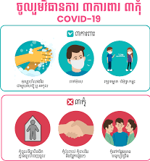
COVID-19 in the community. So, SCC staff members including SCC-CBE teachers have abided by three prevention measures as follows:

Three defenses:
1. Wear a mask in public.
2. Wash your hands with soap, alcohol or gel.
3. Maintain a social and individual safety gap of one and a half meters or more.

Three do not:
1. Do not enter a closed, ventilated area.
2. Do not enter crowded places.
3. Do not touch each other.

In April, during lockdown of the whole country, this incident affected the lives of many students; especially their parent/caregivers could not go out to earn a living, this hard situation made their lives fall into deep poverty.
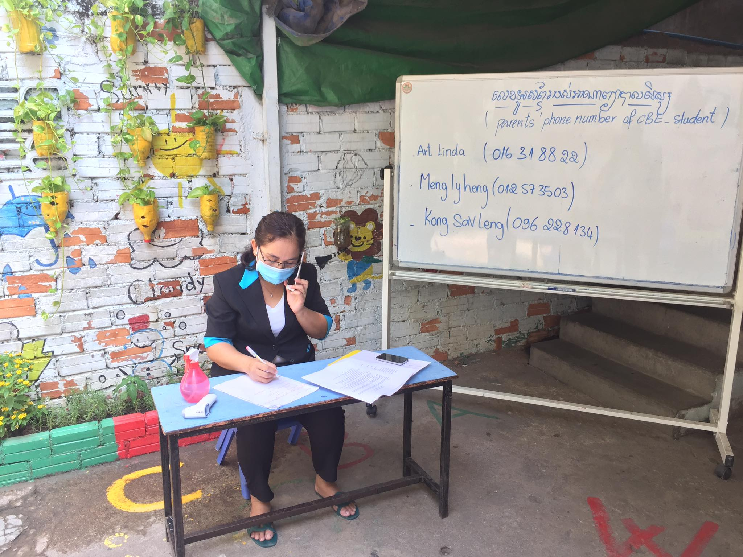
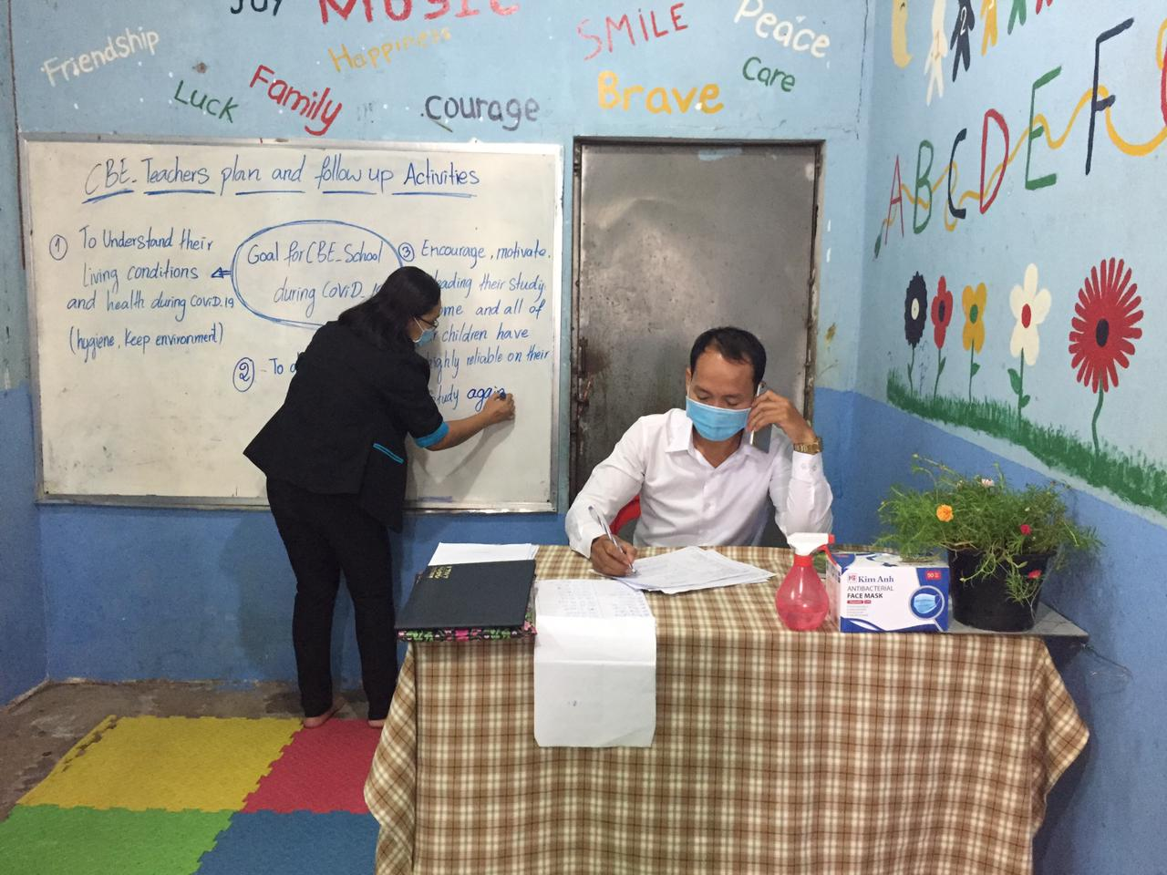
SCC-CBE teachers teaching children via online during Covid-19 and made list for following up parent of children

Students were not allowed to attend the school for a while: Despite facing a bad crisis situation and students could not attend the schools; however SCC-CBE teachers have not given up their duties. They have been working with parent/caregivers through social media such as making phone calls, Messenger, or Telegram on three main tasks as follows:
1- Following up the health issue of students and their parent/guardians during COVID-19 pandemic in the community.
2- Consulting with parent on an equal living. It means parent should equally know the income and expenses during this hard situation.
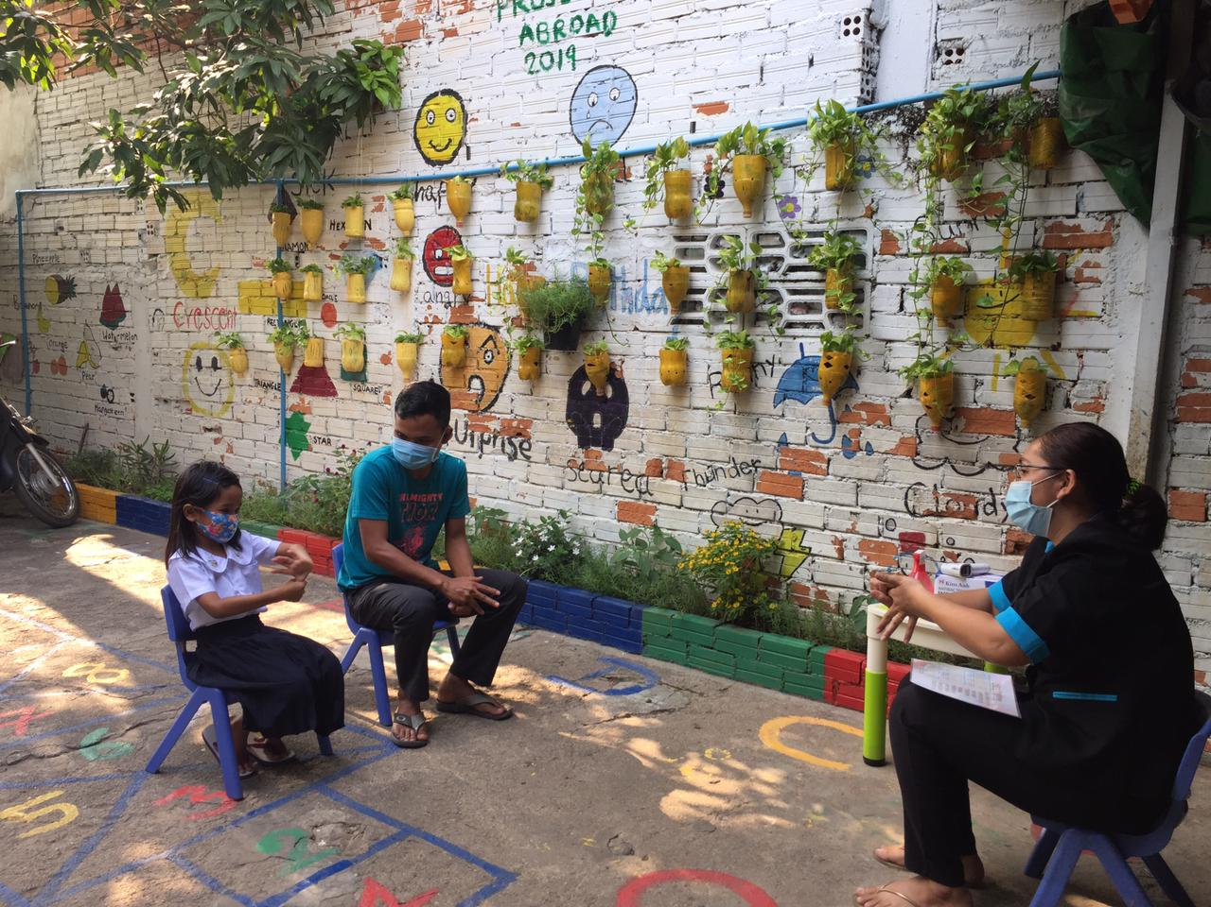

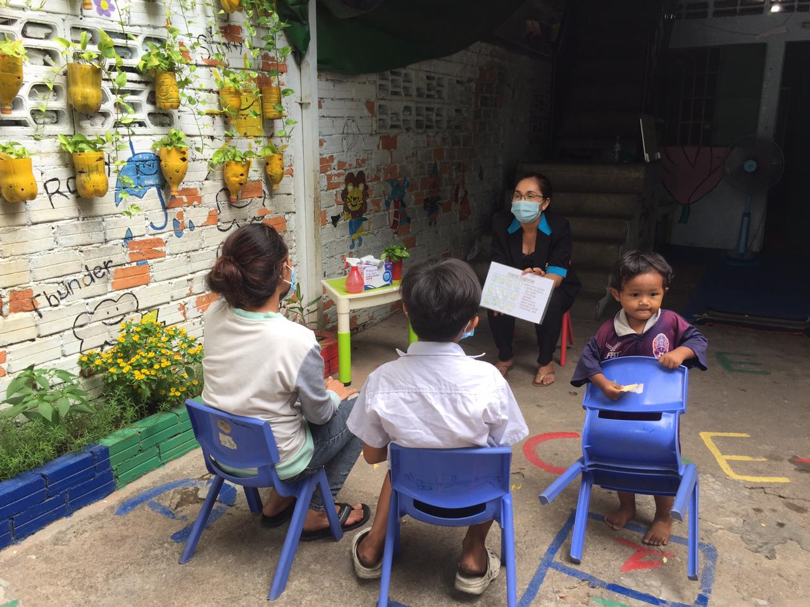
Poor family member received counseling during Covid-19 from SCC-CBE teacher
3- Encouraging parents to pay attention, help teach and educate their children during this difficult time.

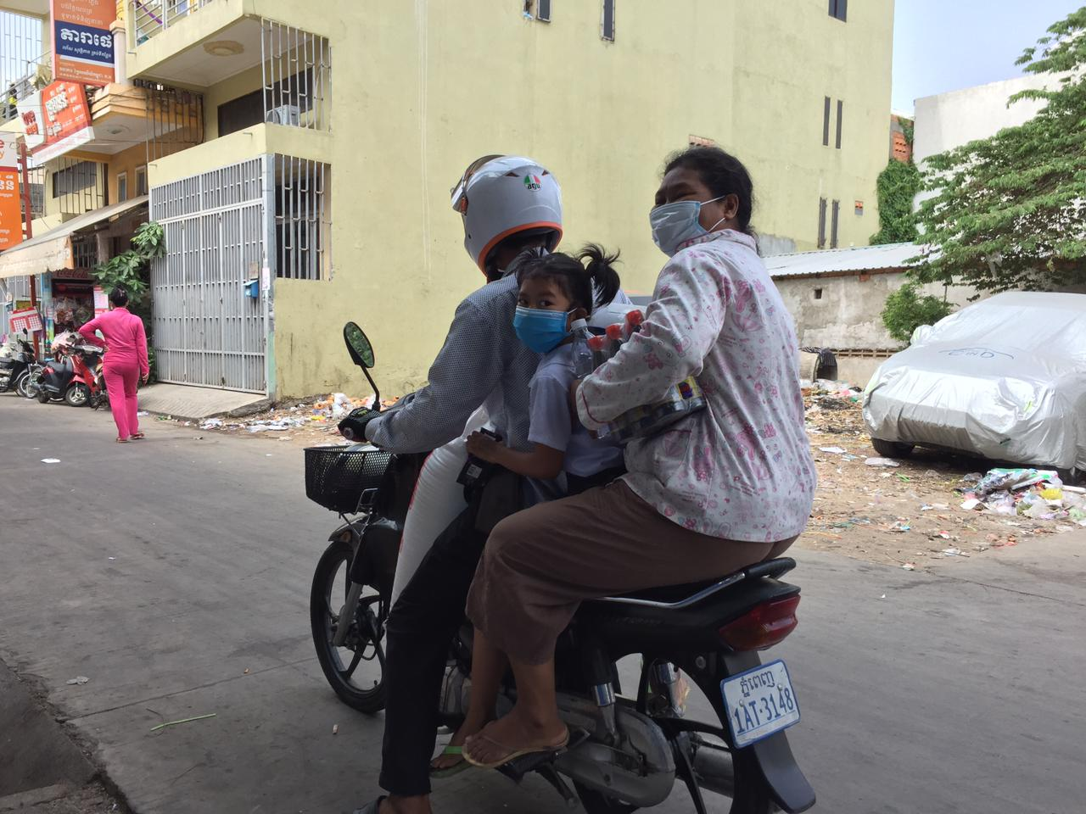
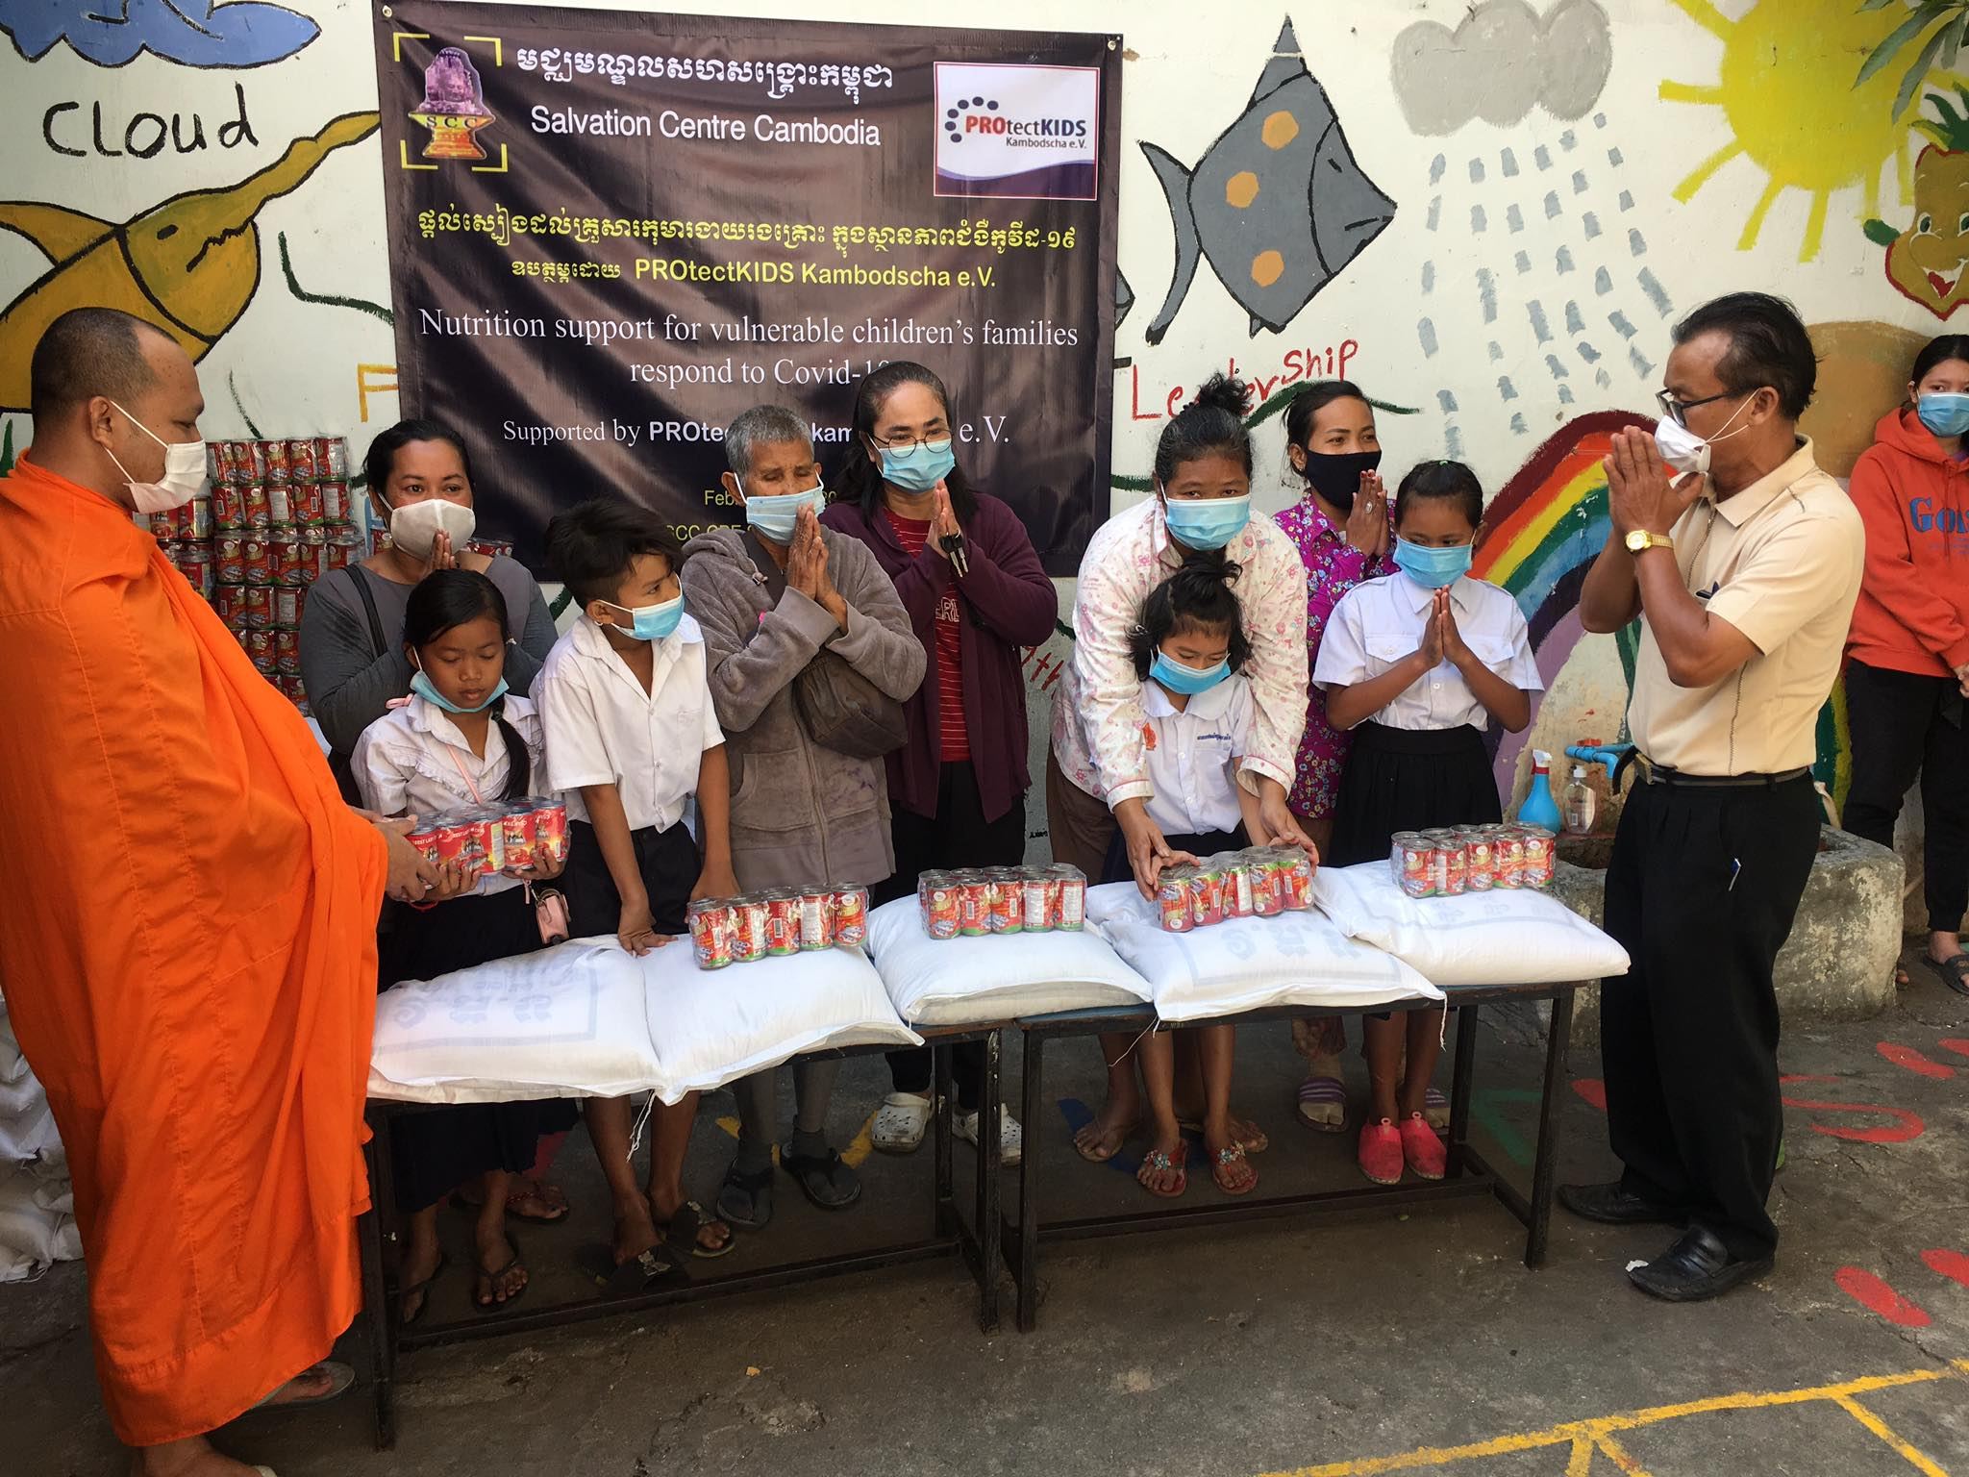
Please be confirmed that the three main tasks which were above-mentioned, SCC-CBE teachers have been doing on a regular basis because COVID-19 pandemic in the community still have new infection in Cambodia in this reporting period.
Poor family children's received welfares support during Covid-19 from SCC Project
Donated rice to vulnerable children since February and March 2021
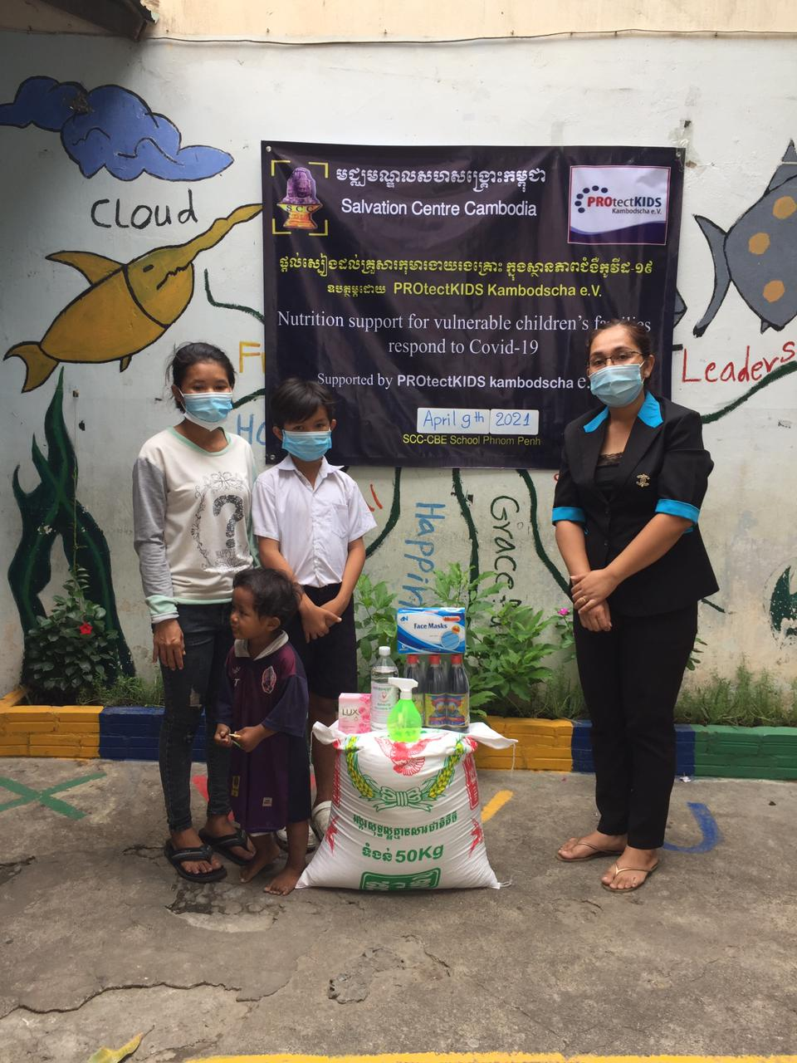
Reduced hunger by providing nutritional support during COVID-19 pandemic: SCC-CBE School provided nutritional support such as 15 kilograms of rice and 10 canned fish to the 56 poorest of the poor SCC-CBE children’s families in Boengkak Slum Area, Phnom Penh city.​ This charitable donation donated by the partner organization PROtectKIDS Kambodscha and generous people through Global Giving, always generously donates rice and other eatable food to reduce the burden of the poorest of the poor people who are in need of food during COVID-19 pandemic in the target areas of SCC-CBE School. Not only that, PROtectKIDS Kambodscha organization has been providing relief aid to assist the poorest people and SCC-CBE children’s families and families who are very difficult to earn income for their living during COVID-19 pandemic. This restriction has a strongly significant impact on earning income of them for living. Some families were very poor; they must force their young children to go on the street to begging or some families send their children to beg. Currently, there were no any tourists visiting Cambodia; they have to rely on the generosity and kindness of the local people to support each other. As the Khmer saying “the rich help the poor”. Their struggle to live during the hard situation, many poor and hungry people in Cambodia calling for help, because of our budget limited we are able to only help the SCC-CBE target group, as for others not impossible to help generally. Noticeably the efforts to do these activities always encounter some problems, some people were happy to cooperate with our organization, but some also conflicted because they did not get those benefits. However, we are confident that the good deeds we have done will be seen by others and help spread the truth that together we can do it.

