QIHE BROCHURE

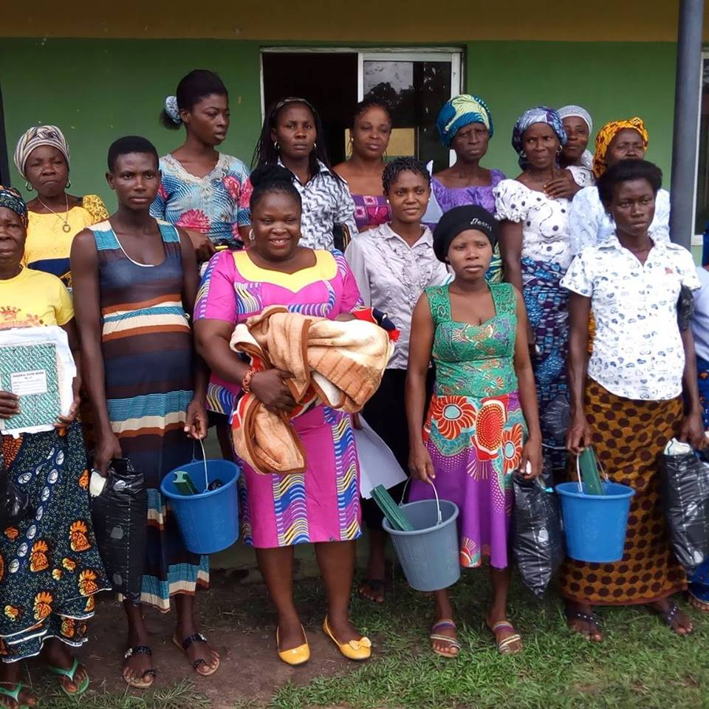

TABLE OF CONTENT
Welcome…………………………………………..

Background………………………………….
Who we are………………………………………..
Objectives………………………………………………
Core Values……………………………………………….
QIHE Program activities ……………………………………
Board………………………………………………………..
Advisory Committee………………………………….
Source of Funding………………………………………
How to partner with QIHE………………………………………………..
Volunteer and Exchange Program………………………………………

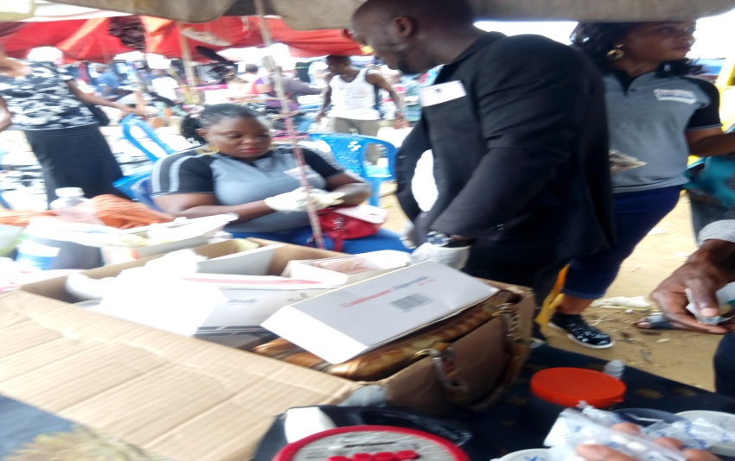
Background
QIHE is a volunteer driven organization that works to uphold the dignity of women and vulnerable groups in Nigeria. We are committed to improve livelihood among women, people living with HIV/AIDS, young people through innovative health, education, development, outreach and Referral Services. We mobilize communities and offer access to information, education, counseling and support through a variety of social, recreational, volunteer opportunities and exchange programs. As women we have a lot to offer to the marginalized group we represent.
QIHE is characterized by committed, dedicated and hardworking members and staff whose skills and level of involvement in the organization has proven results in saving lives and reducing the impact of developmental issues in the communities.

WHO WE ARE
Queenette Initiative for Health and Education (QIHE) is a Not-for-Profit, Non-Governmental Organization established in May-2009 with its head Office in Uyo – Akwa Ibom State, Nigeria. It is registered as a Nongovernmental Organization with Corporate Affairs Commission Reg. No. CAC/IT/NO 55004. QIHE was established to undertake social and economic interventions that reduce vulnerability to poverty, disease, hunger and other famines situations, and to contribute to creation of social systems that promote peace, human welfare and the sustainability of the environment on which life depends, including promotion and provision of palliative schemes [protection of fundamental human rights] in its geographical areas of mandate.

Commission
We are committed to working with women, children, people living with HIVAIDS and youth.
Aim
Our aim is to mobilize organizations, target population to respond to Health and developmental issues in the communities.
Goal
I. to reduce the transmission of new HIV infections while mitigating the impact of HIV/AIDS on citizens within a sustained, effective, multi-secotral infrastructure and soliciting the necessary commitment to support the national response to HIV/AIDs
II. to identify and canvas for the removal of barriers that stand against access to qualitative health services and education.
III. to improve the wellbeing of children through psychosocial, nutritional and educational support
IV. to alleviate extreme hunger and poverty for the excluded and disadvantaged women, youth and children through economic empowerment.
V. to encourage mentorship, education and empowerment of women in rural communities.
To address social and health issues in the communities through innovative strategies.
Mission

QIHE is committed to impact positively on women, youth and children’s life in the area of health and education and general development.
Our Vision
To protect the right of women and children including those infected and affected by HIV/AIDS and to create an enabling environment free of stigma and discrimination while providing access to prevention, knowledge and skills; treatment, care and support; and other services.

Our mission
QIHE is committed to impact positively on women, youth and children’s life in the area of health and education.

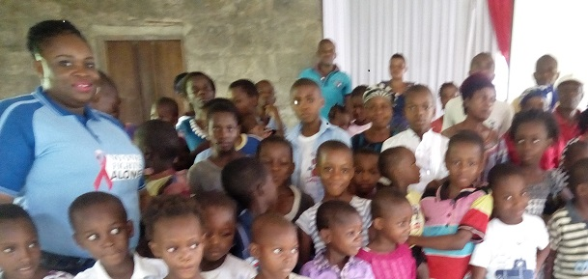
Objectives
- To design, implement and projects in the areas of health, education, economic and human development through wide range of activities.
- To foster and encourage self reliance and self sustaining skills through community development project, Income Generating Activities (IGA) and Micro-credit scheme..

- To improve skills of young people through leadership and life skill training and mentoring activities in order to make informed decision and choices about their general well being.

- To design gender sensitive educational and health related programs for target population.

- To reduce infant and maternal mortality/morbidity through wide range of activities that promote good health.

- To actively promote the rights of women, youth and children in accordance with provisions made in the Nigerian constitutions and international charters

- To create a forum and coordinate networking between organizations interested in providing some forms of assistance in the provision of capacity building and trainings to women, youth , children and other vulnerable groups..

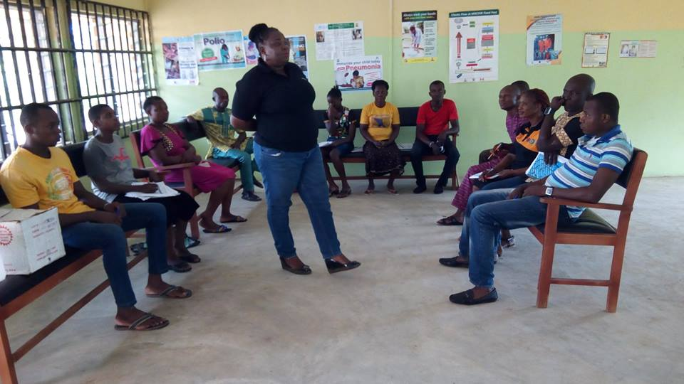
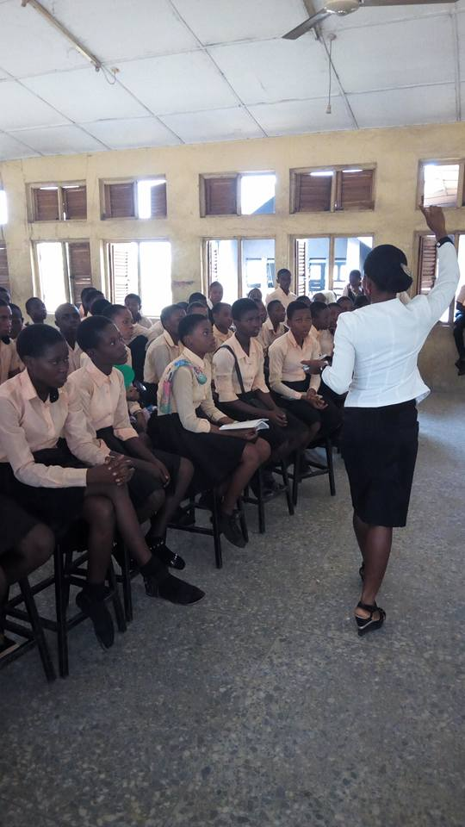
Peer Education Training for in-school youth
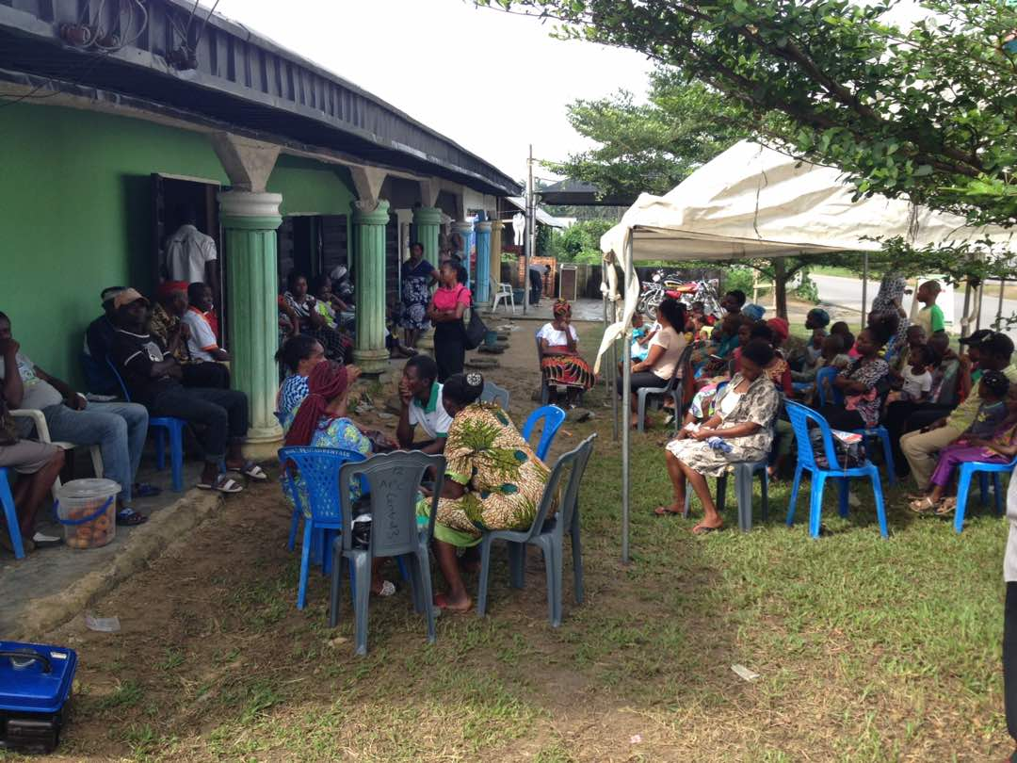
Mobilizing communities to respond to HIV and health related issues
@ Ikot USEKONG
QIHE PROGRAM ACTIVITIES
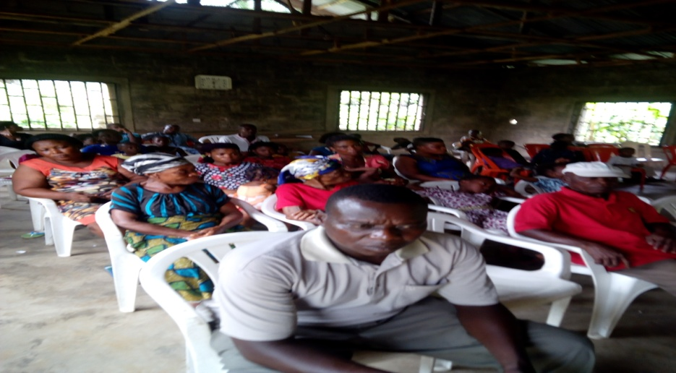

HIV/AIDS AWARENESS CAMPAIGN
“Listen attentively” is a public education program that increases level of knowledge and involvement of community members in HIV/AIDS and reproductive health issues and community development. The program creates an avenue to engage community leaders and gatekeepers in advocacy/intervention efforts and provide platforms for interaction among members of the communities on key health/developmental issues affecting them. QIHE use this medium to disseminate and forge partnerships on information networking and identify community changers to be trained as care providers and Behavioral Change communication focal persons in communities. The following components form the basis of this project: -
- Home Base Care services
- Outreach activities
- Legal AID services
- Sexual Reproductive Health and Rights issues
- Computer Training
- Referral services

SAVE THE WOMEN CAMPAIGN
QIHE works to ensure all women have access to the lifesaving care especially among the poorest and most vulnerable people in the community. It is on this premise that QIHE works to promote mother and child survival at the community level. We provide services to ensure that all women have access to family planning, skilled care at birth, emergency obstetric care and postpartum care and prevention of mother to child transmission (PMTCT) and voluntary counseling and testing(VCT) This campaign seeks to advocate for government and communal investment in health workers and health system functioning and strengthening. The following services are being provided:-
- Community dialogue meetings and outreach
- Advocacy
- Press conferences/releases
- Referral services

SAVE THE CHILDREN CAMPAIGN
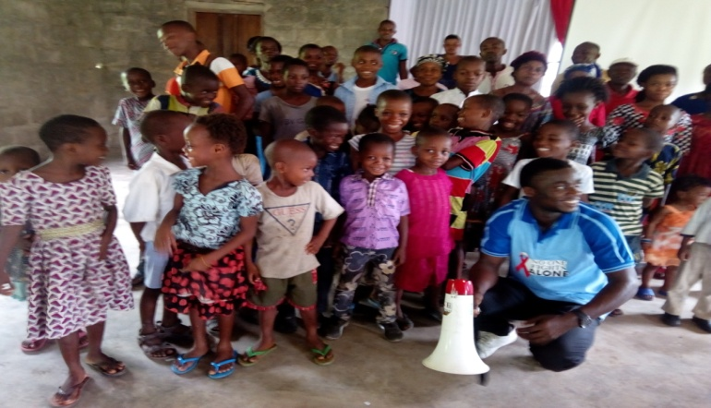
QIHE uses the campaign to advocate for comprehensive care and support for orphans and vulnerable children. QIHE uses blue ribbon as symbols for care and support for OVCs. The components of this project include the following activities:-
- Back to school Program
- Skill acquisition (tailoring, furniture making, carpentry, income generating activities etc) for OVCs and their Care givers/Guardians.
- Provision of books, school uniforms, school fees etc.
- Provision of shelter, food, clothing’s for OVCs and their Care givers
Gender sensitive education and practical support for behavior change, promotion of abstinence, be faithful and condom use through the media (television, radio etc) and other means of information dissemination. Young people need access to accurate information, youth friendly services to make informed decision about their lives. Its objective is to increase young people’s knowledge on sexual reproductive health issues and encourage them to adopt behaviors that reduce the risk of unwanted pregnancy and unsafe abortion. QIHE encourages young people to seek information and services and increase parents and child communication. It also provides linkages and referral system where more information and services are available. Activities embodied in this campaign are as follows;
- Leadership Training
- Interpersonal Communication
- Dialogue meetings
- Peer Education
- Peer Education Plus
- Drama, Songs and choreography Plays to convey Health and HIV/AIDS messages
- Dissemination of IEC materials and promotion of condom use
- Referral to Clinics and Hospitals for treatment
- Community development support in the form of construction work like schoolrooms, (equipments etc), clinic, borehole, toilets and communal income generating activities.
Since the first case of AIDS in 1996, Nigeria has approximately 918,000 orphans and vulnerable children. The steady rise of HIV infection has led to rapid increase in the number of orphans due to the higher number of people living with HIV/AIDS (PLWHA) who begin developing AIDS related symptoms. The OVC situation needs recognition and should be campaigned for to address their needs. Save our children campaign is a program that improves the health, nutrition, psychological care and development of orphans and vulnerable children including their Guardians/Grandparents in Nigeria.
Creating emerging leaders in disadvantaged communities in
BOARD OF TRUSTEES MEMBERS
- BARR. IMO AKPAN
- MMAOBONG AKPAN

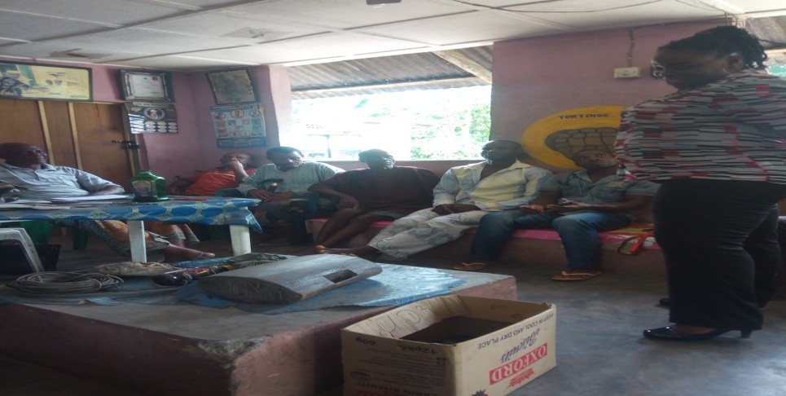
ADVOCACY VIST @Ini Lga
STAFF
- Mmaobong Akpan- Program Director
- Peace Bassey_ Finance Manager
- Uboho Anthony-Program Manager
- Mfon Umoren -M&E Officer
- Rita George-Office Assistant
SOURCE OF FUNDING SUPPORT
- FAZE AUTO
- Management for Health Science (MSH)
- Association of OVC NGO in Nigeria (AONN)
- USAID
- United Nation Development Program (UNDP)/Akwa Ibom State Ministry of Economic Development
- Ministry of Women Affairs and Social Development
- Akwa Ibom State Action Committee on HIV and AIDS (AK-SACA)

HOW TO PARTNER WITH QIHE
You can partner with us through your in-kind contribution to the following activities in the communities:-
- Community Dialogue meetings
- Peer Education Program
- Leadership Program
- Prevention of mother to child transmission outreach
- Malaria Education Program

For details log on to our website www.queenetteinitiative.org email us @ quennetteinitiative@gmail.com or call Mmaobong Akpan 08032583628
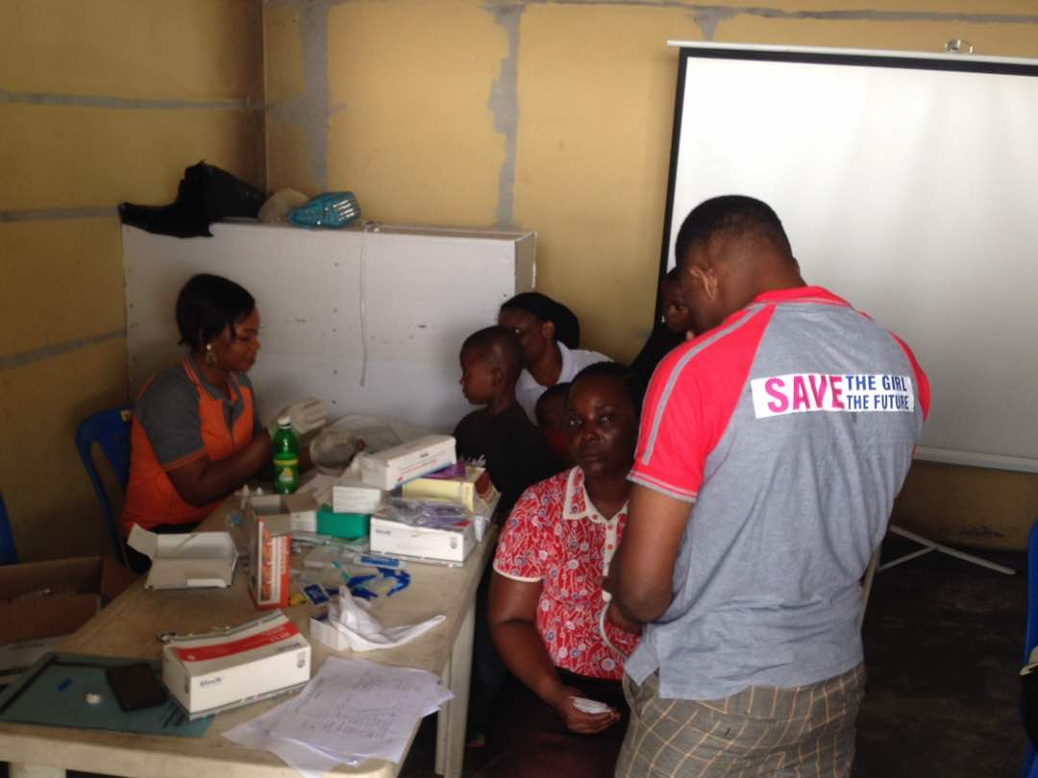
HIV TESTING AND COUNSELLING @ THE COMMUNITY
Volunteer and Exchange Programs
Our volunteer services cut across:-
- Event Planning
- Community Development
- Outreach Activities
- Fund Raising
- Teaching in schools/communities
- Peer Health Education
- Counseling and Home Base Care etc
- Medical services to communities
Volunteer service is one of the avenues QIHE use to carry out activities in the communities as a Not for Profit Organization. Our volunteer services create opportunity for you to feel the Nigerian culture and work with local and indigenous people in the communities.
Donations
QIHE depend on individual and corporate bodies support and financial donations to carry out all these activities in Nigeria. Your donation is an indispensible resource to support our work in hard to reach communities. You can be involved in QIHE projects through your involvement or donation to support the following activities:
- Outreach Newsletter
- Save Our Children Campaign
- Save our Mothers campaign
- Ask a Question

Donation should be payable to:
Account Name: QUEENETTE INITIATIVE FOR HEALTH AND EDUCATION
Account Number: 0031433717
Bank: Sterling Bank Plc, Uyo

