BUGEMA COMMUNITY CHILD BASED ORGANIZATION (BCCBO) UGANDA.

Bugema Community Child Based Organization (BCCBO) was incepted by Social Workers, Nature Conservation Workers, Health Workers, Community Development Workers, Councilors and Academicians, after noticing identifying, realizing and analyzing, that there is / was a great need to help both vulnerable and marginalized populations such as children, women, youths, elderly and refugees to access better healthcare services, quality education, legal assistance, food security, safe drinking water, housing entrepreneurial skills, science & technology and healthy environment.

THE VISION OF BCCBO
To be a modal Community Based Organization in the whole country.
THE MISSION OF BCCBO
To make the society a better place to live in.

BCCBO PROGRAMS
- Human Rights Advocacy.
- Education.
- Entrepreneurship and Skills Development.
- Health.
- Environment and Nature Conservation.
- Community Empowerment and Development.
- Agriculture and Food Security.
- Water Supply.
- Science and Technology.
- Refugee Settlement.
- Disaster Management.
- Housing.

BCCBO BOARD OF TRUSTEES
- Prof. Patrick Manu, Vice Chancellor, Bugema University.
- Mr. Busuulwa Joshua, Head of Department, Development Studies, Bugema University.
- Dr. Golola Moses, Deputy Director, National Council for Higher Education.
- Namirembe, Catherine, Director, Nakisunga Institute of Engineering and Applied Sciences.
- Nalunga Judith, Director, Charity Africa.
- Nalubega Jessica, Director, Bugema International Centre for Research and Community Outreach.

BCCBO ADMINISTRATION
- Renee Anthone Kay Director.
- Namusisi Mariam Assistant Director.
- Mutyaba Paul Programs Manager.
- Sanyu Winnifred Finance Manager.
- Mwesige Samuel Project Coordinator.
- Namuleme Lydia Kisakye General Secretary.
- Katamba Enock Public Relations Officer.
- Kyabwe Betty Mobilizer.
- Nakirya Mariam Chief Counselor.
- Nabaggala Molly Operations Manager.
- Mubiru Fred Human Resource Manager.
- Musiitwa George Estates Manager.
- Nsinjo Teddy Transport Officer.
- Alice Zuba Corporate Social Responsibility Manager
COMMUNITIES WE SERVE IN RURAL UGANDA.
- Nakisunga community.
- Kirondo community.
- Kiwangula community.
- Busoke community.
- Kamira community.
- Bugema community.
- Kamuli community.
- Senero community.
- Vvumba community.
- Zirobwe community.
- Kawuna community.
- Maziba community.
- Mpatta community.
- Kasala community.
- Butonda community.
- Kitanda community.
- Kalanamu community.
- Lunyolya community.
- Kkoko community.
- Lubanyi community.
- Bunsule community.
- Lukyamu community.
- Katente community.
- Kiyoola community.
- Makata community.
- Nakkoosi community.
- Lubuguma community.
- Mangaliba community.
- Namayiba community.
- Bukasa community.
OUR PARTNERS
- GlobalGiving.
- Community Health Workers.
- Village Health Teams.
- Traditional Birth Attendants.
- Community Volunteers.
- Health Centres.
- Schools.
- Local Authorities.
- Bugema International Centre for Research and Community Outreach.
- Nakisunga Institute of Engineering and Applied Sciences.

CURRENT PROJECT
Project Tittle: Providing Clean and Safe Drinking Water to 700 Refugees.
Project Implementing Organization: Bugema Community Child Based Organization.
Project Location: Bunsule, Kamira Parish, Kalagala Sub-County, Bamunanika County, Luwero District, Uganda.
Amount needed: $27,500
Project Fundraising Campaign: Bugema Community Child Based Organization through GlobalGiving is conducting online fundraising to raise $ 27,500 to provide clean and safe drinking water to 270 refugees from South Sudan and Democratic Republic of Congo due to civil unrest. The project will also equip them with education and training in agriculture, poultry, wax processing, bee keeping, juice making, business skills and value- added production allowing them to raise out of poverty.

Project Summary:
Bugema Community Based Child Based Organization plans to construct four boreholes to provide clean and safe drinking water to refugees who hail from the current civil unrest in South Sudan and Democratic Republic of Congo flooding across the borders into Uganda. This project is working towards saving refugees from suffering from typhoid, malaria, Diarrhoea, cholera and filariasis as a result of drinking and bathing dirty water.
Challenge the project is addressing
The current civil unrest in Sudan and Democratic Republic of Congo has sent even more people flooding across the borders in to Uganda. Some of these people are children who have lost their families to war and disease. Instead of housing them in a refugee camp, Bugema Community Child Based Organization will provide them with a family, a home, clean and safe drinking water, an education, medical care, nutrition, legal assistance, an entrepreneurship and an opportunity to become part of a larger solution for their community.
Solution
Providing refugees with a family, a home, clean and safe drinking water, an education, medical care, legal assistance and training in agriculture, poultry, dairy business, bee keeping, harvesting, honey processing, wax processing, packaging, marketing, business skills and value- added production will promote self-reliance and make it possible for the refugees to become part of a larger solution to the community.
Long –Term Impact
The project will provide clean and safe drinking water to 700 refugees which will aid their health and well-being. The project will also train the refugees in agriculture, poultry, dairy business, bee keeping, wax processing, business skills and value-added production allowing them to rise out of poverty and meet their own basic necessities of life.

A CALL FOR ACTION
Bugema Community Child Based Organization (BCCBO) through GlobalGiving is calling for support from everybody around the globe towards this project for a noble cause.

DONATION BREAKDOWN AND OPTIONS
$10 will provide 3 nutritious meals to 240 refugees.
$ 25 will train 240 refuges in agriculture and bee keeping.
$ 50 will buy a cow for a refugee to begin a dairy business.
$ 100 will train 240 refugees in value- added production.
$ 200 will provide clean and safe drinking water.

PICTURES OF REFUGEES THE PROJECT WILL BENEFIT
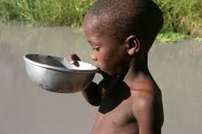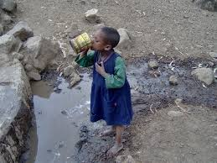
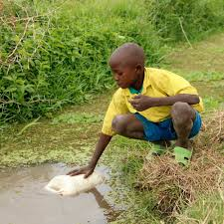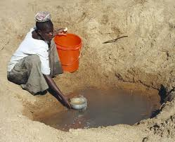
This project focuses on providing clean and safe drinking water to 270 refugee from South Sudan and Democractic Republic of Congo due to civil unrest, sending more people flooding across borders into Uganda.
Thank you very much for choosing this project for your donations.

