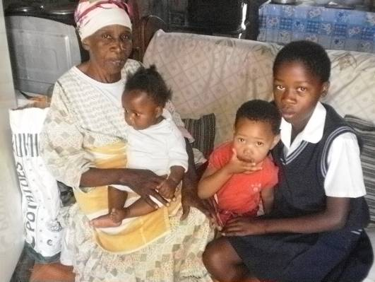

These photos show
Gogo Wendy with
some of the 8
children that she looks after at her home. You can see some of the diligent and caring Topsy staff who do their best to help her to manage the challenges she faces.

