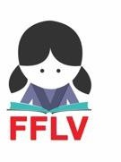 | Thread of Life 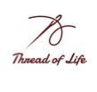  An FFLV Project
Thread Of Life  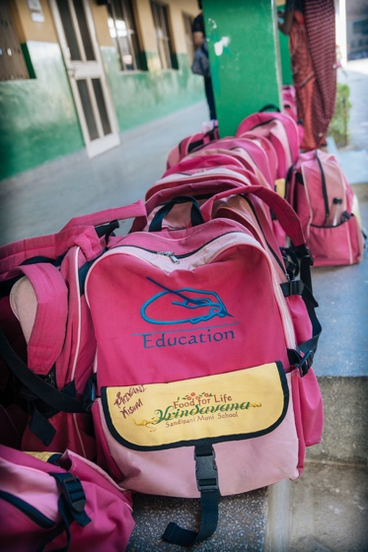  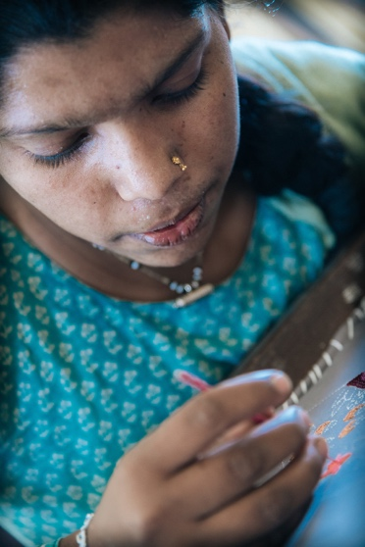 | Region: Vrindavan  Sector: Education  Country: India  Executing Agency: Food for Life Vrindavan  Estimated budget $10,000  About us  FFLV has been working in the field of girl education for the past 25 years. We educate poor girls in Vrindavan, empowering them to transform their lives and communities; through a service oriented approach, committed to integrity and excellence. Our primary goal is to help our girls grow into self-sufficient adults who can give back to the society.  Thread of Life  Thread of Life is a project undertaken by FFLV. The idea is to initially invest to train rural women and girls in sewing and embroidery to eventually set-up a self-sustainable business for them under FFLV supervision.  Project Activities  We plan to provide professional training in sewing and embroidery to 15 interested girls and women from rural Vrindavan for the next 6 months starting from October, 2018. Once the training is complete, they will make the products with the initial help of a designer combining their sewing and embroidery skills. These products will then be marketed and made available for sale. We hope to see the project becoming self-sustainable within the next 2 years post training. FFLV already has a basic infrastructure for the project and within those facilities Thread of Life will be started.

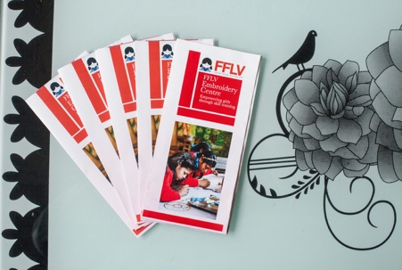
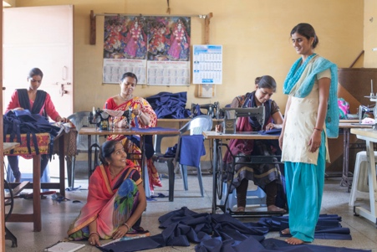
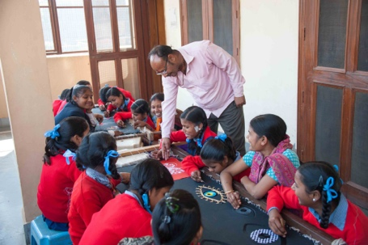
Why train these women?
The ladies that we will be training are mostly from Vrindavan and other neighboring villages. They come mostly from rural background and 90% of them are below poverty line. They have limited source of income where most of the times, only one member of the family is making a very basic income which is not enough to maintain the household.
Training these ladies becomes crucial in order to bring them at par with the wider competition around them. So that they are able to sell the product in the market. These ladies have basic knowledge of embroidery and many would start from scratch. This guidance will take their skills to the next level. It will boost their confidence and ensure their financial independence in the near future. These ladies will be empowered which means growth for them, their children, their families and their communities as a whole.

What will they make?
The products that these women will make through this training will include- Yoga bag straps, Handbags, Yoga bags, Mobile bags, embroidered soft toys and bead bags. Apart from this, they will also be involved in making embroidery clothing such as Kurtas, dhotis and tops. After much study, we realized that there is a huge market around the world for such products especially there are yoga studios around the world that are of great potential market. We are already in touch with many studios around the world who have expressed interest in this project.

Social Impact
Vocational training enables adolescent girls to earn an income and build crucial life skills. In rural areas, girls, more than women or boys, lack access to financial capital and have limited opportunities to gain education, knowledge, and skills that can lead to economic advancement. Inadequate policy frameworks and inequitable gender norms also often create barriers to girls' economic advancement.
Given these challenges, vocational training can play a key role in helping girls get jobs. Vocational training typically includes development of technical capacity, entrepreneurship, and business skills. It also helps girls build a wide set of soft skills, such as conflict resolution, team building, and communication, which they can use in a variety of jobs.
Girls' economic empowerment not only depends on availability of jobs, but also on protective policy environments and community-based support for their entry into the workplace.
The impact of Thread for Life will be short, medium and long term.
Short term: - Through this project, 15 ladies will be immediately employed and improve their skills to professional level.
Medium term: - Once these women will get employment, they will become financially independent, support their families, potentially educate their own children better and become a pioneer in breaking the cycle of inherent poverty.
Long term: - In the long term, women will emerge as leaders, take charge of their families with great confidence and empower other women in their communities. It will also ensure that the best qualified people can get the jobs, rather than the best- qualified men, as this profession in Vrindavan is male-dominated. Therefore, this training and project, will benefit their children, their families and their communities as a whole.

Setting up such a structure, will encourage and empower these women, which is one of our primary goals. Empowering them will build a better society.
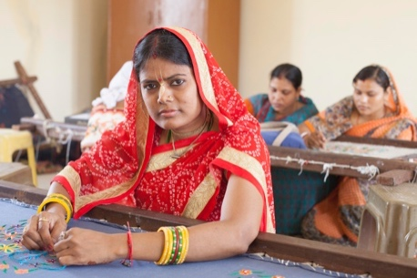
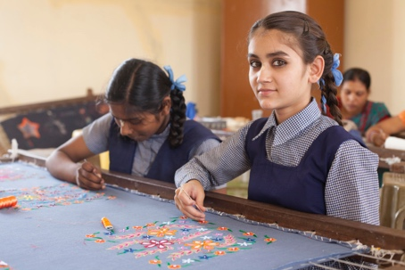
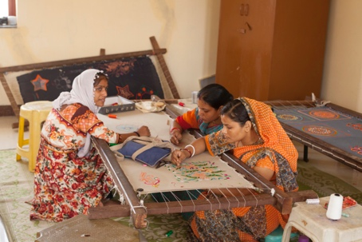

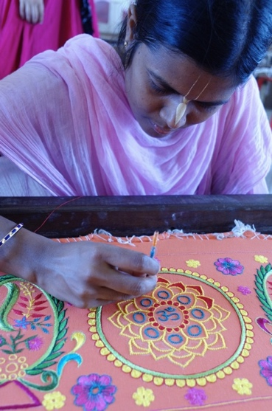
Why support this project?
Your support will provide an opportunity to the women who are currently struggling to maintain their families in a dignified manner. The best part is that you will be doing this by placing them in control of their lives. Once they will be trained, they will lead a life with dignity, self-confidence and hope.

You will receive regular updates and half-yearly reports about the progress of this project.

Budget:

Below is the cost table for 6 months of initial training, set up cost & estimated two years of running cost for Thread of Life Project until it gets established and becomes a self-sustained project.

Amount (USD) | Allocated towards | Duration | When
500 | 1 Trainer | 6 months | Training
1000 | Raw Material for the  training | 6 months | Training
1500 | Supervisor | 2 years | Post-Training
2000 | Online Marketing | 2 years | Post-training
3000 | Sourcing the Raw  Material | 2 years | Post-Training
2000 | Designer | 2 years | Post-Training
10000 | TOTAL

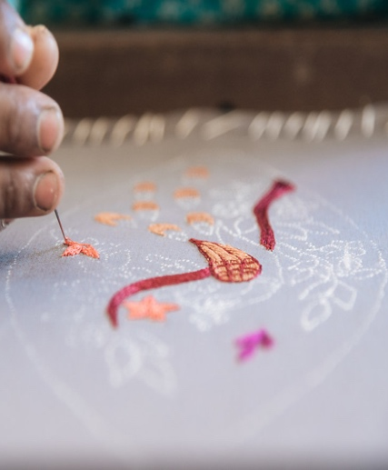

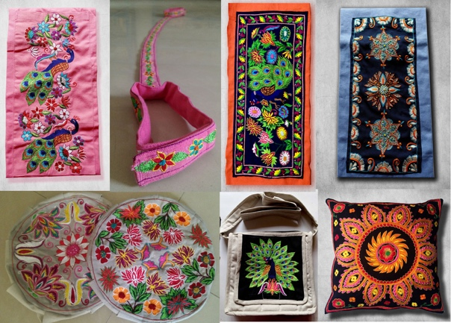
We intend to start this project by hiring two trainers for 6 months, who will be training the girls and women interested in learning embroidery and sewing.
Post-training, they will make products with the initial help of a designer using their newly found skills. The products that they will make will be marketed online and made available for sale. During this process, a supervisor will be hired to supervise their work and certain amount will also be allocated towards
sourcing the raw materials for their work.
We aim to follow this process for the initial two years, until Thread Of Life project gets established and becomes a self- sustained project.
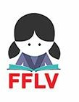
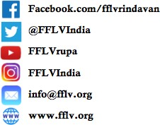
We believe that Thread of Life is a worthy cause that will do a great deal of good for these girls and women coming from underprivileged families. We’re excited to make this project a reality, leading to substantial benefits in the short, medium, and long term.

Address: - Food for Life Vrindavan, Sandipani Muni School, Chaitanya Vihar, Burja Road

