Thanks for your support during 2023!
It has been a year of ups and downs for both the Academy and the students, as both have had adversity and joy. With your support this school year, which in Panama runs from March to December, 14 young people and adult’s graduate. Of our graduates, we have 8 who will enter a first job program, which will allow them to gain work experience, start a professional life and have funds to pay for college.
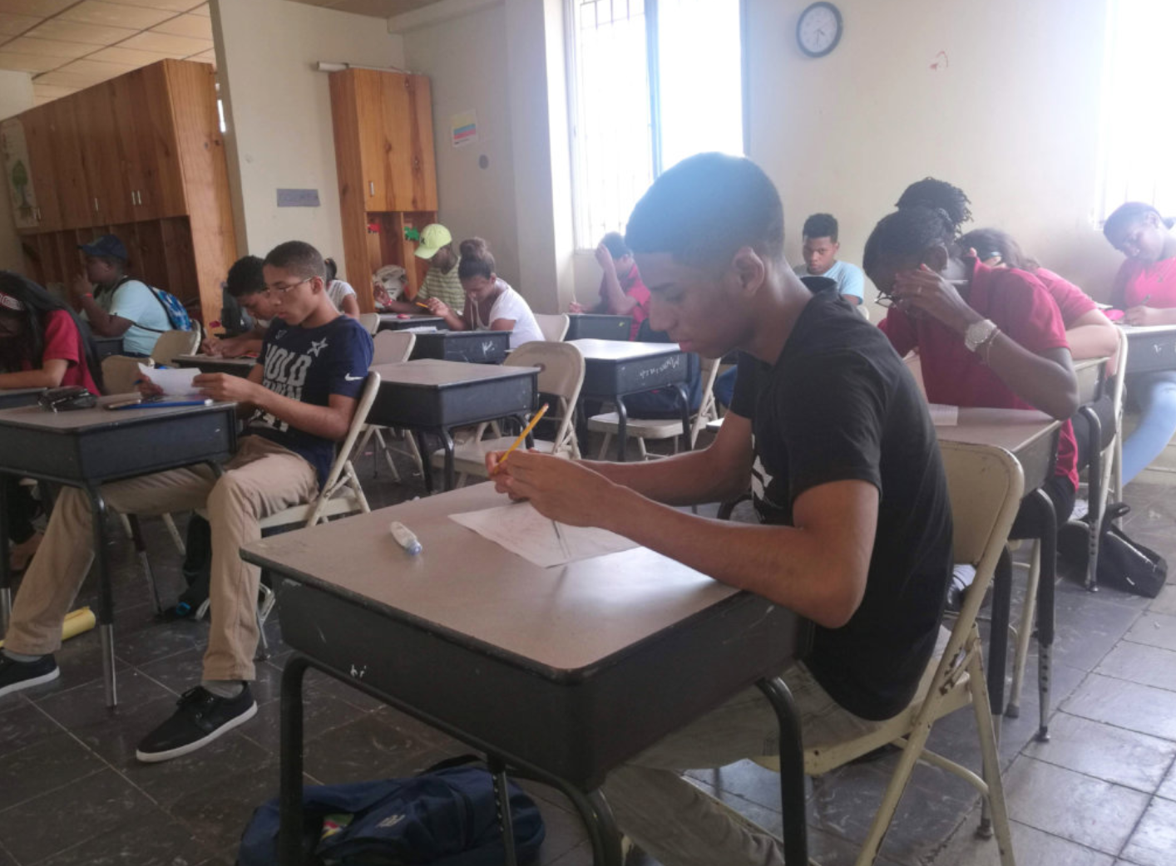
This year the Juntos Podemos Academy partnered with Panamá Lidera, the foundation of motivator and business management guru, John Maxwell, in Panama. The students attended a conference at the convention center in Amador where there were more than 2,500 attendees. As one of the students shared, she had never participated in something like going to listen to a person who talks to you about how to be a better person, so you will have a better life. As a result of this alliance, the Transformation Tables were implemented in the school, a weekly meeting of 25-30 minutes in which transversal values ​​are shared that contemplate the dimensions or basic values ​​for life and coexistence. These meetings have served students to look inside themselves and produce behaviors that lead them to have better results and serve as engines of change in the Curundu community.
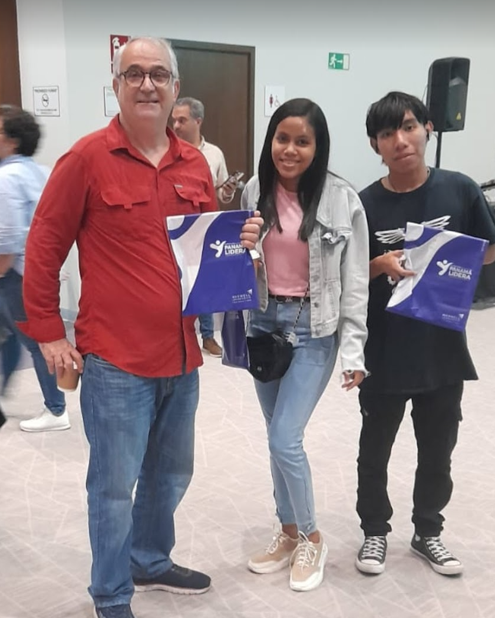
Those are part of the ups that we had this year, in the downs we have a decrease in enrollment because of the pandemic and the income inequality we have in Panama, to counteract income inequality in Juntos Podemos we use education as a leveling tool that allows people to move upward society, thus achieving a better quality of life.
Financially it has been a difficult year, students without money and fewer scholarships for them, the majority of our students do not have the resources to be able to attend school even if they want to finish it and there is more young people that do not enroll in Juntos Podemos because of income issues, this is where you play a decisive role in their lives, because without you they have no way of getting an education and getting out of their circle of poverty.
Some of 2023 Graduates !
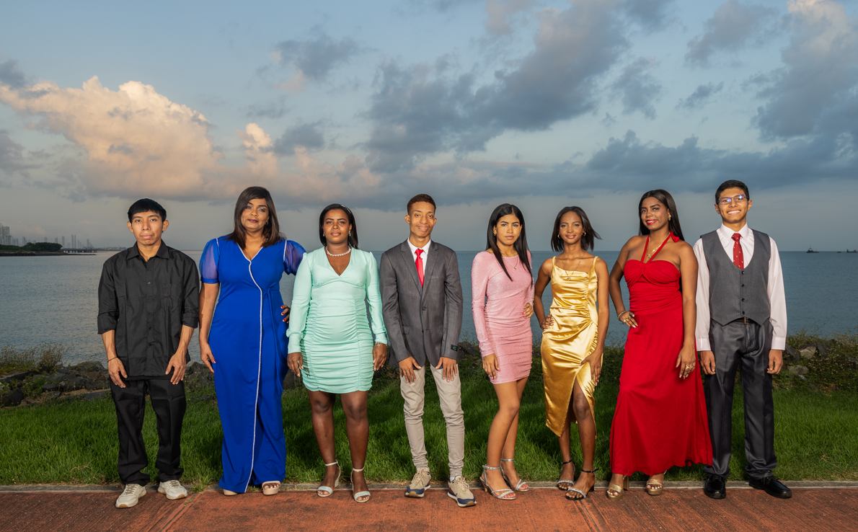
We are grateful for the support you generously provide to these young people, and we encourage you to continue doing so and share with others how financially supporting a student produces a better world.

