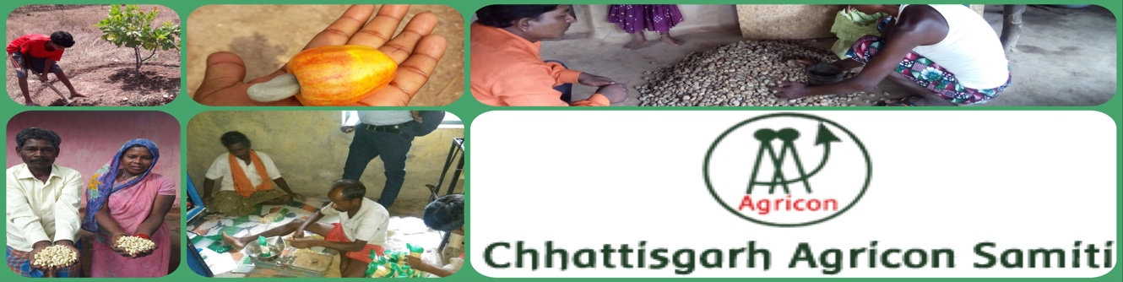Establishing Cashew Processing Unit

Respected Donors
Greetings from Chhattisgarh Agricon Samiti
We have got your valuable support through Global Giving. Your kind support was instrumental in starting up the project.
During this quarter farmers have harvested the cashew nuts and sold it to market collectively. Producer organization where procured 100 kg of raw cashew and stocked it for further processing.
Now farmers are nurturing their cashew plants to ready for next crop. They are doing pruning and applying fertigation for better plant growth and more crop.
Due to early rainy session in Bastar region, the cashew processing activity now off. After the month of October processing will resume.

Some Photos
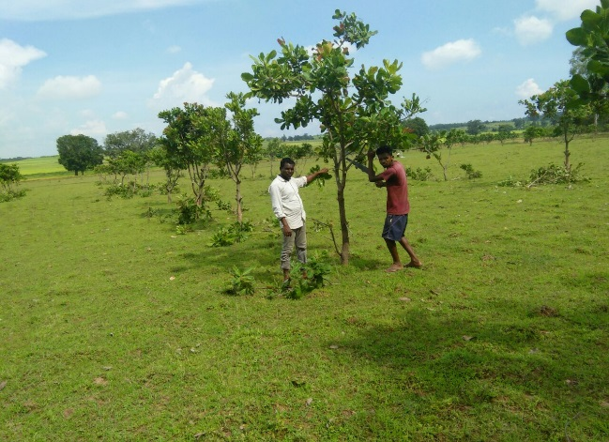
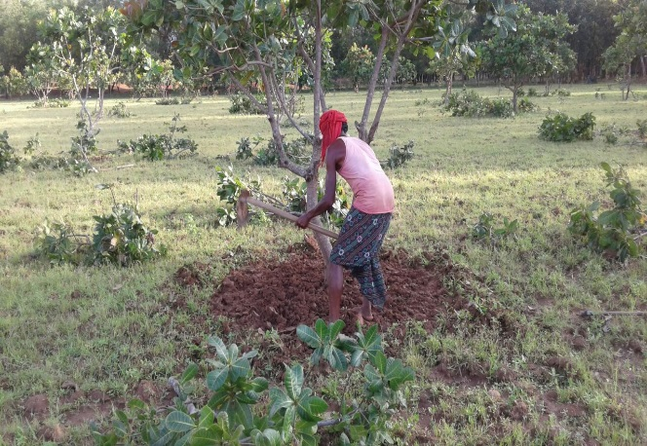

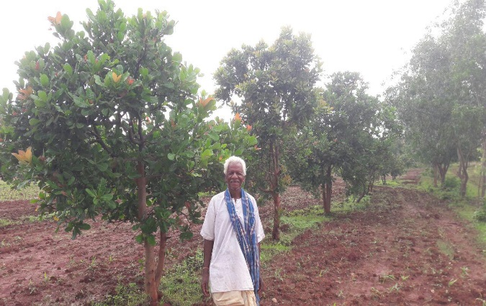
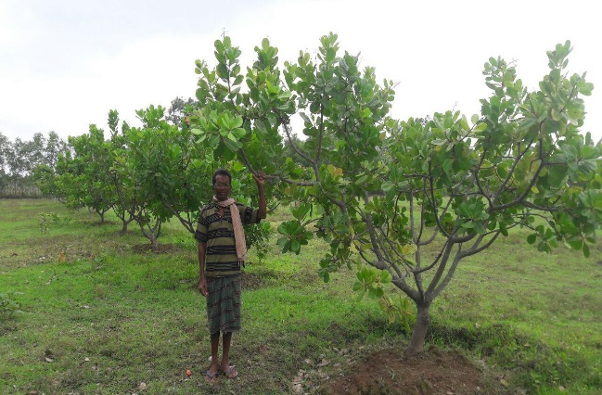

Although the project is running with support of donations, we got but we have a target of 24000$ for running the project for the whole year. We need 17200$ more for successful implementation of the project.
We expect that you will spread the word within your social reach about our work and initiative to help us garner greater support for our farmers

