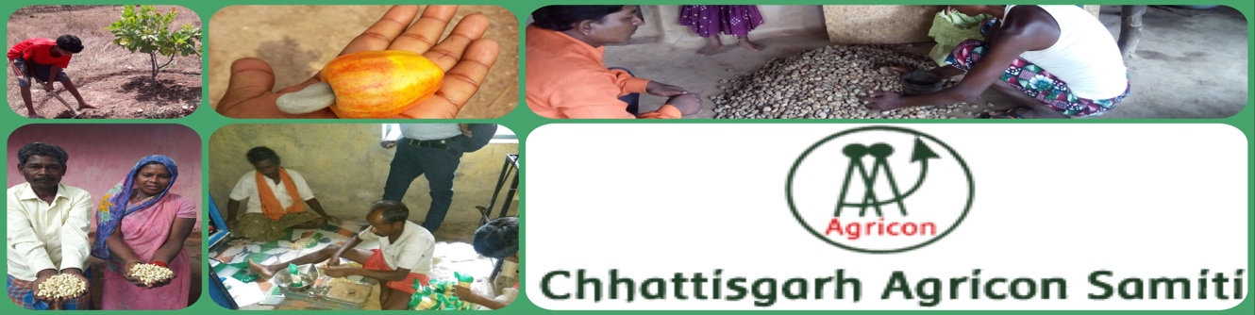Establishing Cashew Processing Unit

Respected Donors
Greetings from Chhattisgarh Agricon Samiti
We have got your valuable support through Global Giving. Your kind support was instrumental in starting up the project.
In this quarter farmers have processed 300 kg cashew nuts. They have sold 50 kg of cashew in packet of 200g, 500g and 1 kg. Now farmers are exploring new markets for there product. Apart from this they are exploring their knowledge and capacity towards processing and marketing technics.
Now cashew is in fruiting stage and yet to harvest. Farmers will harvest the cashew nuts by the month of April. then will start processing again.
During previous quarter, we have set up the unit and Training of the Farmers for processing and Packaging. We have done pilot processing and slowly learning to be compatible as per market standard. One of our farmers has expressed himself as follows:
“Thanks to all donors to give us supports to establish our own Cashew Processing Unit. Now we have started to sell the finished produce from our farms. This is first time that we are not selling the raw cashew. We are selling the cashew nuts with great margins of profit. Now we can earn more and save for our family. It Has only happened because of your donations.”
Bali Ram Majhi
Farmers established Cashew Processing Unit with Dryer, Boiler and Cutting machine at their village in Bastar District. They have processed 500 Kg of raw cashew and got 93 Kg of cashew nuts.
Chhattisgarh Agricon Samiti has organize a training session for processing, packaging and quality control. We had hired a technical person to train the farmers on processing and other technical issues in current practices. Farmers will solve all technical issues soon and hope that the quality of production will increase more.
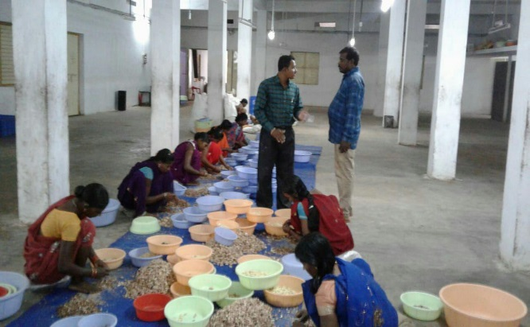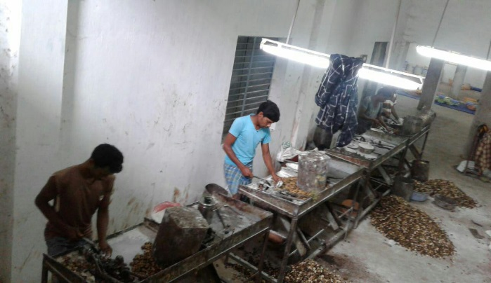
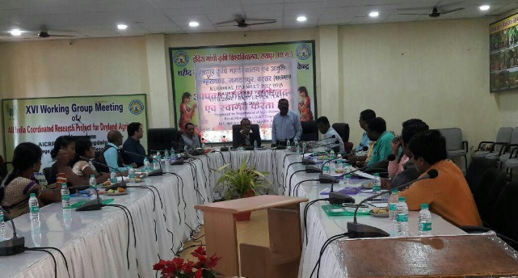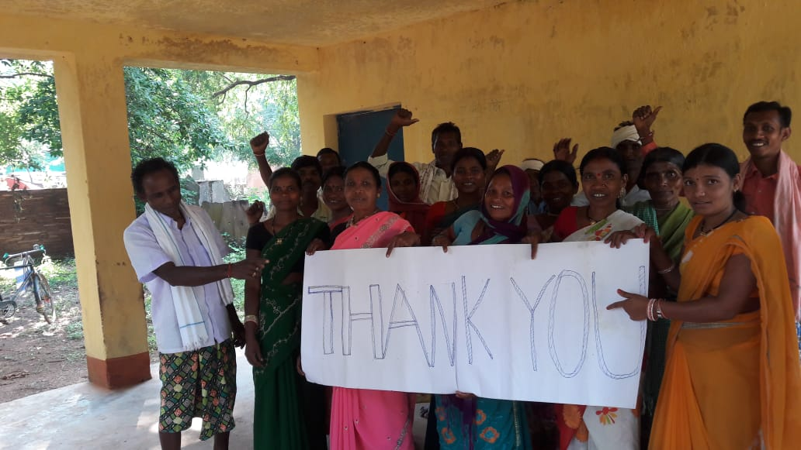
Although the project is running with support of donations, we got but we have a target of 24000$ for running the project for the whole year. We need 17200$ more for successful implementation of the project.
We expect that you will spread the word within your social reach about our work and initiative to help us garner greater support for our farmers
