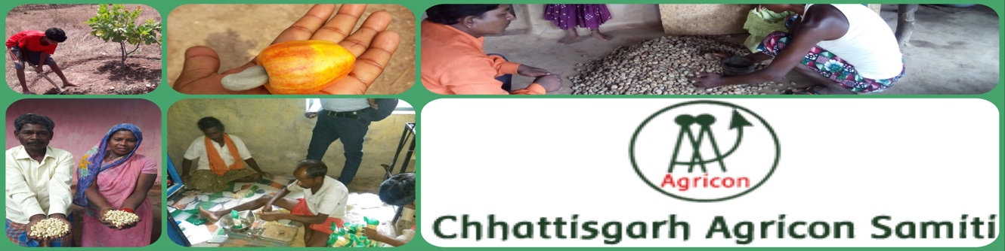Establishing Cashew Processing Unit

Respected Donors

Greetings from Chhattisgarh Agricon Samiti

We have got your valuable support through Global Giving. Your kind support was instrumental in starting up the project. We have got 5800$ through donations which is being utilized to set up the unit and Training of the Farmers for processing and Packaging. We have done pilot processing and slowly learning to be compatible as per market standard. One of our farmer has expressed himself as follows:

**“Thanks to all donors to give us supports to establish our own Cashew Processing Unit. Now we have started to sell the finished produce from our farms. This is first time that we are not selling the raw cashew. We are selling the cashew nuts with great margins of profit. Now we can earn more and save for our family. It Has only happened because of your donations.”**

**Bali Ram Majhi**

Farmers established Cashew Processing Unit with Dryer, Boiler and Cutting machine at their village in Bastar District. They have processed 500 Kg of raw cashew and got 93 Kg of cashew nuts.

Chhattisgarh Agricon Samiti has organize a training session for processing, packaging and quality control. We had hired a technical person to train the farmers on processing and other technical issues in current practices. Farmers will solve all technical issues soon and hope that the quality of production will increase more.

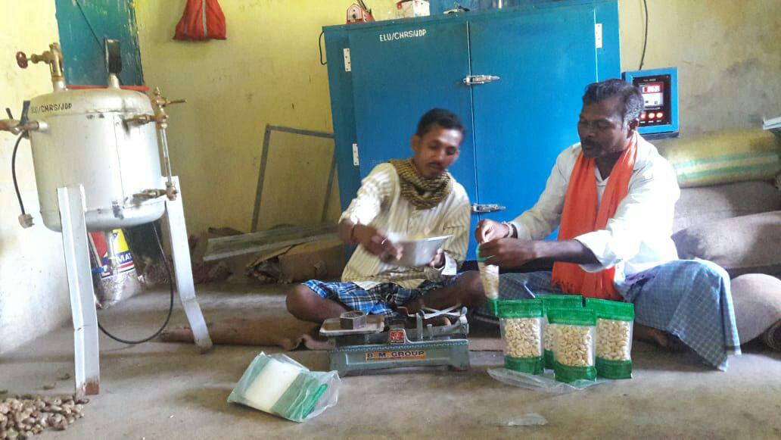 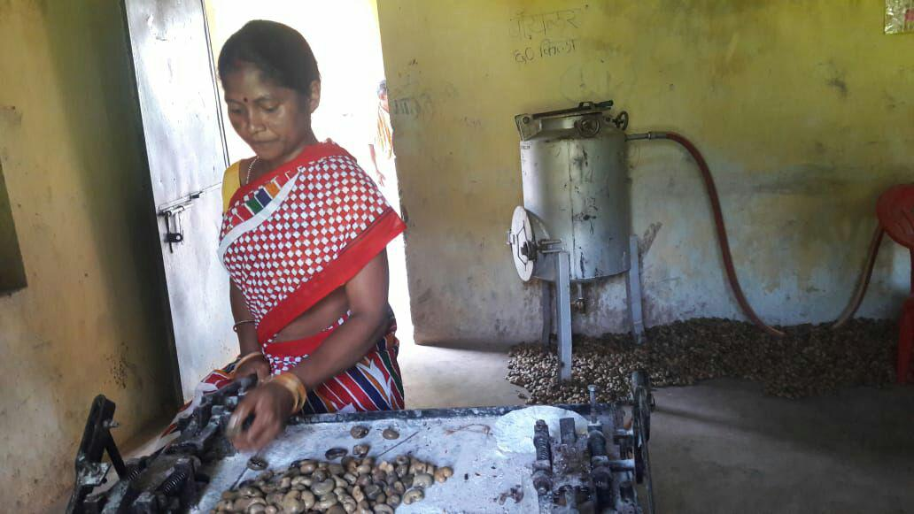

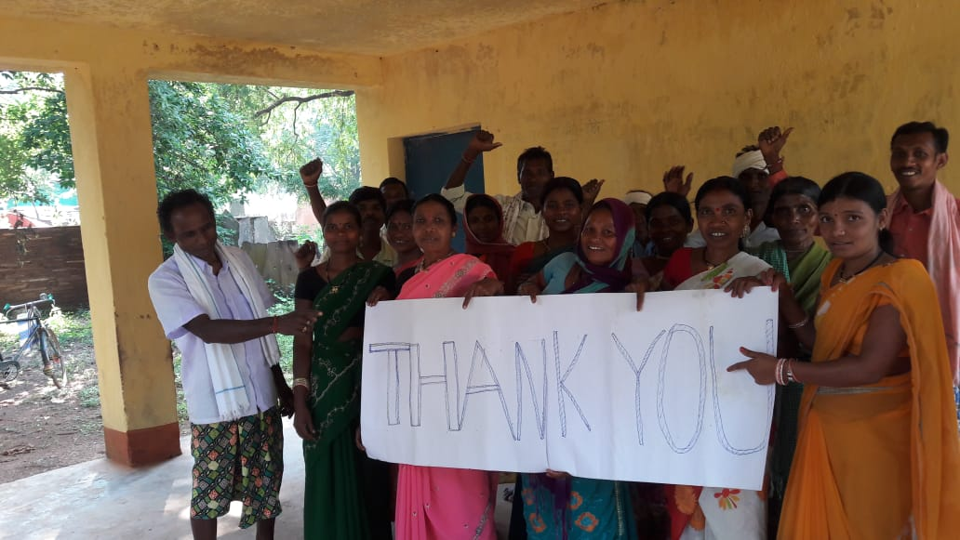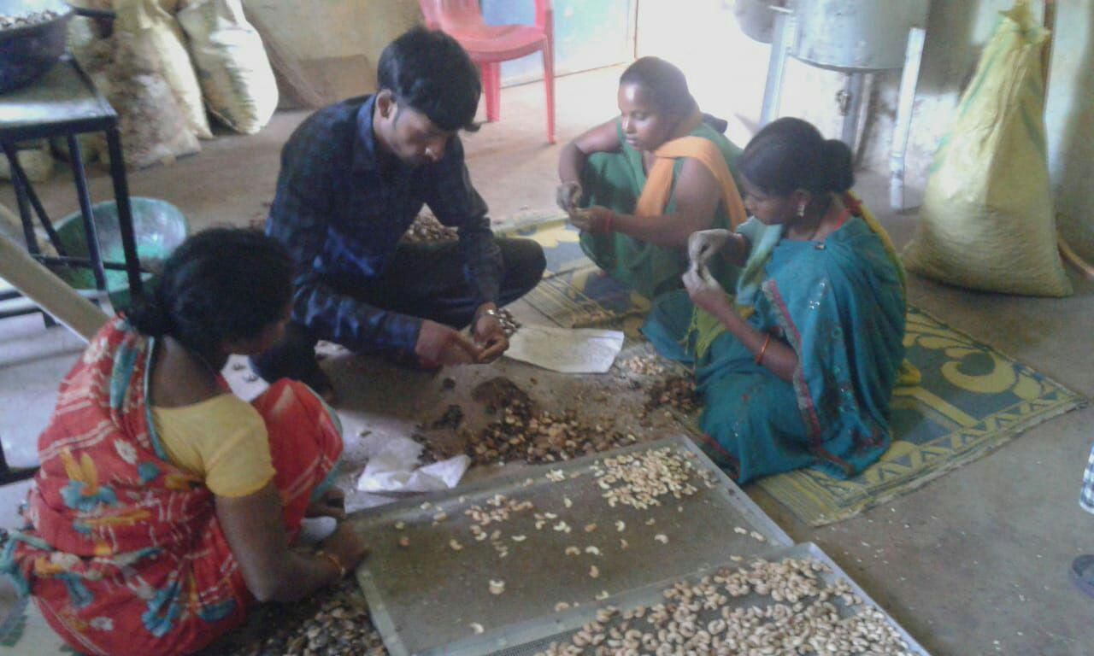

Although the project is running with support of donations we got but we have a target of 24000$ for running the project for the whole year. We need 17200$ more for successful implementation of the project.

This Giving Tuesday we are hoping to raise more funds for the project. We are looking for some recurring donors also to fund the project for longer durations. This year Global Giving is also going to match the fund in proportion to we have raised on Tuesday 27th November 2018 and Then up till 31st Dec 2018.

We expect that you will spread the word within your social reach about our work and initiative to help us garner greater support for our farmers

