SPONSORSHIP PROPOSAL
FOR

SAVE A LIFE IS A COMMUNITY BASED ORGANIZATION

CONTACTS: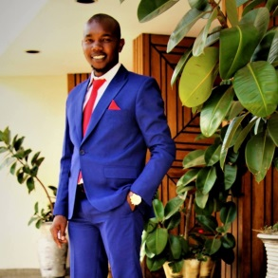

MR. JOSEPH MURIMI
SAVE A LIFE IS A COMMUNITY BASED ORGANIZATION -Chairman/Founder
TEL: 0722214817
OR JACKSON MUCHEMI: RESOURCE MOBILIZER MANAGER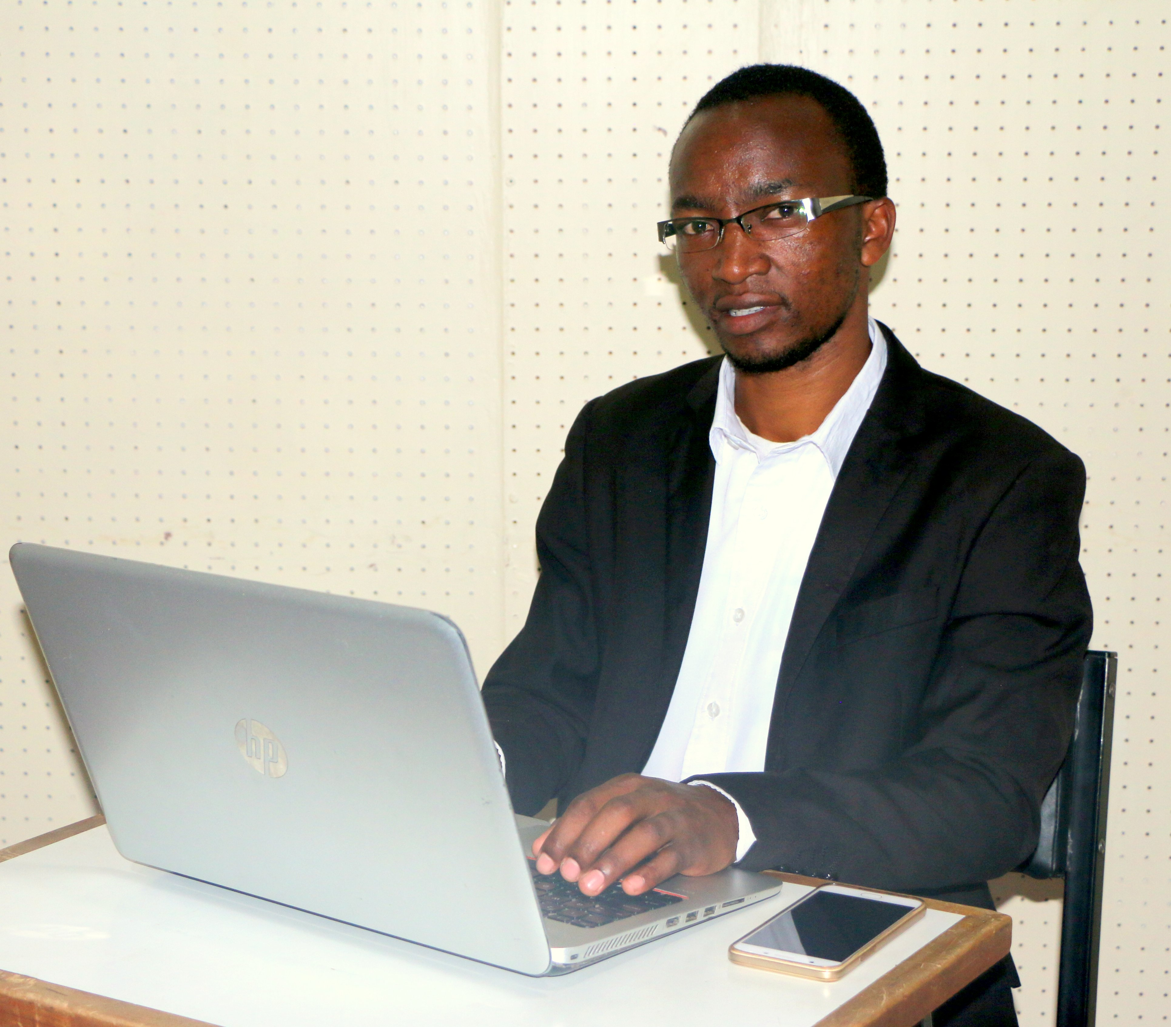
TEL: 0725851121
EMAIL: savealife1@gmail.com
WEBSITE: www.savealifefoundation.com
FACEBOOK: save a life

1.0 ABOUT SAVE A LIFE IS A COMMUNITY BASED ORGANIZATION
Save a life is a community based organization based in Kiambu County Kenya, Our main aims is transforming lives. We started by fundraising for the sick which inspired us to start this organization; we managed to help over 600 patients through this program. We mentor young people; do motivation talks to the youth, train photography, videographer and editing, we also work with street children who live on the street and are forced to fend for themselves with no one to guide them. We partner with other organizations in an endeavor to improve their lives, we visit them in their dens, talk to them and try to convince those who have homes to go back to their parents and live with them. We have managed to convince many children from 2016-2017 and we have established partnership with other organization that has gone an extra mile of educating them. We also teach them how to keep a good health in general, inform them about sexually transmitted diseases and train them on family planning. We give them guidance, counseling, and motivation to improve their lives. https://youtu.be/P_-Zm7VklTM

3.0 Our Mission
Motivate and train youth various skills

Objectives
 | Mentor and integrate abandoned children in the street back to the society.
 | Provide abandoned children with all the necessary intellectual, civil and religious information for their development.
 | Direct them towards vocational training and courses.
 | Reunite them with their families.
 | Train video production & radio production..
 | Build a center for street children where they can get an education and receive useful training.
 | Raise awareness among the people and society through campaigns to support street children.  Our Vision  To transform children to be responsible persons in Africa.
Our Philosophy
Many children have no trustworthy adults in their lives. All children deserve an opportunities for their future like any other person. Save a Life is committed to transform the youth into responsible persons.
Save a Life believes in the potential of all children, as well as ensuring that the rights of all children as described in the United Nations Convention on the Rights of the Child
("UNCRC") should be guaranteed to them. It so happens that some children fall through the holes in the safety nets of family, school, community and existing social welfare support. It is these children, variously described by society as "the most excluded", "the most marginalized", and "the hardest to reach", Save a Life is committed to helping and supporting. Save a Life believes that these children must be given the same opportunities to choose paths in their lives, as we would wish for our own children. Save a Life believes that the first step on the road of helping these children is for us to enter their world, rather than expecting them to come to us. This would be the foundation of a trust-based relationship from which everything else can flow. Save a Life's main idea is to change their mindset, train them, and later integrate them into the society. This cause is far from being a hopeless one. Street children are some of the bravest and strongest persons you may ever have the privilege of meeting. Together, we can help them change into the responsible adults.
Our long-term goal: to build a center with a primary and secondary school and vocational training for all children who have no one to support them.
What we do now: support children through many different activities like feeding programs, motivational speaking, training practical skills e.g. video production and audio productions, guide upcoming musicians and walk with them well as working to introduce welding and art. We also have sports, such as football, and also persuade those in the street who have homes to go back there with follow-ups and also talk to their parents for better communication between them because many children leave their homes because of lack of understanding and problems from their parents.
3.0 SPONSORSHIP PROPOSAL
We invite your organization to make a difference in these children’s lives by sponsoring the activities in full or in part. We have a budget that we work with as we follow up with these children’s progress. We organize forums six times per year and the last one was held this month and the next one is on April this year. The purpose of these forums is to motivate, council and encourage them to engage on positive activities. Below is the budget.

STREET CHILDREN MOTIVATION FORUM BUDGET

NO | ITEM | QTY | COST PER UNIT | TOTAL COST | COMMENT
01 | TENTS | 150 PAX | KSH 10,000 | KSH 10,000
02 | 150 CHAIRS | 150 | KSH 20 | KSH 3,000
03 | 3 TABLES | 3 TABLES | KSH 100 | KSH 300
04 | TABLE CLOTHES | 5 PCS | KSH 70 | KSH 350
05 | REFRESHMENT | 150 PAX | KSH 100 | KSH 15,000
06 | LUNCH | 150 PAX | KSH 350 | KSH 52,500
07 | P.A SYSTEM | 1 | KSH 30,000 | KSH 30,000
08 | Gifts |  |  | KSH 10,000
09 | Mentors | 2 | KHS 10,000 | KHS 20,000
10 | Counselor | 4 | KHS 5,000 | KHS 20,000
11 | Volunteers | 10 | KSH 2,000 | KSH 20,000
12 | Transport |  |  | KSH 15,000
13 | Video coverage |  |  | KSH 30,000
14 | MISELLINOUS |  | KSH 10,000 | KSH 10,000
 |  |  | TOTAL | KSH 236,150

Who we are
Save a Life. We are men and women, boys and girls, guardians, brothers and sisters, keepers driven by the will to see change, make a change, and deliver solutions to who the world has thrown away, shunned and turned its back to. We are people who see the need in the world and want to get up and DO SOMETHING ABOUT IT. We are working with the street children and the youths. We are feeding the hungry. We are bringing water to the thirsty. We are bringing hope to the hopeless.
We mentor children take their important first step towards a different life: we make them realize their worth, why they were created and we groom them as they grow. Our main goal is to motivate that young person into greatness. We also provide hope in the form of water, food, shelter, clothes, and shoes to street children and the youths across the country.
We are the generation that carries light into darkness in search of lost hope and lost love for the lost souls. We are the forgiving generation, the second chance generation that gives a voice to the voiceless and provides the stable home that every child is denied.
Save a Life mingles, rehabilitates, educates, empowers, trains, equips, and finally reintegrates street children and youths back into the society as focused, and sober people, prepared to live in it.
We achieve this through feeding programs and by holding social events such as football tournaments, modeling, and street speeches which allow us to penetrate the hearts of the street die-hards so that thereafter they would willingly come to us.
Save a Life aims to make people aware of the issues affecting the children living on the street. We raise money for the projects that work with such children and help them realize and fulfill their potential.
As we rehabilitate, we focus on detoxification, counseling, and education about sexual transmitted diseases, disadvantages of drugs and alcohol abuse, and behavioral change aimed to avoid or get rid of these abuses.
Save a Life cannot change these children’s past, but we are committed to change their future.
The important question is how to influence those around us to join our mission? Come join us as we strive to answer the call for humanity. Help us restore a street child’s respect for the society.
Let’s transform young generation into greatness. If you won’t to bring down the nation; “mislead a young generation and there will be no leader in the coming generation”
We lose so many children into drugs, peer pressure, early marriage, lack of confidence and lack of education. We are here to champion for this young person who has no hope but we bring hope that show him the direction to greatness
. Our Long term plan: to build a center for housing street children with primary and secondary school and vocational training for all needy youth.
Currently we are training video production and audio production and we are looking for partners to help us establish a video and audio studio for training photojournalism and audio production.
Short term goals: feeding programs and campaigns for raising awareness on different issues, among people to help children and empowerment activities.

BELOW ARE SOME OF THE PHOTOS OF OUR ACTIVITIES.
