**UGANDA YOUTH DEVELOPMENT AND TRAINING PROGRAMME (UYDT**)

**PO Box: 5026, Bukedea, Uganda Tel: +256 782 596860**

**Physical location: Kidongole – Bukedea District - Uganda**

**Email:ugandayouthtraining@gmail.com Website:**

__________________________________________________

**GENDER COMMUNITY COOPERATION AND DEVELOPMENT PROGRAMME**

**REPORT ON PUPIL MANAGED SCHOOL FARM PROJECT 2017**

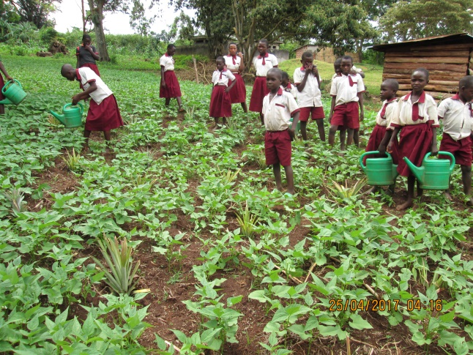 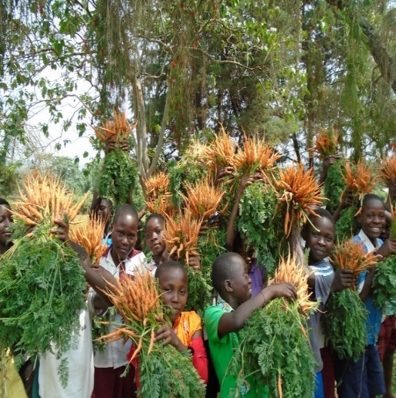

**PRESENTED BY:**

**UYDT TEAM**

Contents

1 UYDT BACKGROUND 1

2 UYDT VISION 1

3 UYDT MISION 1

4 GENDER COMMUNITY COOPERATION & DEVELOPMENT –GCCDP 2

5 PUPILS MANAGE FARM BACKGROUND 2

6 INTRODUCTION OF PUPILS MANAGED FARM. 2

7 PROJECT RESULTS STUDENT LEVEL 3

7.1 PUPILS ENSURE NUTRITIOUS LUNCHES AT SCHOOL FOR ALL 3

7.1.1 At least 1,750 pupils have improved nutritious meals for lunch 3

7.2 IMPROVED PUPILS PERFORMANCE IN CLASS 3

7.3 Pupils skills improved through practical involvement 4

8 PROJECT RESULTS AT SCHOOL LEVEL 6

8.1 Sufficient area under cultivation of nutritious crops 6

8.2 Appropriate technologies used to improve production and productivity of school farm 6

8.3 Institutionalisation of pupil managed school farms improved 7

9 PROJECT RESULTS AT HOME LEVEL 8

9.1 Integration of the principles of a learning home into day to day life at students homes 8

9.2 INCOMES IMPROVED 8

9.2.1 Pupil’s homes have diversified sources of income 8

9.2.2 Pupil’s homes have sustainable farming as a profitable business 8

9.3 Productivity of crops increased 9

9.4 FOOD SECURITY IMPROVED 9

9.4.1 Food production increased 9

9.4.2 Access for all home members to sufficient nutrient rich food and safe water increased 9

10 Appendixes 10

10.1 UYDT team 10

10.2 Pictorial documentation of the pupils managed farm activities 10

# UYDT BACKGROUND

The Uganda youth development and training programme- UYDT is an indigenous community based organisation that works in the Eastern region of Uganda since 2013. Consciousness raising, training, education and information sharing are UYDT’s key strategies to enable the rural people to recognise and embody common vision and values and work together to create for themselves peace, prosperity, health, freedom and happiness.

UYDT witnessed that the rural schools in Bukedea District like any other district in the country, lack capacity to provide education that supports young people to awaken their sleeping genius, and become visionary, self-learning, confident, responsible, entrepreneurial and competent citizens who can make a decent living in rural setting hence this is UYDT’s long term goal.

# UYDT VISION

UYDT is a centre for Transformation and Development that delivers quality training in vocational skills, Technical skills, humanities, social sciences, Development studies and Artisanship for community members, Leaders of voluntary organisations, government staff and other development practitioners. It creates and offers extension services, modern rural communication facilities, intermediation and operates a resource Centre for information exchange and learning that enhances development and self- reliance of people

# UYDT MISION

* To enable the people of Uganda (Bukedea & Eastern Region in particular) recognize and embody common values and work together to create for them – selves peace, prosperity, freedom, health and happiness as they discover that they are key to their development and that they have innate power and wisdom to create an environment that fosters personal and communal growth and express the highest in them.
* To cultivate the spirit of self -reliance to build integrated, self-generating development rural communities and economies by integrating training, education and information sharing in development activities and using local and available resources and technologies as an example of what is possible for national development.
* To enable the people recognize and utilize the inter-relationship between development concerns in health, nutrition, sanitation, agriculture, water management, rural technologies, income generating and the environment so that they have a holistic approach to the development of human life.

# GENDER COMMUNITY COOPERATION & DEVELOPMENT –GCCDP

The UYDT GCCDP is an arm of the programme that links community with the UYDT projects. Hence the pupils managed farm project is under the Gender Community Cooperation and Development and this is to enable community create peace, prosperity, have good health and be happy and live harmoniously with each other.

# PUPILS MANAGE FARM BACKGROUND

The education as a key to personal and home development is obviously not a topic to argue about. However, in Uganda, the access to quality education is only for the happy few due to multiple reasons. The government aided primary schools in rural communities are underfunded, overcrowded and therefore not very successful in producing young people that have entrepreneurial and other skills to create wealth, health and happiness for themselves, their homes and communities. Often rural schools have insufficient funding to provide lunch to the pupils while research shows that pupils having no meals at school perform more poorly than those well fed. This puts such pupils in a disadvantaged position to learn and tap into their inherent genius. As a result, the current education system does not breed many young people with entrepreneurial minds and skills. This has a serious impact on socio- economic growth of the country. Hence UYDT thought it wise to build on this in order to achieve its long term goal.

# INTRODUCTION OF PUPILS MANAGED FARM.

The UYDT through its GCCDP programme works with five (5) rural community schools to set up a pupils managed school farm to provide lunch during school time to help pupils concentrate for better performance and also learn entrepreneurial skills of managing a business venture. Therefore, the Pupils managed project has involved 1,750 pupils from the five school (Kabarwa, Chodong, Malera, Kolir, Kotiokot) primary schools. The pupils them-selves take responsibility of the farms activities for example; field preparation, planting, weeding, watering, harvesting, drying etc. Hence, this report provides pupils’ farm managed project achievements for the year 2017 in the five schools of UYDT intervention

# PROJECT RESULTS STUDENT LEVEL

## PUPILS ENSURE NUTRITIOUS LUNCHES AT SCHOOL FOR ALL

### At least 1,750 pupils have improved nutritious meals for lunch

The reports form school project coordinators, the meal plans and school records showed that: 150 pupils started taking lunch on specific days selected and taking porridge from the harvest of maize and the school has a plan for providing lunch to all pupils.

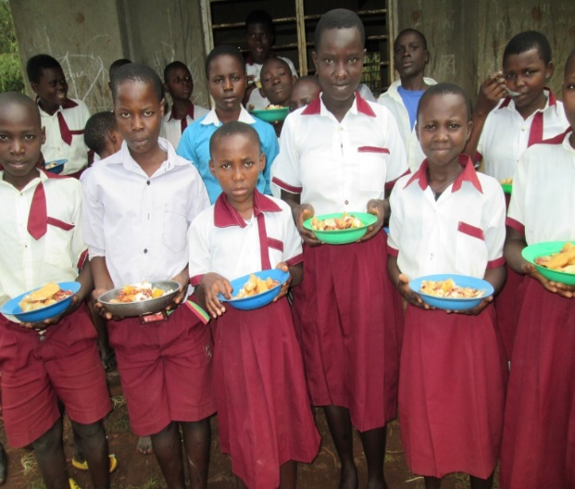

***Pupils of Kabarwa primary school after getting food***

## IMPROVED PUPILS PERFORMANCE IN CLASS

The records of exam results – both school termly exams and UNEB show that there have been a great improvement in the performance of pupils in class for example, in PLE results last year 2017, the schools got more first grades than the previous years and this was attached to the effort by the pupils managed farm project., 85% of pupils got the pass mark compared to last years were only 35% of pupils would get the pass mark to be promoted to the next classes.

From the observation by teachers on levels of concentration and participation it is concluded that there have been an increase on the level of concentration and participation mostly after lunch lessons because pupils eat food hence energy and actively participate in classes.

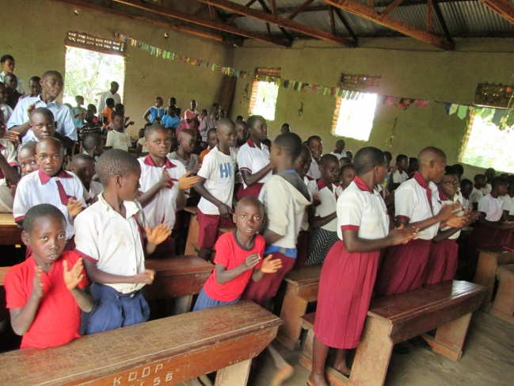

***Pupils of Kabarwa primary school active during the meeting called by UYDT field staff during monitoring***

## Pupils skills improved through practical involvement

The numbers of pupils that participate actively in farming clubs are 1,750 pupils from three classes’ p.5, p.6 and p.4. In the five schools of the project intervention and 75% of that number of pupils have replicated the skills at home and have back home projects for income generating activities.

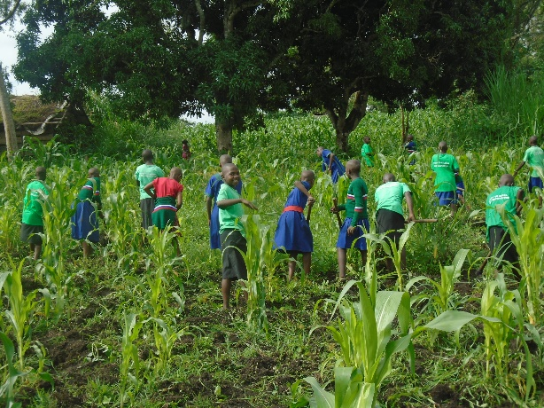

**The table showing Number of pupils per class actively involved in the project**

|  |  |  |  |  |
| --- | --- | --- | --- | --- |
| **No.** | **Class** | **No. of pupils involved** | **Boys** | **Girls** |
| 1. | p.5 | 552 | 350 | 202 |
| 2. | p.6 | 460 | 222 | 238 |
| 3. | p.4 | 480 | 208 | 272 |
| 4. | Other classes | 258 | 150 | 108 |
| **Total** |  | **1,750** | **930** | **820** |

**Types of back home projects**  **implemented by pupils in their homes**

* Piggery project
* Maize project
* Poultry
* Rabbit project
* Bean project
* Pineapple project
* vegetables

75% of the pupils that participate in the project have back home projects for income generation and nutrition to support their families due to the skills acquired from the project. The home visit reports by the UYDT field officer show that, pupils and their parents have replicated the skills to their homes by setting up back home projects and also kitchen gardens

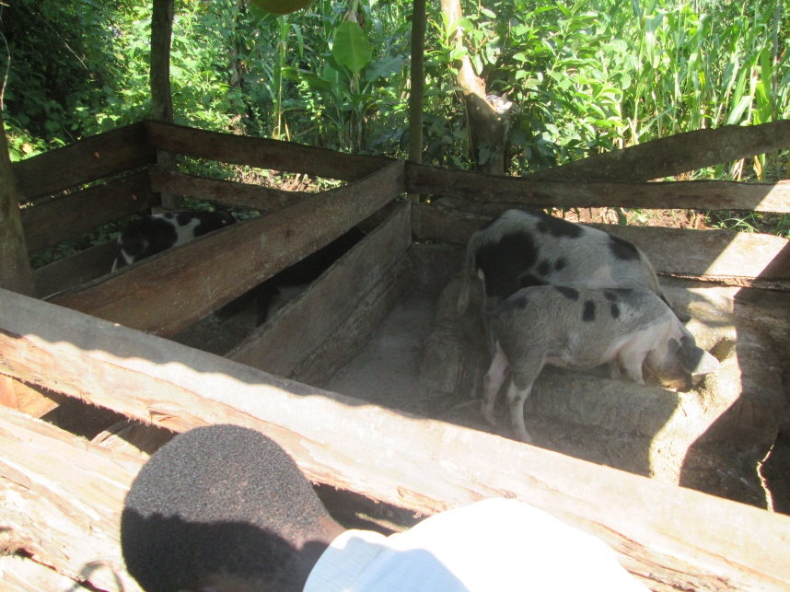

***A sample of a aback home project established at Miss Akurut Josephine beneficiary of PMSFP***

***A sample of a family vision that pupils drew with their parent at the family of omuhereza Kisembo***

Reports from the back home project monitoring by the agriculture teacher, field officer and project coordinator, show that only 57 % of club members and their parents respectively act as an example and demonstration sites of farm entrepreneurs in their communities;

# PROJECT RESULTS AT SCHOOL LEVEL

## Sufficient area under cultivation of nutritious crops

According to the project coordinator’s reports and the school farm records show that, there is an increase in acreage to cultivate food for the pupils compared to last year and on average each school has at least 4 acres of land cultivated with crops like maize, beans, vegetables, bananas, cassava and potatoes.

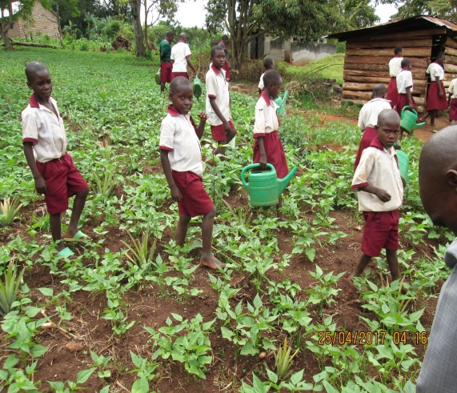 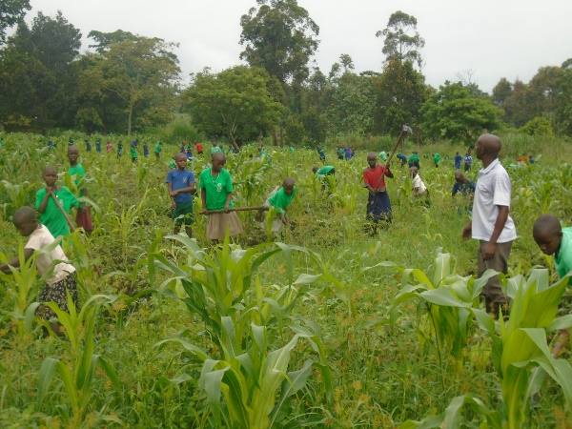

***Kabarwa P/s pupils watering their beans Kolir P/s pupils weeding their maize***

## Appropriate technologies used to improve production and productivity of school farm

According to the project coordinator’s report and the school farm records showed that: mulching, watering using watering cans, application of manure, proper spacing, Crop rotation, early planting are some of the appropriate technologies that have been employed to increase productivity on the pupils managed school farms of all the five schools.

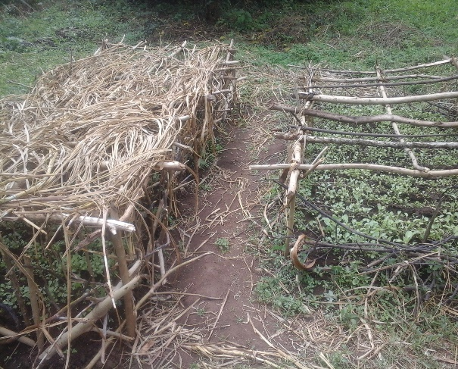 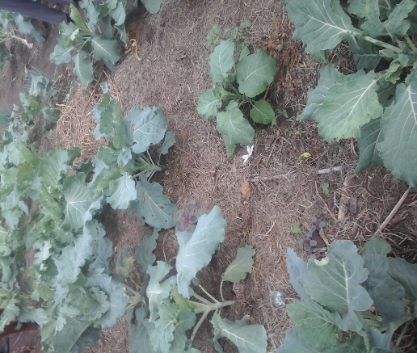

***A sample of a nursery beds of cabbages planted in lines and well managed awaiting transplanting to the school farm.***

***Well maltched vegetables***

## Institutionalisation of pupil managed school farms improved

From the records of the Head teachers, Project Coordinator and the self-monitoring records of the schools, the following has been done and witnessed:

* Relevant lesson plans, textbooks, syllabi, timetable
* Increased access to land for the school farm
* Meal plans in place or budgets made
* Cooks prepare meals as per the specifications agreed upon.
* The schools are managed per the principles of a learning organisation
* Education Ministry aware and appreciates pupils managed school farms as part of the teaching methods. Mostly the sub-county education sector and the inspector of schools during his visit to the schools appreciated the project and the District Education Officer receives the reports about the project through head teachers report.
* 1,750 of the pupils eat a nutritious meal during lunch in the project’s five schools of the implementation.
* The five schools have a well-established farms with nutritious crops grown like carrots African spinach eggplant, maize, beans and others, commercial farm produce on average 11 bags (1,100kgs) of maize in a season
* The schools have embraced the principles of a learning school and they have the farm vision well-articulated as well as the school vision.

# PROJECT RESULTS AT HOME LEVEL

## Integration of the principles of a learning home into day to day life at students homes

The mentoring and monitoring team visited 62 and out of 62 homes, only 35 homes were found with the family visions and no home that was found only 3 homes had development plans prepared and followed. However, there is going to be effort to enable these homes to have home development plans and family vision.

50 Note books of the pupils show the vision, current reality and action steps towards change in their homes and school farm.

Only 3 homes out of 62 homes visited were found withfamily meeting minutes that show that they have been carrying out family planning meetings mostly on planning on what crops to grown next season.

## INCOMES IMPROVED

### Pupil’s homes have diversified sources of income

The field monitoring reports on occupations and enterprises established show that the pupil’s homes have diversified source of income. Pupils practice back home projects and have set different and at least on average 4 projects as income generating projects to help provide food and as a source of income for their families

### Pupil’s homes have sustainable farming as a profitable business

On average, the size of fertile land under use for each household is approximately one acre

The previous season harvests are far better than this season, because of favourable weather condition and application of appropriate technology like mulching because on average, a farmer could get 15 bags of maize in one acre but this season it is estimated to 5 bags due to unfavourable weather condition and this means no gain.

The farm records of harvests and sales show that there have been increased sales for the past seasons but this season the sales are expected to drop for most families because of unfavourable conditions like shortage of rain

The farm layout-plans and crop rotation system adopted show that it has helped mostly in maintaining the soil fertility and increasing productivity

Reports on social capital developed show that most homes are involved in revolving fund, saving & credit, rotational farming, burial groups but the high percentage is in saving and credit at village level and this has increased on the saving culture of these households.

## Productivity of crops increased

From the observations of epicentre manager and the reports from the pupils, there has been increase in crop productivity apart from this season where farmers were disturbed by bad weather conditions. The increase in the last seasons it is attached to good farming methods and good weather conditions.

The farm records in pupils homes show that in the past season on average farmer cultivating maize would get 15 bags in on acre but this season the productivity is expected to reduce up to 5 bags on average in one acre.

## FOOD SECURITY IMPROVED

Food security is one of the challenges in the house holds of Uganda families and eastern region in particular. 70% of the households can’t afford to have 3 meals a day due to poor food storage facilities, poor preservation methods. However, through the projects training of the pupils parents, at least 50% of the households involved in the project implementation have good storage facilities which guarantees food security

### Food production increased

From the food production records compiled by the field officer each season it can be concluded that the pupil’s households are food secure because these homes have planted a variety of food crops on their farm like cassava, banana, beans, maize and vegetables and 78% of the homes can afford 3 meals in a day.

### Access for all home members to sufficient nutrient rich food and safe water increased

From the monitoring reports of the homes, it is noted that 78% of the homes can afford to take 3 meals in a day and there is excess for marketing to generate income for other needs in the family like scholastically materials for pupils, uniform, and other daily requirement of a family

# Appendixes

## UYDT team

|  |  |  |  |
| --- | --- | --- | --- |
| ***No*** | ***Name*** | ***Gender*** | ***Title / position*** |
| 1 | Agwang Catherine Martha | Female | Executive Director and founder member |
| 2 | Odere Emmanuel | Male | Chairman Board |
| 3 | Adeke Aan Gorretty | Female | Secretary to the Board |
| 4 | Antait Joselyn Vivian | Female | Treasure to the Board |
| 5 | Angeki Simon Peter | Male | Board Member |
| 6 | Akwii Lucky Eunice | Female | Board Member |
| 7 | Kaijuka Umaru | Male | Project Coordinator |
| 8 | Akurut Mary | Female | Staff (Trainer) |
| 9 | Owrom Yoweri | Male | Staff (Field officer) |
| 10 | Odele Joseph | Male | Staff (Trainer) |
| 11 | Agwang Gloria | Female | Staff ( Accounts Assistant) |

## Pictorial documentation of the pupils managed farm activities

|  |  |
| --- | --- |
| C:\Users\SDTO\Desktop\pupils farm pics\DSC02132.JPG  ***UYDT Girls primary school pupils drying the maize from their farm*** | C:\Users\SDTO\Desktop\pupils farm pics\pic 2.jpg  ***Kabarwa primary school pupils display the carots they harvested ready to be eaten*** |
| C:\Users\SDTO\Desktop\pupils farm pics\DSC09611.JPG  ***UYDT Girls school pupils weeding their maize in the school farm.*** | C:\Users\SDTO\Desktop\pupils farm pics\farm.jpg  ***Pupils watering beans in their school farm*** |
| C:\Users\SDTO\Desktop\pupils farm pics\DSC09490.JPG  ***Pupils harvesting cabbages from the school farm*** | C:\Users\SDTO\Desktop\pupils farm pics\DSC09494.JPG  ***Cabbages in a school kitchen pan ready to be cooked*** |