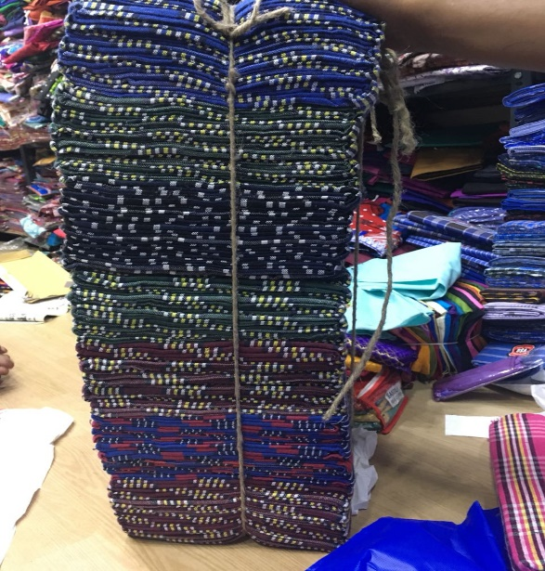
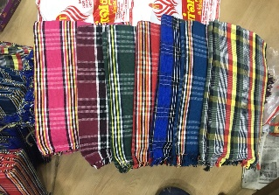
Floods in Kerala had trembled 70% of the living areas across the state. Though it was a massive bout, the people / supporters in the state fixed speedy retrieval in many affected areas.
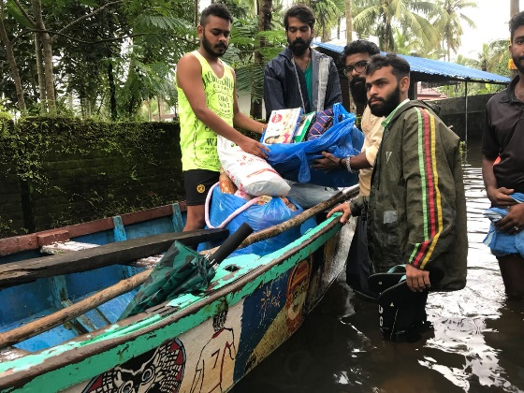
To begin with, the Foundation took immediate measures in the flooded areas and sent the relief materials from Chennai. The first consignment of relief materials was shipped from Chennai to Ernakulum and the nearby areas. The local volunteers along with the Learning Links staff members reached out to the places and distributed the immediate needy materials like blankets, mats, clothing and other essential materials.
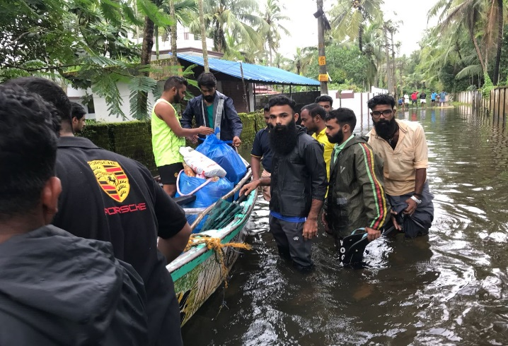
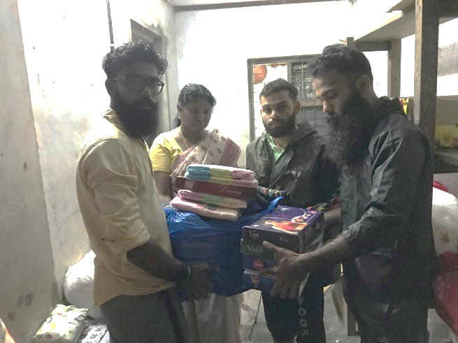
The focus during the first phase was on the immediate requirement of the people living in temporary shelters and the people who were not able to move out of the houses. Nevertheless, the second phase focused on devising permanent solutions to the damage created by the floods by rebuilding of temporary shelters for the needy also, to identify the need for the educational institutions which were devasted during the floods. The Foundation continued the survey in various areas and collected the list of requirements by meeting different school authority’s, officials etc. The next phase will be focusing on revamping the computer labs, libraries etc., in the identified schools.

