1st Update Report on Project Samruddhi
#34813 Livelihood Empowerment of 100 Tribal Women
Dear Global Giving Donors,
We are humbled and excited to share the 1st update report of our Project Samruddhi (Sanskrit word for Prosperity) which aims for livelihood and economic empowerment of 100 Tribal poor women in Dadra and Nagar Haveli, a tribal union territory of India, located on the borders of the states of Maharashtra and Gujarat
Thanks to your generous funding support, we launched the project in mid-October 2018, after receiving the 1st fund disbursement from Global Giving.
Here below is a summary of donations received, as a participating project in the ‘Global Giving September 2018 Accelerator’ (Qualifying criteria: 40 unique donors & minimum $5000 donations to be raised in the 3 week period – September 10 till October 2, 2018):
Sr. No | Target | Achieved by ACT
1 | Minimum 40 Unique Donors | 60 Unique Donors
2 | Minimum US$ 5000 to be raised | US$ 8063 raised
3 | Overall Target Fund Appealed | US $ 20,000
4 | Donations received in our account to date | US $ 6705.5
Project's donation appeal status: Open to receive donations till target of US $ 20, 000 is reached.
We thank you, dear supporters and donors for helping us to raise $ 8063 till date and qualifying for a permanent listing on the Global Giving crowdfunding worldwide portal. We truly appreciate our donors who opted for the recurring donation option. Your continued support makes a big difference to our impact scale.
Whilst ACT has achieved the first milestone a lot more needs to be done to reach the final milestone of US$ 20000 for the project.
Please share the project link among your friends and family with your strong endorsement. https://www.globalgiving.org/projects/samruddhi-livelihood-skills-for-100-adivasi-women/

Please see here below our update of actions taken so far:
PROJECT SAMRUDDHI ACTIVITY UPDATE:
Sr. No | Action | Status | Remarks
1 | Recruitment of Project coordinator | Done | Joined from October 15
2 | Recruitment of 3 Supervisors and 1 Junior Supervisor to cover beneficiaries in 15 villages | Done | Joined from Nov 1
3 | Presentation of the project objectives to the Government Ministry and Women's Welfare Cell | Done | We met the District Collector on Nov 22 and got their support for tribal welfare activities
4 | Enrolment form template and local language translation | Done | Marathi, Gujarati language forms printed
5 | Project launch awareness drive | Ongoing | 6 villages done, 9 villages to go
6 | Enrolment of 100 target beneficiaries 15 tribal villages | Ongoing | Will be completed by December end
7 | Supervisors’ Activity Schedule Plan for Vocational Training, Exposure visits, Capacity building Workshops, Awareness programmes | Work in Progress | Will be complete by mid- December
8 | Fund transfer for implementation | Done | 1st month’s tranche of approximately US $ 700 transferred to on ground NGO partner - Premankur

We are continuously working to generate funds to reach the target of US $ 20,000 from its Donors and is also looking out for new donors. Along with your continued support if you can also support ACT by referring your friends and family then ACT would reach out these potential Donors to ensure the final milestone is reached earlier. We shall continue to keep you updated about our progress every quarter. Our beneficiaries also join us in thanking you for the opportunity of vocational skills training and income generation.

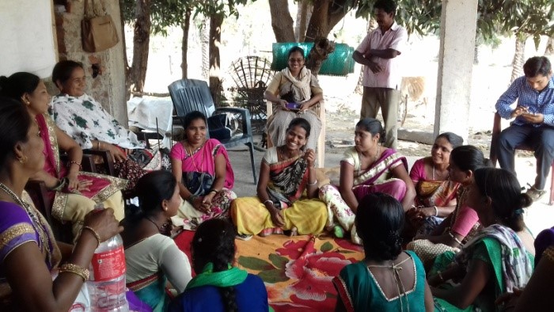

Thank you & wishing you Compliments of the Season,
Nivedita Desai – Managing Trustee
Animedh Charitable Trust (ACT)
December 7, 2018

