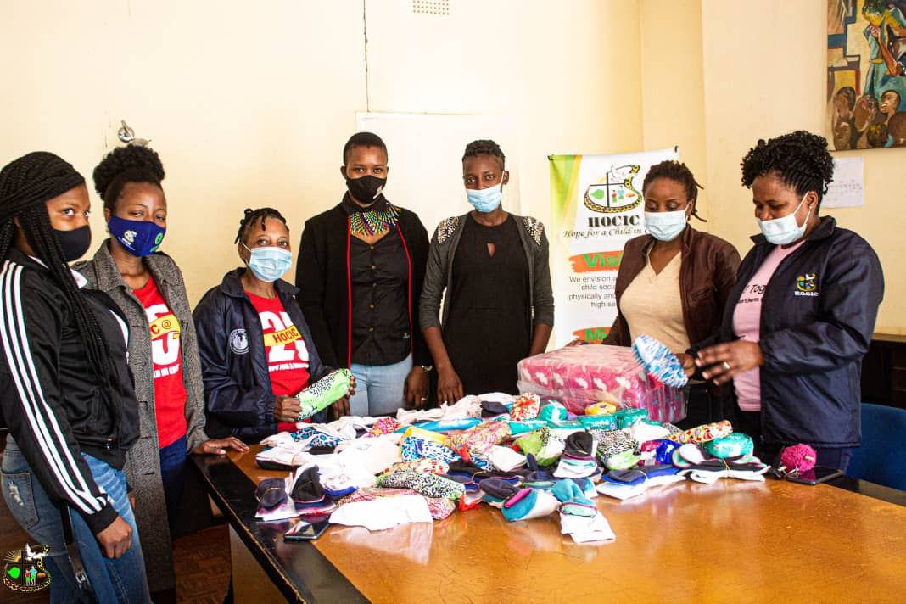
The Access to Sanitary ware team receiving the sanitary wear donation from Angels Foundation Zimbabwe

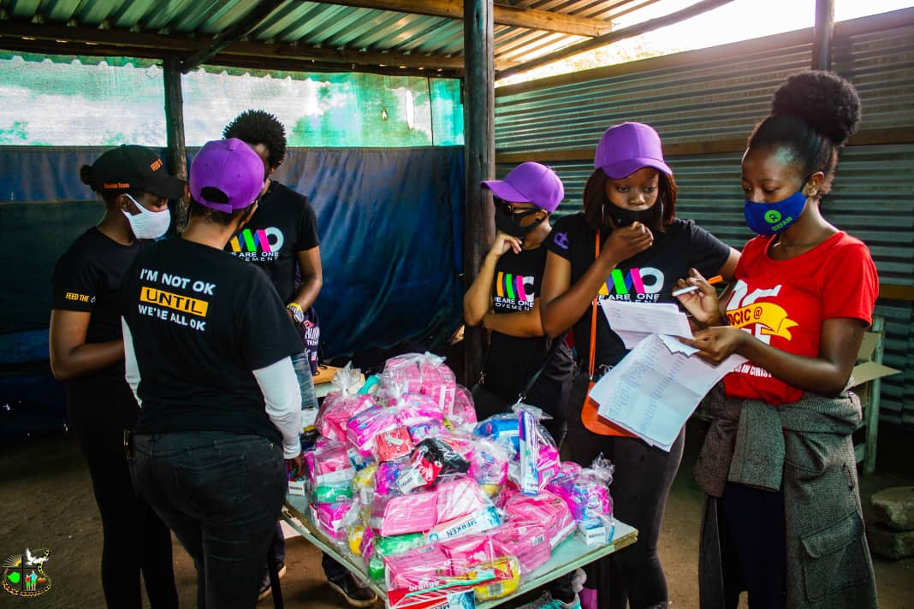

Eugenia Ncube( Programs Assistant) working with other participants from Say What in distribution of sanitary wear at Ngozi mine

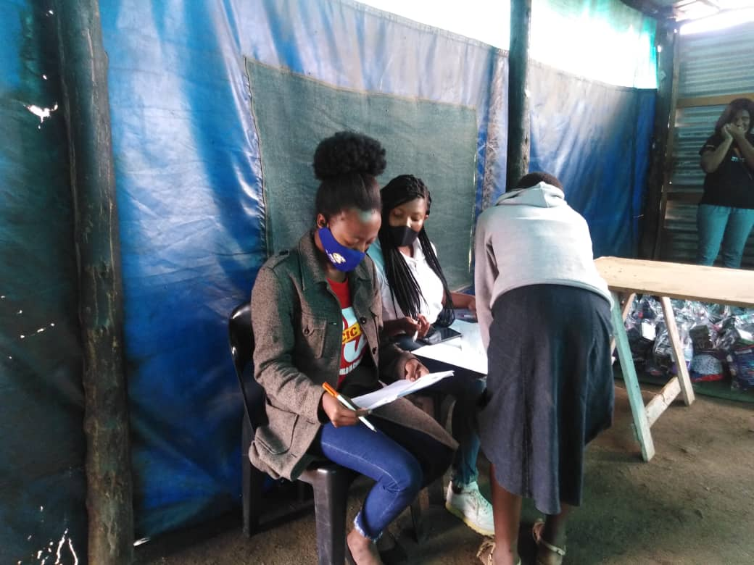
The Access to Sanitary ware team giving out sanitary wear at Ngozi mine squatter camp

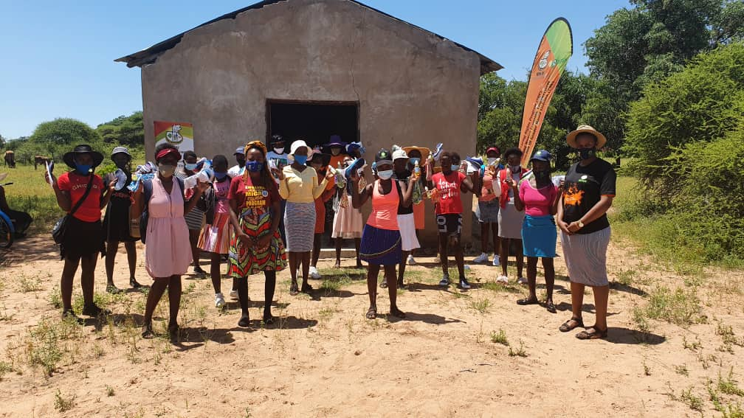

The Access to Sanitary ware team distributing sanitary wear at Matobo Ward 11

