Photo gallery

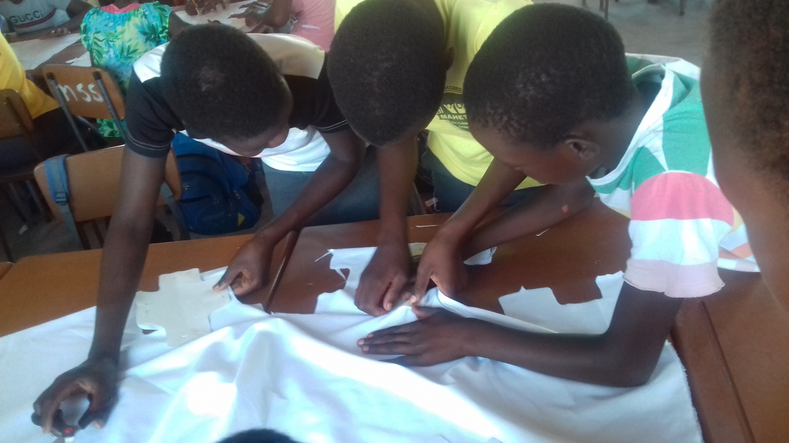
Figure 1 Participants cut out the patterns.
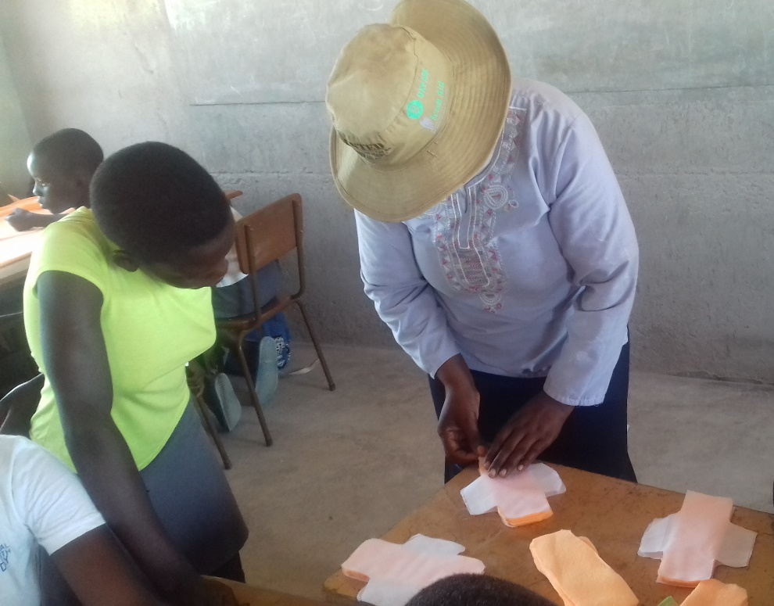
Figure 2 The Facilitator demonstrates how to put together the patterns.

Figure 3 Participants sewing the pads.

Figure 4 One of the completed sanitary pads

.

