FOREFRONT International School Education Project Report
September 6, 2019 (FY19 Q3)

FOREFRONT’s progress toward the completion of its project is divided into two axes: construction/architecture and education. Together, excellent implementation in these two areas will make FOREFRONT International School a high-quality educational opportunity for children in rural India who otherwise lack access.

Architecture
With generous donations from private donors like those who give through the Global Giving platform, FOREFRONT resumed construction of its school in Kolluru, India. FOREFRONT now has sufficient funds to complete construction of the school which is expected to be completed by Spring 2020 in order for school to begin for the 2020 school year. Pictures of the school can be found below. FOREFRONT is now shifting focus to funding and planning the operations for the launch of the school, including the recruitment of teachers, faculty and students.

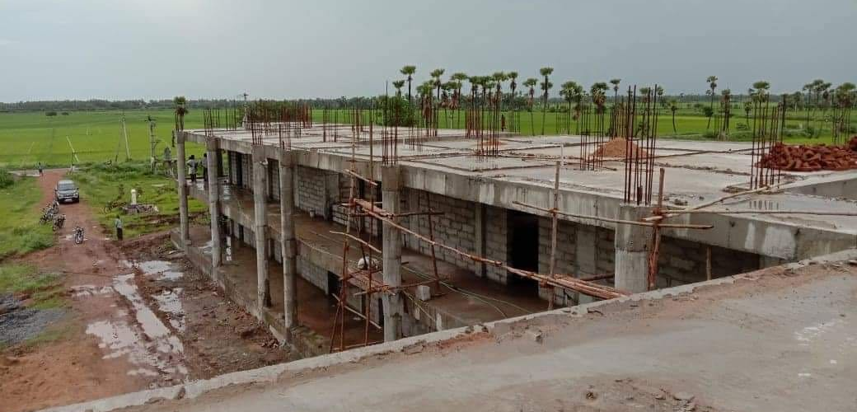
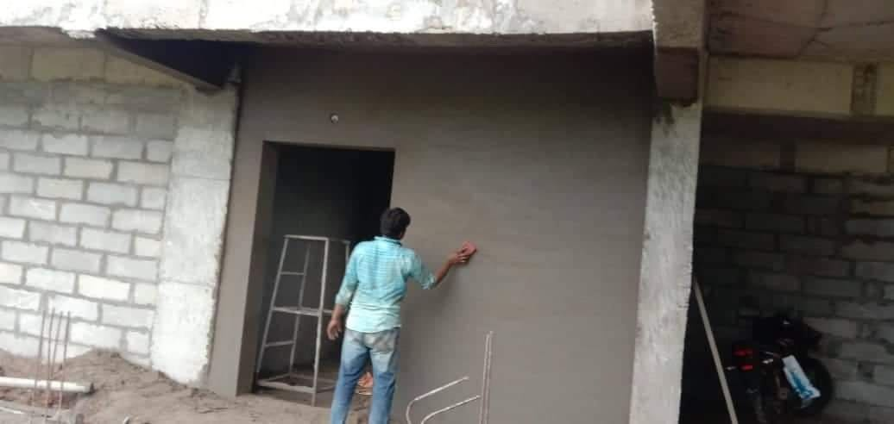

Education
Alongside the community engagement projects highlighted in the previous quarter, FOREFRONT’s education program staff have continued to plan for the launch of an after school tutoring program that will provide elementary school-aged children with English tutoring and mentorship from certified teachers. The program will be supervised by an experienced school administrator who will manage and train the teachers in transformational teaching practices. Children will be placed in small groups to engage in English enrichment and wellness activities that will equip them with skills to become leaders in their community. Wellness activities include physical education, hygiene and character building activities.

This reporting period, FOREFRONT staff interviewed over 20 English teacher candidates from Tenali, Kolluru and the surrounding area. A team of two FOREFRONT staff conducted the first round of interviews along with a resume screen to identify the most prepared and qualified candidates. The most promising applicants were interviewed by FOREFRONT’s Education Team Lead. The Education Team interviewed and extended offers to two highly qualified candidates (Kiran Kumar and Purna Chandra) who will serve as the teachers for the initial cohort of students. As mentioned in the previous quarterly report, the teachers will use the Jolly Phonics English curriculum. The Education team trained the teachers on how to apply the teaching materials in the after school program.

The after school program will begin in September 2019 with an initial group of 15-20 students. FOREFRONT will report on the launch and attendance of the after school program in the next quarter.

