**FOREFRONT International School Education Project Report**

March 9, 2018 (FY19 Q1)

FOREFRONT’s progress toward the completion of its project is divided into two axes: construction/architecture and education. Together, excellent implementation in these two areas will make FOREFRONT International School a high-quality educational opportunity for children in rural India who otherwise lack access.

**Architecture**

This quarter FOREFRONT raised sufficient funds to complete the ceiling of the second floor of the primary school. As shown in the picture to the left, construction is moving at a steady pace. Currently, FOREFRONT is making monthly payments to the construction company to move toward the completion of the school as shown in the figure below. During this quarter, FOREFRONT also began building the walls on the first floor of the building which ought to be completed by the end of the upcoming reporting period.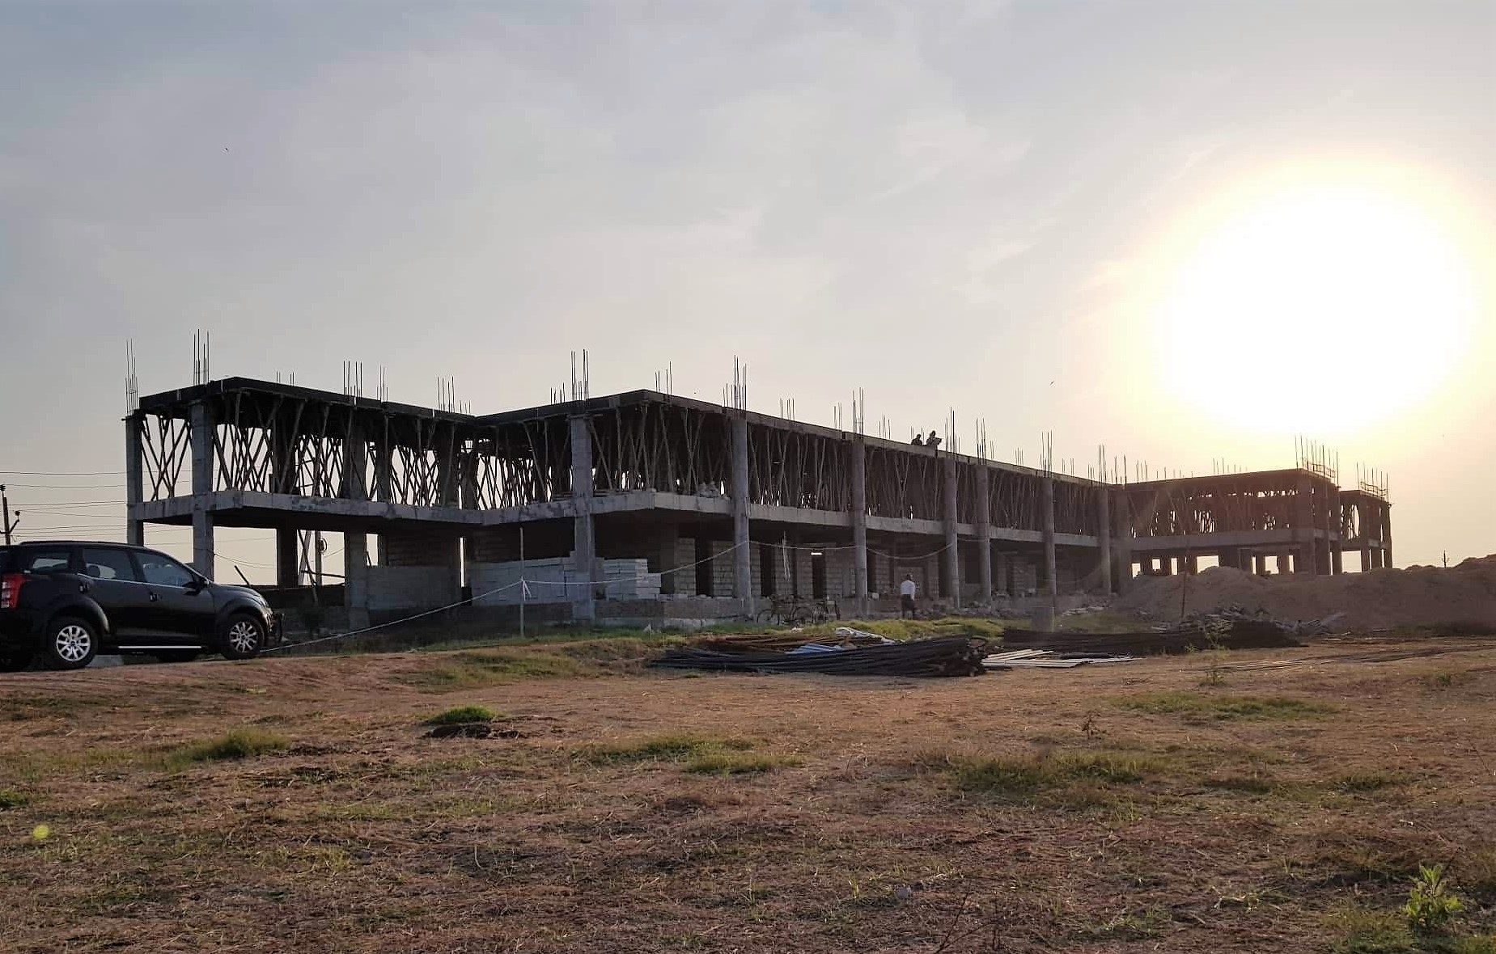

**Education**

Alongside the community engagement projects highlighted in the previous quarter, FOREFRONT’s education program staff have begun to plan to establish an after school tutoring program that will provide elementary school-aged children with English tutoring and mentorship from certified teachers. The program will be supervised by an experienced school administrator who will manage and train the teachers in transformational teaching practices. Children will be placed in small groups to engage in English enrichment and wellness activities that will equip them with skills to become leaders in their community. Wellness activities include physical education, hygiene and character building activities.

To plan for the launch of the after school program, FOREFRONT staff identified the English teaching curriculum, set up a set of monitoring and evaluation indicators to measure the program’s success and established a budget for operations and hiring of teachers. The education program team has established descriptions of teacher’s scope of work in order to recruit the most qualified candidates. Alongside the recruitment of professionally-trained teachers, FOREFRONT plans to reach out to universities in nearby urban centers to recruit students willing to mentor and teach the children on either English or health and wellness practices.

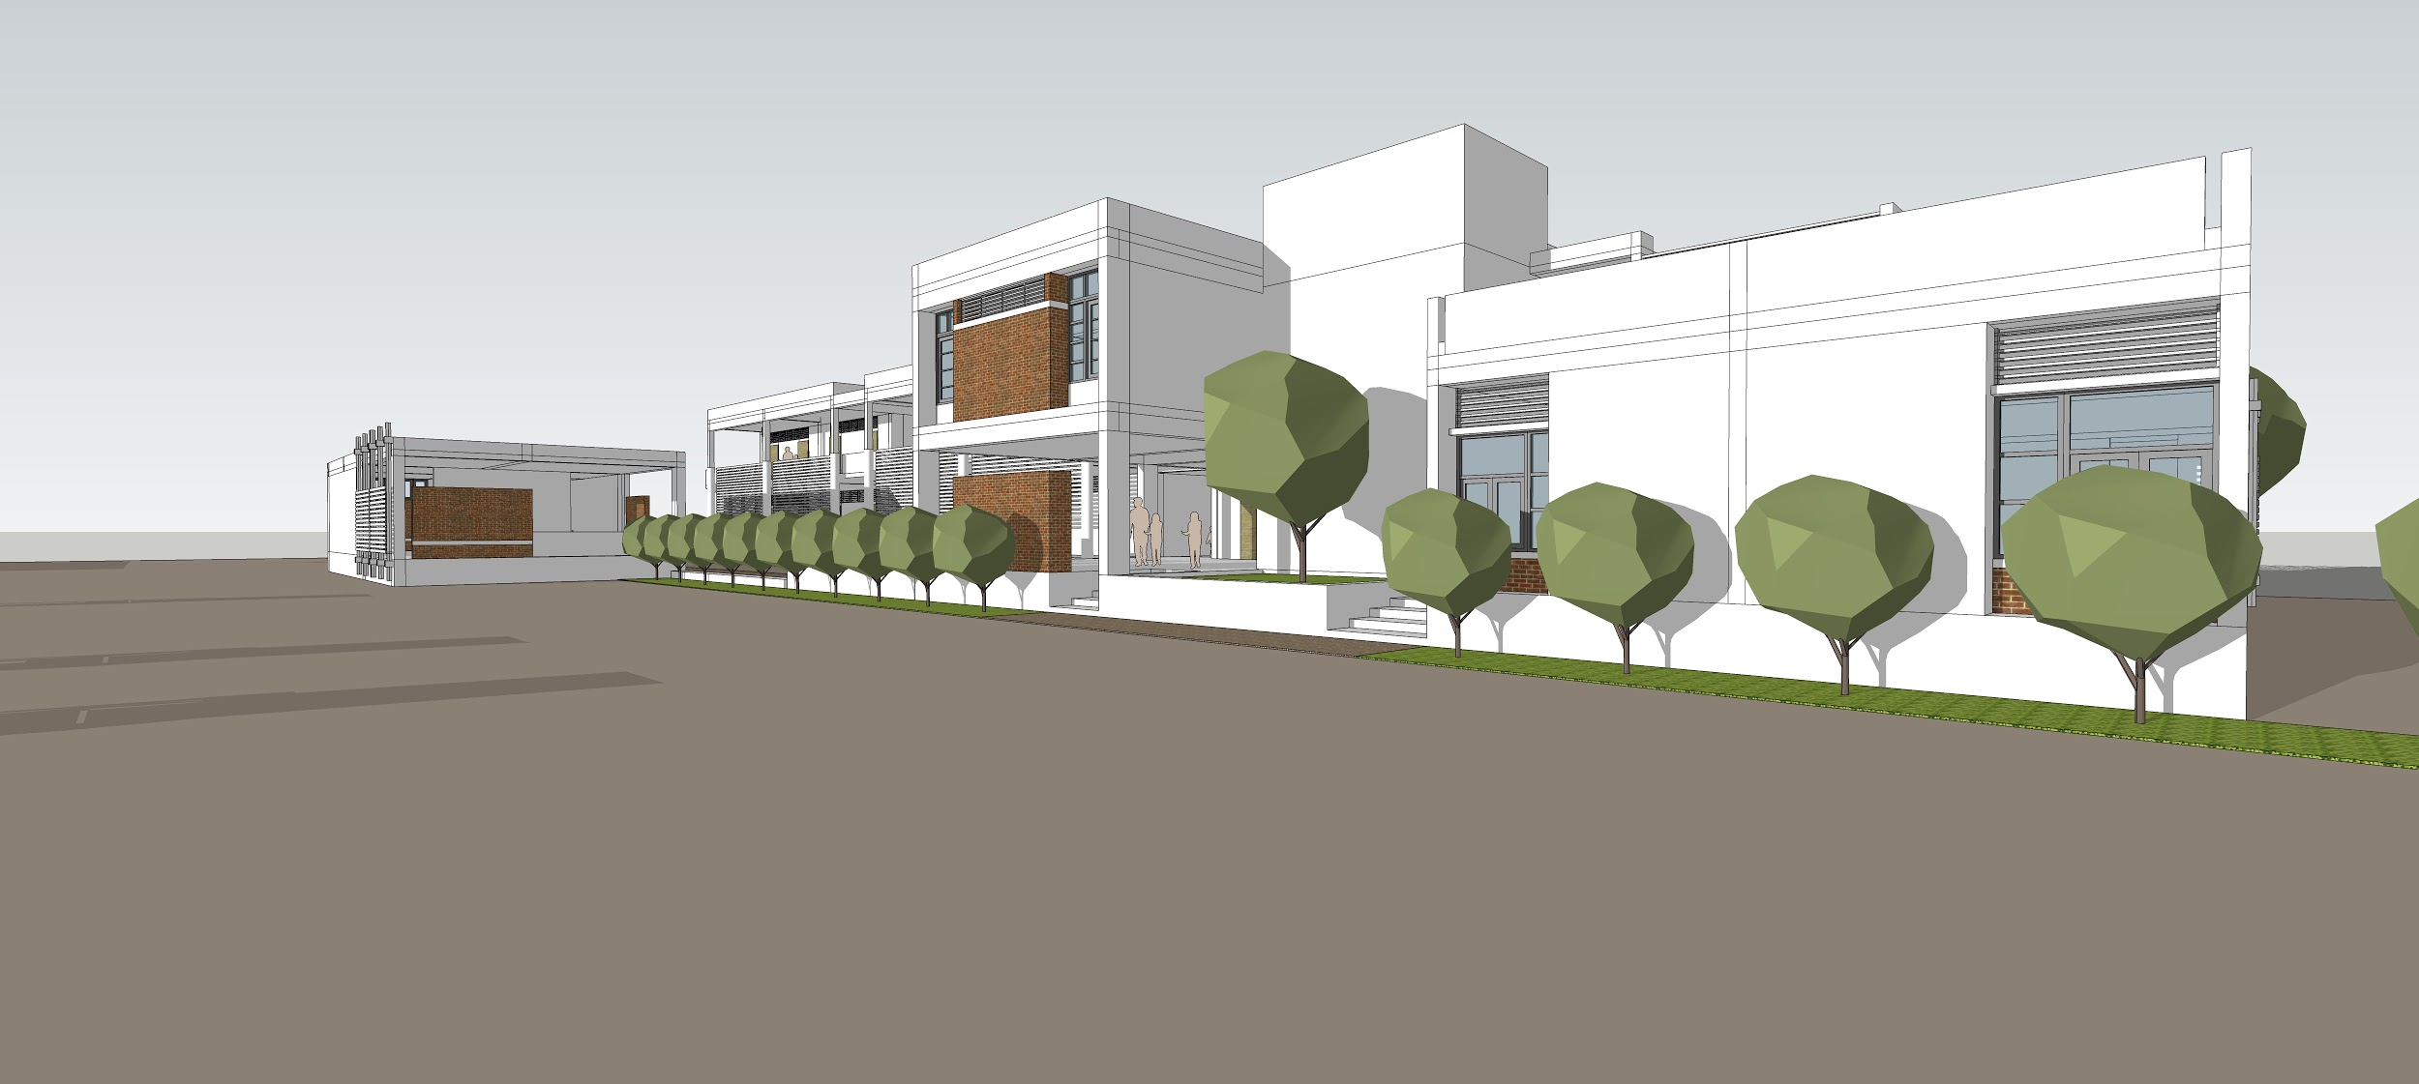

FOREFRONT intends to serve 40 students in its initial cohort of after school participants. These students will be recruited to join FOREFRONT International School when construction is completed and the school year begins. This will allow FOREFRONT to build upon the foundation of learning and critical thinking skills developed during the after school program.