KujaEcoPads Cameroon
…A breakthrough in women’s & wellness

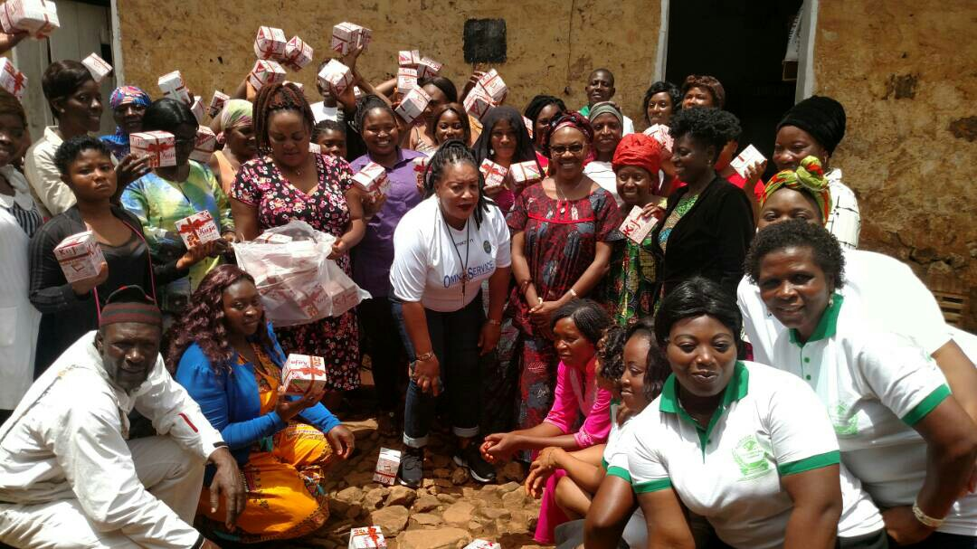
Cameroon’s First Biodegradable Sanitary Pad
Helping Women and Girls “Go Everywhere!”

Address: Bamendakwe, North West region Cameroon
Email: kujaecopads@gmail.com
Tel: +237676222247 +237680741533

CONTENTS

Executive Summary ………………………………………………………………………………………………………………………….
The Problem …………………………………………………………………………………………………………………………………….
Business Concept ……………………………………………………………………………………………………………………………..
Business Model ………………………………………………………………………………………………………………………………..
The Product ……………………………………………………………………………………………………………………………………..
Goals/Objectives ………………………………………………………………………………………………………………………………
Value Proposition …………………………………………………………………………………………………………………………….
Market Analysis ………………………………………………………………………………………………………………………………..
Target Market ………………………………………………………………………………………………………………………………….
Impact of Biodegradable/Affordable Pads in Cameroon ……………………………………………………………………….
Competition ……………………………………………………………………………………………………………………………………..
Project Road Map …………………………………………………………………………………………………………………………….
Risk/Barriers …………………………………………………………………………………………………………………………………….
Business Strategy …………………………………………………………………………………………………………………………….
Minimum Viable Product …………………………………………………………………………………………………………………
Partnership ………………………………………………………………………………………………………………………………………
Funding Required ……………………………………………………………………………………………………………………………..
Team ………………………………………………………………………………………………………………………………………………..

- EXECUTIVE SUMMARY
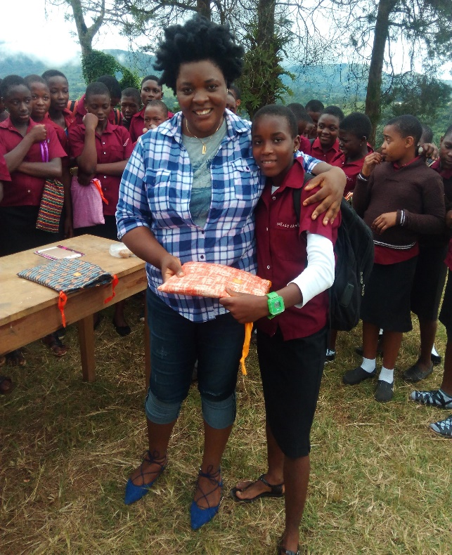
Meet Kuna. She lives in a rural part of Cameroon. Every month, she struggles to attend school while she has her menstrual period. Her menstrual period is extremely painful. Her reuse-able pad is soaked through but there is no running water to clean it. Kuna is actually not able to afford a western pad, so instead she improvises using rags, paper from her school books and leaves. Also, during her menstruation Kuna is faced with marginalization, shame and risk of infection because of the stigma and taboo that surrounds menstruation and the unhealthy choices for her. She is not even allowed to use water sources and latrines! Her community believes her menstruation brings bad luck to the entire community! Basically, Kuna cannot ‘Go Everywhere’ when she menstruates! Currently, a vast majority of young girls in Cameroon are facing the critical need of proper hygiene like Kuna, especially as they enter into adulthood. Deprived of the money to afford western pads and with the taboo associated with menstruation, girls are often left with no choice but to miss school during their period. Rural Cameroon has reportedly the highest dropout rate in Cameroon resulting from difficulties that girls experience when they are menstruating.

Marie-Claire Foundation aims to provide affordable, highly absorbent, biodegradable sanitary pads (KujaEcoPads) as an alternative to current unhygienic means, and commercialized western pads. By utilizing banana and plantain stem fibers to meet the demand of the target market, KujaEcoPads (made by Cameroonian Women for Cameroonian Women) is a win, win, solution. It financially supports banana/plantain farmers, increases resource development and efficiency, and improves the hygiene situation of women in Cameroon. Marie-Claire Foundation also create programs that help to raise awareness and provide education to eliminate the stigma and taboos of menstruation. The pads are currently being marketed and sold to local health maternity centers in each of the rural communities in the North West region, national and international non-for-profit organizations and relevant wholesalers and retailers. Also, rural women entrepreneurs are trained and supported to distribute the product. After the successful adoption of KujaEcoPads in rural communities in the North West region, the pads will be distributed in additional communities in Cameroon.
THE PROBLEM
The lack of affordable sanitary products for young girls has become an increasingly detrimental problem in third world countries. According to UNICEF, one out of ten adolescent girls in Africa miss school during their menstruation and eventually drop out. Young girls are at a disadvantage in terms of education, preventing their mobility and productivity as they mature. This certainly leads to the continuity of the poverty cycle and the inequity between genders in education opportunities. UNESCO reports that the majority of young girls are unable to afford basic sanitary care due to products costing above US $2, more than an average family lives on.
Also, another major problem associated with menstruation is taboo or traditions. Menstruation is still a stigma in major rural parts of Cameroon. This stems from lack of awareness and education about the basics of menstruation. During menstruation women in these areas are kept within their homes owing to certain traditions. Some communities believe that menstruation brings bad luck to the people, farm, business activities and the community at large. And because rural women do not have proper menstrual pad (one that absorbs and keeps the blood from flowing out), menstruating women and girls in rural communities prefer to stay in door 4-5 days a month during menstruation.
Currently, the vast majority of young girls in Cameroon are facing the critical need of proper hygiene, especially as they enter into adulthood. Deprived of the money to afford western pads and with the taboo associated with menstruation, girls are often left with no choice but to miss school during their period. Rural Cameroon has reportedly the highest dropout rate in Cameroon resulting from difficulties that girls experience when they are menstruating. The production of affordable sanitary pad for rural women and girls would enhance their health and encourage societal change. Furthermore, school attendance will increase among rural girls.
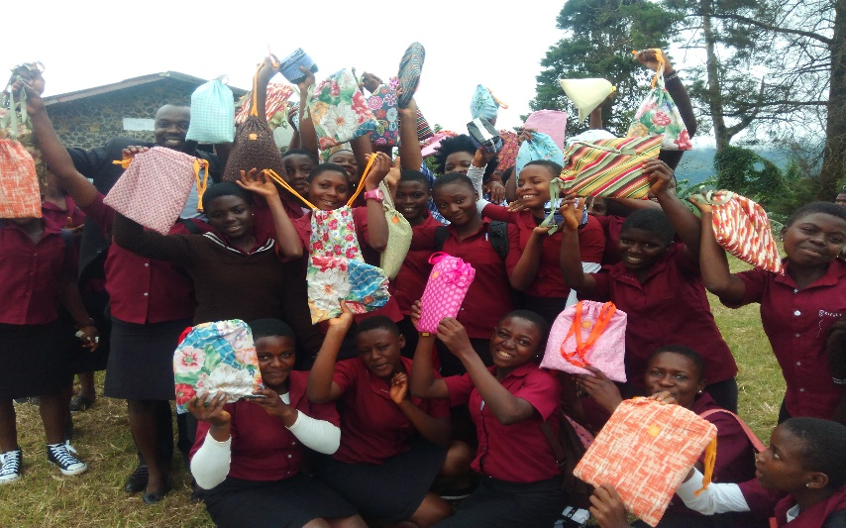

BUSINESS CONCEPT
The extent in which young girls and women are living without basic sanitation care raised the idea of making KujaEcoPads, a women led industry that produces the first biodegradable sanitary pads in Cameroon out of Banana fiber. KujaEcoPads aims to provide affordable, biodegradable sanitary pads as an alternative to western pads which are not accessible/available and affordable by rural women and girls. The Western pads are also purely increasing waste within Cameroon cities; this is neither sustainable nor desirable. KujaEcoPads will become alternative to reuse-able pads and papers, grass, rags, dung used as pads which often become prime breeding grounds for infectious diseases. KujaEcoPads will make use of fiber from Banana stem. Banana farmers will have additional source of income by supplying banana fiber to KujaEcoPads.

KujaEcoPads are designed to provide the ultimate comfort and protection. They are 100% natural with no harmful chemicals, no dyes, no rayon, no fragrances and are luxuriously soft. Our pads are carefully and beautifully packaged like most other feminine care products on the market. One individually wrapped KujaEcoPads cost 25c (100frs).A pack of four individually wrapped KujaEcoPads cost $1.00,( 500frs) a packet of eight individually wrapped KujaEcoPads cost $2.00 ( 1000frs) and a packet of sixteen individually wrapped KujaEcoPads cost $ 4 .00 (2000frs) and each with up to 7-9 hours of absorbency. The banana fiber is proven and completely safe for use in feminine products and is approved by Health Authorities in Cameroon. We have produced over 10000 pieces of sanitary pads manual labor and one machine which we bought using funds from the Pollination Project. The product is currently in circulation and being used by several rural Cameroonian women who are very satisfied with its quality. According to the test results, the fiber feels soft and the pad is easy to use, absorbs for longer hours compared to the less hygienic/traditional pad they use and they feel safe using it.
KujaEcoPads is sold at affordable prices to women to girls who really need them combined with puberty education and advocacy. KujaEcoPads envisions a product that will be identified with girls and women nationwide as Cameroon’s First local and biodegradable Pad brand that is produced “By Cameroonian Women for Cameroonian Women” satisfying the need of over 20 million rural Cameroonian women and girls. KujaEcoPads’s customers are girls and women between the ages of 10 and 55 (basically women and girls who menstruate) who live in rural Cameroon and live on less than a $ a day, who do not have access to the modern sanitary pad and cannot afford to buy one when these pads are available in their communities. Most of these women and girls work with their husbands/parents on the farms.
Marie-Claire Foundation will establish KujaEcoPads factory in North West, south west and central regions of Cameroon where the pads will be produced in collaboration with the local women and farmers. The pads will then be marketed and sold to local Health Maternity Centers in each Local Government Areas, Cameroon’s health and education ministries, and relevant national and international non-for-profit organizations. Also, Marie-Claire Foundation will train and engage rural women entrepreneurs (woman to woman sales force) to distribute the pads. After the successful adoption of KujaEcoPads in rural communities in the North West region, factory location, the pads will be distributed in additional communities in Cameroon. Once we have been able to adequately supply major communities in Cameroon, we will venture into the neighboring West and Central African countries. Also, KujaEcoPads will constantly improve the quality of the product so as to appeal to the growing population of the urban/city women and girls. KujaEcoPads aims to not only provide affordable sanitary care for young women and girls in need, and jobs for local women, but also empower these girls and women to foster sustainable practices, while also removing the barriers to education caused by issues to enhance the lives of future generations.
BUSINESS MODEL
KujaEcoPads extract fibers from banana stem and converts it to sanitary pads. These pads are supplied to local distributors in rural communities to ensure that the pads get to the right people who are most in need of it. We also supply to maternity centers, NGOs, retail shops and schools to ensure women and girls from underprivileged communities access KujaEcoPads
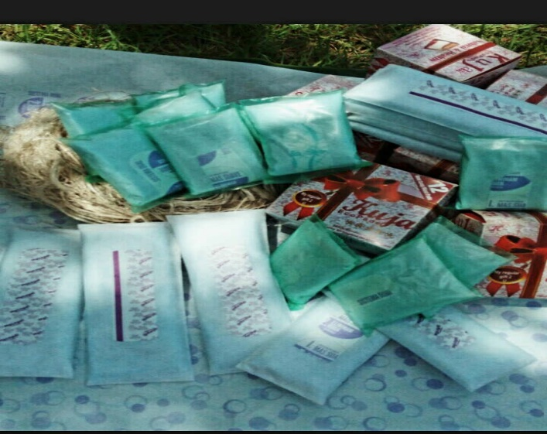

THE PRODUCT
KujaEcoPads is a biodegradable pad that are designed to provide the ultimate comfort and protection. Our pads are carefully and beautifully packaged like most other feminine care products on the market. One individually wrapped KujaEcoPads cost 25c (100 FRS).A pack of four individually wrapped KujaEcoPads cost $1.00, (500 FRS) a packet of eight individually wrapped KujaEcoPads cost $2.00 (1000 FRS) and a packet of sixteen individually wrapped KujaEcoPads cost $ 4 .00 (2000 FRS) and each with up to 7-9 hours of absorbency.

The banana fiber is proven and completely safe for use in feminine products and will be approved by Health Authorities in Cameroon.

The production process begins with Banana farmers taking their banana stems to the low cost Community Fiber Extraction Unit (run by a network of women) to extract the fiber. The tools at the Unit is provided by KujaEcoPads. The women running the unit are adequately trained. The network women pay the banana farmer for the amount of fiber extracted. KujaEcoPads in turn buys the fiber from the women network at the Fiber Extraction Unit and fiber is taken to KujaEcoPads factory where it is processed into biodegradable sanitary pad. At the factory, the fiber gets cut, washed, blended, solar dried, and fluffed and finally assembled.
KujaEcoPads is sold at affordable prices (70% cheaper than mainstream brands) to women and girls who really need them combined with puberty education and advocacy. KujaEcoPads envisions a product that will be identified with girls and women nationwide as Cameroon’s First local and biodegradable Pad brand that is produced “By Cameroonian Women for Cameroonian Women” satisfying the need of over 20 million rural Cameroonian women and girls. KujaEcoPads’s customers are girls and women between the ages of 8 and 55 (basically women and girls who menstruate) who live in rural and semi urban Cameroon and live on less than a $ a day, do not have access to the modern sanitary pad and cannot afford to buy one when these pads are available in their communities. Most of these women and girls work with their husbands/parents on the farms.
We also cater for the needs of women and girls with disabilities, homeless women, women in prison and women from indigenous communities who are relegated to the back.

GOAL/OBJECTIVES
- KujaEcoPads guarantees rural girl participation in school and prevent hygiene diseases caused by lack of resources. We aim to reduce the amount of girls dropping out of school
- Empower women with leadership and self-esteem. Women work for women, enabling them to take a shot at entrepreneurship, enhancing the importance of girls within society, and the future generations.
- Provide an alternative for rural women’s basic necessities. Women now have the opportunity to obtain a low cost pad with reliable materials that have much less environmental impact than traditional and western pads.
- Resource and waste management and boost rural farmers’ source of livelihood. Banana/plantain farmers will have the opportunity to make more money by selling their supposedly waste banana stem. They will earn more and can take care of their families, and send kids to school.
- Help to demystify taboos and traditions around menstruation. Rural women and girls will be able to attend to their normal socio-economic life during menstruation.
VALUE PROPOSITION
Social Value: One of the main values of this project is Community empowerment. Through this network focused and industrialized process of producing the pads, employment is created and education maximized for women involved. Rather than having donations provided, women now have the ability to earn themselves income in the project through running the Community Fiber Extraction unit and working in the production unit. This enables them to achieve financial independence and benefit from an increased acquisition of practical and vocational skills to promote a feeling of self-worth. By having women at the core production of the pad, this helps to promote the self-esteem of women and also adds a promotional value for the product ‘Pad produced by Cameroonian Women for Cameroonian Women”
Environmental Value: Resource and waste management is a key success factor of the industry. We are converting what is considered ‘useless’ on the farm into a useful item that benefits rural women. Also, by using KujaEcoPads, which is biodegradable, there will be a reduction in the use of western pads which is non-biodegradable.
Economic Value: The most important Economic benefit this project generates is Education. The learning and training process achieved through this cycle will enable young women to be economically independent. Women will have new skills to run social enterprises, education on menstruation – an issue that affects every aspect of their rural life. Women will have a new product that will enable them attend to their socio-economic activities during menstruation thus boosting their income. There will be an enhanced livelihood for women who work at the production unit including the fiber extraction unit thus aiding in the reduction of poverty.

MARKET ANALYSIS
Over 20 million women in rural Cameroon do not currently use pads during menstruation because pads are not accessible/available, affordable and rural women are not educated about proper feminine hygiene. The lack of affordable sanitary pads in rural Cameroon currently leads to marginalization of menstruating women. Usually, girls would not go to school when menstruating. Some girls even drop out of the school system due to poor attendance and rural women are pushed out of work when they menstruate making them lose 4 – 5 days of income. School girls feel stigmatized whenever they stain their uniforms therefore they opt to stay at home until after their period. The situation is no different at home; they are pressurized to keep the tiny rags they use to pad themselves out of sight from their family members. Girls often hide these rags in dark places resulting in many not being fully dried before reusing. This exposes the girls to bacterial-infected cloths in their genital region, imposes risks of infection and hygiene-related illnesses which might cause reproductive issues in the future and possibly infertility.
Also, conservative current estimates conclude that there are over 40 million women in Cameroon between the ages of 12 and 50. Given that currently the rural/urban divide is 50%, which equates to 20 million rural women of menstruating age. If every woman needs an average of 5 pads per month, 100 million pads are required in rural Cameroon every month, and 1.2 billion every year. At an average of $1USD per monthly supply, that makes the market worth approximately $1.2 billion USD per year and $100 million USD per month. With the population of Cameroon set to double within the next 30 years, there is going to be an increasing need for sanitary pads in the foreseeable future. The core problem is rural young women and girls do not have sanitary pad when on their menstrual cycle, increasing the need for an affordable, biodegradable and durable padding solution. This possesses an opportunity for KujaEcoPads, as there is evidently a consumer demand.

TARGET MARKET
There is an awaiting need for an alternative to western and unhygienic menstrual towel. KujaEcoPads is able to satisfy this need through recognizing the importance in targeting school girls and young women from the ages of 12-50, who live in rural areas and households where basic hygiene needs are disregarded in favour of basic household items for survival. After the successful adoption of KujaEcoPads in rural communities in the North West region of Cameroon, factory location, the pads will be distributed in additional communities in Cameroon. Once we have been able to adequately supply major communities in Cameroon, we will venture into the neighboring West African countries. Also, KujaEcoPads will constantly improve the quality of the product so as to appeal to the growing population of the urban/city women and girls. KujaEcoPads will target; local schools, health care clinics, NGOs that work with underprivileged women and girls, rural women entrepreneurs, encouraging them to promote the sales of KujaEcoPads as an alternative to similar products on the market.
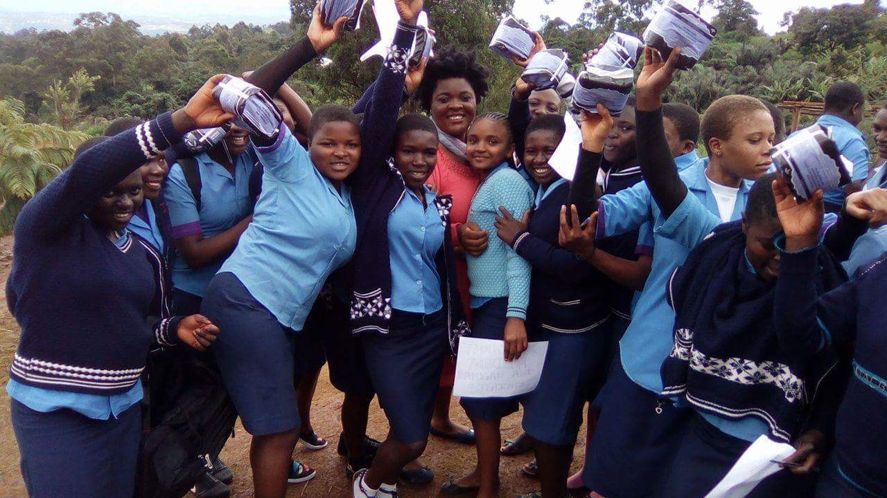

IMPACT OF BIODEGRADABLE/AFFORDABLE SANITARY PADS IN CAMEROON
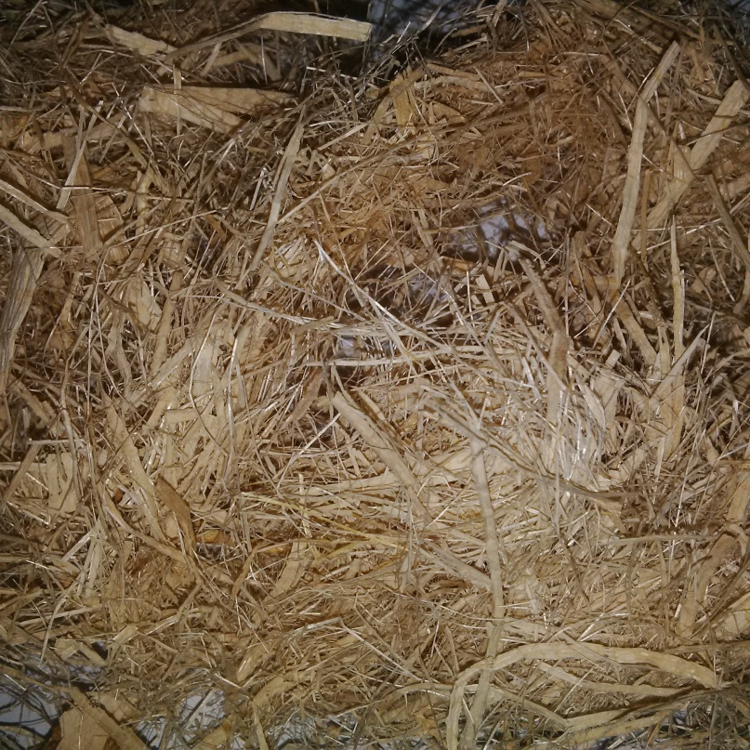
The production of a locally made pad provides young women/girls a low cost, biodegradable product that sustains income-generating jobs. It provides girls with access to necessary personal hygiene products, with the goal of breaking the stigma around menstruation. Using the banana fiber helps to provide additional income for rural farmers and manage resources and farm waste. The presence of KujaEcoPads in the market will restore confidence in the girls, increasing class attendance, boost socio-economic activities of women as they will be able to go about their day without discomfort.
KujaEcoPads will also stir the locals and associated taboos providing solutions for menstrual bleeding, through the presence of local curiosity. KujaEcoPads will provide educational discussions on the importance of the female menstrual cycle, teaching locals how to effectively approach the topic. This will tackle the issue of embarrassment, reassuring them that there is no shame in asking questions, also teaching them how to dispose of their pads publicly without having to secretly hide them. It is necessary for the world to make sound decisions at present, in order to avoid limiting the choices of generations to come.
Within the community, KujaEcoPads will be contributing to the local economy by creating jobs for women through KujaEcoPads, thus empowering previously disadvantaged women as well. Furthermore, these women will learn the importance of using biodegradable products to preserve their environment for current and future generations.

COMPETITIVE ANAYSIS/COMPETITORS
We compete directly with other sanitary pad making companies such as Hygenix, Diva comfort, and other local producers of western pads. Although these companies have already entered the market for pads, few are addressing the needs of rural girls and young women. These large companies do not have viable distribution channels in rural Cameroon. Sometimes, when these pads eventually reach some rural communities, they become unaffordable for rural women and girls. Buying a pack of pads at a price over $1.5 in rural communities is seriously unaffordable for these poor women and farmers’ children,orphans,women and girls with disabilities and women in prison who live on less than a $ a day! Also, there are no producers of biodegradable sanitary pads in Cameroon market. Reusable menstrual cloths on the other hand are a hazard here because of the lack of running water to keep the cloths clean after use. We have noticed that girls do not like the reusable pads and always convert them to face towels, wipes, handkerchiefs etc. and go for disposable pads.
KujaEcoPads is the first biodegradable pad in Cameroon and central Africa made from banana and plantain fiber. KujaEcoPads is produced to quality and is 70% cheaper than regular pads and accessible to rural women and it is fully biodegradable. We offer the highest quality product at its price.

SCALING UP/PROJECT ROAD MAP
- Buy a piece of land and establish a production center that will serve communities in North West Cameroon and implement a plan to open 5 new production centers over the next 5 years in 5 Geopolitical Zones in Cameroon. The first factory will be located in the North west and South West regions with good proximity to banana/plantain farmers
- Establish 5 Fiber Extraction Units in 5 communities that have high numbers of Banana/Plantain farmers
- Recruit and train 20 project managers and staff in various fields, including finance, production, marketing, distribution, human resources, fundraising and Health Education
- Recruit and train 20 rural women and girls from 5 communities who will manage/run the Fiber Extraction Units, work at the production factory and serve as distributors and Puberty Education Agents within their communities.
- Attract USD100,000 funding to purchase production equipment, materials and construct the first production center and Fiber Extraction Units
- Buy a four wheel truck to assist in transporting banana and plantain stems from farms to the extraction units
- Buy sanitary napkins vending machines to facilitate sales of pads
- Buy 5 solar dyer to dry fibers during rainy season.
- Buy 5 fiber extraction machines for the extraction unit.
- Buy a generator to help us during electricity cuts. We sometimes do not work for a whole week due to constant power cuts.
- But a solar dryer to use during running season when the sun rarely shines enough to dry the fibers
- Set up local radio programs to demystify unhealthy traditions and taboos about menstruation
- We will constantly Review and Refine: A reflective look on our project, what’s worked, what hasn’t worked, what can be adjusted and improved.
- Purchase licenses and trademarks such as, Intellectual property right, ANOR and factory space. At the same time, we are working on developing key partnerships with rural development organizations, Ministry of Health and NGOs which will play important roles in marketing and distribution.

RISK/BARRIERS
The biggest challenges this project will face includes the following:
- Competitors: When they notice that Cameroonian women (especially in urban/cities) are buying more of biodegradable pads and less of standard/western pads, the direct competitors – Divacomfort and Hygienix might want to start producing pads that are biodegradable and initiate marketing and pricing plans to target rural women and girls. KujaEcoPads must be prompt with its marketing strategies and expansion to other geo-political regions in the country. Marie-Claire foundation, the initiator of KujaEcoPads, has large network of banana/plantain farmers in Cameroon. We will continue to develop and expand on this network so that we will have monopoly of the major raw materials – banana/plantain fiber.
- There is a risk of malfunctions and defects with the pads since we are using a fiber based plant. To face this problem, we will have to be very meticulous in testing our product and speedily responding to any defects.
- Piracy. Products that excel in the Cameroonian market are open to the risk of piracy. We will have a team that constantly checkmate this and will keep orientating our customers to constantly look for the original product seal.

BUSINESS STRATEGY
Growth Strategy
After the successful implementation of this business venture, KujaEcoPads proposes to expand its operations to other remote parts of Cameroon and neighboring countries including all CEMAC countries and neighboring Nigeria, Ghana, Togo etc. Each of these areas provides evidence of decreasing educational attendance, and poor sanitation practices. These geographical locations provide prevalent demand for sanitary products, due to markets, which have not yet been entered into. We would have to make further investments targeted towards setting up more factories. Our aim is not to stop here, but to develop our pads further, while establishing an education programme for girls and young women promoting a supportive environment for discussing periods and how to manage them. These sessions will be led by local rural nurses, and will occur once a month.
Marketing Strategy
As KujaEcoPads stands to be a new product, we will use a product development approach to introduce the new product. Then, as KujaEcoPads becomes more visible in the industry, we will shift to a combination of push and pull strategies in order to increase consumer demand, while enlarging market share.
A “push” promotional strategy makes use of a company's trade promotion activities to create consumer demand for a product. This will be done through: Educational outreach sessions provided in schools, and local events to tackle the stigma surround female youth and menstruation. Local healthcare clinics will provide seminars to young girls explaining the dos and don’ts in regards to hygienic practices and appropriate products to use (KujaEcoPads will use this as a form of distribution/advertising). They will therefore go on to promote the use of KujaEcoPads throughout their operations, establishing their key advantage to other brands. KujaEcoPads will also create incentive schemes for retailers and wholesalers on the benefits of supplying KujaEcoPads compared to others. Also, rural women entrepreneurs will form strategic distribution partners in their various communities.

MINIMUM VIABLE PRODUCT
In early 2017, KujaEcoPads tested the product in several communities in Cameroon. With support from pollination project USA we purchased one machine which combined with manual labor has helped us to produce 10000 pieces of biodegradable pads till date with the use of banana fiber. We distribute these pads to girls and young women in many communities in North West, Cameroon to test.
These are some of the feedbacks gotten from the women and girls who used the sanitary pad:
- It doesn’t itch; I like it.
- I think it’s very soft.
- I am surprised that something from the environment can be used to make something this useful.
- I am happy because now I can get affordable sanitary pads.
- I wish it was longer.
- Yes, this is our own!!! This is made in Cameroon!
There were some defects identified by the users of the pad when we first started production. But we corrected already.
Also, we publicized the product on Facebook where we received over 800 feedbacks and emails. We have received emails and phone calls from distributors in Limbe, Yaoundé, Douala, Buea, Kenya and Ghana who are interested in partnering in the area of distribution.

ESTABLISHING PARTNERSHIPS
Partnerships with non-governmental organizations would be beneficial for both parties as, whilst promoting KujaEcoPads products, they will be encouraging sustainable behavior, working towards diminishing poor educational attendance, and improving hygienic sanitation.

KujaEcoPads would seek sponsorship from Donor organizations that target rural development, women and girl empowerment, Health, Mother and Child development and Entrepreneurship Development. We will identify these organizations, submit proposals to them and also set up meetings with them.

We have contacted the maker of sanitary pad equipment in India. We will receive further technical support from them.

The Ministry of Health Cameroon would be the foremost alliance in which KujaEcoPads would seek. Through their constant mission to provide the highest possible level of health services to all people in Cameroon, healthcare is their upmost concern, through purchasing and distributing our products both parties can profit from this relationship; via increasing hygienic sanitation issues in girls, and providing KujaEcoPads with financial sustainability.

Team: KujaEcoPads have a team of three:
- Marie-Claire N.Kuja, Founder/CEO
- Samuel Atigi Motom,Chief Operating Officer
- Kuja Yvette, Secretary


Fomuso Blessing
Secretary
Marie-Claire N. Kuja
The Founder/CEO

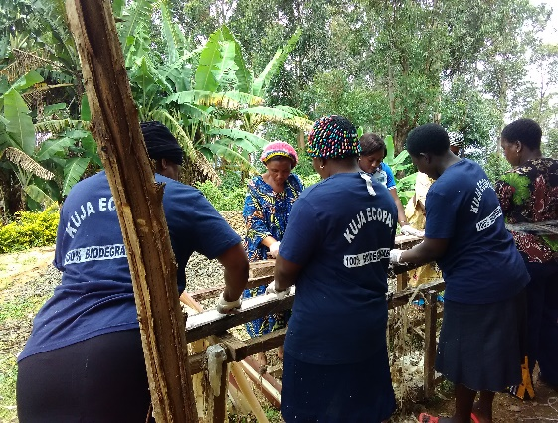
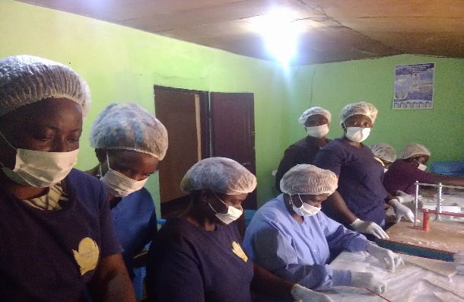
Samuel Atigi Motom
Chief Operating Officer
Figure 6 Kuja Women in the production unit making sanitary pads
Figure 5 Kuja Women extracting fiber from banana stem

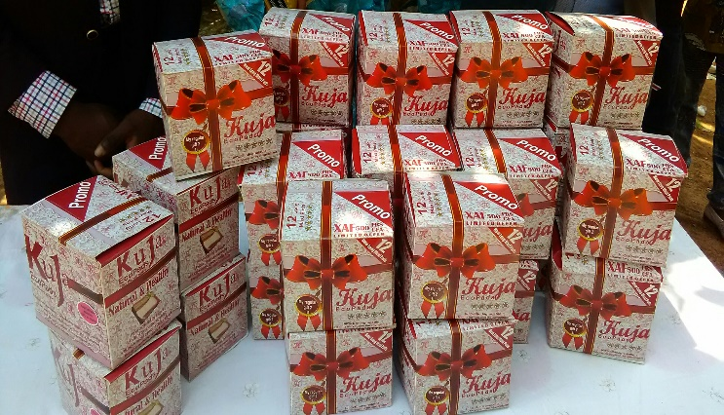
Figure 7 our packaging