GRANT ASSISTANCE FOR CONSTRUCTION OF THREE CLASSROOM BLOCKS FOR 150 CHILDREN IN GHANA AKURA COMMUNITIES

1. Full Name and Address of Organization Applying: LOVE AND CARE FOUNDATION

Contact Person: _DANIEL ASHONG NARTEY

Town, District, Region Where Project is Located:

EJURA SEKYEDUMASE MUNICIPALITIES (JATO AKURA located in Ghana Akura)

EVA ADJEI POKUAA ANAGRO STREET ALAFIA JUNCTION (Konongo Odumase)
TEL: 0322494691 /0244544820 / 0245879325

2. Background, Membership, and Objectives of the Organization:

Love and care Foundation evolved through the vision of its chairman. He discovered how the rural poor suffer during their farming activities (3-5 miles walk to their various farms), and how children of school going age help their parents in the farms instead of being in classrooms. The founding chairman, Daniel Ashong Nartey, whiles working at the Jasikan District Assembly in the Volta Region; as a Civil Servant, embarked on a personal initiative and organized free evening classes for children of school going age. Later with the help of the Vice Chairman and the Secretary of the organization, it was legalized as a registered charitable organization with the primary objectives of helping the vulnerable and needy (children) across the length and breadth of Ghana. On the 26th October 2017 the organization was registered as a Non-Governmental Organization. The Organization is democratically operated. According to the organization’s guidelines, elections will be held once in every four years. It is governed by Bye Laws, sexual harassment laws and a code of ethics for employees.

The organization is made up of ten members, with five in executive positions:
Daniel Ashong Nartey: Chairman
Nathan Wleh : Vice Chairman
Eva Pokuaa: Treasurer
Brandford Twumasi: Senior Project Officer

3. List of the organization’s past and present Self-Help Programs and how they have aided in developing the community and district:

- Eight Thousand Cedis apartment located at Konongo Odumase (Office and two bed room apartment to aid children with special needs.

- Donated clothes, and shoes worth two Thousand Ghana Cedis to the people of Ghana Akura (Jato Akura, Yaayaaso, Samale Akura, Nkyensen Akura, Nokware Asa and Bompa, Ashanti Region.

- Donated teaching and learning materials worth GHS1,000 to Jato Akura RC, and the children of Akura, Ashanti Region.

- Educational support for eight children between the ages of six and ten years at Akura, Ashanti Region. This support included teaching and learning materials.

- Acquisition of Land for school building at Ghana Akura, Ashanti Region.

- Financial literacy programme to the small holder farmers at Jato Akura, Yaayaano and samale Nkwanta. That is basic Income and Expenditure, profit and savings etc.

- Massive spraying exercise at Ayimadukrom, Ashanti Region.

4. Purpose of Fund: Construction of three Classroom Block

The fund will assist for construction of three complete Poured concrete classroom blocks. The following are the specifications of size and structure of the school complex: it includes Classrooms, Staff rooms, Latrine, and Disability access/facility:

Site selection criteria for school
- maximum of 3 km from the villages.
Students per classroom
- class 1-6 shall contain 45-50 children, from the various villages
Class size and School size are as follows:
- Classroom space shall 0.7m2 per child
- classroom size shall be 7.5m x 5m
Classrooms windows :
- Natural Lighting from left of Children
- Blackboard position vis-a-vis window side
- Area of windows: 20% of floor area
- Sufficient ventilation

Doors:
- Wider corridor/paved pathway on outside

Roofing
- Long span aluminum roofing sheet 289m2 and 48m.
Disability response
- Provision of ramp access

5. The following are the information on the cost of the project:

Total project cost: $27,750.00

Community contribution: $1,667.00

Global given: $23,333.00

Other contributions: $2,750.00

6. List of items to be purchased with the project fund.
Size or Model | Unit of Sale | Cedi Price  Per Unit | Quantity | Total Price
Example:  12”x1”x16” | Each  case | 1,000  3,350 | 75  4 | 75,000  13,400

Wood  Wawa: 2*4*16  2*6*16  2*3*16  2*2*16  Facial Board  Afram  Wawa Board  Sapele  Doors  Paniel Simple Doors: 900*2015  Mazoria Door  Odum Door  Red wood door  Single Face Door  12*100mm Hollow design PVC tongue and grooved profile Board (Ceiling)  Rendered walls and Sofit  Glazed Aluminium Louvre Windows(supply and installation)  Power Supply Materials and Equipment’s:  120mm2 all aluminiun conductor (AAC) with all stringing accessories  4*1 core 25mm2 pvc insulated copper  25/120mm copper/aluminum bimetallic line tap  Concrete/ Block work  150mm solid sand b block wall in cement and sand (1:4) Mortal provisional  12mm Diameter bars I beam/linntel | Each  each  each  each  each  each  each  Each  Each  Each  Each  Each  M2  Each  Each  Each  Each  Each  M2  kg | GHS/UNIT  24  35  19  55  65  45  30  1,000  200  190  190  115  2,976.00  9.55  6  1,000.00  5.00  72.00  96.00  5.60 | 1  1  1  1  1  1  1  1  1  1  1  1  1  526  583  300  200  4  184  277 | GHS  24  35  19  55  65  45  30
287.00

1,000

200

190

170

115

2,976

5,023.30

3,498.00

3,000.00

1,000.00

288.00

17,664.00

1,551.20

Total Amount Requested _________$10,000

10. What has already been done?
Land acquired and cleared, excavation and Earth work have been done, hard core fillings is completed, foundation laid, erection of walls is ongoing, part of the wood is supplied by the community members

7. When did work on the project begin?

October 2018

8. Approximate time it will take to complete the project once funds are granted. How Much work needs to be done and how long it will take.

By March 2019 with the help of the global given fund raising grants construction will be complete. Foundation is laid and wall is built to three layers.

The following are the work that need to be done:

- Block and concrete work to fence / window level
- Carpentry and joinery Work
- Metal work (glazed aluminum and louvre windows)
- Roofing Sheets
- Plumbing and engineering installation
- Electrical Installation
- Plaster work and other floor wall and ceiling finishing
- Painting and decorating

9. Details of contributions to be made by the community:

1 professional carpenter (8hrs per day *5days): 40hrs
12 male laborers (8hrs per day*5days) : 480hrs
5 female laborers (3hrs per day*5days) : 75hrs
70 pieces of wawa 2*6*16 @ GHS35 : GHS2,450.00
2trips of Sand @GHS750 : GHS1,500.00
3plots of land 100*120@GHS1500 : GHS 4,500.00

10. Who will be the project leader and the person responsible for ensuring completion of the project? What are his/her qualifications for the project?

Mr. Daniel Ashongg Nartey

11. When completed, will the project need any professional or technically trained people to operate it?

YES, the Ghana Education Service is ready to assist us with professional teachers. (Attached is a letter of support from the Director of Ejura Sekyedumase Municipal Education Service).

11. Approximate number of people who will benefit directly from the project.

150 children from six deprived communities (Yaaya Akuraa, Jato Akura, Adamu Akura, Bompa, Nukwreasa and samale nkwanta all in the Ejura Sekyedumase Municipality of the Ashanti Region.

12. Will records be kept for at least three years and be made available for inspection?

Yes, Love and care Foundation keeps accurate records of all financial inflows and outflows, donations, and projects undertaken for Audit purposes. This is to ensure transparency and good standing in the eyes of donors and the general public.

23. What role, if any, will the government of Ghana play in this project?

The provision of Professional teachers from Ghana Education Service, Syllabus and Text books

Brochures
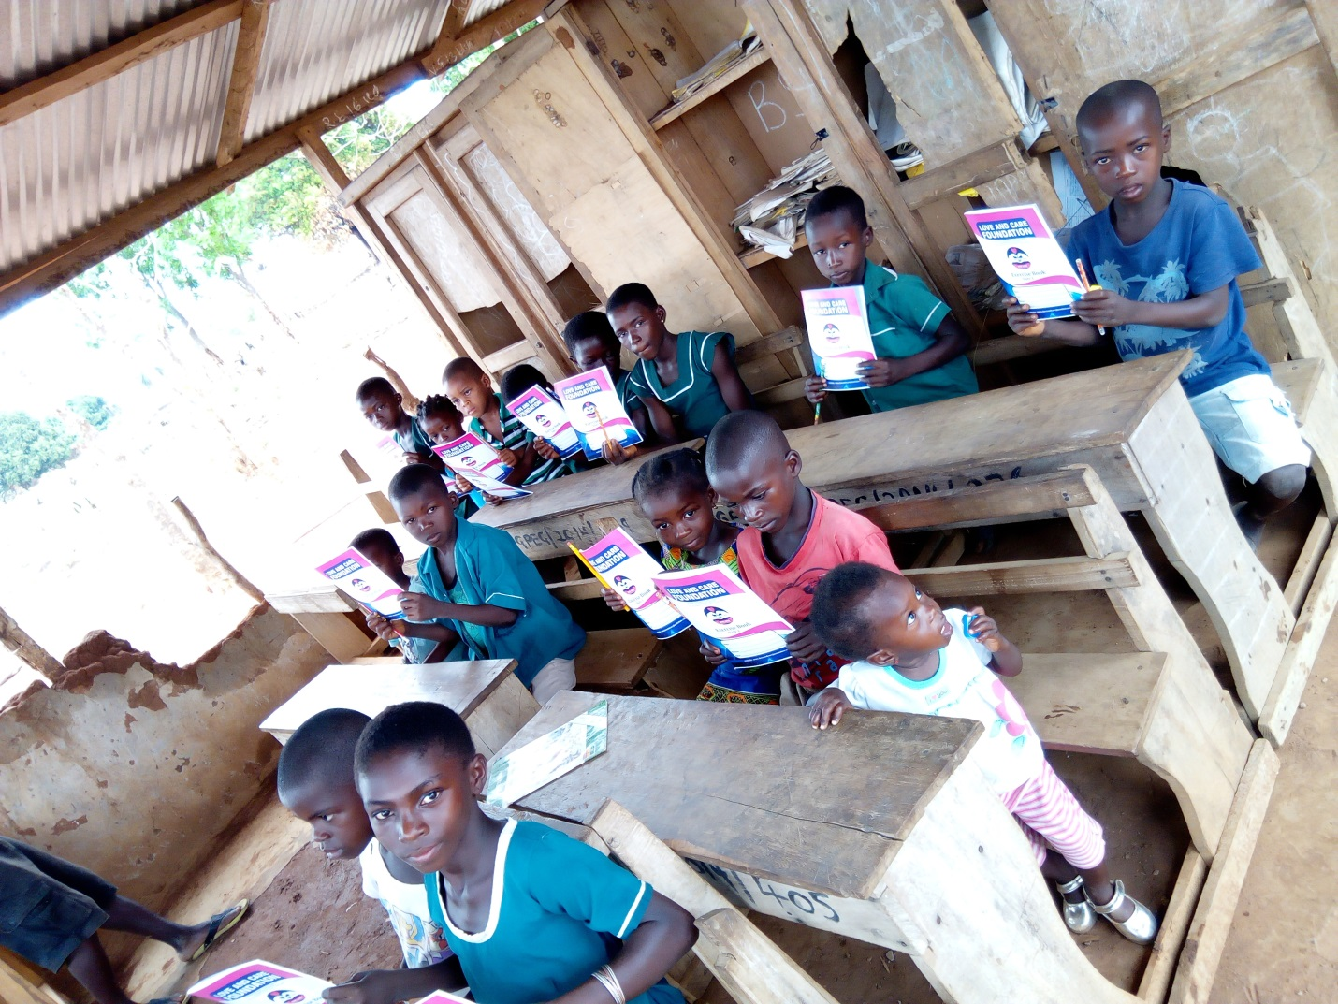
Distribution of teaching and learning materials to Jato Akura L.A

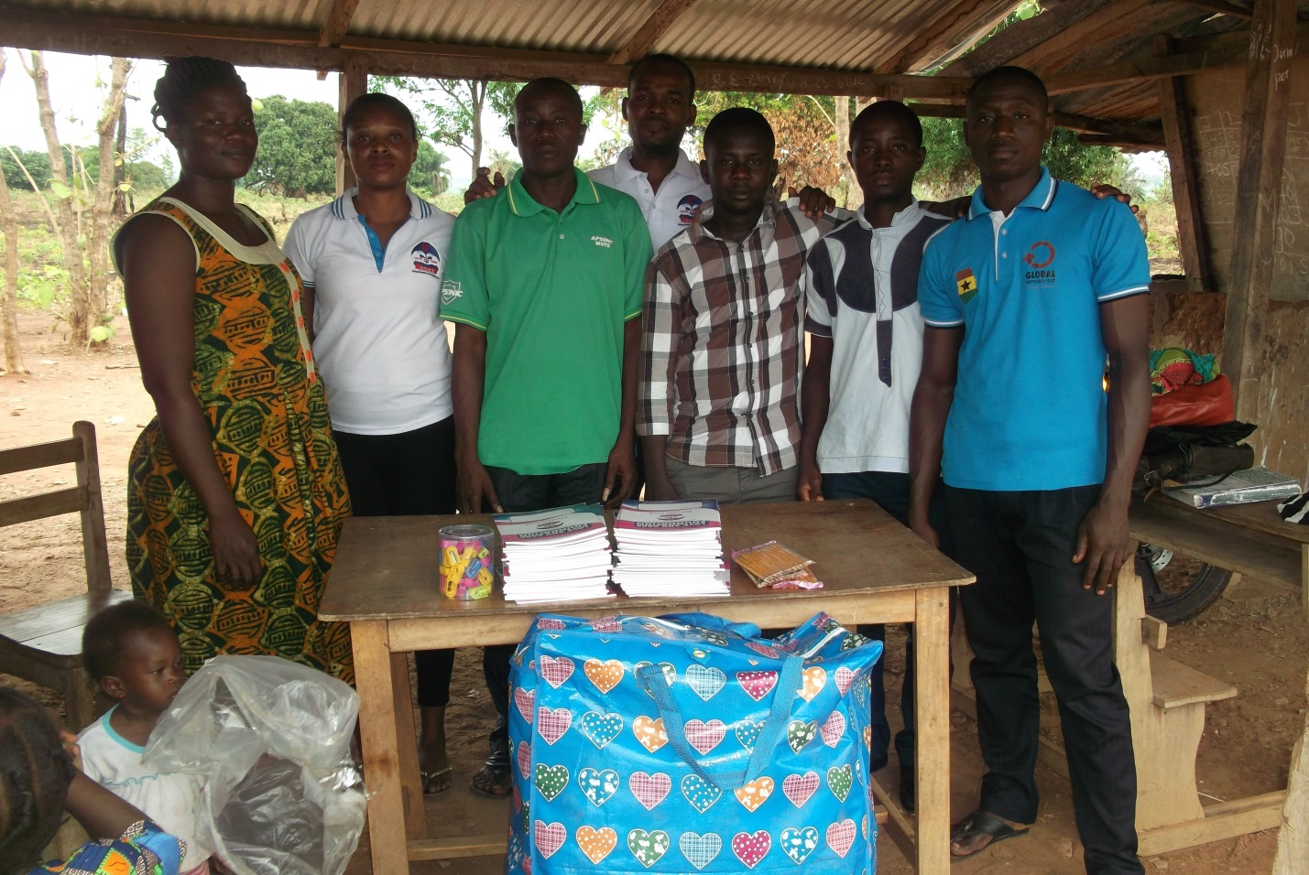

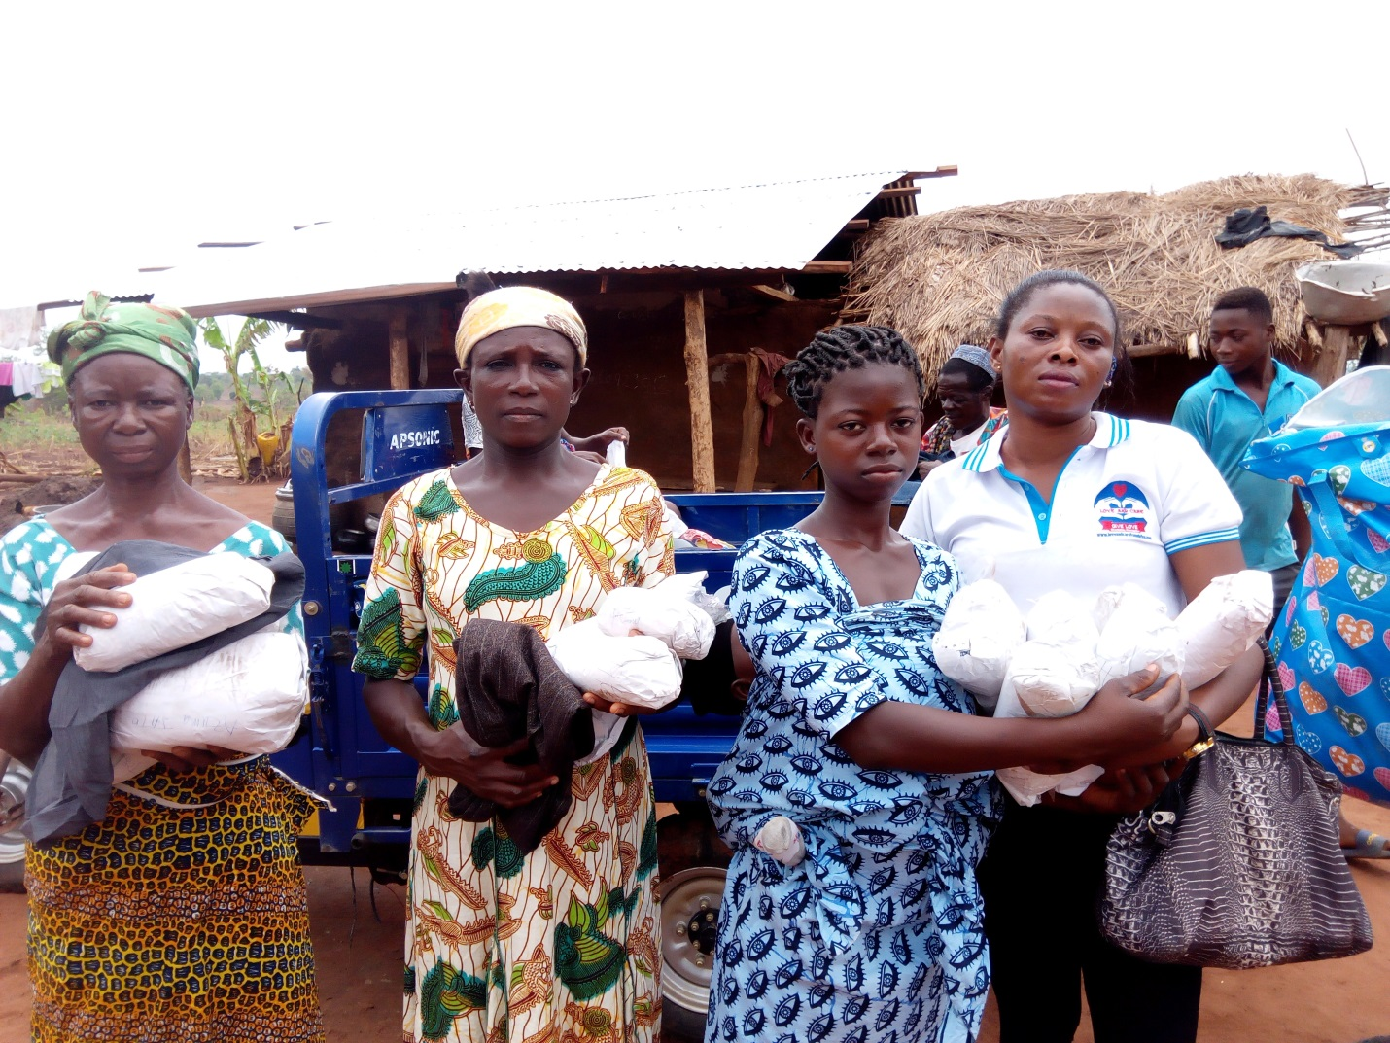

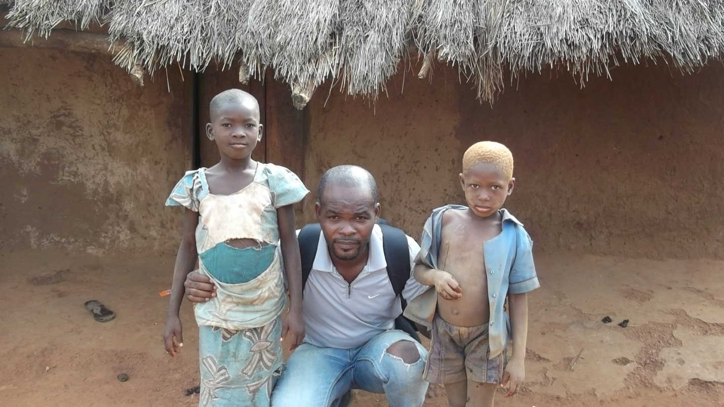

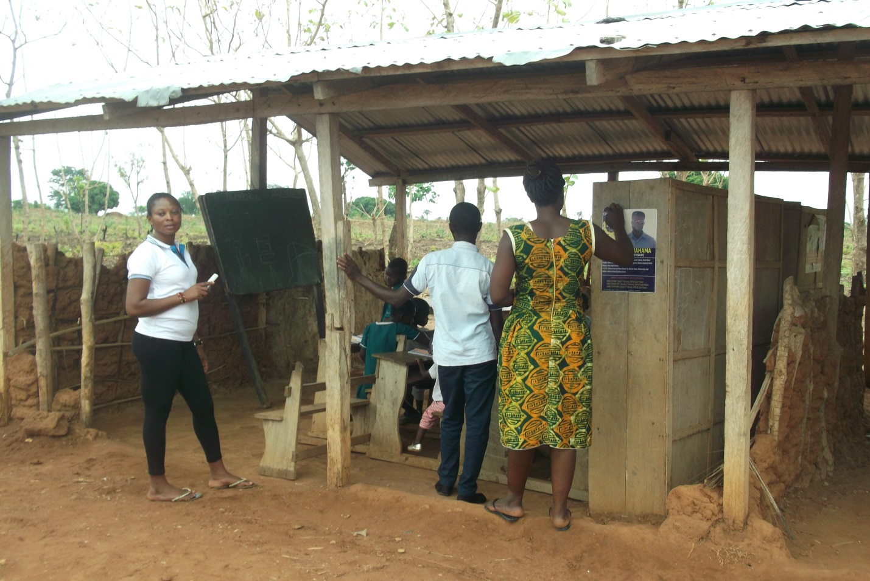
Jato Akura L.A the Only school that serve the community

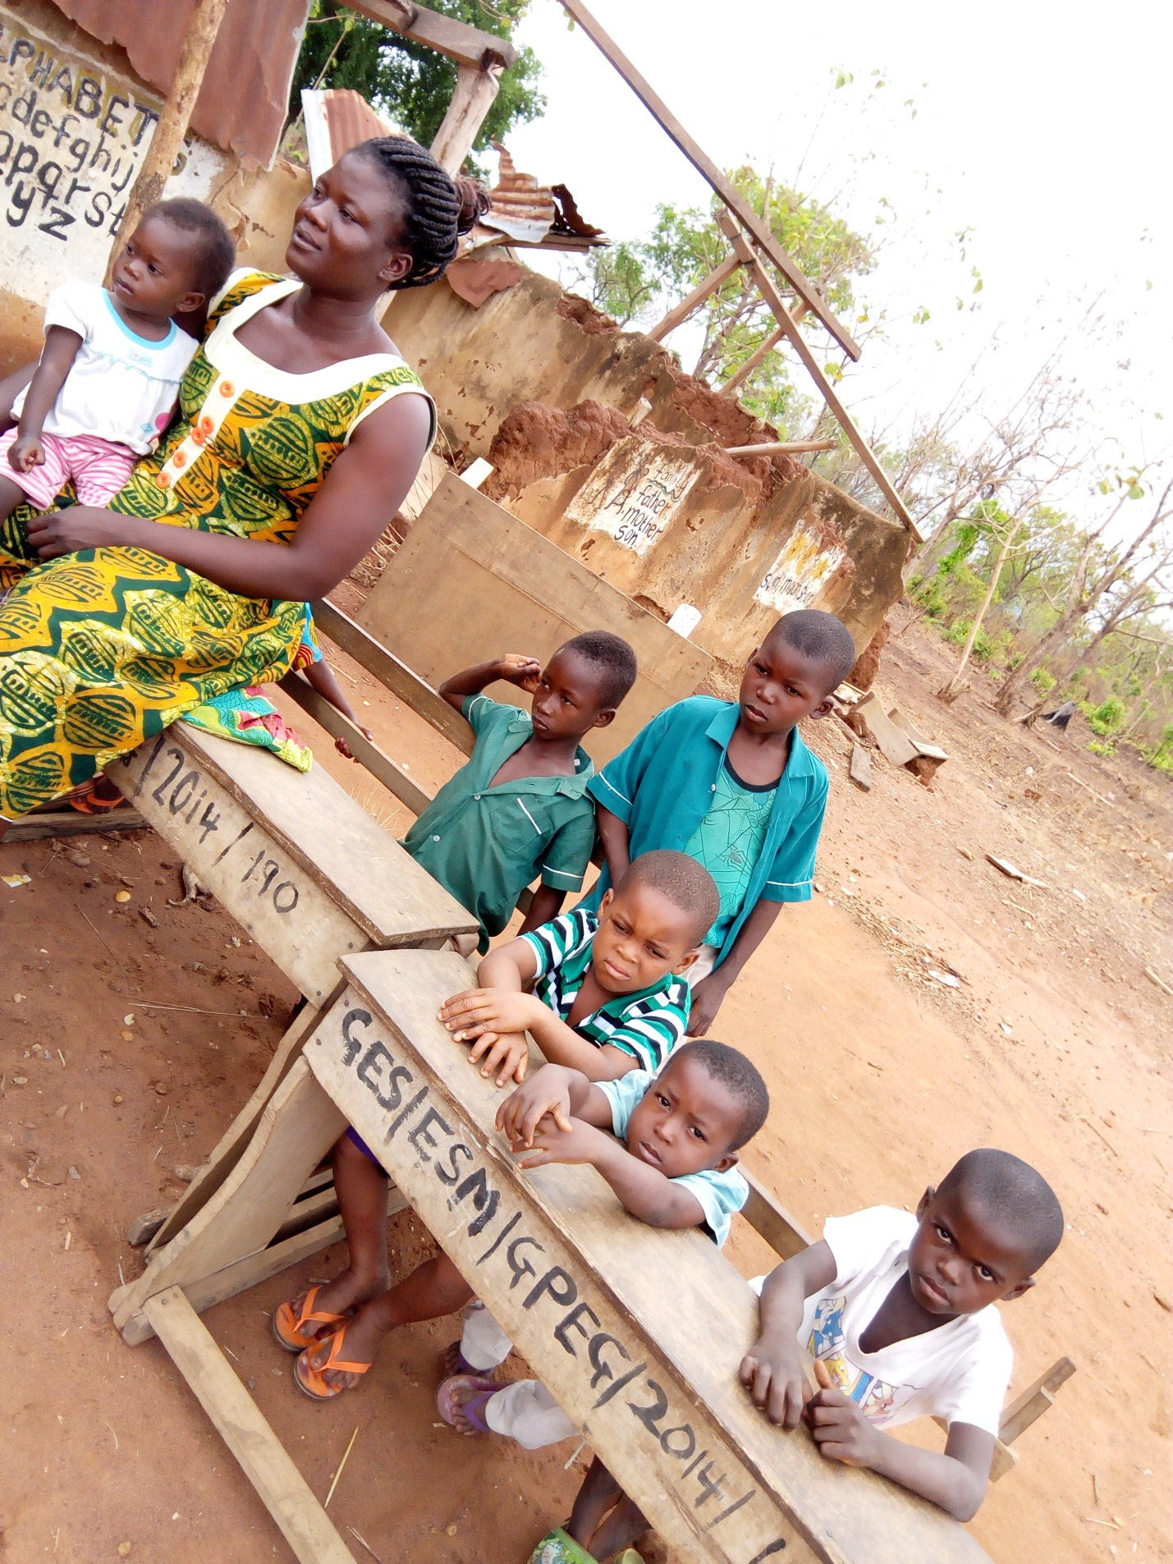

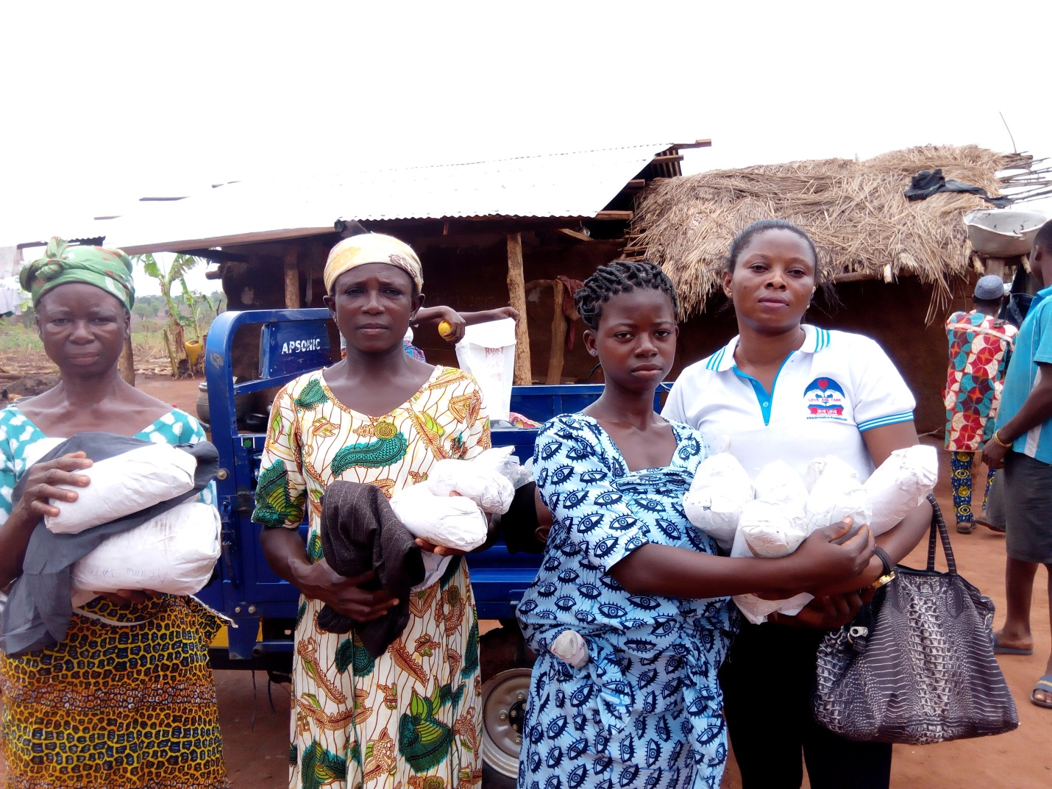
Distribution of clothes and shoes toGhana Akura community

