Nsawo Church of Uganda
Primary School

P.O.BOX 87 WOBULENZI
Email: nsawocuprimaryschool@gmail.com
Tel: +256772837918

A five –year
School Development Plan;
2016-2021

Compiled by:
KASAJJA PATRICK
HEAD TEACHER

TABLE OF CONTENTS

TABLE OF CONTENTS i
SUBMISSION OF THE FIVE-YEAR SCHOOL DEVELOPMENT PLAN 2016-2021 ii
ACRONNYMS iv
PREAMBLE v
FOREWORD vi
ACKNOWLEDGEMENT viii
PICTORIAL DOCUMENTARY ON THE BAD STATE OF THE CLASSROOMS 1
TEACHERS’ HOUSES A HEALTH THREAT TO THE TEACHERS AND THEIR RESPECTIVE FAMILIE 3
A GENERAL VIEW OF THE TEACHERS’ HOUSES IN A WORRYING STATE WARRANTIG AN URGENT NEED FOR RENOVATION TO MOTIVATE THE PROFESSIONALS WORKING AT GREAT RISK 4
A 5 YEAR SCHOOL DEVELOPMENT PLAN (SDP )FOR ACADEMICS FROM 2016 – 2021 6
CO-CURRICULAR DEVELOPMENT PLAN FOR FIVE YEARS 2016 – 2021 10
A FIVE YEAR SDP FOR FINANCE, PLANNING AND INFRUSTRUCTURE FROM 2016 – 2021........................................................................................................................................................... 14
HEALTH, SANITATION, SECURITY, SAFETY AND WELFARE DEVELOPMENT 17
PLAN 2016 – 2021 17
DISCIPLINE DEVELOPMENT PLAN 2016 – 2021 19
SCHOOL DEVELOPMENT PLAN IMPLEMENTATION EXECUTIVE SUMMARY 22

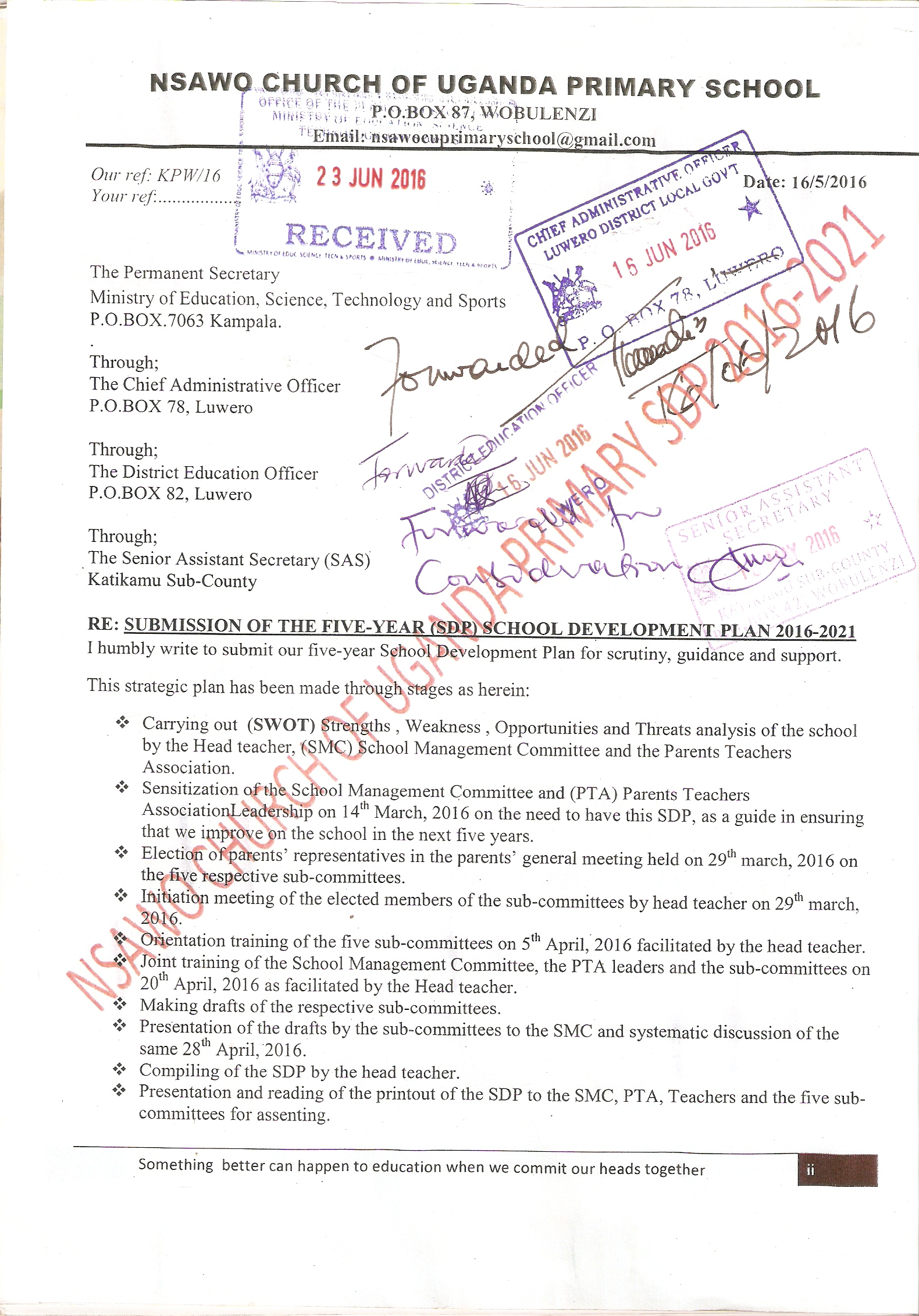

- Submission of the assented SDP to the Ministry of Education, Science, Technology and Sports through the relevant authorities.
It is in our plan to present this living document to the parents in a general meeting in term II, 2016 and launching will be done on our “NSAWO DAY” in term three, 2016.
We look forward to receiving your profession
nal consideration and support in the course of its implementation to benefit the child, the community and the country at large.
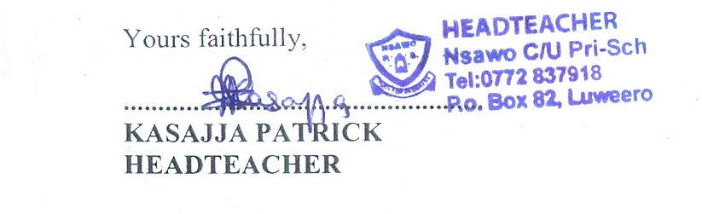

ACRONNYMS
SDP : School Development Plan
SMC : School Management Committee
PTA: Parents Teachers Association
CAO: Chief Administrative Administrator
DEO: District Education Officer
DIS: District Inspector of Schools
SAS: Senior Assistant Secretary
CCT: Cluster Centre Tutor
DOS: Director of Studies
MoESTS: Ministry of Education Science Technology and Sports
OGs: Old Girls
OBs: Old Boys
ECD: Early Childhood Development
M&E: Monitoring and Evaluation

PREAMBLE
The School Management Committee after critically carrying out a School SWOT analysis in relation to its development, haphazard education service delivery was discovered to being a major challenge, provision of services in the school according to our school vision, mission and motto, was also identified as a great missing link in the school.
Much as there has always been effort by teachers and some other stakeholders to provide education services to the children, QUALITY AND QUANTITY of the produce is still low, partly as a result of lack of focus and low community involvement in education (CIE).
Low literacy and numeracy levels in the school are yet our great problem to avert.
Not having enough teachers’ houses leading to mismanagement of time as a resource to quality service delivery to the learners is an issue that calls for urgent attention.
The classrooms and a few teachers’ houses which are in bad conditions as reflected in the photographs herein somehow reflect the state of school infrastructure. This negatively impacts on the quality of service delivery to the learners.
Having low health, sanitation, security and child safety levels resulting into limited participation of children in learning was yet another challenge observed.
Hence, all the above to mention but a few, necessitated the need to design this School Development Plan.
Looking forward to deliver improved education service delivery to the pupils, in accordance to the Education Act 2008, in line with the National Education Mission;“Provision of Quality Education to all children” we focus on:
- School Vision: Production of an all-round citizen.
- School Mission: To efficiently and effectively provide Equitable Education Services.
- School Motto: “We study for progress.”
- School Objectives:
To have willing, collaborative, committed, responsible and morally upright staff, children and community.
To have children who can freely, openly, simply, precisely and correctly express themselves orally and in writing in both Luganda and English language.
To have a supportive, healthy, secure, safe, equitable and motivating environment to enhance child development to their full potential, as a basis for their future productivity and meaningful livelihood.
Therefore, I recommend that all stakeholders in education especially in Nsawo C/U P/S at the different levels read internalize and practically take part in development of the school through the implementation of this Plan.
Collective effort is called for from all stakeholders if we are to let the recipients of the SDP, to ideally gain from this arrangement effectively in the event of promoting National and Global development at large.

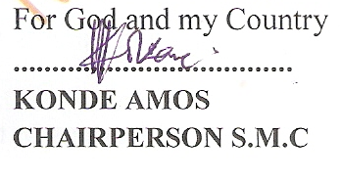

FOREWORD
Dear fellow professionals, all Educational stakeholders and well-wishers, I am grateful to present to you this Five- year School Development Plan (SDP-2016-2021) which has been designed to make Nsawo C/U P/S a model UPE school by 2021, in line with education aspirations of our country Uganda.
Nsawo C\U Primary School is currently blessed 626 pupils, trained and qualified teachers, availability of some infrastructure, responsible parents, regular release of U.P.E Funds, regular payment of salaries for teachers by the Government, availability of the UNEB centre Number, Visionary SMC, PTA and school administration, a responsible and supportive foundation body, availability of hydro- electric power in the school, reasonable school security ensured, easily accessible resource persons and Skilled labour from the community, support staff like the cooks and the school watchman, some school furniture in the school, accessibility of clean water for use at school, support supervision from the education department all of which have resulted in some literacy and numeracy levels BUT still low.
As a unit for Special Needs Education, we also get some Termly Subvention grants to support Special Educational Needs Children in due course.
Categorically, we are challenged by having dilapidated and inadequate school infrastructure like Classrooms, Latrines, and Staff houses. Many of these structures are a health threat to the children and the teachers for they can collapse and harm them any time.
In addition to this, we have inadequate instructional materials, insufficient water harvesters, and inadequate furniture for both pupils and teachers in the school.
Incomplete installation of H.E.P in all classes, poor school fencing and low parental support of their children at school are yet other challenges.
This SDP is geared towards general improvement of the quality of education service delivery to the children for societal transformation.
The SDP prioritizes five focal areas with greatest aim on quality education service delivery, through improving on the following sectors:
- Academics Sector
This plan is geared towards having improved literacy and numeracy for a meaningful and productive life.
- Co- Curricular Sector
Talent identification and promotion as early as primary education levels as a target.
- Finance, Planning and Infrastructure
Improving on school revenue, efficiency and effectiveness to realize quality school infrastructure is paramount herein.
- Health, Sanitation, Security, Safety and welfare sector.
We intend to have a healthy environment to nurture learners by the human resource in the teaching/learning situation.
- Discipline
We focus on promotion of self-discipline amongst learners, teachers and parents for an improved society.
The effective implementation of this SDP is intended to lead to quality performance of all learners in the school at their respective levels and thereafter.
This plan emphasizes quality literacy and numeracy, notwithstanding computer literacy skills in both learners and teachers for.
We intend to produce all round productive citizens hereafter if the rest of the four sectors are collectively improved to facilitate realization of quality academic outcomes.
In this regard, infrastructure and human (teachers) capital development will be of equal importance in the course of implementing this plan.
The school administration will greatly focus on the challenge of school classroom blocks and the teachers’ houses that are in bad condition as reflected in the pictorial documentary herein.
To realize the goal of this plan all stakeholders in public and the private sector are humbly called upon, to embrace the plan and join hands in the implementation of the selected and inevitable areas with the commitment it deserves.
In this regard, I humbly request the Government of the Republic of Uganda, through the MoESTS, to consider RENOVATING and REFUBISHING the existing old classroom blocks and the teachers’ houses that are currently a health threat.
Finally, I wish to register appreciation with all those who contributed to the development of this living document in the next five years.
God bless you abundantly.
For God and my Country

ACKNOWLEDGEMENT
I wish to thank with gratitude the various stakeholders in their different capacities, for their tremendous effort in coming up with this quality of work.
Great appreciation is registered with the active and potential parents, who in the general meeting elected members of the five School working Sub-committees;
The five School Management Sub committees are thanked for accepting to be trained, drafting, presenting their respective SDP drafts for discussion and consequently constituting this document
The SMC is acknowledged for conducting the several meetings that have culminated into realizing this living document. “The five -year School Development Plan; 2016- 2021.”
All community members who have worked hand-in-hand with the School Administration to produce this document are thanked too.
Technical guidance given to staff and all other stakeholders by the head- teacher in the process is greatly acknowledged.
In a special way, the chairman Mr. Konde Amos is thanked for practically being part and effectively delegating Mr. Bugembe Simon who has always stepped in to chair many meetings very ably on his behalf; He is applauded too, for his commitment that has resulted into this quality of work, which is now our focus towards the School Development process Five years ahead
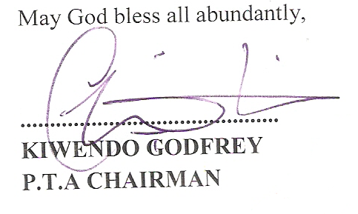

PICTORIAL DOCUMENTARY ON THE BAD STATE OF THE CLASSROOMS

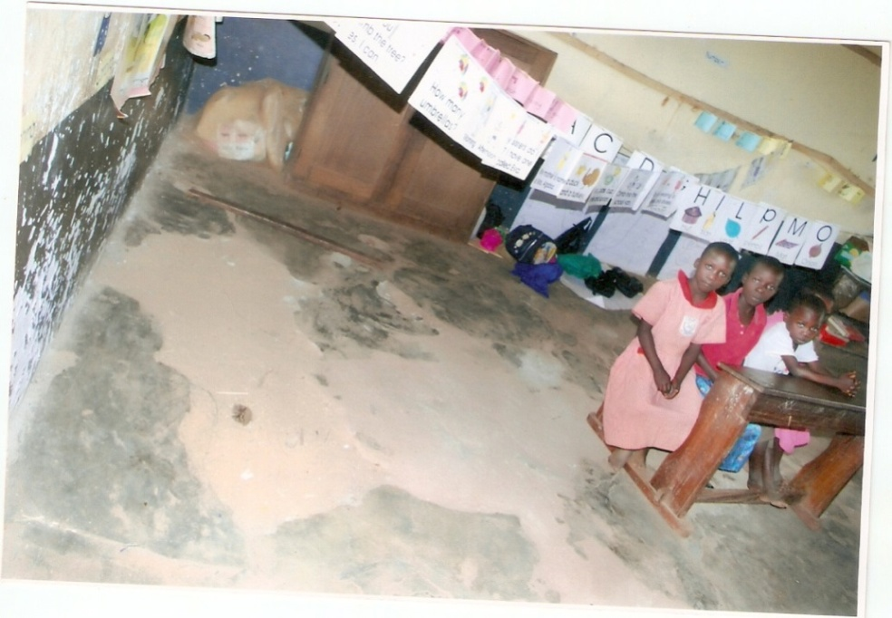
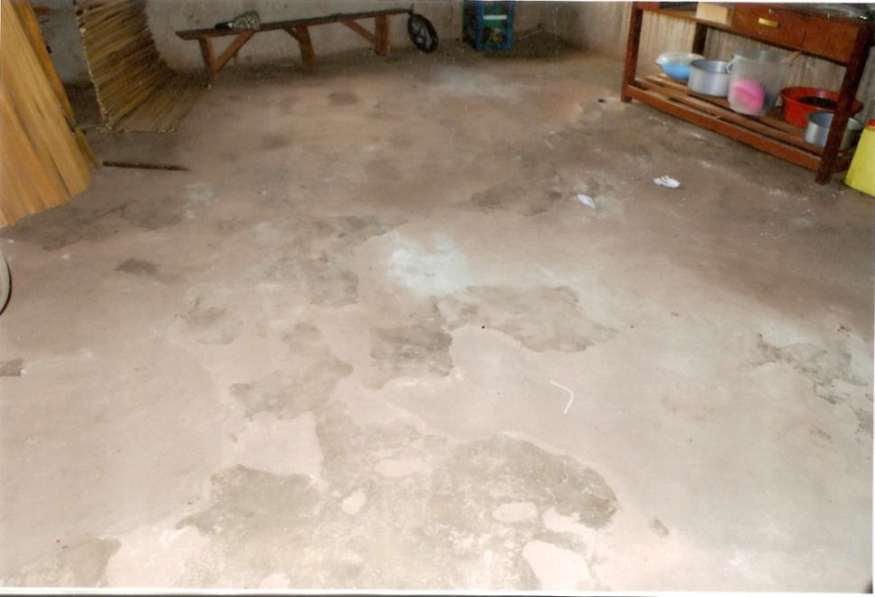
Classroom Conditions warranting serious renovations
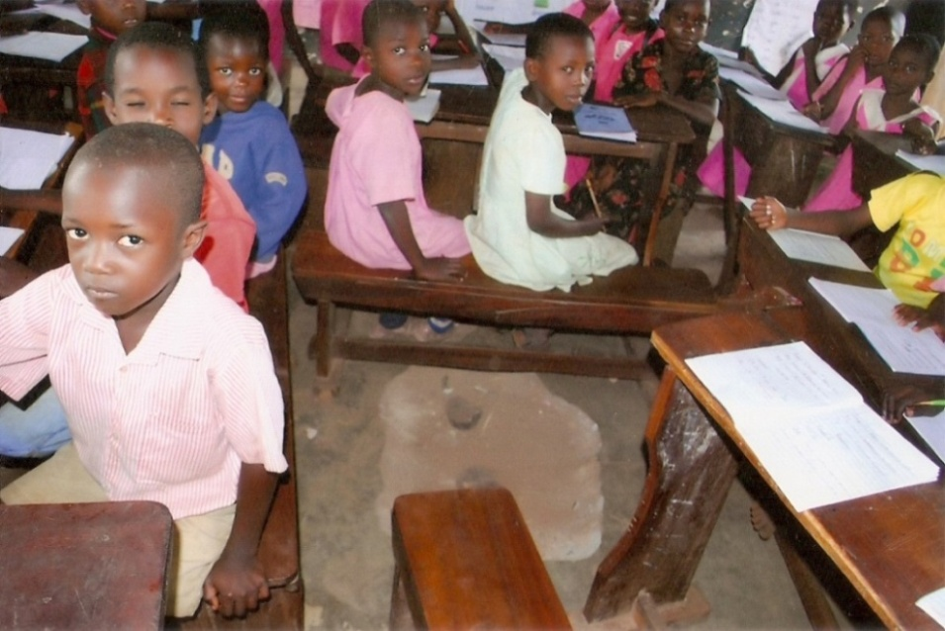
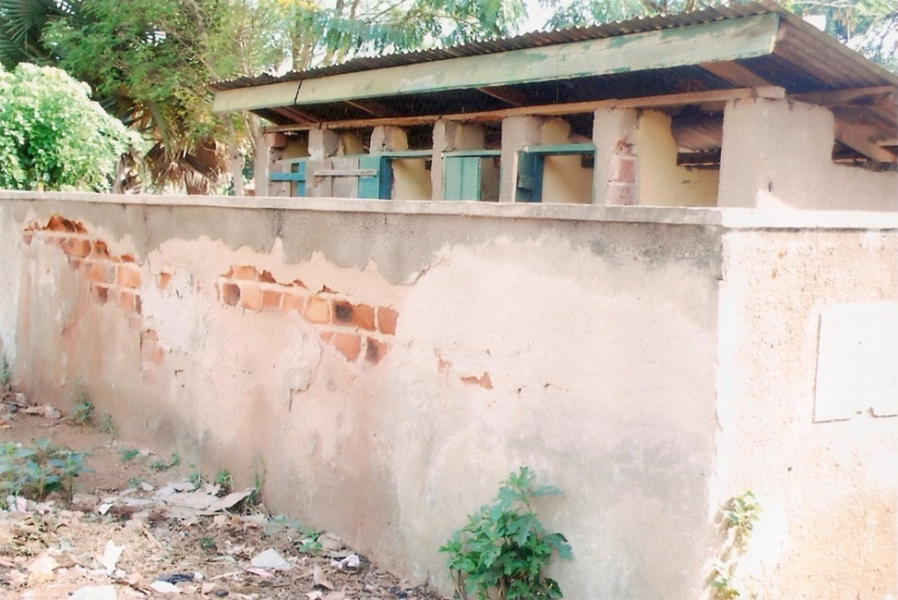
The Boys’ Latrine in a bad state, about to be filled and requires another one
TEACHERS’ HOUSES A HEALTH THREAT TO THE TEACHERS AND THEIR RESPECTIVE FAMILIE 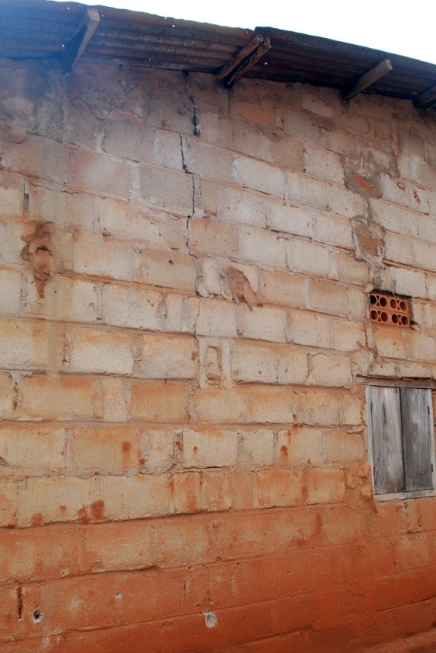 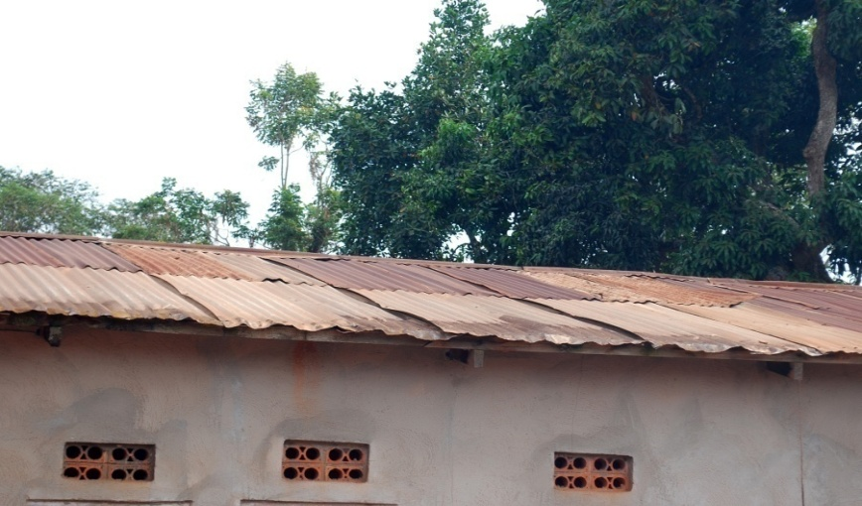
Major cracks in the wall as reflected A terebly leaking roof of the teachers’ houses

A GENERAL VIEW OF THE TEACHERS’ HOUSES IN A WORRYING STATE WARRANTING AN URGENT NEED FOR RENOVATION TO MOTIVATE THE PROFESSIONALS WORKING AT GREAT RISK

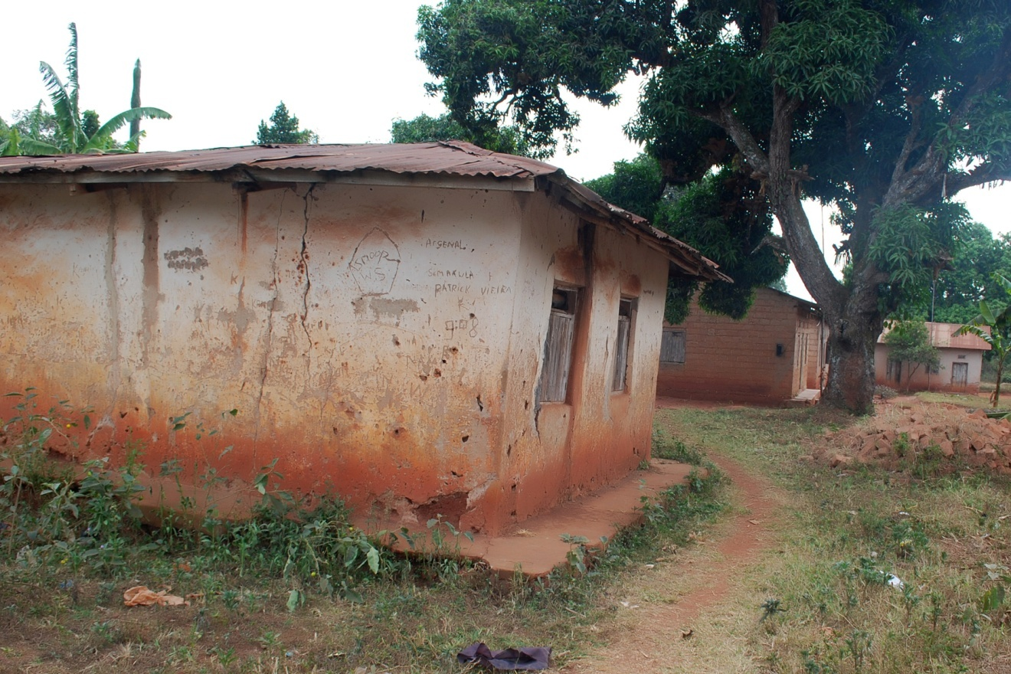

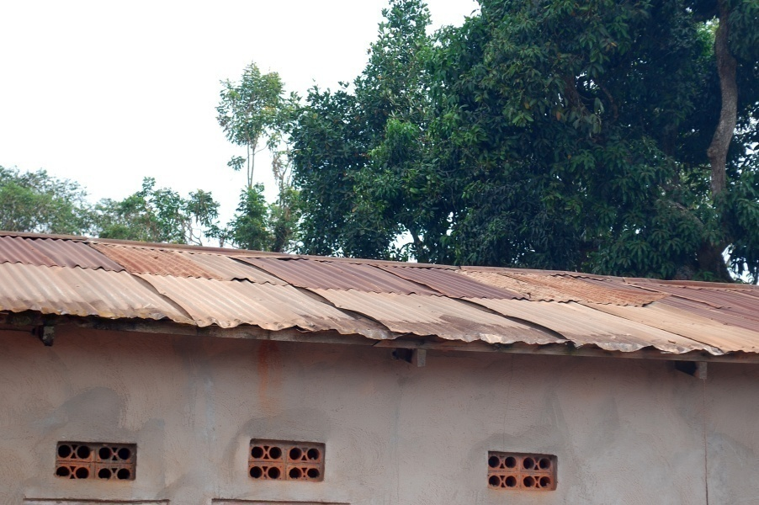

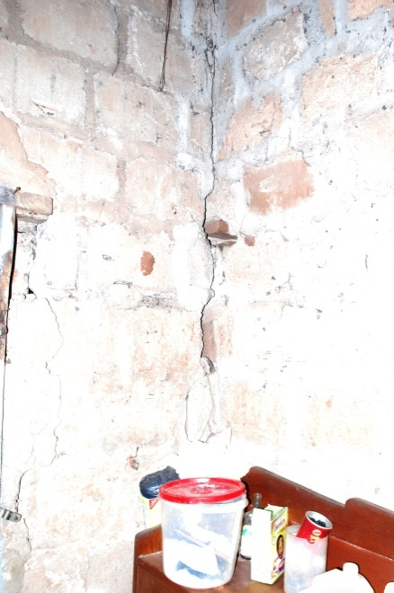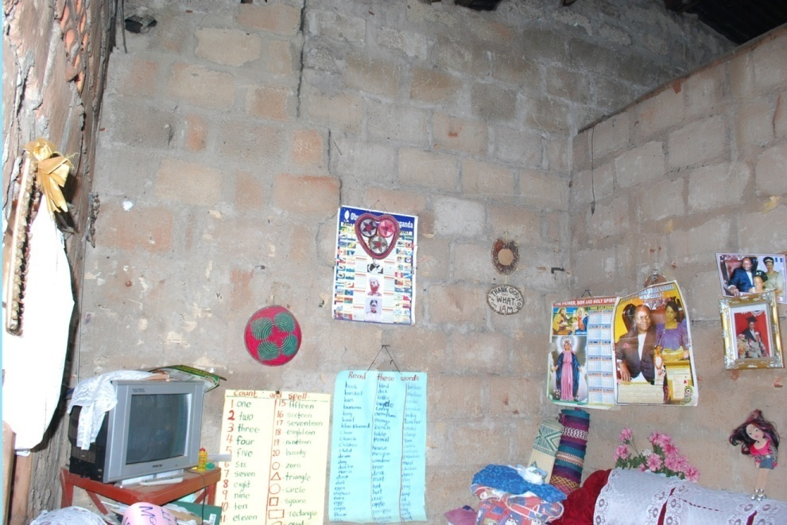
The internal sorrow state of the teachers’ houses with the walls that threaten to collapse any time.

A 5 YEAR SCHOOL DEVELOPMENT PLAN FOR ACADEMICS FROM 2016 – 2021

Draft Making Session

A FIVE-YEAR DEVELOPMENT PLAN FOR ACADEMICS 2016-2021
TIME FRAME | STRATEGICACTIVITY | STRATEGIC OBJECTIVES | OUT PUT | PERFORMANCE INDICATORS | RESOURCES PERSON | RESOURCES | SOURCES | BUDGET | REM
From May 2016 to Nov 2017 | Effective  teaching | By the end of 2017, we should have realized 95% a collaborative committed, efficient and effective staff | All teachers doing routine periodic scheming according to a greed format  Doing regular lesson planning according to recommended guidelines  Preparing and using learning aids effectively and storing them well. | Approved schemes and lesson plans.  Learning aids available to promote incidental learning promptly.  Periodic class target available in all classes  Time tables available and adhered to in all classes.  Well marked pupils’ books by all teachers.  Annual teachers’ performance plans available. | - Health teacher  - Deputy  - CCT  - DOS  - Teachers  - SMC  - Inspectorate  - DIS  - DEO  - CAO  - MOESTS  - Parents  - SAS | - Stationery  - Time  - Funds  - Human Resource | MoESTS Projects  Parents  Community | Shs 8 millions
From May 2016 to Nov 2018 | Effective learning | By the end of 2018, 85% of our pupils should have achieved proficiency in literacy and numeracy | All pupils having ability to listen effectively.  All pupils should be able to speak correctly in local language and English  Pupils to the target should be able to write and read correctly. | Effective communication orally and writing | - Head teacher  - Deputy head teacher  - CCT  - DOS  - Director of Studies  - Teachers  - SMC  - Inspectorate  - District Education Officer  - Pupils | - Scholastic materials  - Teachers  - Funds  - Time | - District Education Officer (DEO)  - Parents  - School Administration  - Community | Shs 3.5 millions
From May 2016 to Nov 2018 | Establishing a balanced and well stocked Library | By the end of 2018, we should be having a well-stocked Library ready for use by at least 40 pupils at a time. | All pupils having access to all available and relevant books in the Library as Scheduled | Record on the use of books in stock available and accessible for inspection  Timetable available and adhered to | - Library teacher  - Library prefect  - Deputy head teacher academics  - Head teacher  - SMC  - Parents  - Pupils | Human resource  Funds | Community  School administration  Parents  MoESTS | Shs 17.85 millions
From May 2016 to Nov 2018 | Establishing a computer Laboratory  with computers and a Risograph Printers | By the year 2018, we should have acquired a computer laboratory with all accessories ready for use by all teachers and at least 75% of the enrolled children | All pupils having access to computers as scheduled. | Pupils and teachers having computer Literacy  Attendance records accessible for Monitoring and evaluation.  Class data bank by class and sex for usage effected.  60 computer sets and 18 laptops available in use and effective management ensured.  Two modems available | - Head teacher  - Computer laboratory teacher  - Computer laboratory prefects  - Pupils  - Other teachers responsible  - SMC  - Community | School funds | NGOS  Charity organization  Local fundraising  Well wishers  MoESTS | Shs 93,600,000
From May 2016 to Nov 2018 | Establishing and developing ECD play areas in the school | By the year 2018, 90% of ECD pupils should have enough playing equipment and facilities to aid development of the three domains | All ECD learners having access to ECD play materials and equipment | Approved play equipment and facilities  Time table (Schedule) available and adhered to.  ECD learning framework. | - Head teacher  - CCT  - Teachers  - DOS  - SMC  - Inspectorate  - DEO  - Community  - Parents | Land  Funds | - School funds  - School  - Well-wishers  - Parents  - Charity Organization  - Local and international NGOs  - MoESTS | Shs 4.68  Millions
From May 2016 to Nov 2017 | Developing a talking environment | By the year 2017, 97% of the school community should be able to acquire educative information from the school environment | The school environment school be educative to the community | Educative messages in the school structures available  Talking classes to enhance incidental learning.  Talking office for transparency and communication of all school programmes  Talking compound for learning and guidance and instructions to all stake holders | - Head teachers’  - DOS  - Parents  - Teachers  - Pupils  - Community  - SMC  - PTA | - Funds  - Specific Materials.  - Human resource  - Time | - School Projects  - Well wishers  - NGOs  - Charity Organizations  - MoESTS | Shs 2.74 millions

CO-CURRICULAR DEVELOPMENT PLAN FOR FIVE YEARS 2016 – 2021

Draft Making Session

CO-CURRICULAR DEVELOPMENT PLAN FOR FIVE YEARS 2016 – 2021

TIME FRAME | STRATEGIC  ACTIVITIES | STRATEGIC OBJECTIVES | OUT PUT | PERFORMANCE INDICATORS | RESOURCE PERSON | RESOURCE | SOURCE | BUDGET | REM
FROM MAY 2016 to MAY 2017 | - Establishing modernized facilities.  - Establishing effective management of co-curricular activities. | By the end of 2017 we should have;  Achieved quality structures and facilities for co-curricular activities.  - Modernized and establishing play grounds.  - We should have bought co-curricular equipment ie Huddles ,tape measures ,scales short put , javelin and discus | 2 offices and storage rooms for the different departments. | 2 rooms available for use. | -Teacher  -Pupils  -Parents  -Community.  -S.M.C  -P.T.A. | School funds. | - Local fundraising.  - School projects.  - Community  - Well wishers  - OBs and OGs.  - MoESTS  - NGOs (charity organization). | 17,000’000 ug. Shs.
FROM MAY 2016 TO MAY 2017 | Developing strong teams.  - Children  - Teacher  - Parents’ | By the end of 2017 we should be able to:  - Employ at least 2 trainers in each co-curricular activities.  (Department).  - Involve 95% of the learners well in co-curricular activities  s. | - Having quality participating in co-curricular activities at all levels.  - Having skilled trainers.  - Teachers with developed co-curricular skills available on staff. | - The school participating in co-curricular activities at all levels.  - The school winning certificates and trophies for the school.  - Keeping departmental records available for monitoring and evaluation. | - Parents  - Teachers  - Community  - S.M.C.  - P.T.A  - Well-wishers. | - Funds | - Local fundraising  - School projects.  - Charity organisation (NGOs). | 13,000,000 ug.shs.
FROM MAY 2016 TO MAY 2017 | - Community involvement in co-curricular activities (CIE).  - Establishing clubs. | By the end of 2017 we should be able to;  - Achieve 90% of a full parents and some well-wishers in co-curricular activities. | Children being motivated to participate fully in co-curricular due to the parents and community attitude reflected in attending and supporting children. | - Parents involvement in co-curricular  - Available departmental records.  - Having strong relationship in the community documentaries  - Pictorial documentaries  - Annual calendars.  - Approved periodic work plan. | - Parents  - Pupils  - Community  - Teachers  - Well wishers  - OBs & OGs. | Funds | - International charity organizations.  - Parents. | 9,000,000 ug.shs.
FROM MAY 2016 TO 2020 | Purchasing a school truck.(Coaster). | By the year 2020 we should be able to;- own a school truck. | 1 school truck should be available for use at school. | - Parents  - Pupils  - Community  - S.M.C  - P.T.A | Funds | - Local school projects.  - Charity organization. |  | Shs 73  Millions

A FIVE YEAR SDP FOR FINANCE, PLANNING AND INFRASTRUCTURE FROM 2016 – 2021

Draft Making Session
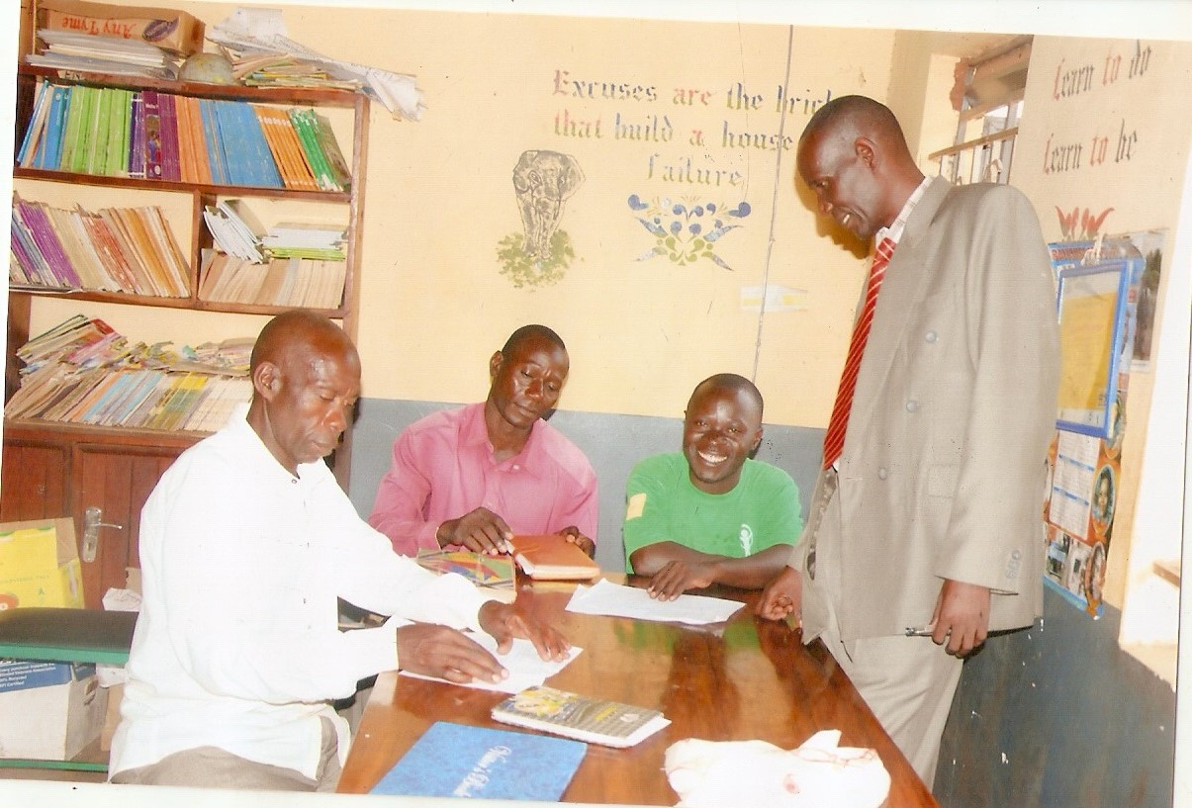

A FIVE YEAR SDP FOR FINANCE, PLANNING AND INFRASTRUCTURE FROM 2016 – 2021
TIME FRAME | STRATEGICACTIVITY | STRATEGIC OBJECTIVES | OUT PUT | PERFORMANCE INDICATORS | RESOURCES PERSON | RESOURCES | SOURCES | BUDGET | REM
From May 2016 to May 2019 | Constructing more water harvesters and Renovation of current ones | By the End of 2019, we should be able to: have 80% of water harvesters in the school | 5 water tank of 10,000 liters each available | 5 water tanks available and in use | - Community  - Parents  - PTA  - Old students  - Head Teachers  - Teachers  - SMC | Funds | Charity Organizations  Local fundraising  NGOs  Friends and well-wishers | 20,000,000 Million Uganda Shillings
From May 2016 to May 2017 | Completing with the installation of Hydro Electricity | By the End of the year 2017, we should have 100% of the required light system in the school | Having enough power system in the school | 100% illumination in the school | - Old students  - Parents  - Local Leaders  - Community  - Head teachers  - Teachers Pupils | Fund | Friends and Well-wishers  Charity Organizations  NGOs | Shs 600,000
From May 2016 to May 2019 | Renovation of 3 classroom blocks and three staff houses and having enough furniture for pupils and teachers. | By the end of 2019, we should have 70% of the required accommodation for teachers  100% renovated classrooms of the school and enough furniture. | 3 staff houses to accommodate at least 12 teachers  Improved classroom blocks and enough furniture in the school. | We should have.  3 staff houses,  3 classroom blocks ,  70 desks ,  14 tables and 24 office chairs in appropriate conditions for use. | - Head Teacher  - SMC  - Local Leaders  - D.E.O  - Parents | Funds  Local Materials | Friends and Well-wishers  Charity Organization  OBs and OGs  Community | Shs 77,300,000
From May 2016 to May 2017 | Fencing the School | By the end of 2017, we should have the whole school fenced | Whole school enclosed and well maintained so. | A well fenced school with a gate and well maintained. | Community  Parents  SMC  PTA  Old students  Pupils  Teachers  Head teacher | Funds | Local and International Charity organization  Friends and well-wishers.  Local Fundraising | Shs 5,400,000
From May 2016 to May 2020 | Constructing 4 more staff quarters | By the end of 2020, we should be able to have 80% of the required staff houses in the school | 4 staff houses constructed | 4 staff houses completed and in use by teachers | District Engineer  Community  Parents  S.M.C  P.T.A  Old students  MoESTS | Funds  Local materials  Human Resources | Local and International Charity organization  Local fundraising  Friends and well wishers  NGOs  Community | Shs 120,000,000

HEALTH, SANITATION, SECURITY, SAFETY AND WELFARE DEVELOPMENT

PLAN 2016 – 2021

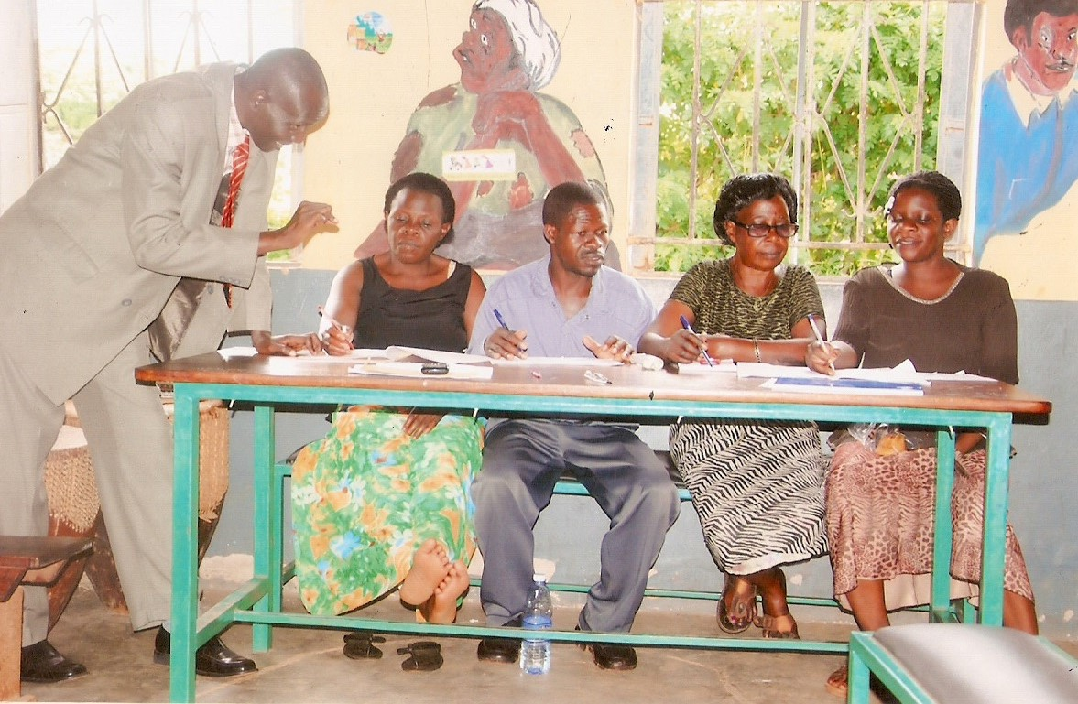
Draft making Session

HEALTH, SANITATION, SECURITY, SAFETY AND WELFARE DEVELOPMENT

PLAN 2016 – 2021
TIME FRAME | STRTEGIC  ACTIVTY | STRATEGIC OBJECTIVE | OUT PUT | PERFORMANCE INDICATOR | RESPONSIBLE PERSON. | RESOURCE | SOURCE | BUDGET | REM.
MAY 2016 TO NOV. 2017 | Employing 1 school guard. | By the end of 2017 we should have 100% of the school effectively guarded. | 1 School guard | 3copies of memorandum of understanding between  the school and the selected firm available | -P.T.A  -S. M. C  -Local leaders  -Head teacher | Funds. | -School projects  -Local leadership  -Well wishers  MoESTS | 18,000,000 ug.shs
MAY 2016 TO NOV. 2017 | Establishing a functional school first aid box. | By end of 2017, we should have 90% of the school equipped with essentials in the first aid box. | Having a functional first aid box services | Well managed records of first aid service  provision available  in the school. | 2 first aid teachers  2 first aid prefects  -Head teacher  -S.M.C  -Old students  -Community | funds  Human resources | Local leadership  NGO’s  Well wishers  MoESTS  Parents | 1,800,000 ug.shs.
From May 2016 TO Nov. 2019 | Establishing a school garden and putting in place enough garden tools. | By the end of 2016-2019 we should have 70% of the food got from the school garden. | 3 acres of land under productive food cultivation and effective management of the produce | 70% of the school food got from the school garden  Well managed records | We should have 3 acres of land in productive use.  -Good quality and quantity food consumed by pupils and teachers. | -Land  -Funds  -Human resource | Community  -Local leaders  -Well wisher | 930,000 ug,shs.
From MAY,216 TO NOV. 2019 | Digging and constructing more school pit-latrines. | By the end of the year 2019, we should have 85% of the required pit-latrines. | 4 more pit-latrines blocks dug and constructed | 4 pit-latrines blocks available and in use by the school. | - Community  -Local leadership  -Parents  -Old students  Head teacher  SMC, PTA | -Land  -Human resource  -Funds  Local materials | - S.M.C  -Local leadership  Community  MoESTS | 16 millions ug.shs.
From MAY.2016 TO NOV. 2019 | Renovation and expanding the kitchen | By 2019 we should have had 100% of the required kitchen and lark in the school. | 1 completed kitchen and 2 larks. | 2 larks and a modernized and sizeable kitchen available and in use. | Head teacher  Local leadership  - Parents.  - S.M.C, P.T.A | - Funds  - Human resource  - Land | Well-wishers and friends.  Local leadership | 3,000,000 ug.shs.

DISCIPLINE DEVELOPMENT PLAN 2016 – 2021

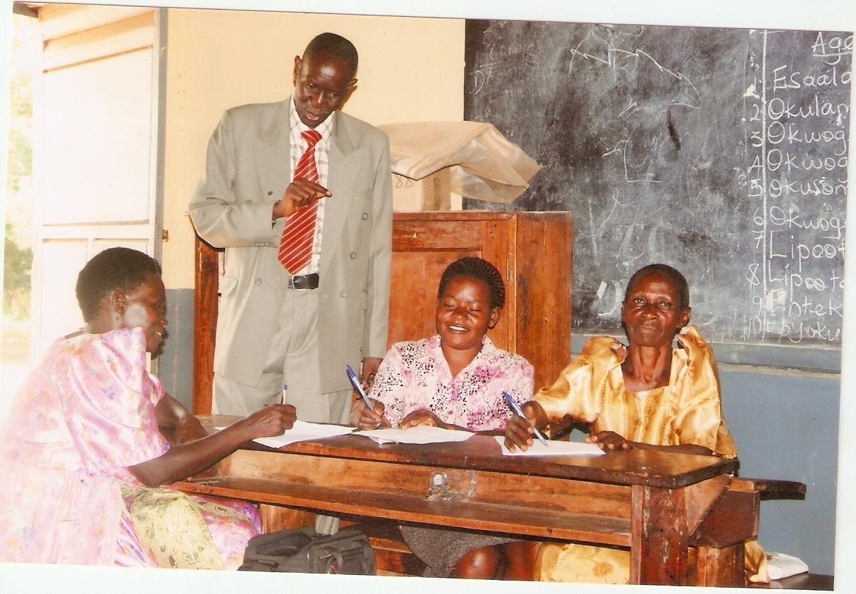

Draft Making Session

DISCIPLINE DEVELOPMENT PLAN 2016 – 2021
TIME FRAME | STRTEGIC  ACTIVITY | STRATEGIC OBJECTIVES | OUT PUT | PERFORMANCE INDICATORS | RESOURCES PERSON | RESOURCES | SOURCES | BUDGET | REM
May 2016 to Dec 2017 | Designing school rules and regulations for pupils, Parents and teachers | By the end of 2017, 85% of the children should be able to:  - Behave well at school and outside  - Change their behavior positively  - Abide by the rules and regulations of the school. | Three categories of rules and regulation designed and put to use. | 3 categories of rules:  - Pupils, teachers and Parents rules and regulations available  and assented to. | - SMC  - PTA  - Parents  - Pupils  - Community  - Religious Leaders  - L.Cs | - Local leadership | MoSTS | Shs 510,000
May 2016 to Dec 2018 | Carrying out General counseling and guidance to ensure discipline | By the end of 2018, 80% of the children should be able:  - Maintain discipline at school and beyond  - Practice good health habits  - Reduce school drop outs | 80% of the pupils in all classes and exercising behaving morally.  Teachers, parents and community members living with each other in harmony | - A functional Guidance and Counseling system  Termly well managed records on Guidance and Counseling  - Reduced drop outs in the school  - Should have cubed  - Reduced indiscipline cases in the school | - SMC  - Head teacher  - Teachers  - Pupils  - Prefects  - Peer Counselors  - Resourceful persons  - Religious Leaders. | - Time  - Funds  - Stationary  - School funds  - Resourceful persons | - Local Leadership  - MoESTS  - Community | Shs  430,000
May 2016 – 2019 | Writing Periodic magazines on discipline | By the end of 2019, 85% of the children should have developed interest in the Writers Club activities.  Respecting others in the school and outside school  Acquiring skills reading and writing | 80% of the children should have acquired the language  Skills in writing magazines on ensuring discipline | annual magazines on discipline written and available in the school  Periodic copies of articles available for use and reference | - SMC  - Parents  - Head teachers  - Teachers  - Pupils | - Time  - School  - Funds  - Stationery  - Local Leadership | - NGOs  - School Administration  - SMC | Shs 4,500,000
May 2016 – Dec 2021 | Developing learners, teachers and Parents spiritual domain | By the year 2021, 90% of the teachers, Parents and pupils should have acquired spiritual values for moral uprightness. | About 85% of the pupils, teachers & Parents should be God fearing in the school | Pupils attendance records for spiritual church service available for M&E.  Observable ability to conduct prayers by pupils when selected at random.  Observable ability to open and read a given bible verse correctly.  Observable harmonious living life style in the school and beyond.  - 50 Bibles  - 20 Qurans | - Religious Leaders  - Head teacher  - Pupils  - Religious Prefects. | Bibles  Time  Teachers  Parents  Religious Leaders. | Foundation Body  School administration  Community | Shs 2,000,000

SCHOOL DEVELOPMENT PLAN IMPLEMENTATION EXECUTIVE SUMMARY
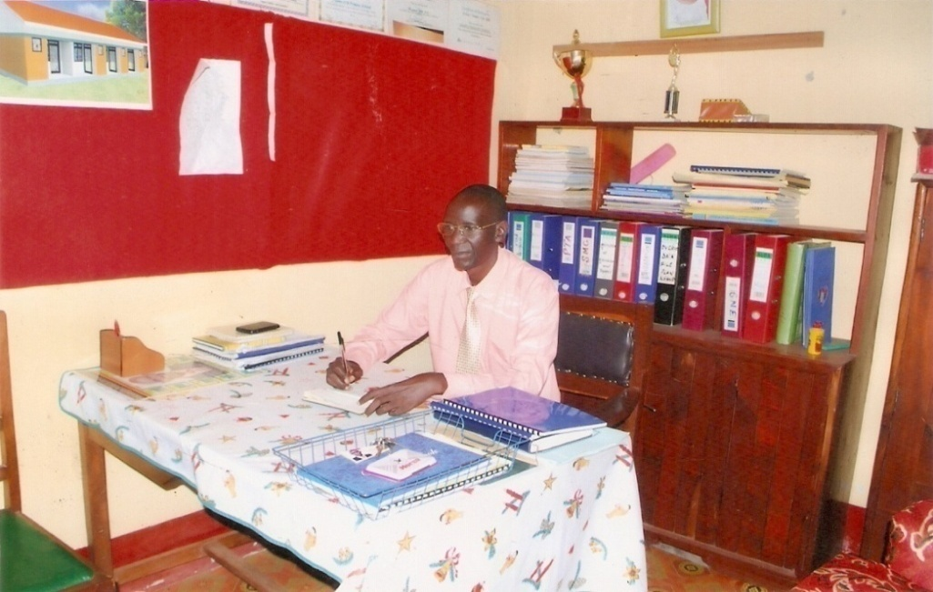
The head teacher in the office making the executive summary
Implementation of this SDP is scheduled to be in three phases in the ratio 2:2:1 years and it’s ground total budget is Shs 512,840,000
The School Management Committee did resolve that, this executive summary is tentative and subject to review as need and possibility may arise in the best interest to school development.
SDP IMPLEMENTATION SCHEDULE:
PHASE | TIME FRAME | STRATEGIC  %age  COVERAGE | AMOUNT | REMARK
1 | May2016-May 2018 | 40 | 205136000
2 | June 2018- June 2020 | 40 | 205136000
3 | July 2020-July 2021 | 20 | 102568000
Grand total | May 2016 July 2021 | 100 | 512,840,000
Categorically, the summative evaluation meetings for this SDP will be held in August 2021 in preparation for accountability presentation to the entire stakeholders on the NSAWO DAY in term III of 2021, which will culminate into drawing of the SDP II 2021-2026
Monitoring and Evaluation of this SDP will be done through ten steps including, conducting a Readiness Assessment, Agreeing on Outcomes to Monitor and Evaluate, selecting key indicators to Monitor Outcomes, having Baseline Data on Indicators-Where are we today, Planning for Improvement-Selecting Results Targets, Monitoring for Results, Observing the Role of Evaluation, Reporting Findings, Using Findings and Sustaining the MONITORING and EVALUATION System within the Organisation.
Concerted co operation and commitment of all stakeholders in the implementation of this SDP is highly called for.
