REPORT ON GOAL COMPLIANCE AND IMPLEMENTATION OF THE OBJECT

Fundação Dorina Nowill para Cegos (Dorina Nowill Foundation for the Blind)

Title of Project / Activity / Service: Autonomy and Independence for children and adolescents with visual impairment

REPORT

Description:

The project aims to promote the autonomy and independence of 220 children and adolescents with visual impairment and their families through specialized services such as early intervention programs, special education support, educational supplementation, psychological guidance to the family and school. In addition to the development of the independence of the child and adolescent and social affective contact, from an environment that favors the extra-familial social life, expanding the possibilities of experiences and contact with the other and the environment that surrounds him.

Actions developed, in the period, to fulfill the object:
During the first quarter of the project (May to August / 2018) activities occurred as planned.
Children and Youth waiting for service were called, participated in the Reception process and are already in specialized care, according to the demand presented by each one. All the demands are evaluated individually, the child and the young are sent to individual or group care, according to the context raised. The majority of the young people are assisted in a group, understanding the innumerable gains from their own life.
Thematic groups were also held to support their development.
- Developing talents: workshops in groups having as a working tool the corporal expression through the artistic language, like theater, music, dance, among others, being defined from the profile and interest of the group. 06 young people participated in the workshops, built an interview scene where everyone had roles, and the main theme was: What are my talents?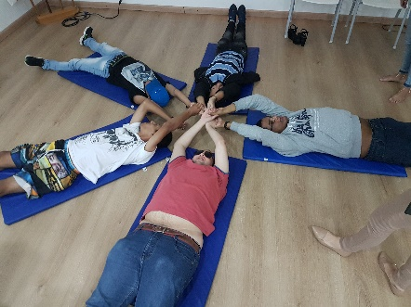
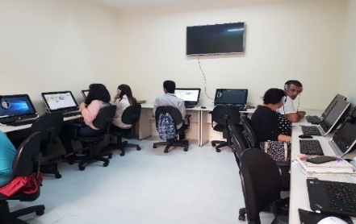
- Digital inclusion workshops: It is a basic requirement in the work world, so we offer the course with emphasis on student employability, which in addition to learning the Office suite, learns to use the accessibility and assistive technology features of visual impairment.

We emphasize the testimony of a young woman: "Even with great demand I had the opportunity to take the course quickly, which motivated me to go back to study and continue the use of the computer. "
In addition to the interventional interventions, we carried out the following socio-educational activities:
- Week of the Professions, which had a series of activities aimed at young people with visual impairment, where issues related to the search for guidelines on the universe of work, career development and professional growth were addressed. Among the activities we highlight:
- Conversation wheel, on the choice of profession, conducted by professionals with visual deficiencies: Maria Regina Lopes (Social Work), Monica Barros (Psychology), Marcelo Panico (Law) and Marcos Nakagawa (Technology and geek universe);
- Workshop and Dynamics on non-violent communication conducted by the consultant Ismael Almeida Iba of the company DorseyRocha;
- Career Protagonism Workshop (Curriculum, LinkedIn and Job Interview) conducted by the Lee Hecht Harrison Team.
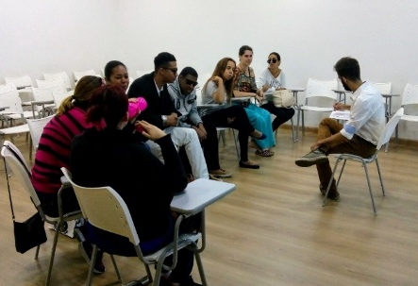

- Nautical experience with Adaptive Sailing - Through the Sailing Sense project, customers were able to drive the boats, were responsible for both the rudder, giving direction to the sailboat, as well as cables and sails. With these actions we were able to work on essential points in the holistic development of Dorina Foundation clients.
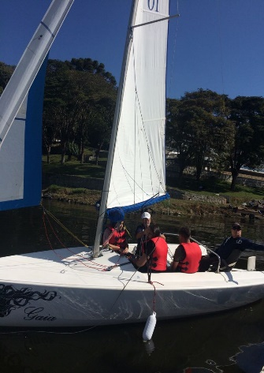
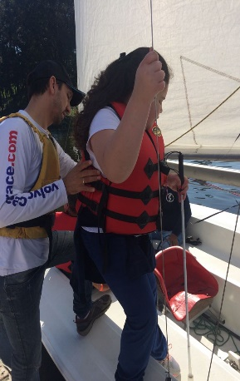
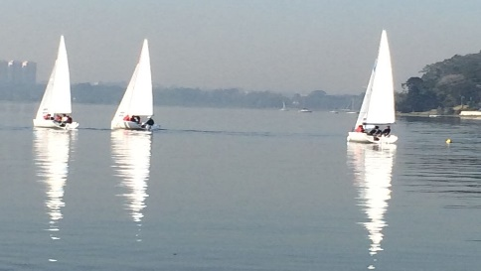

- Visit Brazilian Paralympic Center - We take a group of 15 children and young people with their families, to know the space and experience all the activities offered. Everyone was delighted with the accessible space, trained professionals and the range of possibilities of inclusion in the Sport !!!
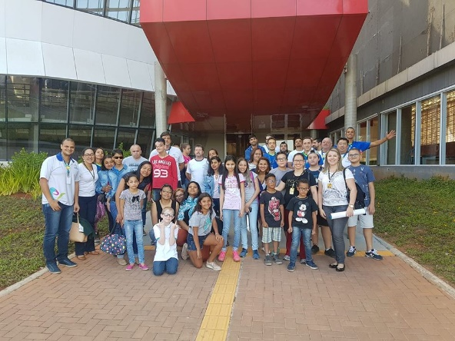
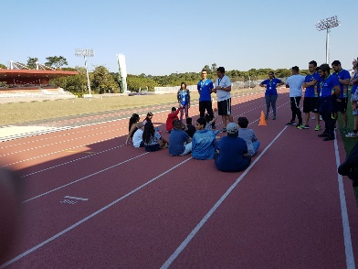
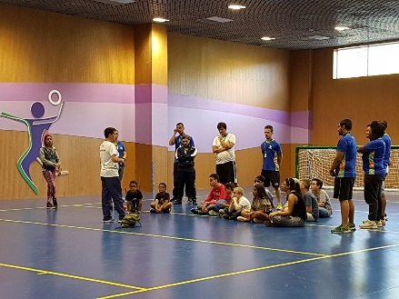

- Visit the Louis Braille Library - taking advantage of the school holidays, we carried out a Socio-educational activity in partnership with the Louis Braille Library at the Vergueiro Cultural Center, with the aim of presenting and encouraging the use of reading-related accessibility resources for the children served; 14 children and their families participated. Guaranteed, yielded good stories!

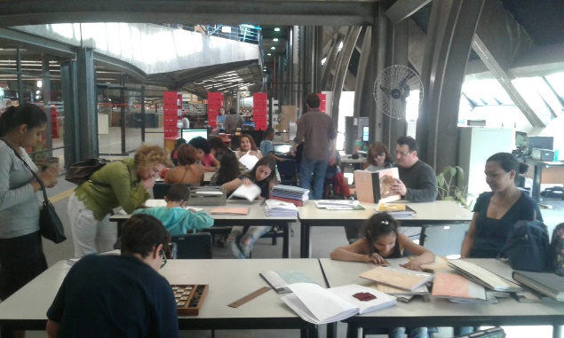
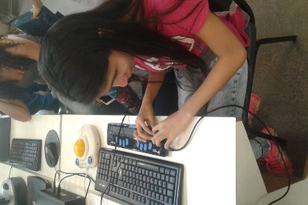
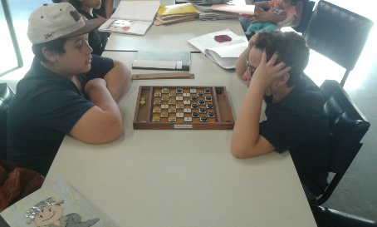

Testimonies collected during the visits and activities of some young people:
Rodolfo, also in a context of how he imagines the future, told us: "To have the freedom to hunt for your dreams of survival, this is how I feel things today. In the future people would have more posture, they could face the masculine world knowing how to position themselves in relation to what one wants.It is not easy being you.Talk what you want, what you think about you, about the world, about The public is the people around us, all without exception."

Nikolas: "Sometimes I think I was born to be tragic. Not everything is flowers today. The future will be what we do today. And live within reality. Collaborating with the other, independent of that other being a disabled person or not. People have to be more patient with each other. Understand the limitations of each. For example, people need to be patient with the blind. Know and understand their limitations. What we face in the day to day."

Talking about potentialities and limitations, Marlon quotes: "Each is a vital organ in this great living organism. This life that sometimes fucking fucked us ... I've already broken things, I felt revolted; but I've learned something from the theater course I'm doing.

The difference between life and theater is that the theater ends up being a rehearsal for life. In the theater things happen on time and you can change. But in life everything needs some time. This time comes from the past and leads us to the future. The present is just an interval, where things suddenly happen. "

Gabriel: "People often do not see the potency of another person because that person does not see."
Felipe: "I think it's all a matter of allowing ourselves to be who we are. Life is like a dance, every step, a discovery that the very movement of life takes us. We need to let ourselves be led by that flow. To believe."

 | Scope within the period of application of the Accountability
Nº | Description of the goal (Specific Objective) | Goal achievement | Means for calibration
1 | 60 children and 160 adolescents attending specialized services, according to demand raised; | From May to July:  26 Children and 23 Adolescents received specialized care.  Counting 580 individual attendances or group for Children and 774 calls for young people. | - Follow-up reports prepared by specialized care professionals
2 | 70 children and adolescents literate in the Braille system; | From May to July:  20 children and 15 adolescents are in the literacy process of the Braille System  13 schools were guided on the literacy process of the visually impaired person. | - Follow-up reports prepared by specialized care professionals
3 | 200 family members or guidance counselors on issues related to the visual impairment and participants in the process of including their children. | From May to July:  49 family members received care and participated in the entire habilitation process.  Counting 720 care for relatives of children and adolescents. | - Follow-up reports prepared by specialized care professionals

