Supporting Syrian refugees with disabilities living in refugee camps

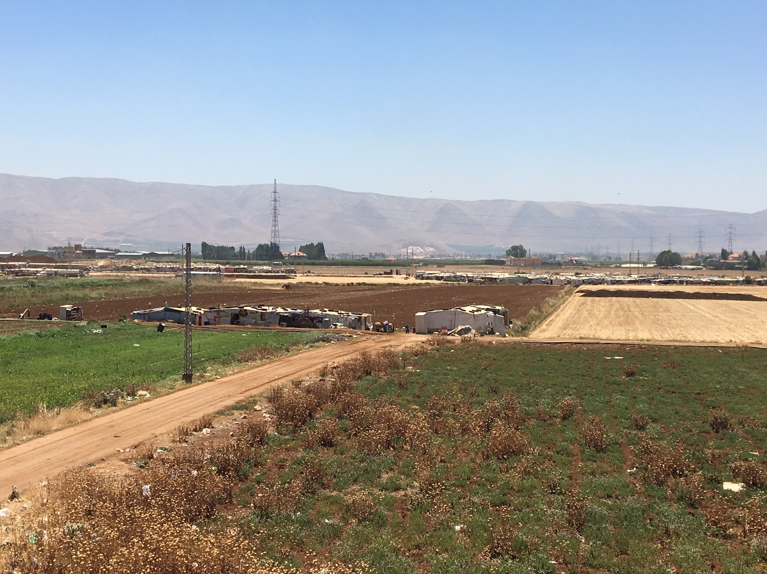
Help us to provide support to children with disabilities living in refugee camps like this one in the Beka’a Valley in Lebanon, by training local outreach workers to help parents understand their child’s condition and provide practical support for everyday life.

Professor Stephen Hawking: “My advice to other disabled people would be, concentrate on things your disability doesn't prevent you doing well, and don't regret the things it interferes with.”
MAITS works to support those with disabilities to realise their full potential and to break down the barriers they face by raising awareness of their conditions and how to provide practical support for everyday living.

Project summary
Supporting Syrian child refugees with disabilities living in refugee camps and their families through training which increases awareness of their conditions and practical guidance on how to support them and translating these materials into Arabic and make them available to other Arabic speaking communities free of charge.
Amount requested
£5720
What the funding is for
Providing support for Syrian children with disabilities such as autism, living in refugee camps by building the capacity of outreach workers to work with parents to increase their understanding of developmental disabilities such as autism and support them to use simple techniques to help manage their child’s condition and increase their independence and daily living skills. To translate existing Community Health Worker training resources into Arabic, so that it can be used by other Arabic speaking communities.
Location of project:
The project will be run in Lebanon including in refugee camps in the Beka’a Valley and other areas where many families have been living in tents for many years and the resources will be available on MAITS’ resource library in Arabic, on the MAITS’ website.
- What does MAITS do?

MAITS is an international disability charity that works with people with developmental disabilities in developing countries. We have a team of highly qualified healthcare and education professionals who volunteer their time to provide training and capacity building to those working with and caring for people with disabilities all around the world. We bring people together to improve the lives of those with disabilities and we produce and share resources on development disabilities in our free resource library.

Three MAITS’ volunteers recently won the Prime Minister’s Point of Light Award for their voluntary work for with us. These three MAITS’ volunteers were part of a group of only six people recognised to coincide with the Global Disability Summit. Our aim is to improve the lives of some of the world’s most vulnerable individuals living with disabilities to enable individuals to reach their full potential, through access to family support, quality healthcare and education.

- Who are you helping, how many and how?

Overview of MAITS work - We work with and help some of the most marginalised children globally – children with disabilities living in some of the poorest countries in the world. There are 150 million children living with a disability and of these the majority live in developing countries. Since 2008, we have provided training to 4700 staff working in the disability sector in 21 countries and helped over 600,000 individuals living with disabilities. The people we have trained include therapists, nurses, special educators, staff working in children’s homes and community health workers. We do this through training, creation of disability resources and matching organisations who need training with those who can provide it.

For this specific project, we will train between 15-20 people, predominantly Mental Health Outreach Workers, working directly with Syrian refugees living in refugee camps. We will also train senior mental health staff and psychologists. The Outreach Workers have a caseload of 398 people, 123 of which are children. 42 of these have a diagnosis of a developmental disability, such as autism, cerebral palsy, ADHD or similar. There may be more children who are undiagnosed. The Outreach Workers serve Syrian refugees who have been living for years in tents in make-shift refugee camps (including the one pictured on the front page) and who have little access to services. These families often have few or restricted rights to work and they are living in poverty. For many families, the outreach workers are the main link between themselves and other services, as living in remote locations, lack of money and lack of accessibility for those with disabilities mean that they are not easily able to move around. These children are amongst some of the most marginalised children in the world and they are in desperate need of support for their special needs, in addition to the hardship that they have experienced during their young lives. The Outreach Workers work as part of a larger structure of healthcare provision and are also able to refer children with more acute needs to specialist services. We have also been asked to provide training to senior workers in MdM, so that there is a mainstreamed approach to working with children with developmental disabilities. We are also offering the training to other organisations in other areas of Lebanon, if we are able to raise the funding needed.

Through the translation of the resources, which would be shared on our resource library which is accessed by therapists, the information would be more widely available for Arabic speaking communities and as we provide small grants and volunteer trainers, it could open up the possibility to deliver this training in many similar contexts and other Arabic speaking countries. With the current refugee crises in Syria, Yemen and other Arabic speaking countries and an increasing awareness of the importance of disability mainstreaming, particularly following the first Global Disability Summit co-hosted by DFID, this is particularly pertinent.

- Our projects

Skill matching and coordination of training – MAITS brings people together to improve the lives of those with disabilities. We match organisations looking for training with those that can provide it and also provide small grants to enable that training to happen.

In the year 2016-17, 24 grants were awarded to enable the training of 685 staff and healthcare trainees working in 10 different countries, in charities, clinics, special schools and university hospitals, benefitting 43,000 service users in this year. Our recent projects have included:

- Supporting children with developmental disabilities at school, in institutional settings and in the home- Jamaica, Cambodia, Ghana, India
- Working with young children with cleft lip/palate to eat and drink and communicate - Sri Lanka (South Asia conference) and Ghana
- Simple physiotherapy techniques for staff working in refugee communities - Tibet
- How to make low cost equipment for children with disabilities out of paper and card - Sri Lanka
- Higher education speech and language therapy training- Pakistan and Sri Lanka
- The use of Therapeutic Art in working with individuals with mental health challenges - Zambia

- Our previous success with this project and how we want to replicate this in Lebanon. The training that we have been asked to provide in Lebanon is part of a Community Health Worker training programme devised by MAITS. Some of our experienced trainers wrote a Parent’s Guide which was piloted in Nepal. This was developed into a Community Worker’s Programme and piloted in Jamaica for carers of children with disabilities in children’s homes. Our support was requested in children’s homes where there were consistent serious case reviews with children dying or seriously ill every few months. After we went in and provided training to the carers on the MAITS programme and resources, there has not been a single serious case review and the children we supported are doing well and have gained independence.

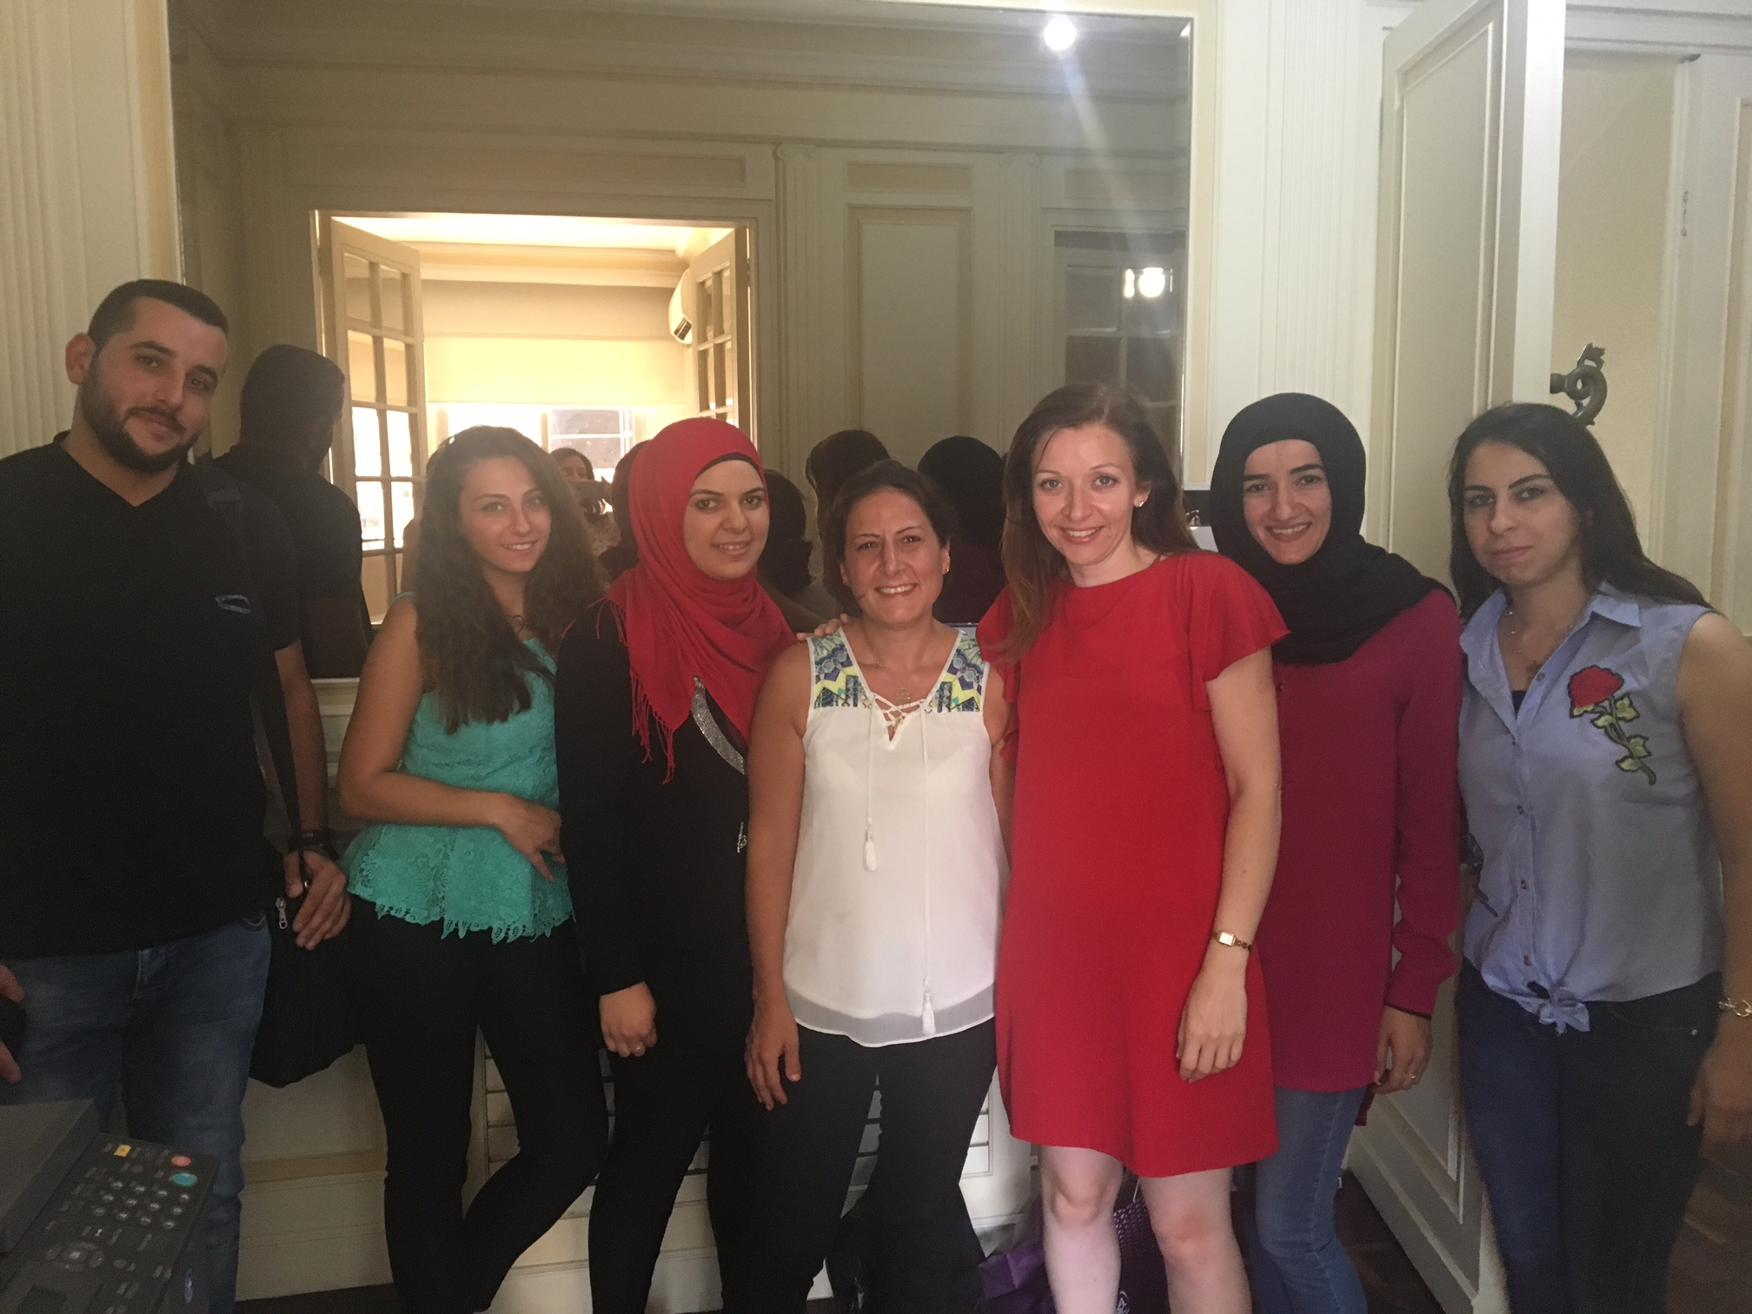
Some of the MdM team, including some of the Outreach Workers and their Clinical Psychologist with MAITS’ CEO

In 2017, we were contacted by MdM, a long-established charity in Lebanon, which has an excellent reputation. The team there were aware that a MAITS’ staff member was in the region and knew we provided disability training and invited us to do a needs assessment. They have a team of really dedicated workers who regularly visit extremely vulnerable refugees to provide mental health support, but these workers have no specific disability training on developmental disabilities. We undertook the needs assessment and visited the refugee camps and clinics, as well as accompanying the outreach workers on field trips. The work these outreach workers were making to those with mental health illness was remarkable. There was a huge level of need and we could see the difference these outreach workers could make to families with children with disabilities with some additional training and resources. This project will improve access to health services for children with developmental disabilities by:

- Increasing the identification of children with special needs in the community by trained community health workers
- Providing support for the child at home, through caregiver training, that will have a direct impact on the child’s health and well-being
- Strengthening referral systems between community and specialist services
- Providing resources on disability for parents and community workers in Arabic

- What do you need the money for?

We have identified a highly qualified Occupational Therapist, who was one of the authors of the Community Health Worker training programme, who is willing to provide the training on a voluntary basis. We need funding to enable the training to happen, which would include the cost of training resources and the costs for translation into Arabic of the materials which include a very visual, simple Parent’s Guide, the training package and the Community Health Worker’s manual and the cost of travel for the volunteer trainer. MdM would provide the cost of accommodation for the trainer for the time she is training them and some local transport costs too. Accommodation costs would be needed for additional training run.

When do you need the money?
We are requesting funding for August/September 2018 ideally, to cover the costs of the training which is due to take place in November 2018. We have identified a volunteer trainer from our database of highly qualified trainers and we need some modest funding to put this in place. Our charitable registration number is 11262628. Thank you for supporting children and their families.

