ESCUELA DE EDUCACIÒN BÁSICA PARTICULAR
“LOS ALGARROBOS”
CANOA - MANABI – ECUADOR

ENVIRONEMENTAL EDUCATION PROJECT 2019-2020

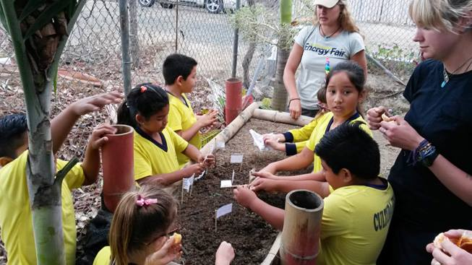

DATA:

Name of the Institution: “ESCUELA DE EDUCACIÓN BÁSICA PARTICLAR “LOS ALGARROBOS”
Zona: 4 | Distrito: 13D11 |  | Circuito: C6_a | Año Lectivo: 2019 – 2020
Name of the Project: Programa de Educación Ambiental |  |  | Number of Students in the Project: 34
Sublevel: |  | Prep. elemental media básica superior  X
Teacher Responsible:
Lcda. Rachel Isser, Prof. Enrique Vera
Start Date: May 2019 |  |  | End Date: February 2020
Quote for this Project:  "Unless someone like you cares a whole awful lot, nothing is going to get better. It's not" Thel Lorax, Dr. Seuss  ” |  |  | Logo:  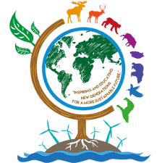

What is Environmental Education?

Environmental Education demonstrates to students that each of them is responsible for taking care of the natural environment. Environmental Education should:
- Teach students what is the environmental damage that is happening to the planet right now.
- Help the students become closer and learn to love and care an unaltered natural environment.
- Teach the students alternatives and solutions for daily habits that might harm the environment.
- Help students feel empowered through project based learning.
OBJETIVE: Why have we developed this project?
In the past few years, governments, NGOS, and the general public have all realized that a dramatic climate change is underway worldwide. Although the majority of the damage has been cause by large companies, bad habits at a familiar level are also contributing to the environmental damage our planet is experiencing.
In our small town, we observe many bad habits that hurt the environment including:
- Throwing garbage on the ground, particularly on the beach
- Using many (many!) plastic bags
- Asking for plastic to-go containers instead of bringing a reusable one
- Excessive consumption of meat
- Excessive use of private vehicles, particularly on the beach
- Excessive use of agricultural chemicals
- Excessive cutting of trees.
SPECIFIC OBJECTIVES.
- Introduce students to two different ecosystems, each just an hour away from each other and protected in reserves.
- Observe environmental projects already in process.
- Put in practice recycling habits
- Put in practice responsible deposit of garbage in appropriate place
- Put in practice planting trees
IMPORTANCE: Why are we doing this?
In addition to being an important part of our institution’s mission, the students need to understand the power they possess to change their own futures. Climate change is real and urgent and if the generation of young people growing up now don’t take action, the situation for our planet will be come worse with every passing generation. It is the responsibility of any institution to instil the values related to caring fo the natural environment.

VALUES AND COMMITMENTS: How will we act and participate?

AGREEMENTS:

These are the most important aspects of hands on work experience, and we must be sure that our students are aware and are able to avoid any kind of danger associated with the tools and materials that will be used. We must consistently remind them of the following values and commitments:
- In any occasion in which we leave Canoa, each student must be accompanied by an adult representative. If it is not their legal representative, a signed permission form must be submitted to administration at least a day before the field trip.
- Be sure to have all materials on hand before starting project work.
- Pay attention when the facilitator is talking. If you have a question or comment, please raise your hand to speak.
- Treat others in class with respect.
- Optimize the time allotted for project. Please don’t occupy project time with other unrelated activities.
- Before each activity, it is necessary to explain an risks related to the activity so that students may enjoy their time while also participating safely.

VALORES:
- Discipline
- Punctuality
- Respect
- Responsibility
- Solidarity
- Kindness

ATITUDES:
- Friendship
- Perseverance
- Enthusiasm
- Humility

RESOURCES:

Physical:

- Ecological Reserve Cerro Seco
- Work Site Foundation Planet Drum
- Canoa Beach
- Los Algarrobos School
- Waterfall Rio Muchacho
- Finca Caracol, Rio Muchacho

Materials:

- Seeds
- Tree Nursery
- Hole Digger
- Shovel
- Trash Bins
- Garbage bags
- Baby plants

RESPONSIBILITIES

ACTIVIDAD | RESPONSABLE/S
Motivation | Teacher Rachel Isser  Teacher Enrique Vera  Students  Parents  Director
Adaptation
Basic Instructions
Recreation

RESULTS: How will we measure if we have succeeded?

- In both Science and Social Studies class, students will have the opportunity to reflect on their experiences and present what aspects affected them most. In the long term we hope these activities will instil deep set values that will mostly be demonstrated outside of school in the home.

CALANDAR:

MAY
- Meet with parents and students, presenting this years Environmental Education Program
- Coordination of transportation and materials

JUNE
- JUNE 15: Field Trip to Bahia de Caraquez (7th Grades)
  - 9:00 AM Leave Canoa in rented vans
  - 9:30 Arrive at Work Site Foundation Planet Drum
  - 10:30 Snack Time
  - 11:00 Leave Planet Drum
  - 11:30 Arrive at Ecological Reserve Cerro Seco
  - 1:00 Finish nature hike
  - 1:30 Leave Bahia de Caraquez
  - 2:00 Arrive in Canoa
AUGUST
- August 12-16: Recycling Competition (1st through 7th grades)
  - Each grade will bring plastic garbage, plastic, glass or cardboard. Discussion and practice separating garbage.
  - Pizza Party prize for the class that collects the most recycling!
  - Sale of recycled materials to recycling center in San Vicente o Chone

SEPTIEMBRE
- September 14: Beach Clean-up (1st through 7th grade)
  - Each class will meet on the beach at 9:00AM
  - Pizza party prize for the class with highest percentage of participation!

NOVIEMBRE
- November 4-8: Elaboration of tree nurseries with Planet Drum (6th and 7th grades)

DICIEMBRE
- December 9-13 Transplant baby trees to recycled bottles with Planet Drum (6th and 7th grades)

ENERO
- January 18, 2020 : Field Trip to agricultural community Rio Muchacho Caracol (7th grade)
  - 9:00 Leave Canoa
  - 9:30 Arrive at community Rio Muchacho, Finca Caracol. Plant trees.
  - 11:00 Snack time.
  - 11:30 Walk to waterfall site.
  - 12:00 Swim and play! Back to the van.
  - 2:00 Return to Canoa
CONCLUSION.
As an educational institution, on of our goas is empower our students to provide their own safety and security as adults, preparing them for the challenges that lay ahead. A difficult reality that they must face is the climate change we are starting to feel in the last few years, and it will only become worse in the future. It is our responsibility to teach our students how to take care of nature, how to prevent environmental damage, and to avoid the planet’s situation getting worse than it is now.

Lcda. Rachel Isser

FACILITATOR PROYECTO ESCOLAR

