Corridors of Peace Mediating through union of hearts and minds
« When brothers and sisters urinate together it foams better »
(African Proverb)
July 26. 2018

Project Title: Provision of Vocational Training for 100 Female Victims of War in Guerida Chad.
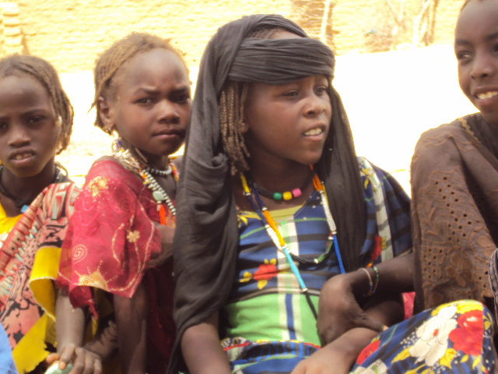
Project URL?
Project Summary:
Corridors of Peace plans to provide free vocational and literacy training for girls and Women who were victims of the clashes between the Zhagharwas and the Tamars. Also to provide free meals for their children who hail from the poorest land locked sections of the society in Guerida Chad,
The project would build a vocational center in North Eastern Chad, to provide a rich supply of vocational skills, like Sowing Machines, Solar Water Pump for Agriculture and Solar Powered mill for income generating activities and critical literacy support services to 100 Women and their children traumatized and displaced by the rebellion and communal clashes.
Requested Funding Amount: $35,000 (Thirty Five Thousand Dollars)

Donation Options:
- $15will buys pencils and pens for Women training
- $35 will provide Needles and Threads for sowing machines.
- $60 will provide copy books for victims’ writing
- $80 will provide pure drinking water for Victims and Children during training
- $100 will provide tissues and sowing materials for vocational training
- $150 will provide lunch for 75 children of female victims
- $200 will provide agricultural seeds for 50 families
- $250 will provide 6 Goats for Agricultural Project
- $360 will provide seats and tables for vocational Training.
- $1600 would buy a solar water pump for Female Agricultural skill training
- $2800 will buy a solar Grinding Mill for victims Income generating training skills.
- $3000 will provide Monthly salary for 4 Vocational instructors for 1 year

What is the issue, problem, or challenge?
Decades of clashes and strife in North East Chad Guerrida left , most Tamar women and girls are illiterate, jobless, poor, widowed, the only option for survival is to join the FUC rebel force for retaliation or for Security and protection. Corridors of Peace would provide culturally sensitive vocational training education for females victims, and their children in Guerida Central. 90% of the participants of this project would come from Guereda, central, Koulbous , Dourkoulé, Wili-Kouré, Lima, Faré and all those females who have returned from living as refugees or Rebels in Sudan and the neighbouring countries provinces to escape fighting and insecurity in their rural home areas.
Solution
Corridors of Peace would provide the female victims (women and girls) an opportunity to learn skills such as tailoring and embroidery, agricultural skills, and income generating skills, so that they could use these skills to support themselves, their families and community. Once Empowered, these women go on to replicate the training in their own communities, give women and older girls a chance to catch up on years of missed schooling by learning vocational skills and empowering basis. Participants would be encouraged to spend a minimum of 8 months to 1 year before certification and empowerment to be independent.
Long-Term Impact
After the first 2 years, 100 women and girls would be empowered every year. They will become independent and mentors to other victims in their societies. They would gain back their dignity and integrity. There would be improvement in the standard of life of the female victims, economically, social, culturally as they gain more opportunity for a better life. Start up resources would be given in groups and and certified beneficiaries would be encouraged to work in groups in their local communities. They would be mainstreamed into their societies instead of living clandestine lives. This empowerment would reduce and eventually stop the sexual favours to militias for survival. Many female and girl child would choose to have the vocational training program as a way to life in other to prevent conflict. This action would reduce and stop the recruitment of female and girl child into the militia and rebel forces. Former female rebels and victims would become advocate of their own communities some will mainstream into Job givers at appropriate age and levels befitting. Understanding the value of vocational education, would enable the women support their children’s education, development and growth. With open mind, these women understand they would mentor and train others and can be leaders and contribute positively to society.

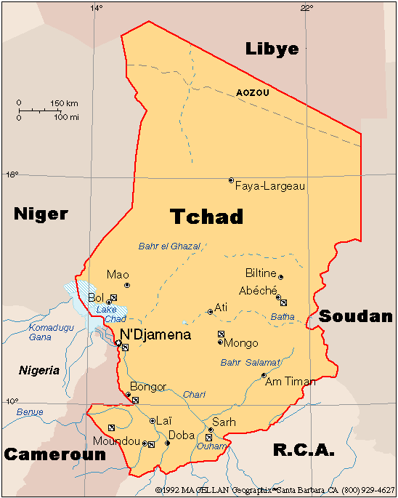
Conflict, Landlocked, desert,drought ,and arid gground.

L

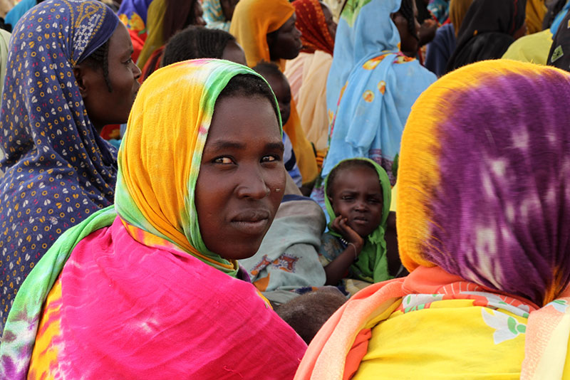
This is from the internet, not from me. But it is from Chad, What can we do about it?

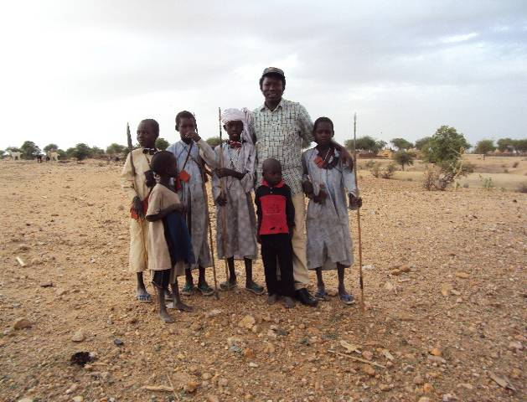
ADDITIONAL INFORMATION

CONTEXT FOR OUR INITIATIVE AND MOTIVATION
President Idris Déby of Chad republic is concerned about the level of support that
Khartoum provides the Union of Resistance Forces (URF), with the hope that
diplomatic relations are broken off. The URF successfully tests the Chadian military
forces, achieving a balance-of-power that tips slightly in favour of the state. As such,
the coalition is able to raid refugee/IDP camps and contest government power in
most areas of the country (with the exception of N'Djamena).
. North East Chad is a difficult place to penetrate, more so when it has to do with women and girls. I have lived in Chad, Cameroun, Nigeria and have visited neighbouring countries like Central Africa and Sudan.
During our last visit to Cameroun, working with Rights for all, an Anti-Trafficking Non-governmental Organisation N.G O. We discovered from the fleeing women who fled to and through Cameroun, that women, teenage mothers, and young girls were
seriously assaulted, violated and dehumanized by the Zaghawa tribal rebel group,
this led to the clandestine registration of young girls, teenager and even mothers
and those widowed by the Zaghawa’ rebel group, into the FUC (Force Unifie pour changément) rebel group for protection and probably revenge. Since the accord between the government in Libya, November 2006 and the announcement in Chad 2007, to end the rebellion and the recruitment of rebels by the FUC, various international organizations in collaboration with UNICEF, UNHCR and other partners have reunified and reintegrated over thousands of male soldiers, and even male child soldiers but nothing for the females.
Total population: 13,200,000people
UNFPA, as of Dec. 2014
Conflict: 85,500 internally displaced
As of Feb. 2015

Disasters: 133,163
Newly displaced in 2013
48,600 refugees
Originating from country, UNHCR, as of Jan. 2014
Location: Chad
Actors: Female Victims, Community, Government, NGOs.

