GlobalGiving Report – Sept 2026
Co-authored by Charles Appleby and Muskaan Banatwalla
A Hot Dry Summer That Made the Climate Case for Us
A progress update from IAHV - Climate Action Now & FLY GREENER
Thank you — you raised £11,874 for trees
Since our last report, our donors have given £11,874 which should plant around 23,000 trees in Madagascar. And would bring the total number of trees we have planted to 1,900,773. An important milestone. Thank you
That money does two jobs at once, and both matter.
It pulls carbon out of the sky. Trees do the one thing no technology has yet managed to do cheaply and at scale - they take CO2 out of the air and lock it into wood, roots and soil. Excess CO2 is what scientists identify as the driver behind the heat, drought and wildfires that made this summer so hard across Europe.
And it puts food on a family's table. We plant fruit trees, and every piece of fruit belongs to the farming family who tends them. No middleman. No deductions. A family that was living on the edge of poverty gains an orchard that feeds them and can earn them an income for decades.
Two voices from Madagascar
Mirina, Nursery Gardener "My name is Mirina, and I'm a nursery gardener. My job is to nurture the young plants that will one day grow into tall trees. I love this job because I know that every tree can make a difference to our land and our future.
I also love taking little Samuel with me to the nursery. He's still very young, but I believe that it's from childhood that we learn to love and respect nature. When he's with me, I show him how to fill the pots with soil, how to plant a seed and why we need to look after the young seedlings every day.
For me, passing on these actions also means passing on values. If children understand from a very early age that nature gives us so much, they'll naturally want to protect it.
I hope that as he grows up, Samuel will remember these moments spent at the nursery. Perhaps one day, he'll plant trees with his own children. That would be the greatest reward of all."
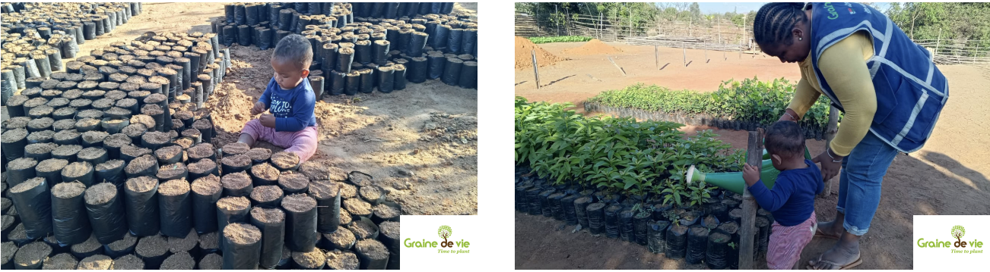
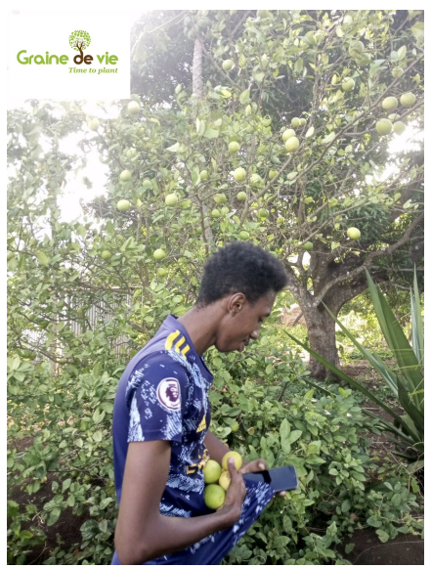
Jacquinot, who received seedlings from the Marivorahona nursery "Five years ago, I was lucky enough to be given some young Cythère plum saplings. At the time, I planted them full of hope, never imagining they would grow so quickly. Today, the trees are already producing a large quantity of fruit, and every harvest is a real blessing for our family.
I live with my grandfather, who suffers from joint pain. Cythère plums now play an important role in our diet and help us eat more healthily at no extra cost.
Although these fruits cannot replace the medical treatment my grandfather needs, they help us to look after his health better on a day-to-day basis. When the harvest is bountiful, we share the fruit with our neighbours or sell some of it to generate a little extra income.
I would like to thank Graine de Vie for this initiative. These trees represent much more than just a crop: they have become a source of health, solidarity and hope for our family. I encourage others to plant Cythère plums, as it is an investment that quickly bears fruit and brings about a tangible improvement in living conditions."
(Cythère plums - also known as the Polynesian plum or Tahiti apple - are crisp, tart tropical fruits.)
Read Jacquinot's story again and notice the timescale. Five years from a sapling in the ground to a harvest that changes what his family eats. That is what your donation buys: not a one-time gift, but a working asset.
This summer, nobody needed convincing
Drought. Record heat. Hosepipe bans across much of England and Wales. This summer, you didn't need a scientist to explain climate change to you - you only needed to open your front door.
Brown lawns. Withered crops. Shrubs and hedgerows dying back in July. Wildfires on British heathland and across Western Europe. The argument that took thirty years to win in the newspapers was settled in a single season by the weather.
Was this predicted? Yes - for more than twenty years. We are currently at roughly 1.4°C of global warming. When the Paris Agreement was signed in 2015, 1.5°C was widely described as the upper edge of "relatively safe."
Well. Now we know what 1.4°C feels like.
Where this is heading
CO2 in the atmosphere is still rising. That means temperatures keep climbing, and summers keep getting hotter and drier.
The consequences are already showing up in your weekly shop. This summer's news has been full of damaged harvests, ruined fruit crops and warnings of rising food prices. And we can't simply import our way out of it - because the same heat and drought hit farms across Western Europe at the same time.
So we will pass 1.5°C, and head towards 2°C. Does it stop there? On current evidence, no.
The respected Climate Action Tracker projects that, based on policies actually in place and pledges actually made, the world is heading for 2.6–2.7°C - a level most scientists describe in language they normally reserve for disasters. Some scenarios run higher still at 4C.
Why? Not for lack of warning, and not for lack of science - the scientists have been broadly right for decades. The gap has been political will. Governments collectively have not moved at anything like the speed their own commitments require, and the interests that profit from fossil fuels have had a strong hand at the table.
Perhaps a summer this visible will change that? It is much harder to argue with a wildfire than with a graph.
Even the oil industry is now asking to be taxed
Here is a detail worth sitting with. At the end of July 2026, as the wildfires burned, the chief executive of Shell called on governments to introduce carbon taxes in order to drive customer demand for green energy - while his company reported quarterly profits close to $10 billion. (The Times, 31 July 2026.)
Read that again. The fossil fuel industry is now asking governments to make its own product more expensive! That's not a green conversion - it's an admission that the argument is over and the only real question left is who pays, and when.
Should we wait for a carbon tax before doing anything? There is no need to wait. You can act on carbon and act on poverty today, by planting fruit trees with FLY GREENER - Campaign of IAHV and N0CO2

Flying this year? Fly greener.
Whether you've already travelled or your trip is still ahead, FLY GREENER makes it simple. You plant fruit trees, the trees draw CO2 out of the air as they grow, and a farming family in Madagascar keeps every piece of fruit those trees produce.
And right now, every donation is matched 1:1.
We normally plant 50 trees for £40. With match funding, that's 50 trees for £20. There are currently 11,000 trees available under the match fund — once they're gone, they're gone.
Recommended trees by flight length (return, economy)
Flight time each way | Recommended trees | Your cost with 1:1 match
1- 2 hours | 20 | £8
3–5 hours | 50 | £20
6–8 hours | 88 | £35.20
9–10 hours | 200 | £80
2 year package | 300 | £120

What can any of us actually do?
If we each did a little more, the arithmetic changes fast.
1. Cut the fossil fuel you don't need. Start with the easy wins. Turn the heating down a degree in winter, drive a little less. It costs nothing and saves you money.
2. Plant trees. Restoring forests is one of the most effective and affordable tools we have for removing carbon that's already up there. But let's be honest about what it is: planting trees is like bailing out a boat. Vital, urgent, and it keeps you afloat - but it doesn't plug the hole. We still have to stop burning the fuel. Do both.
3. Come and join us. Our Climate Action Now project runs on volunteers. If you'd like to give time as well as money, we would love to hear from you.
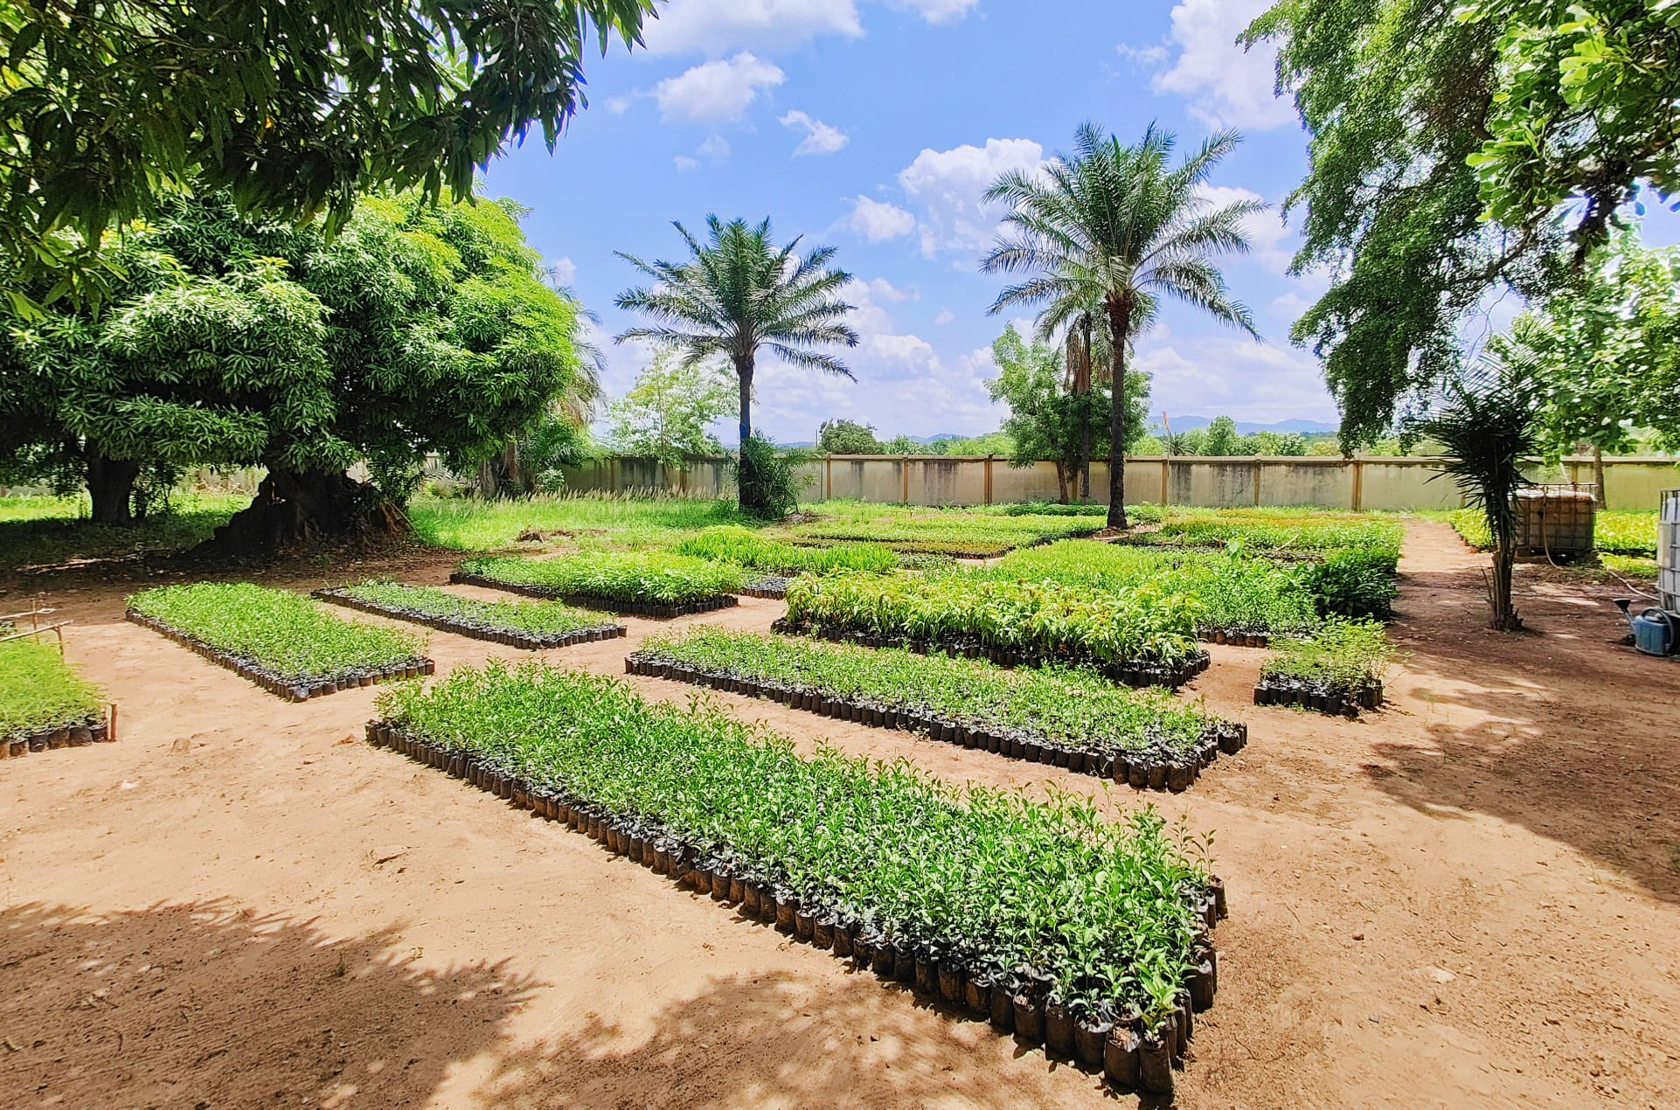

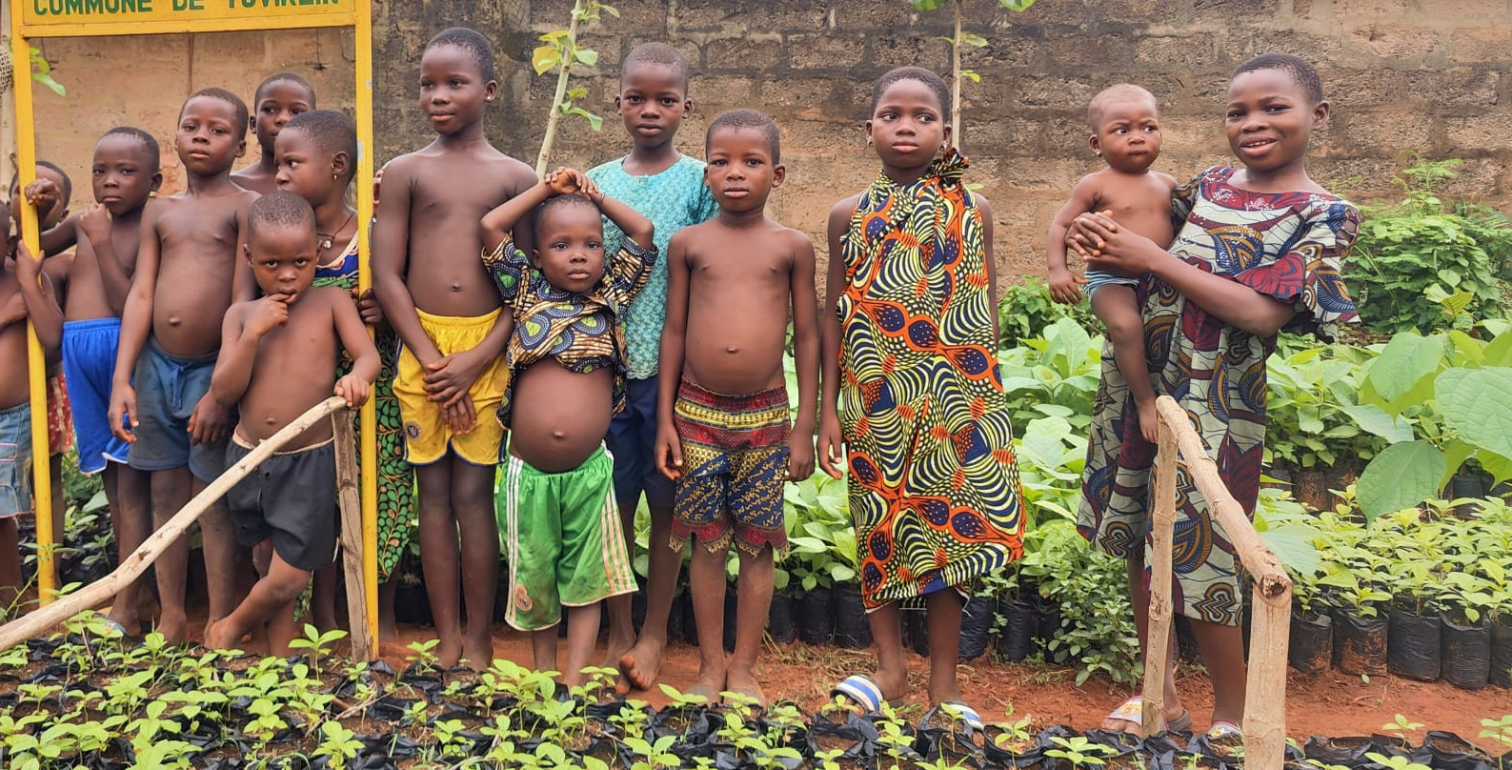

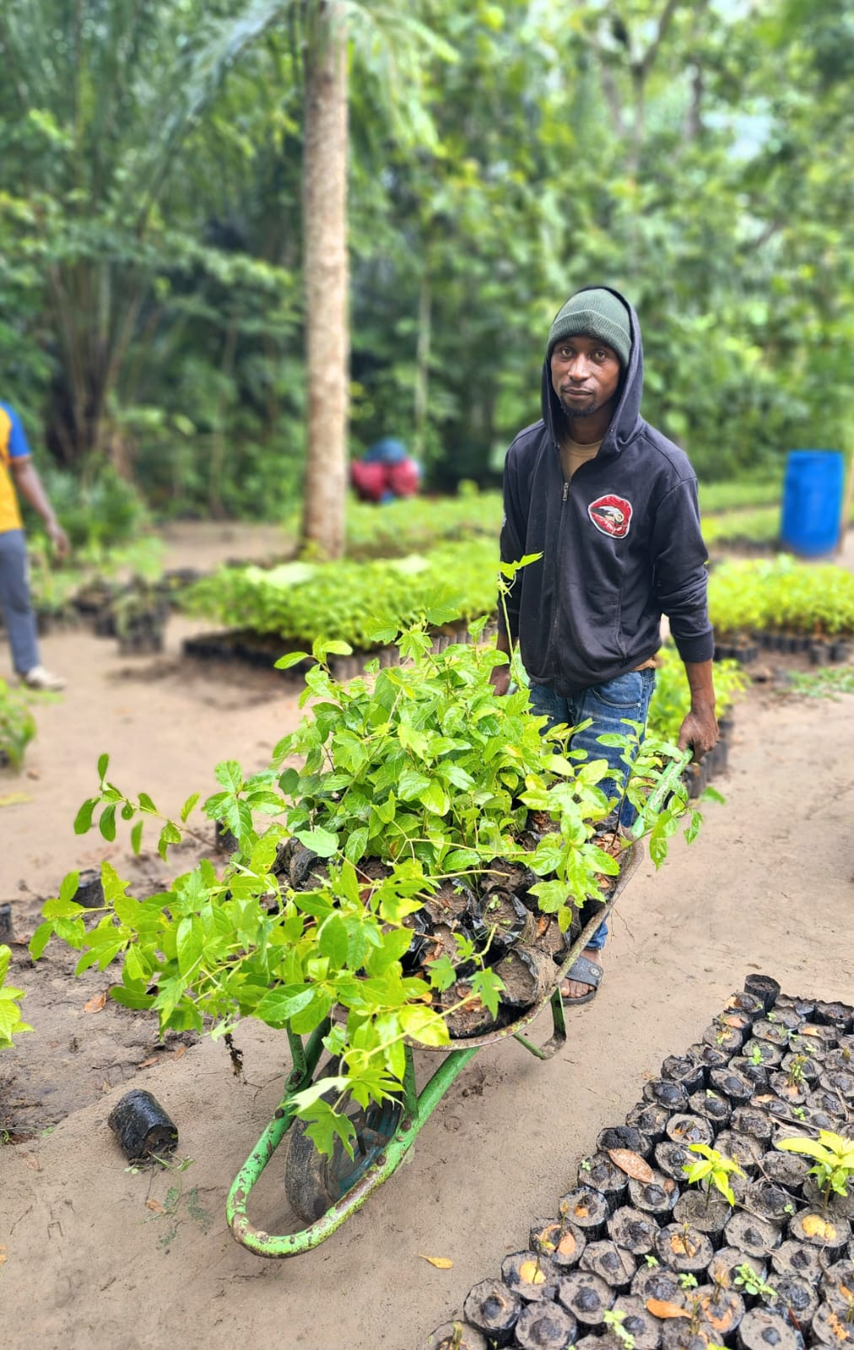
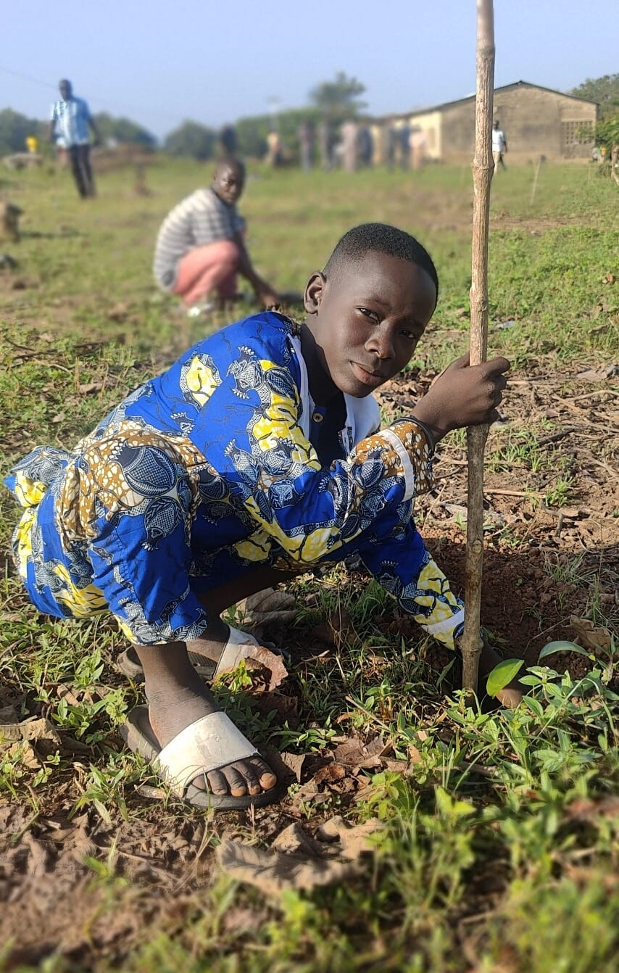

Once again, thank you. Genuinely. This summer showed everyone what the problem looks like. You're one of the people already doing something about it.
With gratitude, The IAHV team — Climate Action Now & FLY GREENER
IAHV UK is a registered charity in England and Wales, No. 1103261. Carbon figures quoted are estimates based on published scientific literature; tree growth and carbon uptake occur gradually over the lifetime of the trees.

