September 27, 2021

Dear respected partner, hope all is going good with you,
This is a project report on raising income for 70 single mom’s living in slum area of Addis Ababa.
Introduction
Yengat Birhan is a local NG established in 2016 and re registered on May 2019 to assist disadvantaged family especially poor women headed and child headed one. Since February, 2016, the organization approaches friends and individuals who share the vision of the founder and able to get financial, material and technical support and continued operating in collaboration with many stack holders with the Mission: Yengat Birhan Charity Organization working towards ensuring healthy family and community through supporting and encouraging peoples to know and release their potential in the integrated programs.
Objectives
- Assist widows to engaged them in income generating activities and earns income to cover cost of families, basic needs
- Providing school material, tutorial class with snack which focused on English, mathematics and Ethics for School aged children
- Providing health education on Hygiene, drug/substance abuse, Reproductive Health, HIV prevention and Psychological support for living with HIV, nutrition care/services especially for pregnant women and under five years old.

In this quarter the organization was working in Yeka Sub City, woreda 08, with 58 women/mothers, for socio-economic empowerment and giving preventive health education.
On the specific quarter the organization performed the following activities under the women economic empowerment:
Economic Empowerment
The ongoing activities under the economic empowerment division were more focused on the socio economic of the mothers/women. We worked with 58 mothers under Economic Empowerment. It was to make changes in the mothers and on their families life mainly on the economic part, by assisting the women to engaged in income generating activity so as to improving the families incomes. For this quarter the project facilitate to had 46 meetings of four self-help groups/SHG (4 group, one group contained 13-20 women) for a total of 58 women, by using SHG approach as a women empowerment model.
During their weekly meeting they also saved money in order to engage and improved their business. The organization also couldn’t provide one day training, which focused on how to save and improve their businesses for the SHG members as well as for 12 SHG facilitators/leaders, because of the current pandemic, COVID 19.
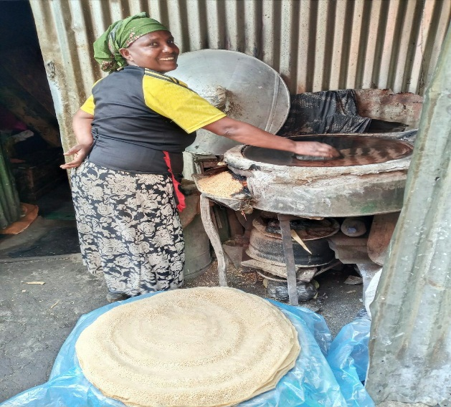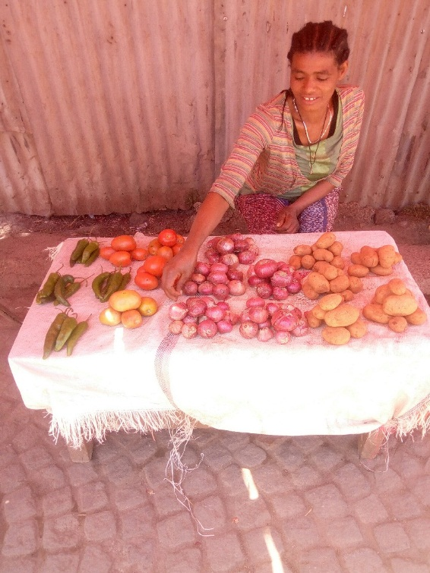
Some of the income generating activities
Performed activities under the Economics Empowerment:-
- Assisted the women to had weekly meeting for 58 women in four groups in order to creating opportunity to discussed on their problem and on other social issues ,
- Assisted the women groups to save money from birr 5 to 10, on weekly basis in order to had self-reliant and to prepared them to engaged in income generating activities,
- The groups continues in giving loans, so that members started their own small business and others, who started their businesses already used it to improves it
- Education given on the group how to improve their savings to enable them engage in income generating activities
- Encouraged them to contribute to a group savings according to their financial strength
- Support family with different food items like wheat flour, past, oil because of COVID 19 effects
Organizational Management
Yengat Birhan has been strengthening its organizational capacity, by organized professionals to give a volunteer service to develop the organization salary scale so that now the organization has its own salary scale even if it is for limited position. Yengat Birhan General Assembly as the government policy, on last year meeting, it was replaced by the board. The board has 7 members and now responsible for the overall strategic direction and organizational policy, The Board of directors, executive director and other members who elected as a member expected to participate on the meeting.

Obstacle / constraints
Yengat Birhan faced unexpected and major problem that affect the implementation of its activities. COVID 19 affect many of our activities, as you know it is not simple especially for organization like Yengat Birhan Charity because we usually doing things by collecting resources from local source’s\concerned individuals’. By the grace of God, we were survived and keep supporting the needy.

Please note that supporting us by sharing our message to other is great.

Thank you!

