February 05, 2022

Dear all respected partner, hope you are healthy and doing well.
This is a project report on raising income for 70 single mom’s living in slum area of Addis Ababa.
We are thankful for what you are doing in our project, without your support we couldn’t have an opportunity of changing others life.
Short Description of YBCO
Yengat Birhan Charity Organization is an indigenous humanitarian organization established as an Ethiopian Residential Charity in June 2016 with the registration number 3645 and the vision, aspires to see society enjoying healthy life. It works in Yeka sub city, Woreda 08 slum (Sholla local Market) for about five years after we have the license.
The focus of the organization is to reach marginalized families by supporting families especially single mothers who are struggling to support their children and child headed family (orphan) who lost their parents and become responsible for their younger siblings. The main support areas includes: supporting women in income generating activities; provide school materials and tutorial class for school children and preventive health education for both group to create health seeking behaviors’.
Currently, the organization is working to assist 78 very poor women to engage in an income generating activities including the newly added one self-help, which contain 20 members in order to support school children in a better way.
The ongoing activities still focused on the three strategic objectives: poor family economic empowerment, education and health. We do believe our intervention brought a visible improvement in the lives of women. As our main interventions focused area, income generating activities, YBCO is working to make a visible difference by way of introducing a sustainable community owned projects through building self-esteem and strong partnership to its stakeholders.
Our truck record shows almost all organization activities are managed by volunteers, who are sharing the founder vision. In the meantime, we have a plan to reach many more using the limited organizational resources.
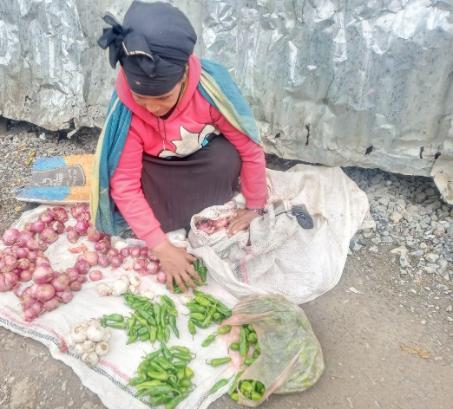
For the last three months the women empowerment intervention is underway.
We uses the Self-help group /SHG approach as a women empowerment model. We facilitate and lead the following activities with currently 78 women with in five groups. One group contains 13 to 17 members. In all their discussion, Yengat Birhan community facilitator is there to help them in their challenges.

We could perform the following activity for this quarter under this project:
- Discussed on their varies problems and issue on weekly basses for one hour in their villages
- Saved money from Birr 5 to 20 on weekly basis in order to engage in income generating activities, so as to improve the family life.
- The women groups now giving loans so members starting small business and others to use it to improve their business.
- Learning and discussing of the family need and related intervention is continuing, the project team visits each family and discuss on the different aspect of their life. In the discussion, the project team is learned specific family need and further discuss the type of future intervention, how it will be implemented and expected role and responsibilities.
- Till now the four groups saved a total Birr of 147,471.00 birr in their group bank account and the new additional group, has 20 members able to save Birr1600.00, so by using the money women will start\upgrade business and changed their family life.
insert additional picture

As we all know, it is a cross cutting issue helping the women to start IGA by equipping the skill and finance for children wellbeing. Therefor Yengat Birhan reassessed the status of children’s family on December 10, 2021, having a meeting\discussion with parents\guardian, who do not involved in income generating activities previously and tried to include the additional 20 mothers to start IGA (income generating activities) activities.
We discussed and agreed with them to start the discussion\meeting and to saving money every 15 days and to electing the leaders and to fix the amount of money. Based on their decision they started the saving Birr20\15 days and discussing on their different social issues.
There are many more mothers who are struggling to raise their children and sending to school in the slum areas of Addis Ababa, Ethiopia.
Therefore, YBCO would like to call up on our supporters to realize our vision of serving the underserved single mothers and to share our load by sharing our vission by using your network.
With regard
Meseret Tesfaye, Project Leader
Yengat Birhan Charity Organization

