Date September 26/2020
Dear respected partner,
It is the quarterly report, on raising income for 70 single mom’s living in Addis Ababa slum.
Introduction
Yengat Birhan Charity Organization is an indigenous humanitarian organization established by a volunteer health professional, as an Ethiopian Residential Charity, in June 2016, and re-registered on May 24, 2019 with number 3645. Its mission is to empower poor and disadvantaged individuals, family and communities, by helping to actualizing their latent potential through integrated family development programs. The project was designed to respond to the problems of disadvantageous families’ especially single mother or child headed/orphan family by provides innovative and comprehensive support related to their economy, children education and health.
Currently, the organization works in Addis Ababa Yeka Sub City, woreda 08 slum. In this quarter our project called raising income for 70 single mom’s living in Addis Ababa is continuing the implementation of the ongoing activities of the project. In fact we were not providing or implementing like training or big meeting to them as we planned early in the beginning of the year, because of the COVID – 19 Pandemic, but we could assist them to made their weekly meetings on open air and providing other kinds of timely support like food items. We hope you know and will understand how the current pandemic affects every activity on the world at large.
The ongoing activities of the project, raising income for 70 single mom’s providing some food items in addition to the usual assistance as part of the women support since they were in need of it.
Now a day the ongoing activities are more focused on supporting the women’s family by strengthen their economic part mostly through providing food times for them in order to feed their children, family since their daily activities decrease because of the pandemic.
Major activities performed during the quarter
In this quarter under this program as mention above we able to provide both the usual support and the food items. The provided food items and related materials were very helpful for the prevention of the COVID 19 pandemic. We provided for 58 women’s, households and the support materials include the following: 2 litters of cooking oil, 4kg of Macaroni, 5 pieces of hand washing soap, 2 bag of Tea of 100gm.
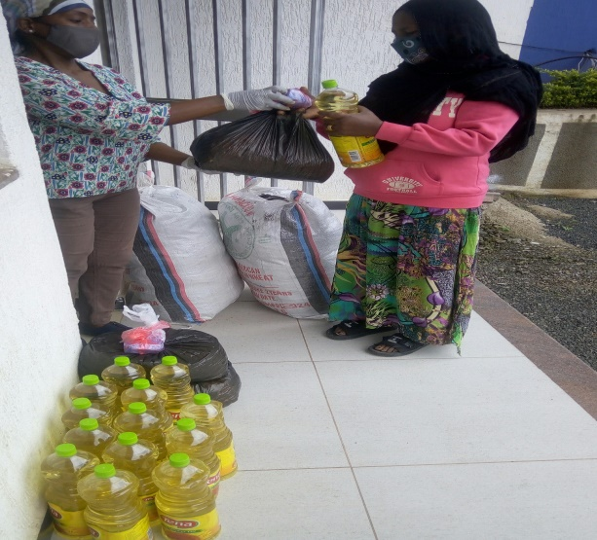
On providing food items for the mothers
As the overall goal, we tried to contribute for the changing of the living standard of marginalized and disadvantageous family especially headed by women with children and child headed family (Orphan) through building their capacity and self-esteem in a continuous improvement of life. We were continuing in keeping assisting mothers to engage in income generating activities and to earn income to cover cost of their family’s basic needs.
Activities performed in this quarter related to income generating activities were:
- The women able to discuss on the weekly meeting on open air for one hour on their problem and its solutions
- Perform weekly saving that help to engage and to improve in income generating activities by using it as startup capital, so as to improve the family income and life.
- Three groups members started new businesses and another four improved their businesses by taking loans
All of the ongoing activities under the economic empowerment division in this quarter were going well in spite of the current challenge, COVID 19. The entire four groups called: Tesfa Lenge, Yenge Fery, Edget Lefray, and Edget Behbret saved on their weekly meeting from 5-10 birr for the last three months. Their saving helped them to initiate them to engage in businesses activities and to improve their small businesses. Many mothers’ improves their business by taking loan from the group capital.
A very small support which we gave to the mothers to engaged in income generating actvities help the life of the family to live better. Therefor we encourage you to support us conuntinualy to do more to improve the activities of income geneating activities to bring more chang on others life.
Organizing additional donations
Currently our major work of the organization shifted to organizing resources both as in kind and financial both locally and internationally (through Global Giving) in order to give more timely support to our beneficiaries. In this quarter we received a donation both in the form of in kind and finance that gave us potential to support the needy women timely to minimize the damage. We are also forming a partnership with some organization which found in Addis Ababa in order to get more resources to sustain the needy life.
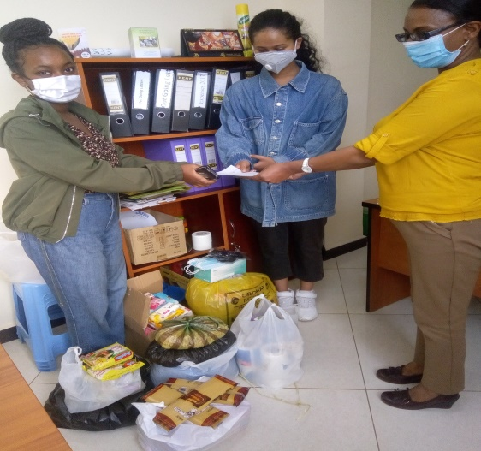
While we received donation
Obstacle / constraints
In this quarter, even though Yengat Birhan, faced major unexpected problem, COVID - 19 that affect the implementation of its activities, we are still doing our best in supporting the mothers by all the means in spite of having small donation. This is because of almost all of the organization activities were managed by Par time and volunteers, from all professions but one thing we should share for you is we need additional support still to sustain the food items support to them if the pandemic persist. The women/mothers status is in a very low economic states to feed their children.

Therefore we remind and encourage you to share our objective to your family and friends to sustain the very poor life during this COVID 19 pandemic.
Stay safe!

Meseret Tesfaye
Project leader of Yengat Birhan Charity Organization

