Dear all respected partner,
We are grateful for you making us to change others life. Without your support we couldn’t get an opportunity of changing women’s life
The quarterly report from Oct – Dec 2019, on raising income for 70 single mom’s living in slum.
Background
Yengat Birhan Charity Organization a none profit organization established by a volunteer health professional that represent a family committed to assist disadvantaged family especially marginalized women and child. The family has a long story of supporting disadvantaged children and their family for over four years using their own financial and material resources plus rich experience in humanitarian service. Since February, 2016, the organization approaches friends and individuals who share the vision of the founder and able to get financial, material and technical support and continued operating in collaboration with Yeka Sub city Woreda 08 and the surrounding community; in the area of women economic empowerment, improve school enrolment of disadvantaged children and improve the health seeking behavior of disadvantaged family.
- Vision: Yengat Birhan Charity Organization aspires to see society enjoying healthy life.

- Mission: Yengat Birhan Charity Organization working towards ensuring healthy family and community through supporting and encouraging peoples to know and release their potential in the integrated programs.
Objective: 1. Assisted mothers to engage in income generating activities and to earn income to cover cost of their family’s basic needs
Goal
The overall goal is to contribute for changing the living standard of marginalized and disadvantageous family especially headed by women with children and child headed family (Orphan) through building their capacity and self-esteem in a continuous improvement of life.
Currently the organization works in Yeka Sub City, woreda 08, with 70 very poor households on order to help to start and improve their own income generating activities.
Activities performed in this quarter are:
- The women able to discuss on the weekly meeting for one hour on their problem and its solutions
- Perform weekly saving that help to engage in income generating activities by using it as startup capital, so as to improve the family income and life.
- The groups member improved their businesses by taking loans and others start new businesses
- The organization provided training for 8 of the women group representative and 2 facilitators to lead the group weekly meeting by their own.

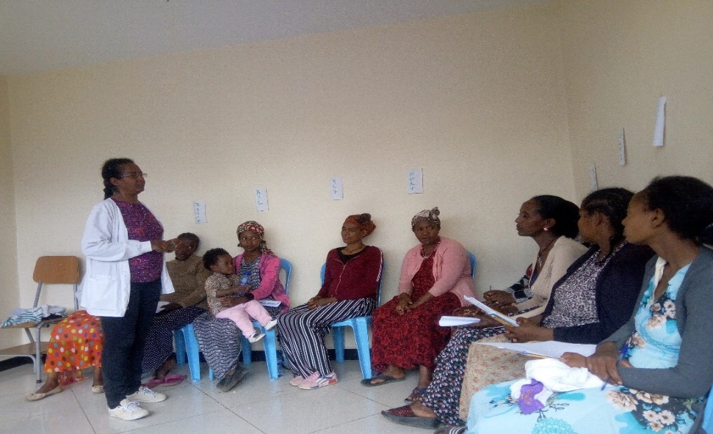

Mothers on taking training on how to manage their weekly meeting

The ongoing activities under the economic empowerment division in this quarter going good. It was to make changes in the mothers and on their family’s life by assisting the women to save money on weekly bases so as to engage in income generating activity, to increase the family income. We also created opportunity to them to discuss on their problem and to find solution by their own on weekly basis. For the last three months, from Oct to December 2019, the project facilitate to have 48 weekly meetings for the four self-help groups/SHG (4 group, one group contained 15-20 women).
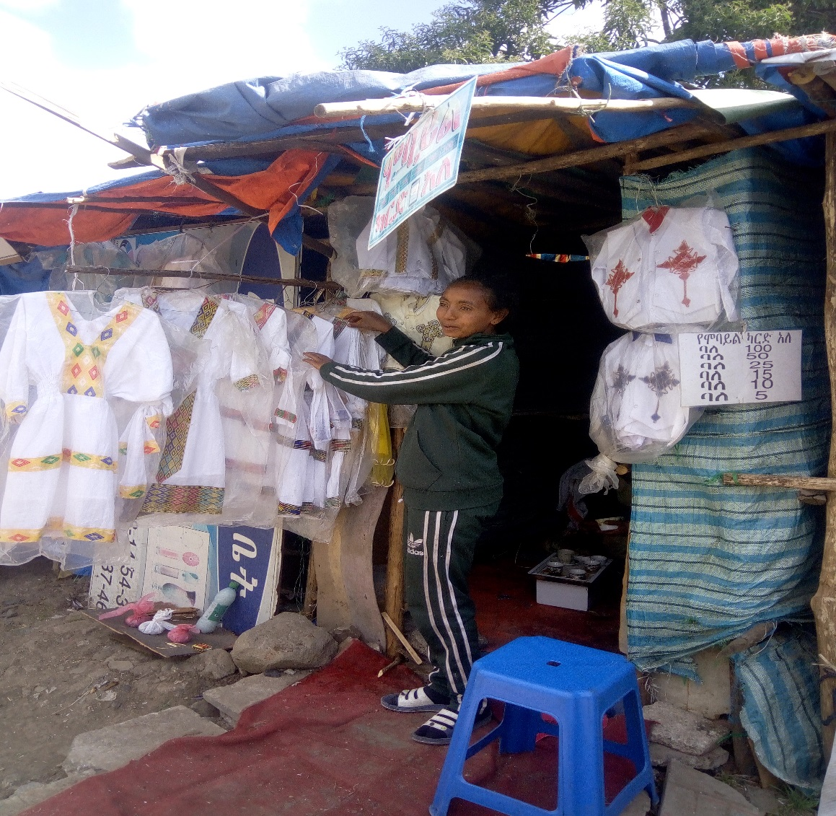
Mother starting a new business
On this quarter all the four group called: Tesfa Lenge, Yenge Fery, Edget Lefray, and Edget Behbret saved on their weekly meeting from 5-10 birr in order to start or improved their business. Together with Yengat Birhan donated birr for the 4 groups, in this quarter they have a total of birr98, 986.00 it helps to initiate them to engage in businesses activities and to improve their small businesses. Many mothers’ improves their business by taking loan from the group capital. In this quarter we were also providing a training for two facilitators’ and eight group representatives which focus on leadership.
As you read the above writtings every small support which we gave to the mothers chinging the life of the family. Therefor we encourage you to support us to bring more changt on others life.
With best Regards!
Meseret Tesfaye
Project leader of Yengat Birhan Charity Organizati

