June 05, 2022
This is a quarterly project report on raising income for 70 single mom’s living in slum area of Addis Ababa, Ethiopia.
Report period from March-May, 2022
Dear our partner, thank you for your contribution in supporting us in changing other’s life!
Introduction
Yenegat Birhan Charity organization is an indigenous humanitarian organization that works on women empowerment, child education, and health since 2016. The main support areas includes supporting women in income generating activates and creating awareness on some important social and political issues, providing school materials and tutorial class with snack for school children in order to perform better and creating awareness on health related issues and help them to get health care in need of it.
Yengat Birhan works in Yeka sub city, Woreda 08 slum (Sholla local Market) for about six years after it has got the license. The focus of the organization is to reach marginalized families by supporting families especially single mothers who are struggling to support their children and child headed family (orphan) who lost their parents and become responsible for their younger siblings. The main support areas in the project is supporting women to engaged in income generating activities and to create awareness on some important social and political issues and to support their children to send school in a sustainable way. .
On this quarter, for the last three months the organization was working in assisting 76 very poor women to engage in an income generating activities including the newly added one self-help group, which contain 20 members.

For this quarter, on this project we kept doing all the ongoing activities to improve women’s life, our intervention brought a visible improvement in the lives of women. As our main interventions focused area, income generating activities, YBCO is working to make a visible difference by way of introducing a sustainable community owned projects through building self-esteem and strong partnership to its stakeholders.
On this quarter, we assist the women in a better way by the donation we have got through Global Giving and women were happy. As usual we were also using volunteers to involve in organization activities, who are sharing the organization vision.
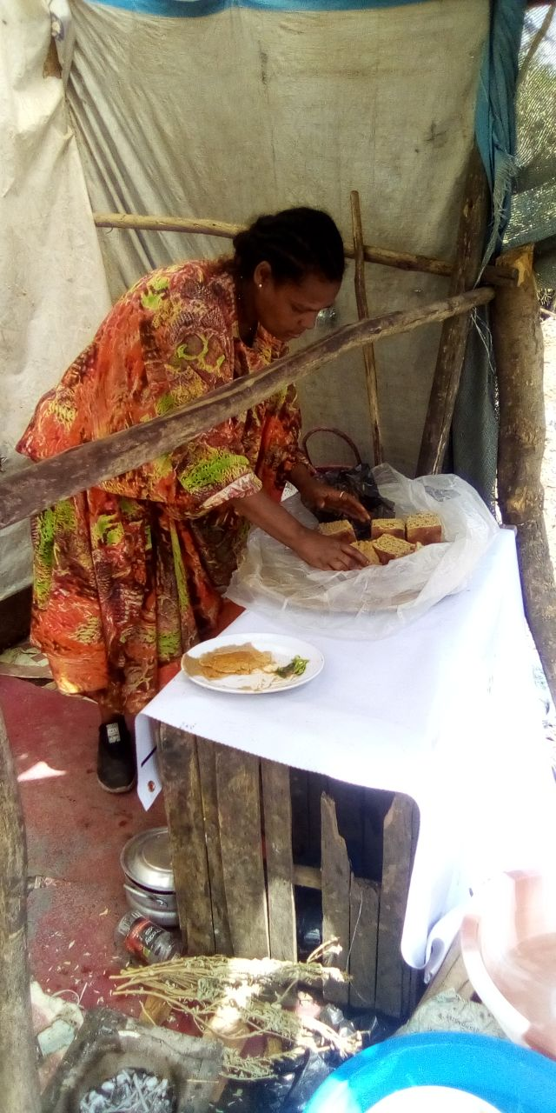
A single Mom starts new business
The following activities were accomplish in this quarter in the women project
By using Self-help group /SHG approach as a women empowerment model. We facilitated and lead the following activities with 76 women with in five groups. One group contains in average 13 to 17 members. In all their discussion, Yengat Birhan community facilitator is there to help them in their challenges.
We could perform the following activity for this quarter under this project:
- Discussed on their varies problems and issue on weekly basses for one hour in their villages
- Saved money from Birr 5 to 20 on weekly basis in order to engage in income generating activities, so as to improve the family life.
- Women starting small business and others improving their business by using their group money, capital.
- Learning and discussing of the family need and related intervention is continuing, In the discussion, the project team is learned specific family need and further discuss the type of future intervention, how it will be implemented and expected role and responsibilities.
- Till now the four groups saved a total Birr of 154,203.00 birr in their group bank account and the new additional group, has 20 members able to save Birr4000.00, so by using the money women could start\upgrade business and changed their family life.
As we all know, it is a cross cutting issue to improve the family life by helping the women to start income generating activities with equipping the skill and finance. During these three months, out of 76 mothers of both group, three school children mothers, have got special support to start income generating activities and could lead a better life.
There are many more mothers who are struggling to raise their children and sending to school in the slum areas of Addis Ababa, Ethiopia.
Keep sharing Yengat Birhan for others so that we can involve more in changing others school children life.
With regard
Thank you again!
Meseret Tesfaye, Project Leader
Yengat Birhan Charity Organization

