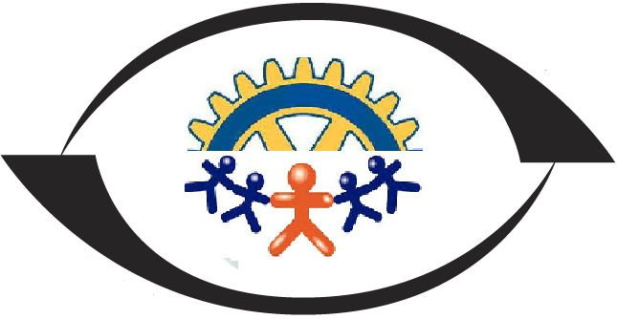
Construyendo Desde Abajo
Title:
Feed 75 children with low nutrition in Azua, Dominican Republic
Summary:
This project seeks to provide healthy and free food to 75 children with low nutrition in ages ranging from two to six years; children, single mothers, widows and unemployed in the neighborhood La Bombita; the poorest sector of the province of Azua, Dominican Republic.
Issue:
Iniquity and an unfair distribution of wealth is the main problem that causes poverty in the Dominican Republic. The gap between the rich and the poor is widening. These powerful sectors have little or no social commitment and promote a social model that continues to perpetuate poverty.
This situation prevents families from fully enjoying their rights because they lack opportunities, together with their communities, to benefit from the goods and services produced by all.
The impact of poverty is more dramatic because it affects a segment of society that in fact have always been marginalized, by culture, by ignorance, by the exclusionary system, they are childhood and adolescents, which are, (in more than 55% of the population that is, between 0 to 12 years.
La Bombita neighborhood in terms of poverty has an 80% poverty level, and because of its marginal urban characteristics and its social and demographic composition, the percentage is higher than the other neighborhoods of the province of Azua.
That is, of every 100 people who live in La Bombita, 80 live in poverty, 45 very poor, and 40 can not read or write. These levels of marginality and poverty are more reflected in women and children.
The community of La Bombita is located northwest of the Municipality Cabecera, being the neighborhood of the periphery with urban-rural characteristics of the city of Azua.
It has a population of 25,000 inhabitants, of which 12,765 correspond to the male population and 12,235 to the female population. There is a significant immigrant population due to the geographic location of the community. We find the presence of Haitians. They are located mainly in the peripheral areas of the community.
Activities.
We will make a medical evaluation to the childrenϖ
We will provide a monthly food ration for one year to 75 children from two years to six to ensure good nutrition.ϖ
We will train the parents of these children on the food system and family production.ϖ
We will make periodic home visits to each home to follow up and guide parents about household hygiene.ϖ
We will have a quarterly assessment of height and weight in childrenϖ
Impact:
The project will feed 75 girls for a year that will allow you to eat well and stay healthy with healthy growth, as well as 75 mothers of these children will know and apply the appropriate knowledge of food systems and will be motivated to seek means of work or a business family that will guarantee that in the future these children enjoy a healthy and safe diet.
No | Description | Budget Amount  (USD)
1 | Delivery of a food and vitamin ration for a year to 75 boys and girls | $30500
2 | Do quarterly medical evaluation | $25000
3 | Training workshops for 75 mothers | $35000
4 | Purchase of materials and supplies | $4000
5 | Medical fees | $2700
6 | Recreational activities and family life | $2300
 | Total | $45500(USD)
Budget request for the project

