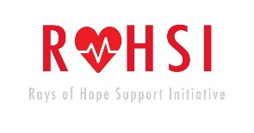
MISSION STATEMENT
The mission of ROHSI is to provide a platform for wellness and wellbeing to our community by providing consistent, excellent and accessible health-awareness programme to all in need of care, regardless of their status.
At ROHSI, our mission is to educate and impact people’s lives by promoting health and well-being through outreach campaign by giving them the right to make choice as it affects their health. We have the vision of establishing a medical centre strictly for the treatment of hypertension and diabetes and related cases. There will also be a mobile clinic equipped with modern medical facilities that we will go around with, in our community outreaches.
Rays of Hope Support Initiative-ROHSI, is an organization established with the objectives of providing awareness, health education among others basic medical care to the people in the community we serve especially the less privileged members who cost of medication has run deep into their little family income.
At ROHSI maiden programme, we screened 500 people, provided medication and additional one-on-one clinical examination and counselling for 100 of them, despite our limited resources.
Today, Rays of Hope Support Initiative has educated over 10,000 Citizens on disease prevention, screened over 3,000 people, and provided medication to over 3,000 Nigerians suffering from hypertension or diabetes
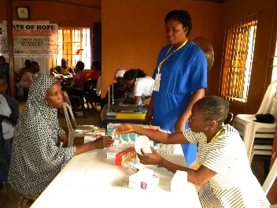
KNOW YOUR HEALTH NUMBERS
Cardiovascular disease is the worlds’ number one killer. World Heart Foundation statistics reveal that cardiovascular diseases account for 17.3 million deaths per year, and by 2030 this is expected to rise to 23 million. One of the key risk factors for cardiovascular disease is hypertension and diabetes.
Researchers have estimated that currently over 20 million Nigerians are estimated to have hypertension and its associated complications and it currently kills a large number of Nigerians, especially from the productive sector. Hypertension occurred in Nigeria affecting 1 in every 4 women while the figure may rise to 39 million cases by 2030.
Statistics showed that about 70% of hypertensive and diabetic patients go on compulsory ‘’drug holiday’’ while the prevalence among Nigerians is dangling between 30 to 40 percent on the area of location. There are significant health and economically attached to early detection, adequate treatment and good control of hypertension and diabetes.
Today, many of these patients are now going back to herbal medicine which often worse their condition resulting into more health complications
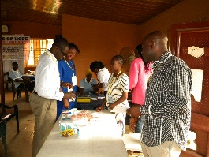
WHO WE ARE
Rays of Hope Support Initiative-ROHSI is a non-profit Organization that raises awareness, provides health education, screening, medical advice, free medications and follow-up to people with hypertension and diabetes in Nigeria.
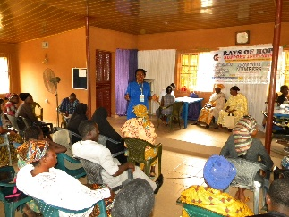
CONTACT US
Phone: +2348056749931, +2348038510714; +2348033637478
E-Mail: contact@rohsi.org;benjamin.olorunfemi@rohsi.org;rohsi.yahoo.com;rohsi2017@gmail.com
Website: www.rohsi.org
Twitter: www.twitter.com/ROHSI3
Facebook: www.facebook.com/ROHSI3
Instagram: rohsinigeria

