PROPOSAL FOR A
NEW HEALTH CENTER FOR BANDE DU NORD, CAP-HAITIEN, HAITI

ULS or “Unite de Lutte pour la Sante” might best be translated into English to mean “Fighting Unit for Health”. Indeed, as their name implies, the challenge that they have taken on is a true struggle. With very limited means, this small local non-profit organization has been helping the people of their community be healthier and more self-sufficient citizens for the past 8 years.
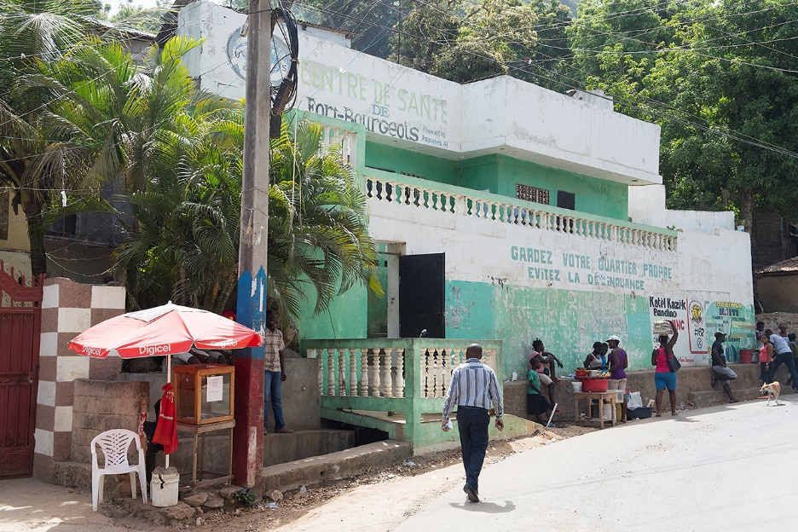
Their primary health care center was established in 2010 in Bande du Nord, an economically poor communal section of Cap-Haitian. Although it is currently operating in leased space that is not well-suited for the provision of care, it was made available at low cost by a local resident and is the first and only fixed center for primary health care for this population of about 25,000 people. Even though it is not far from the urban center, many of the people live on more rural mountainsides, often without road access.
Current leased ULS Health Center space will no longer be available
The ULS health center provides general consultation, medicines, simple lab tests, immunization, ready-to-use therapeutic foods for the treatment and prevention of childhood malnutrition, and family planning and other services. Most of its supplies and medicines are donated by the Haitian Ministry of Health and donor agencies. ULS offers free services whatever patients can pay or not, and they currently serve an estimated 400 clients per month.
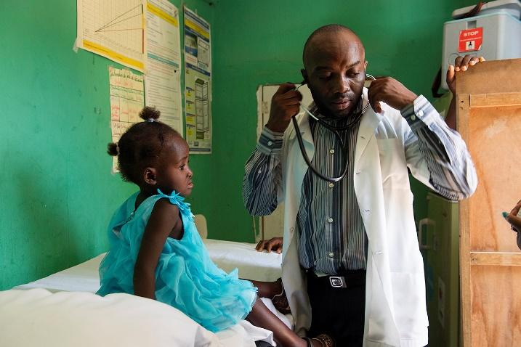
The clinics staff include three doctors, five nurses, one laboratory technician, six community health workers, one manager, and an office attendant. ULS also engages the area’s Traditional Birth Attendants (local midwives) and other volunteers to support their work. In fact, when funding has been insufficient to support salaries, the core staff have continued their work as volunteers. From their beginning, they have demonstrated that they understand that positively impacting on the health status of the people in their community depends on more than just good medicine, and as a result
Dr. Mesadieu, Director of ULS, seeing young patient

have developed programs and services that support good nutrition, economic well-being and education. We have observed how closely they work with the people from the community, and establish strong partnerships with them to address their problems together, including the creation of a community advisory board to help inform their work.
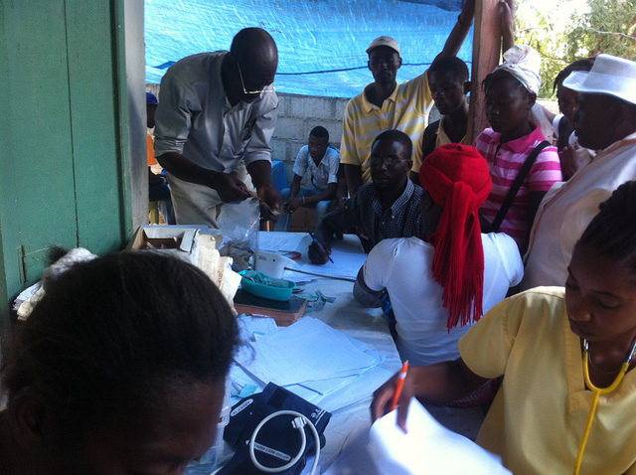
At Konbit Sante, we endorse this approach to capacity strengthening at all levels of the health system, and for that reason have chosen to try to help them establish a sustained and secure presence in the area. Our greatest impact has always been the result of identification of the local champions for positive change and helping them be successful in realizing their vision.
Several years ago, realizing that their ability to continue serving the residents of this area was tenuous as long as it relied on leased space, we said that we would try to help them build a permanent health center for the community if they could secure ownership of an appropriate piece of land for that purpose. So, they met with the community, and through a series of negotiations, contributions, and trade-offs, the organization now owns land close to their current location.
ULS Mobile outreach clinic in remote community
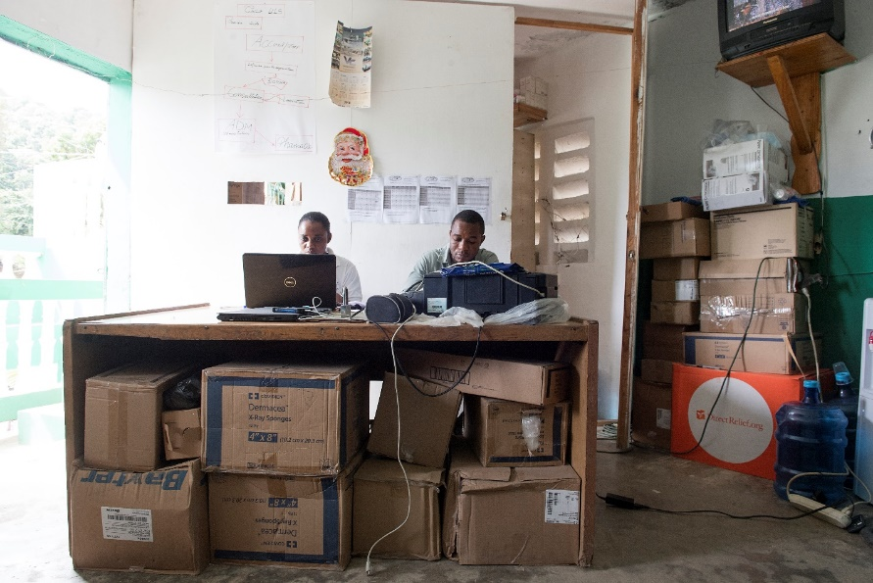
There is not enough space to store essential supplies and materials
Konbit Sante volunteer engineers from Maine have surveyed the land and developed a site plan appropriate to this mountainside location.
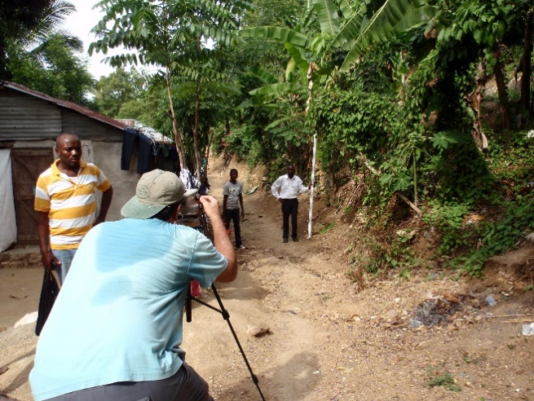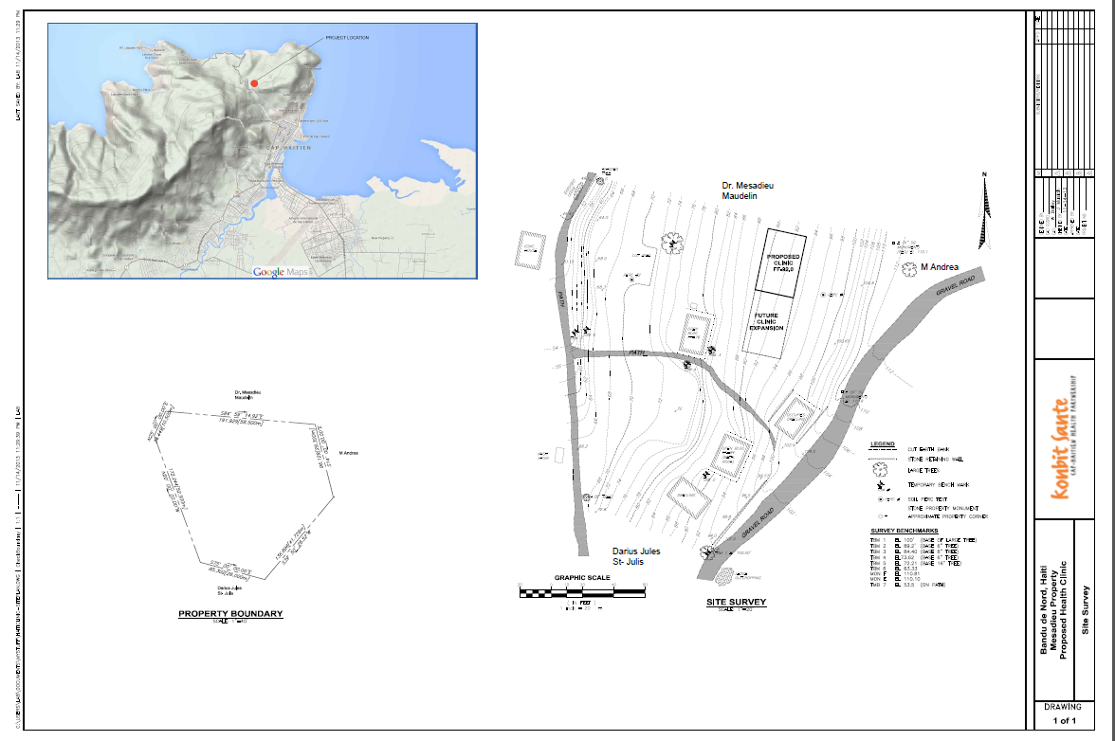
Surveying the land for site planning Site plan for excavation and building
A volunteer medical architect from London worked with us and the ULS staff to develop a very simple health center space that would meet their needs, and that was suitable for later expansion, should that be needed and possible.
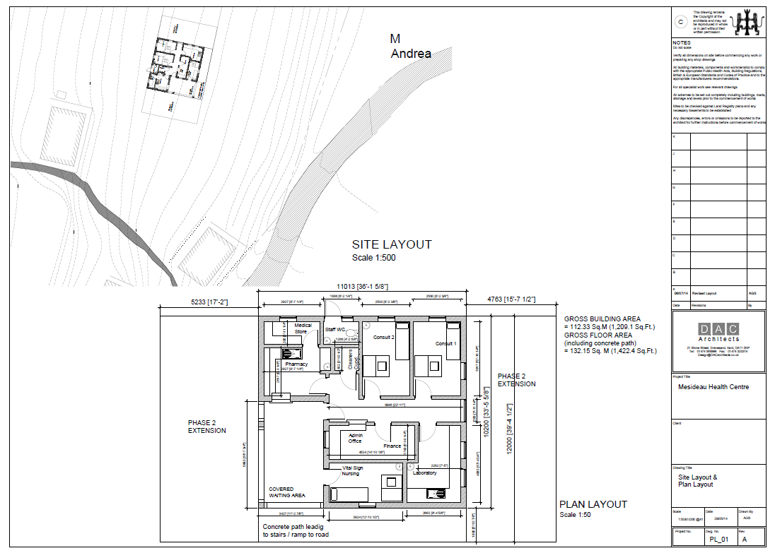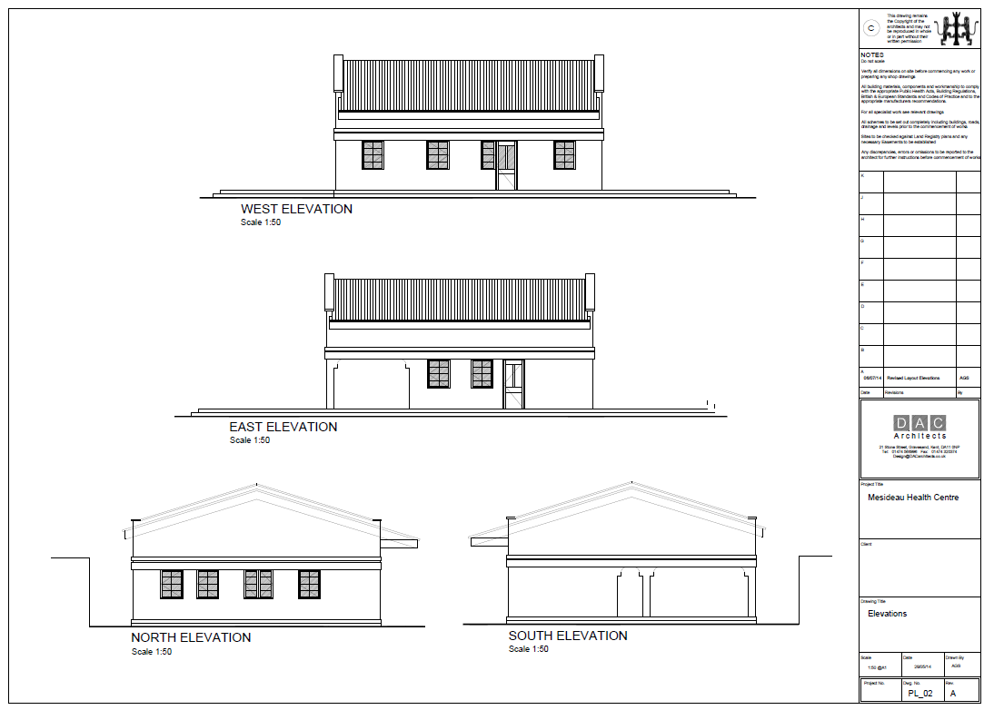
Architect’s rendering of room layout and siting Exterior design of proposed Health Center
A local engineer builder/contractor that has done a number of other construction project for Konbit Sante over the years- always on time, on budget, and of good quality- has costed out the project for us. Based on this preliminary study and work, we believe that this project can be fully implemented for a cost of approximately $200,000, and would be a good investment in the continued success of ULS to serve that community. The urgency has recently increased, as the owner of their existing leased space would like them to vacate it. They have secured an agreement for the next two years, but there is no renewal.
Challenge: As of this writing, we have two donors that are willing to contribute $50,000 each in matching funds to make this a reality. If we can match that challenge, the center can be built in the next year.

