Project description

“Green meals” help 170 kids in Wakiso study and protect the environment
How it started
I, Theo, live in the village of Kayunga since 2000 and got to know the people and their challenges quite well. One of the things I learned over all those odd 30 years I live and work in Africa is the importance of especially primary and pre-primary education. The first 15 years of a child’s life will determine his or her future. Good primary education is a gift no one can take away. So that’s why I couldn’t refuse the request of the community when they asked me to help with their primary school.
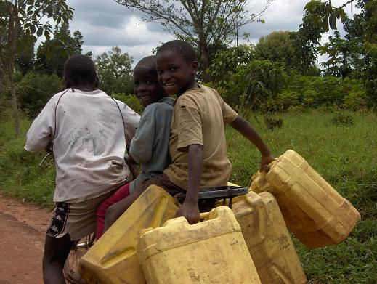
Although I recently was awarded permanent residence for life in Uganda, I only want to do things together with others. Stephen Galiwango is one of those remarkable people who can look beyond their own immediate needs and desires. He is passionate about education. So together with the help of a few other folks we embarked on this fascinating journey of giving kids of not so well-off families a chance for a better future. The smiles on their faces make me smile as well.

What is this project about?
This project wants to kill several birds with the same stone. The entry for our work in the community of Kayunga in Wakiso town in Uganda is the local primary school. For us good education means no more than 30 kids in a class, text books for every child, teachers who are willing to go the extra mile and school meals.
Research has shown that a meal, ideally complemented with a multivitamin/mineral pill can do miracles for kids who come to school on an empty stomach and who have never heard of lunch boxes either. Thus providing simple meals is a first objective of this project.
Most schools and households cook meals on open fires. This as you can imagine consumes a huge quantity of firewood every year. One household of 4 – 6 people emits 2.5 tonnes of carbon dioxide into the atmosphere a year; the traditional use of firewood is the main culprit. Every year Uganda loses 2% of its forest coverage. So something needs to be done.

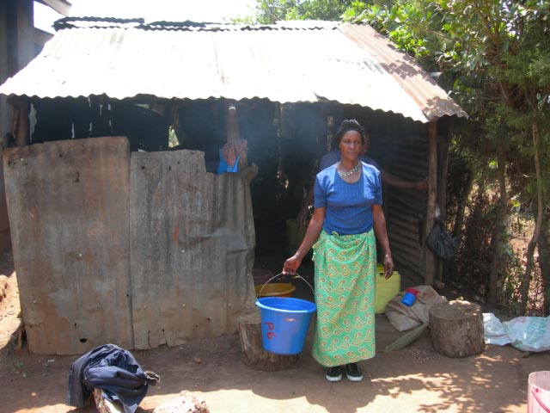
We want to build a new, simple kitchen since the old one is really nothing more than a shack. It will be fitted with an innovative firewood saving stove. In future we even think of building a biogas installation that would be ideal. So this is our second objective: reducing the quantity of firewood we use in the school for cooking the meals.
We think that kids can be great change agents. They are keen to learn new things, are very persuasive and will make sure things get done. As change agents they will convince their mothers to start using wood saving stoves as well. Simple household models have been developed that can reduce fuel consumption with up to 50%. The kids will show their mums and grandmothers how to use the stoves and once they see for themselves the money they save, these stoves will be quickly adopted. We don’t want to give things for free, but are willing to subsidize them a bit. In the end even in Europe we get government grants if we put up solar panels. These are objective three, kids as change agents in their families and community and objective four, promotion of family wood saving stoves.
The budget (in US dollar)
Construction of a simple kitchen of 60 m² | 4.800
Wood saving stove to prepare 170 meals per day | 2.300
Second hand container for storing food stock and kitchen utensils | 2.500
Plumbing and electricity (rainwater harvest) | 2.200
50 subsidized household stoves | 750
Meals for 170 kids for one school year 65$ per child | 11.050
Multi vit/ min for one year 10$/ class/ month | 630
Miscellaneous 5% | 1.212
Sub-total | 25.442
12.5 % Global giving | 3.180
TOTAL | 28.622
Bondeko Foundation Netherlands
We closely work with a charity in the Netherlands, the Bondeko Foundation. This is a growing group of friends who give money, help with technical questions, disseminate information, raise awareness, visit Uganda, receive Ugandan visitors, provide small loans and give emergency support people if hey are unexpectedly confronted with a devastating problem. The foundation is a living sign of hope for the community of Kayunga. Its members show the people here that they have friends they can rely on. They are professional in what they are doing, but they do it with a great heart. All work as volunteers and give our time, money and energy for free. (More info on www.bondekofoundation.com). The Bondeko foundation guarantuees the money needed to run the school (salaris, scolastic material, maintenance, cost of photocopies etc).

