June 2021 update: Providing psycho-social support to Cambodian children

Children who are victims of sexual exploitation require long-term support from trained professionals to accompany them on their journey towards reintegration within their families and communities. Terre des Hommes Netherlands in Cambodia works to provide them adequate legal aid and psychosocial services.
At the school and community level, prevention is essential to improve community-based child protection, reporting and fight discrimination against victims.
Rehabilitation of child victims  22 children (7 girls) identified as victims of sexual exploitation benefitted from legal aid and psychosocial support provided by TDHNL social workers and by the specialists of Action Pour Les Enfants (APLE)  33 welfare and hygiene packages were distributed to these children and their families to support them to cope with the loss of income under COVID-19; 1 child received a bicycle to support him complete his education  We collaborated with our NGO network to find vocational training for 2 boys who are over 16. The case of a boy who started working as a mechanic was successfully closed  Prevention of sexual exploitation through travel and tourism  452 children regularly involved in children's clubs to learn about the risks of sexual exploitation  2,027 community members were involved in awareness raising events  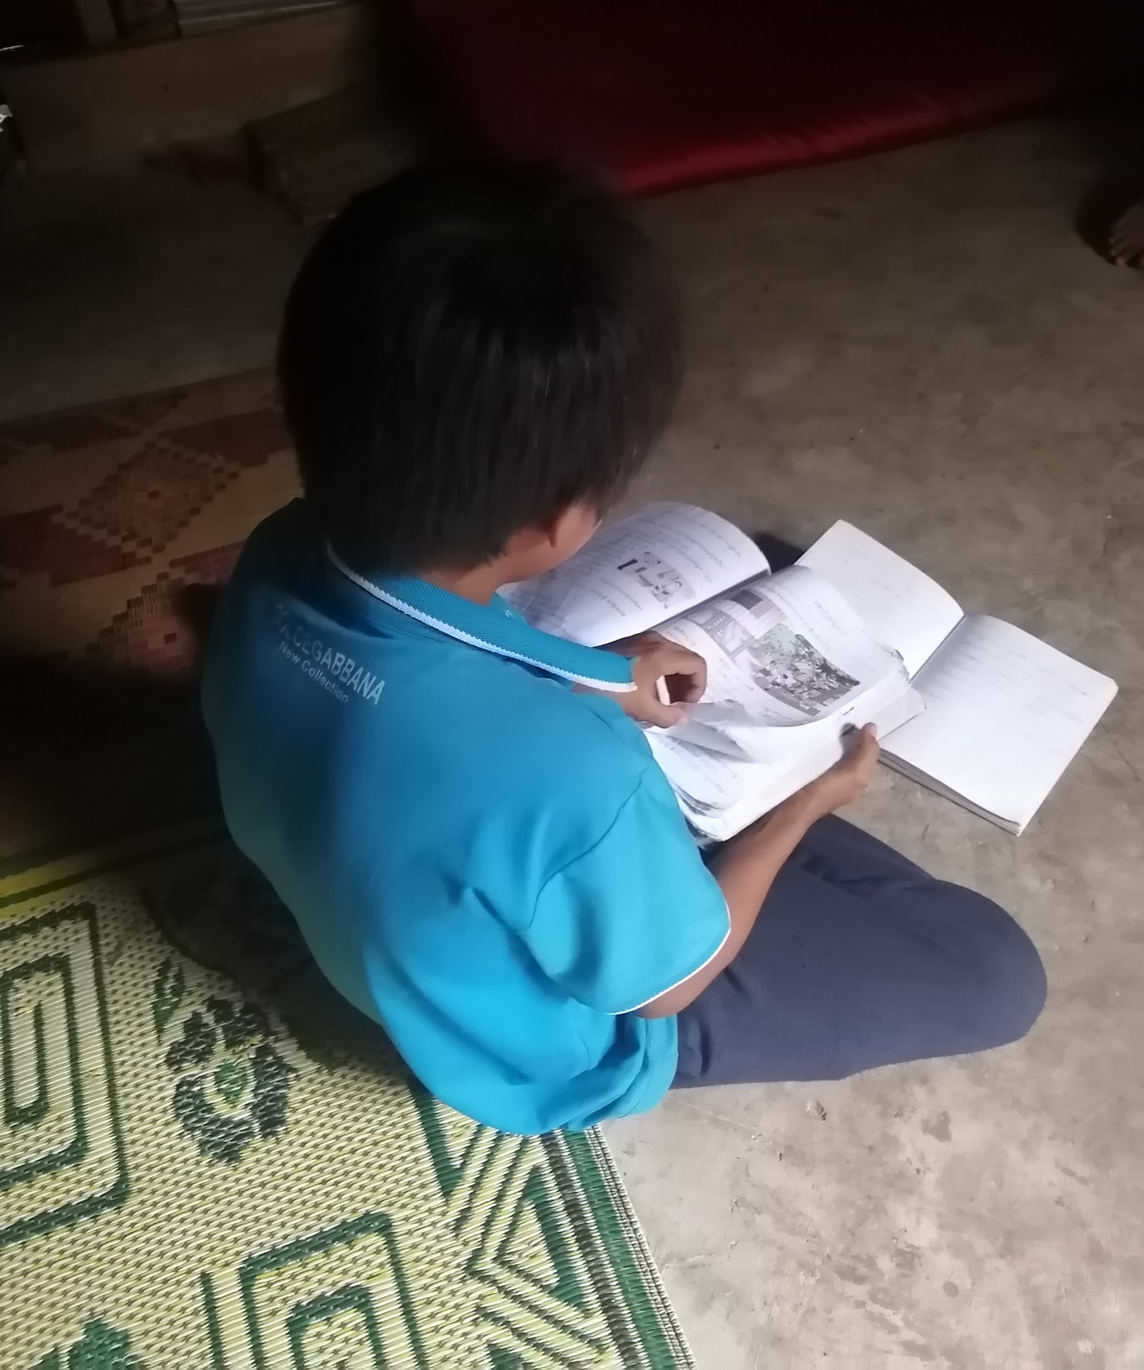  Our social workers support children to go back to school, a key step towards reintegration | 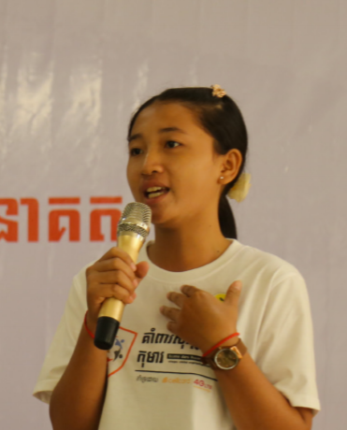  Our child volunteers advocated for better child protection through awareness raising campaigns  Testimonies  Nara, 12: “I am feeling better and because of this I have made new friends in the neighbourhood. I am brave now if compared to before, now I can communicate with my friends, they motivate me to study hard. I learned how to protect my sister and cousin from the abuse when we go to school.”  Ven, 16: “I am very happy to have met the TdH-NL social workers and to get support. Now, we all have a good relationship, especially the relationship between me and my stepfather. He stopped blaming me and using bad words.”  Thida, youth volunteer, 17: “I feel optimistic about the future to see my community environment and children safe with a better understanding of SECTT both to protect themselves and to report incidents of SECTT and other forms of violence.

