Vanasiri Rural Development Society, Ranebennur Taluk, Haveri District:
Implementation of Empowering the Girl child Education Program
Report as an end of Feb, 2019;

Profile of the organisation:

The Vanasiri Rural Development Society was established in 2004 and implementing various socio –economic development activities in Haveri District. The VRDS is significantly contributed empowering local community to access their legitimate rights on food, social security, employment opportunities, natural resource management, other development activities etc... The VRDS has demonstrated successful development modules with support of various agencies.

Justification of the project component:

The girls from the difficult circumstances find it difficult to follow their education to higher grades due to various reasons like getting into puberty, lack of parental support and also economic reasons. The VRDS focuses to work with such children who are from the community or have migrated in to other far off places.

The Girls from these families to pursue their dreams, scaffolding from various initiatives play an important role. The project has been initiated from April, 2018 onwards. The VRDS identified and finalised target villages, hamlets, and urban slums of Haveri district for the above project implementation. The process was done through field visit, extensive debate with the students, parents, school head masters, and teachers and with our staff. Further house visits were done to access the socio-economic condition of the family in the villages.

Before the selection, we have also approached the concerned School authorities and had discussions with the Head of the Schools and class Teachers. Through this process we understood the present problems, education standard of the children and family condition of the girl students. From the school records, we have collected academic standards of the each student and discussed the significant problems for continuation of girl student education. By following this process we have collected the list of 35 girl students from the different schools of the project area.
Finally, the selection has been done keeping in mind some of the following points: Girls from the low income and needy back ground like single parent, lack of responsible guardians, or any other hard pressed socio economic situation.

- The girls who have not covered under any other scholarship
- The parents of the girls who have been associated with the NGO for the past 2 years
- The girls from the families of below poverty line.(BPL)
- Girls from SC/St and minority communities
- Girls from the BPL families

The girls selected from the following places.

Sl. No. | Area/Location | No of children selected
1. | Ranebennur - Urban Slum | 07
2. | Budappanahally, Byadagi taluk | 04
3. | Hanumapura, Ranebennur taluk | 04
4. | Hanumapura Thanda, Ranebennur Taluk | 02
5. | Hosahonnatti, Ranebennur taluk, | 06
6. | Gudi Honnatti, Ranebennur taluk | 02
 | Total | 25

Soon after getting the list of the girls selected, the family visits have been done to verify the family conditions. We met the family members and had a thorough discussion. The real assessment of the family has been done by taking in to account of the sources of income to the family and support required for the girl child education have been noted.

In the second round, once again we met the children’ parents, care takers and the head of the family members. An open house discussion and interaction was held with them in the presence of the children. We were able to assess the family issues, problems, social practices, and gravity of the poverty which are causing for continuation and quality education of the Girl Child. We also discussed and understood the present facilities provided by the State Government in order to attain to strengthen the Education program in the area. Apart from this, the other support expected from the parents and children were also discussed and reciprocally agreed upon.

After the above discussions a team has been formed consisting of Projector Supervisor, field staff, and village volunteers and then team has visited to each family and once again assessed the real situation of the family. During the process, the real deprived families were found and finalised the required and eligible 25 Girl students have been shortlisted and selected in total across various schools as program beneficiaries.
Details of the girls;

The base line data has been developed of the girls selected to know the academic background of the children enrolled under this program. This will help in assessing the areas of focus and prepare the support plan for them accordingly. The required education materials were listed out, which were included school bag, compass, pencils, water bottles, note books, dictionary, white sheets, colour pencils, pens, atlas maps, drawing sheets, pads, white dress, white shoes, and socks etc...

The listed materials were procured for 25 Girls. The distribution of the materials was arranged on 14th June, 2018 and on the same day formal Education Program for the Academic year 2018-19 was launched. The Block Education Officer (BEO) from Education department, Child Development Program Officer (CDPO) from ICDS department, the District President of Women and Child Welfare Committee, the local Advocates, general public, students and parents have participated in the program. A wide publicity has been given by the media by covering the event.

The VRDS staff has been made responsible for regular home visits to ensure the required support is adequately given and the children are attending the schools and are able to perform well in their examination. This has created favourable atmosphere in the school education program and the other girls also cooperating with these selected girls and a cordial atmosphere has been created in the school.
Additional support;

We found that, the girls are required additional support to learn English, Maths and Science subjects and decided to conduct the special tuition classes which are required to learn as the subjects are difficult to rural area girls. Hence the special bridge courses are organised on;
- On every Sundays at the VRDS office, Ranebennur from 10.00 am to 3.00 pm.
- On every Saturday evening special classes are conducted at Village level at Hanumapura village, and Hanumapura tanda- from 3.00 to 6 .00 pm
- On every day in the evening classes are conducted for 4 girls at Budappanahally
- And for the local minority community girls, the special classes are conducted on Fridays at VRDS office, Ranebennur from 2.00 to 5.00 pm.

To conduct the special classes, we have identified 4 qualified and well experienced Teachers to teach Maths and Science subjects for these girls. Besides this, the care has been also taken to teach them spoken English, science, and grammar. The students got more interest to increase their ability and quality of learning. The parents of the children are also got interested; they are sending their children to special classes regularly. The bridge course is also facilitated to solve difficulties in learning by counselling by the teachers with the girl child individually.
Additional topics covered;

These adolescent girls have been also given information on both in physical and mental changes takes place as they attend to puberty. The classes are conducting on the importance of personal safety, health, and hygiene and on communication skills also. This has enhanced their knowledge and the personal hygiene has improved among the girls.

Soon after the selection of the girls, before starting the additional tuition classes, we have called a meeting of all the parents of the girls in the beginning of June, 2018 to discuss and to orient them on the project objectives and the role and responsibilities of the parents. The parents were informed in detail and they have agreed to send their children regularly to schools and as well as for the additional special classes conducted by us.

The second meeting was called the parents on 2nd Sep, 2018 at theVRDS office and discussed to take about the opinion of the children from parents and the feedback received was very positive. Subsequently, the 3rd meeting of the parents was also held on 20th of Jan, 2019 at VRDS Office, Ranebennur and had an interaction in detail. The parents/guardians are also happy about the progress taking place among their daughters and also on the services provided by the VRDS.

Photo gallery:
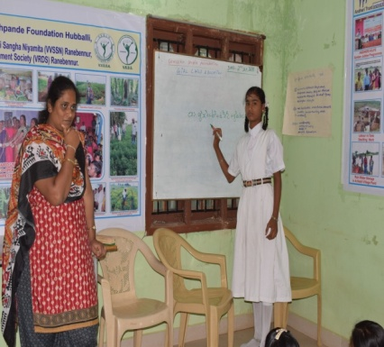
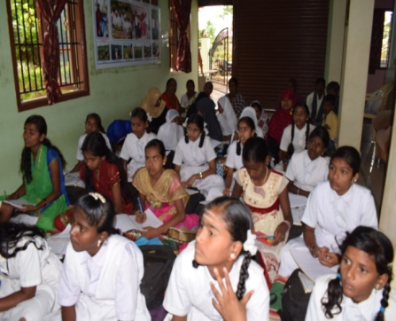

Kumari. Bharathi, a student of 8th grade has taken a session to other girl students at the special tuition classes. .

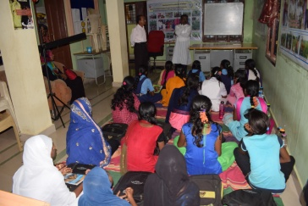
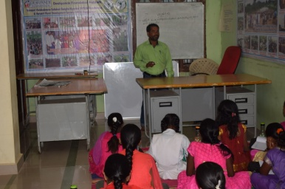

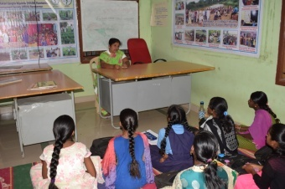

Resource person called from outside the project area to conduct the classes

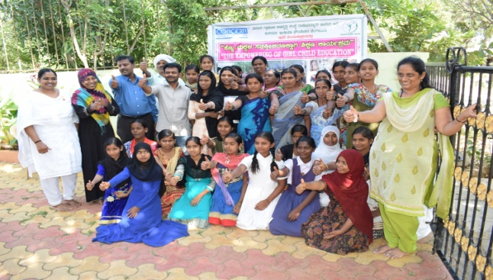
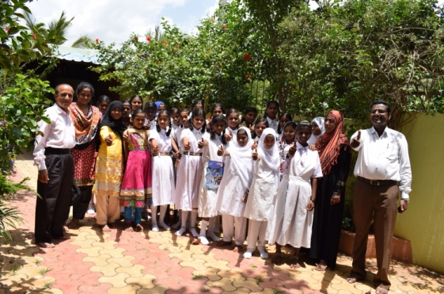

Girl children group photo with local Advocate, the resource person conducted a session
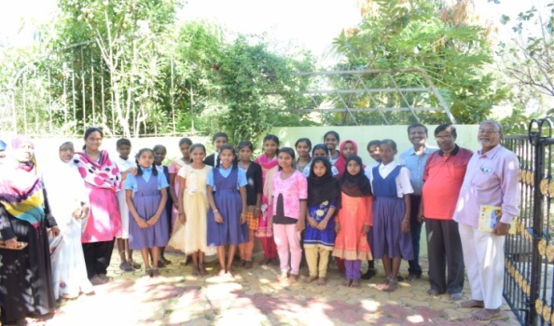

The VRDS President, Mr. Vijay Raghava, visited the girl child education program on 17th Feb, 2019
Conclusion;
The girl child education program is ongoing very well and the attendance is also very good as the girls are interested to attend on their own to the special classes. A very good rapport has been built among the students and the teachers. The Coordinator is also visiting the schools of the girls who are studying and the feedback has been collecting on their performance, the manners, and way of approach from the schools. It was noticed that there is lot of development in the personality of the girls. They are studying well and have become very daring and independently travelling to their native places.

We extend our sincere thanks and gratefulness to the Global Giving for having extending this support and giving us an opportunity to serve for the underprivileged girls and to bring them on the right pathway of education and to give them the quality of education in Ranebennur taluk of Haveri district, in Karnataka State.

------------------------------0----------------------------------

