VRDS – Educate a girl child EDUCATION PROJECT PROGRAM PHOTO
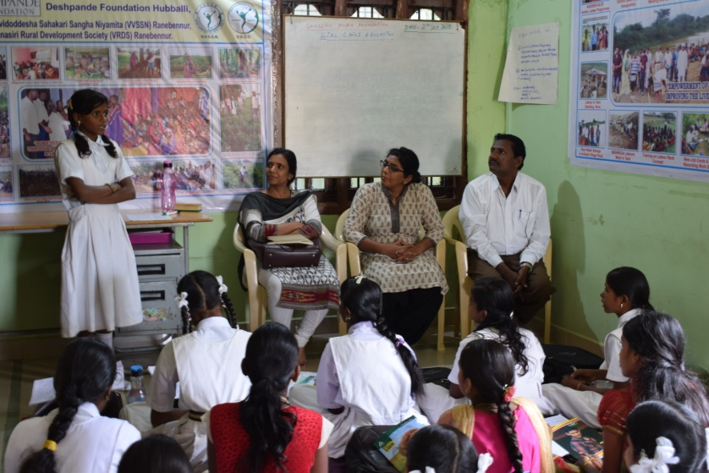 | 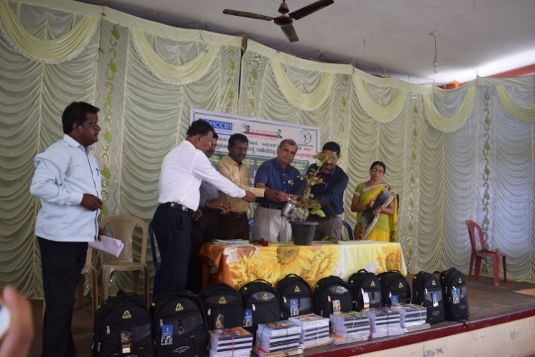
Girl child explaining the learnings from tuition | Inauguration Girl; child program
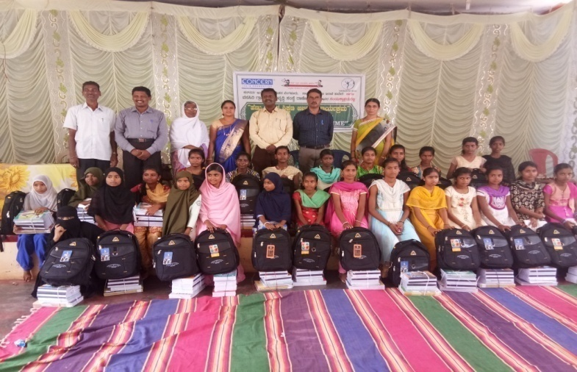 | 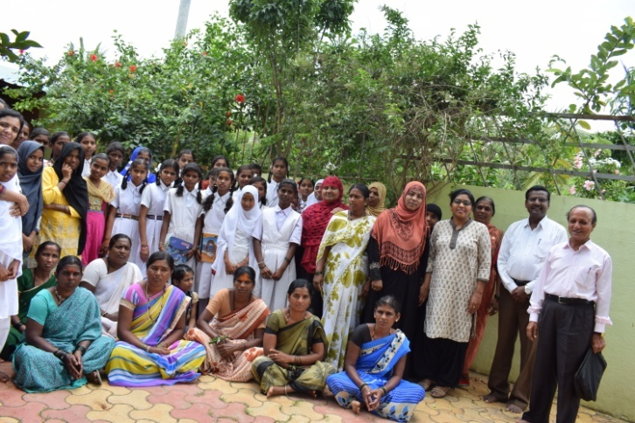
Education material distribution | Girl children’s with parents participate
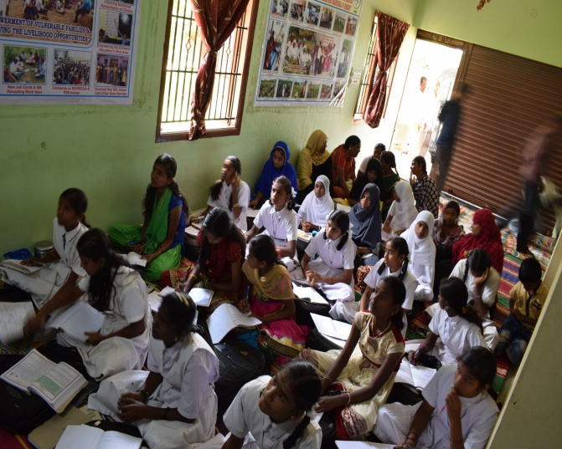 | 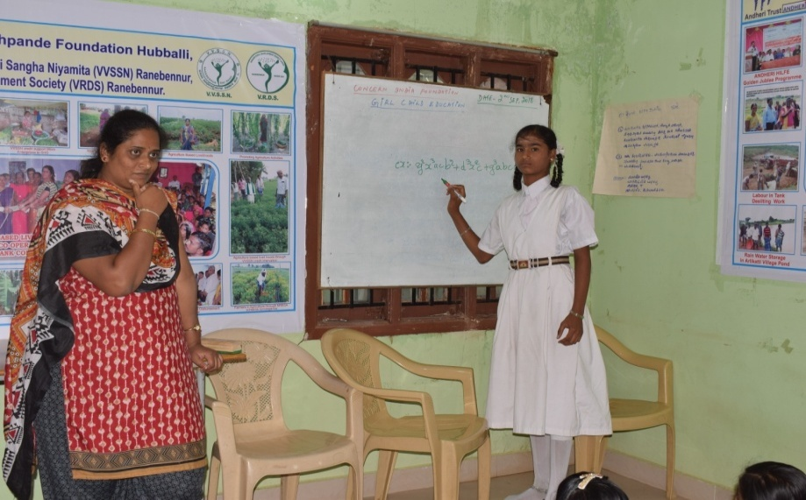
Intervention of girl child | Tuition class from every Sunday in VRDS office

